“Just Frog” Game

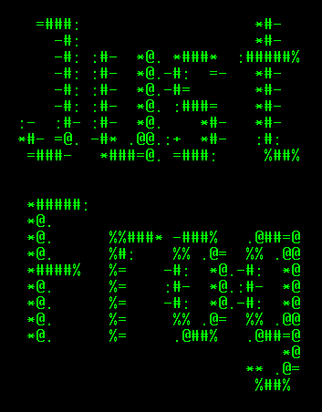
About the game:
Just Frog is based on the 1981 arcade game Frogger, developed by the Japanese company Konami Corporation. The player controls a frog, which has to first cross a road without being hit by any of the passing vehicles, and then cross a river by hoping onto the things, which float in it. The objective of the game is to cross the road and the river before the time runs out.
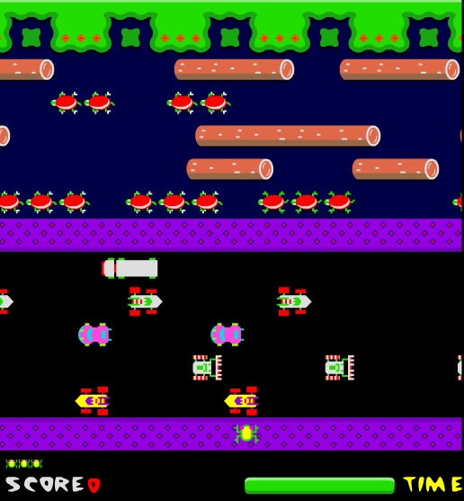Frogger screencap | 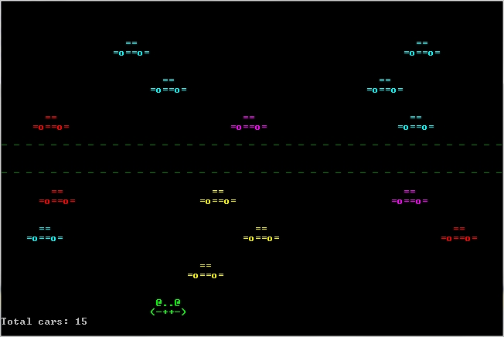Just Frog screencap
Similarly, the Just Frog game presents the player with the challenge to cross the road without getting hit by any of the passing at random cars. There are a total of six road lanes, separated by a resting space, which the frog has to cross to get to the other side of the road. The frog is allowed to move in all directions and is controlled by the keyboard arrows.

Making the game:
The Just Frog game source code contains several Classes, responsible for different aspects of the game. The Classes are: FrogMain, Lane, Car and Frog.
The FrogMain contains the core logic of the game and runs the game cycle. It is responsible for creating the six lanes, which are objects of class Lane. The main class then calls the methods of the Lane objects to generate new cars and move the cars.
Class Lane contains a list of cars, which are objects of class Car. Each lane has its own direction and speed, so that cars on one lane cannot crash into each other or overtake each other. When the Lane generates its list of cars, it passes them its direction and speed. The Lanes calls the ReDraw and Move methods of its cars. When cars are outside the Console window, they are removed from the list.
Class Car has two methods – RedDraw and Move. It is also responsible for watching for the Frog, which is created as public. If a car bumps into the Frog, it changes the game state to RoadKill.
The Frog, controlled by the player is a separate object, belonging to the class Frog. Both the Frog and the Cars are visualized on the Console through two-dimensional char arrays.
The main game cycle uses a Stopwatch to time the intervals between the three independent operations – moving the frog, generating new cars, and moving the existing cars. Each of these operations watch that a certain time interval has passed before they are executed. This allows to have cars moving at different speeds, independent of the console refresh rate.
To minimize flicker, the game does not use Console.Clear method to refresh the console. Instead, each object is redrawn – it is deleted from its old position and drawn again on its new position.
Drawing the cars as a sequence of chars, rather than strings, allows for gradual entering of the cars in the Console (so a partial car can be seen), rather than just appearing of a whole car.
The game makes use of three one-dimensional arrays (allLanes, colors, titleLines), and a set of static and instance methods. The static methods such as StartNewGame(), SetConsole(), RoadKill(), Success(), etc. serve to establish the sequence of events in the game, while the instance methods such as lane.DrawCars(), frog.Redraw(), etc. control the behavior of the objects in the game.
At least 4 existing .NET classes such as Console, Random, List and Stopwatch are also used in the game source code. A text that is animated on the welcome screen is read from a text file.

Work on the project was split as follows:
Class Cars: Ivan Tochev
Class Frog: Nina Anatchkova
Class Lane: Georgi Prodanov and Nikolina Varbanova.
Class FrogMain: Jivko Rusev and Angel Raev.

TFS repository URL: https://justfrog.codeplex.com/

