# PiRover

By Christopher Albarillo, Lawrence Puig, and Patrick Ng

Febuary 10, 2018

Project Build Website: https://chris0707.github.io/PiRover/

# Declaration of Joint Authorship

We, the PiNivea group, here by declare that the project report entitled “PiRover” confirm that this work submitted for assessment is our own and is expressed in our own words. Any sources and material used are all documented. A list of references that were used for this project is provided and can be found under Technical References section.

PiNivea: Christopher Albarillo, Lawrence Puig, and Patrick Ng.

Date: February 23, 2017

# Proposal

## Executive Summary

As students in the Computer Engineering Technology program, we will be integrating the knowledge and skills we have learned from our program. This proposal requests the approval to build the hardware portion, which is the PiRover, that will connect to a mobile device application using Bluetooth connection. The mobile device functionality will allow the user to register and login their information, gain access wirelessly to control the hardware(PiRover), voice commands to control the PiRover’s features (lights and code execution).

## Background

We believe that the most difficult part of this project is building the script that will handle the voice command functionality that will control the PiRover’s pre-implemented features such as; lights and other code executions.

This prototype project that our team has constructed has been inspired by other rovers such as NASA’s own rover. By utilizing all of the abilities acquired in our previous Hardware course we have gained further knowledge and become accustomed to the further advancements we are applying into the prototype. The PiRover was designed to be controlled via Bluetooth with an android application from any android device. With this feature working, we plan to implement other features such as; lights, voice activations and maybe further perfect the controller from the android application.

## Methodology

This proposal is assigned in the first week of class and is due at the beginning of class in the second week of the winter semester. My coursework will focus on the first two of the 3 phases of this project:  
 Phase 1 Hardware build.  
 Phase 2 System integration.  
 Phase 3 Demonstration to future employers.

*Phase 1 Hardware build*

The hardware build has been completed in the fall term and will finish it with an enclosed case for protection and stability this winter term. It will fit within the CENG Project maximum dimensions of 12 13/16" x 6" x 2 7/8" (32.5cm x 15.25cm x 7.25cm) which represents the space below the tray in the parts kit. The highest AC voltage that will be used is 16Vrms from a wall adaptor from which +/- 15V or as high as 45 VDC can be obtained. Maximum power consumption will be 20 Watts.

*Phase 2 System integration*

The system integration will be completed in the winter term.

*Phase 3 Demonstration to future employers*

This project will showcase the knowledge and skills that I have learned to potential employers.

The brief description below provides rough effort and non-labour estimates respectively for each phase. A Gantt chart will be added by week 3 to provide more project schedule details and a more complete budget will be added by week 4. It is important to start tasks as soon as possible to be able to meet deadlines.

|  |  |  |
| --- | --- | --- |
| **Labour Estimate** | **Hrs** | **Notes** |
| **Phase 1** |  |  |
| Writing Proposal | 9 | Tech Identification Quiz |
| Creating Project Schedule | 9 | Proposal Due |
| Creating Budget (Mock group setup for CENG355/Phase 2) | 9 | Project Schedule Due |
| Acquiring Components / Begin to film unboxing | 9 | Project Budget Due |
| PCB Fabrication | 9 | Component received for the project |
| Mechanincal Assembly / Status Meeting | 9 | Showing acquisition for the project |
| Finish off the PCB | 9 | Mechanical Assembly Due |
| Writing 30 second Video Script and creating Placard Design | 9 | PCB Due |
| Creating 30 second Video with the script created and Demonstration the hardware | 9 | Video Script and Placard Due |
| Writing Progress Report | 9 | 30 second Video Due |
| Creating the Hardware Presentation | 9 | Progress Report Due |
| 1st round of presentation and Writing build report | 9 | Presentation Due |
| 2nd round of presentation | 9 | Build Report Due |
| **Phase 1 Total** | **117** |  |
| **Phase 2** |  |  |
| Recreate the Proposal | 9 | Form the group for the project |
| Meeting with collaborators (SRS) | 9 | Proposal Due |
| Status Meeting | 9 | SRS Due |
| Meeting with collaborators(Abstract, Introduction and Declaration of Authorship) | 9 | Family Day Holiday – No Class |
| Meeting with collaborators (Email Progres Report by Student A) | 9 | Abstract, Introduction and Declaratiob of Authorship Due |
| Meeting with collaborators (Merged Build Instruction ported to Technical Report and App, Web and Database Independent Demonstration) | 9 | Group Status Progress Report Due |
| Meeting with collaborators(Email Progress Report by Student B) | 9 | Merged Build Instruction ported to Technical Report and App, Web and Database Independent Demonstration Due |
| Meeting with collaborators(OACETT basic requirement report checklist) | 9 | Integration Progress Report Due |
| Meeting with collaborators(Email Progress Report by Student C) | 9 | OACETT basic requirement report checklist Due |
| Prepare for Demonstration | 9 | Troubleshooting Progress Report Due |
| Prepare for Presentation | 9 | Demonstration Due |
| Writing Technical Report | 9 | Presentation Due |
| Extra Day | N/A | Technical Report Due |
| **Phase 2 Total** | **108** |  |
| **Phase 3** |  |  |
| Interviews | TBD |  |
| **Phase 3 Total** | **TBD** |  |
| **Material Estimate** | **Cost with tax** | **Quantity** |
| Raspberry PI Starter Kit | $112.99 | 1 |
| Electronic Learning Kit for RaspPi | $19.05 | 1 |
| 100000mAh Portable Power Bank | $23.72 | 1 |
| Micro Servo Motor FS90R | $21.00 | 2 |
| Ultrasonic Sensor HC-SR04 | $5.00 | 1 |
| Laserut Chasis from Humber | N/A | 1 |
| 3D Printed Wheels from Humber | N/A | 1 |
| Total | $181.67 |  |

## Concluding Remarks

This proposal presents a plan for providing an IoT solution for search and rescue situations or even for historical research. This is an opportunity to integrate the knowledge and skills developed in our program to create a collaborative IoT capstone project demonstrating our ability to learn how to support projects such as the initiative described by T. Kubota, Y. Kuroda, Y. Kunii and T. Yoshimitsu, "Path planning for newly developed microrover," Proceedings 2001 ICRA. IEEE International Conference on Robotics and Automation (Cat. No.01CH37164), 2001, pp. 3710-3715 vol.4.  
doi: 10.1109/ROBOT.2001.933195  
keywords: {computerised navigation;data structures;microrobots;mobile robots;path planning;planetary rovers;probability;data structure;elevation map;mobile robots;navigation;path planning;planetary exploration;planetary microrover;probability;Data structures;Instruments;Mars;Mobile robots;Moon;NASA;Navigation;Path planning;Rain;Space exploration},  
URL: http://ieeexplore.ieee.org/stamp/stamp.jsp?tp=&arnumber=933195&isnumber=20185  
  
 We request approval of this project.

# Abstract

Technology is growing fast and is considered to be a powerful tool to help us in our daily lives. One of these technologies that lead us to our project is the rover, that can be controlled wirelessly and also can fit in small and tight spaces which no average person can fit into. In addition, it gives the researchers comfortability to not worry about the dangers of a certain place that they will explore. Having a rover can benefit a lot of situations such as; outdoor research, emergency situations, and for learning purposes. However, with such technology that has a lot to offer, also comes with an incredible amount of price. And this is where our project will come to play. Our project, which is called PiRover, is a portable rover that is powered by an open source computer called Raspberry Pi. In this project, we focused on the portability, low cost, and functionality of the PiRover. This gives the people opportunity to get themselves their own rover for a lower cost to explore and learn using the PiRover at the same time.

Table of Contents

PiRover 1

Declaration of Joint Authorship 3

Proposal 4

Executive Summary 4

Background 4

Methodology 5

Concluding Remarks 10

Abstract 12

Table of Contents 13

Illustration List 14

1. Introduction 15

2. Software Requirement Specifications (SRS) 16

2.1 Purpose 16

2.2 Overall Description 16

2.2.1 System Interface 16

2.3 Hardware 16

2.3.1 Components 16

2.3.2 Chasis Specifications 17

2.3.3 Motor and PCB(Optional) Specifications 17

2.4 Mobile Application 18

2.4.1 Database 19

2.4.2 Connectivity 19

2.5 External Interface Requirements 19

2.6 System Features 19

3 Progress Report 21

4 Conclusion 22

5 Recommendations 23

6 Technical References 24

7 Appendices 25

# Illustration List

# Introduction

# Software Requirement Specifications (SRS)

## Purpose

The purpose of our software is to provide full control of the PiRover(Hardware). Using the mobile application, it enables the user to control the PiRover manually and automatically and have his/her own account to simply store the PiRover’s collected data in the database.

## 2.2 Overall Description

### 2.2.1 System Interface

The system interface for our project consists of the following: PiRover hardware, mobile application, and a database server. The user will have full control of the PiRover using the mobile application. When the user chooses the option to control the PiRover automatically, it will run autonomously while recording data and having an option to review and store the information in the database.

## 2.3 Hardware

Our hardware is called PiRover. Once the PiRover has booted up, it will automatically open a Bluetooth server connection. It should be able to receive the connection from the mobile device that the hardware is currently paired with. Once the connected is established, the user is can now control the PiRover manually and automatically. Patrick Ng will be leading this section.

### Components

PiRover Components:

* Raspberry Pi 3
* UltraSonic Sensor HC-SR04
* 100000mAh Portable Power Bank
* Micro Servo Motor FS90R (x2)
* Laser cut Chasis from Humber College
* 3D Printed wheels from Humber College
* PCB Printed from Humber College
* USB Microphone

### 2.3.2 Chasis Specifications

Chasis Size:

Width – 8.99cm

Height – 5.99cm

### 2.3.3 Motor and PCB(Optional) Specifications

Motor Specifications:

Size:

23.2mm x 12.5mm x 22mm

General Specifications (at 6V):

Free-run current: 120 mA

Stall current: 800 mA

Speed: 130 rpm

Stall Torque: 21 oz-in

General Specifications (at 4.8V):

Speed: 100 rpm

Stall torque 18 oz-in

Lead Length: 10 in

PCB Specifications:

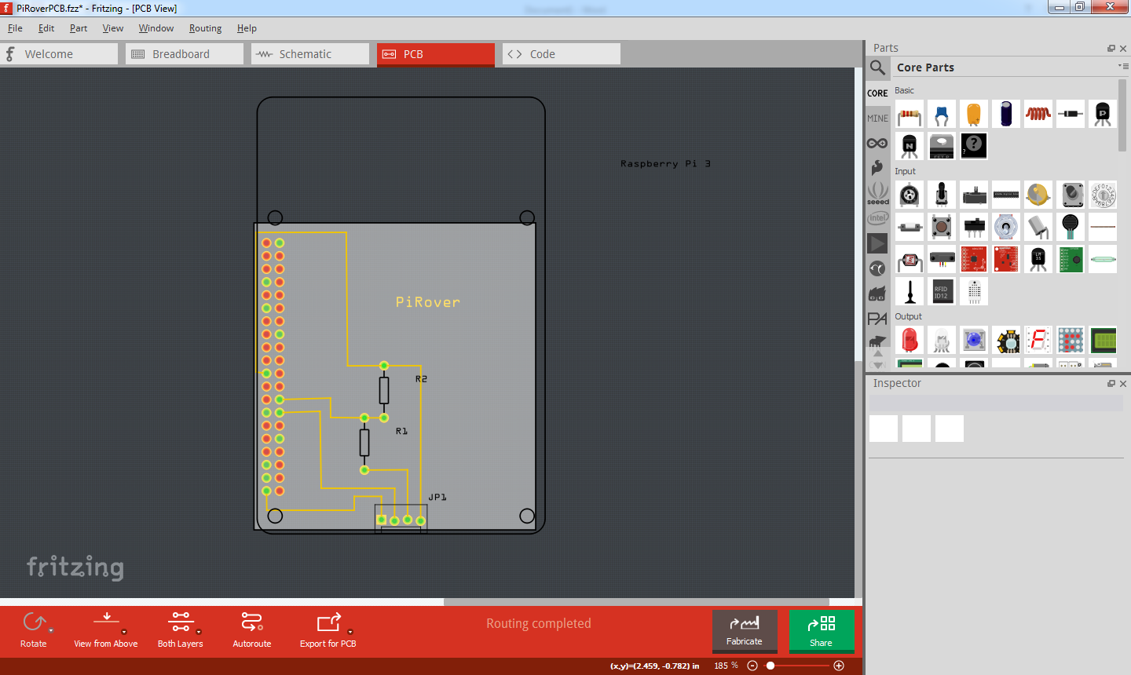

PCB Size:

Width – 55mm

Height – 60mm

## 2.4 Mobile Application

Our mobile application is called PiRover controller. The mobile application is only available for android users only. Once the app is opened, it will give the user options to – login, register, and proceed in offline mode. After the user has logged in, there will be two control options provided for the user: manual and automatic. If the user selected manual, he/she will have the ability to control the PiRover using the manual controls provided. And if the user selected automatic, he/she will only have one option to control the PiRover, and that is by selecting or clicking the button “start automap”. Lawrence Puig will be leading this section.

### Database

The database server that is being used in this project is the Hostinger’s database. Using the database, it enables us to store user’s information, as well as the data that will be gathered by the PiRover. This will give the user comfortability to review their gathered data as long as the user has access to the internet and currently logged on to the mobile application. Christopher Albarillo will be leading this section.

### Connectivity

The mobile application allows the user to graphically control the PiRover via Bluetooth integration to the Raspberry Pi 3. The Android device and Raspberry Pi 3 should be paired in order to control the PiRover. For further details refer to the Mobile application’s “Help” section.

## External Interface Requirements

In order to run the android application, an Android device that is above API 21 (Android 5.0) is required. Any device under this API will not be able to run the application. For the voice activation control, it will require an external microphone as the PI doesn’t have an integrated microphone. This can be a USB webcam with a microphone, USB microphone or 3.5mm microphone. To use the 3.5mm microphone, a USB sound card is needed as the PI 3.5mm jack is an output and not an input. The USB ones are plug and play.

## System Features

The PiRover has multiple features and still going through multiple updates for further implementations. Up to date features include;

* Full Manual Control of the PiRover
* Automatic Sensor Mode

System Features in the process of being implemented;

* Voice Activation Control System *Patrick*
* Lights (May be Voice controlled) *Chris*
* Movement (Possibly voice controlled) *Lawrence*

# Progress Report

# Conclusion

# Recommendations

# Technical References

# Appendices