These are the users that I will add into the userDetails:

|  |  |  |  |
| --- | --- | --- | --- |
| Field Name | Sample 1 | Sample 2 | Sample 3 |
| Username | davidKing119 | jamesNelson | susanWilson |
| Password | preme_King34 | JellieN_956 | susie101 |
| Email | davidKing@gmail.com | jamesNelson@gmail.com | susanWilson@gmail.com |
| Full name | David King | James Nelson | Susan Wilson |
| Telephone | 07123456789 | 07123498756 | 07987654321 |
| Address1 | 61 Bolven Walk | 48 Grove St | 34 Park St |
| Address2 | Lotherton | Firlington | Kirbington |
| Address3 | Witlockery | Readingly | Harrow |
| City | Bradbury | Gogelbury | Thistle |
| Postcode | BT93 0YR | GH45 0HY | TR23 0FR |
| Profile picture |  |  |  |
| Card Number | 5159927655617746 | 1749927652967746 | 512392764517746 |
| Expiry date | 01 | 27 | 05 |
| Expiry Year | 2021 | 2017 | 2019 |
| SCN | 162 | 698 | 409 |

And I added these orderDetails:

|  |  |  |  |  |
| --- | --- | --- | --- | --- |
| Field Name | Sample 1 | Sample 2 | Sample 3 | Sample 4 |
| User ID | davidKing119 | davidKing119 | davidKing119 | jamesNelson |
| Order Date | 2018-11-08 | 2018-10-25 | 2018-10-18 | 2018-11-01 |
| Item Category | Shoes | Sweatshirt | Jacket | Accessories |
| Item Keywords | Supreme Nike Air Force 1’s | Raglan Sweater | North Face Pullover | Thermal Crew Neck |
| Item Sell-out time | 20 | 40 | 10 | N/A |
| Order-success? | Card Decline | Yes | Sold Out | Yes |
| Retail Price | 130 | 120 | 120 | 20 |
| Resale Price | 230 | 150 | 250 | N/A |

Finally, I must query the database to ensure the data of the orders link to the respective user.

|  |  |
| --- | --- |
| Fields and calculations | userDetails.fullName , orderDetails.itemCategory |
| Tables and queries | userDetails, orderDetails |
| Search criteria | none |
| Grouping | none |
| Sort Order | orderDate |

Expected result (show orders in chronological order with the full name associated):

|  |  |
| --- | --- |
| David King | Jacket |
| David King | Sweatshirt |
| James Nelson | Accessories |
| David King | Shoes |

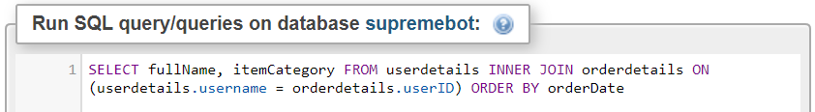Results:

