My market research went very well as I was able to get a much better idea on people’s thoughts about supreme bots buying items automatically. I was able to speak to 10 people in total, through social media and in person. One of the people I talked to is a famous hype beast on Instagram @ericwhiteback

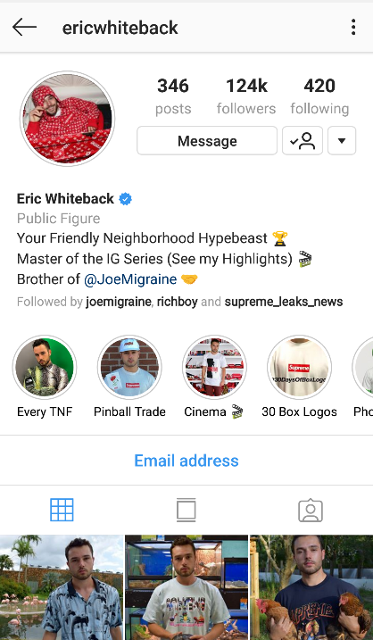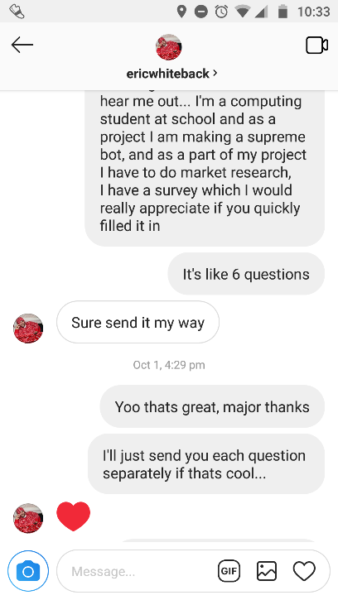

He was very helpful, as he has been following and buying supreme for a long time and has plenty experience with bots.

From chatting with Eric, others on social media and people I know I have a much better idea of the opinions of the target market. Out of the 10 I spoke to, 7 had never used a bot before and 3 had. Out of the 7 people who hadn’t used a bot, it was mainly due to the price of them, and they didn’t trust that they would be reliable enough for the price paid. The 3 people who had used them previously had mixed experiences, some saying very positive and some not so good, from further investigation I found this is because bots are never 100% consistent at getting items, they can’t ever guarantee the order of an item. With further conversation I found that this could be due to very small external changes such as internet transmission speed and the speed of the hardware. This can affect the order by seconds which can be devastating if you are buying supreme. If the item is very hyped it can easily sell out in under 5 seconds.

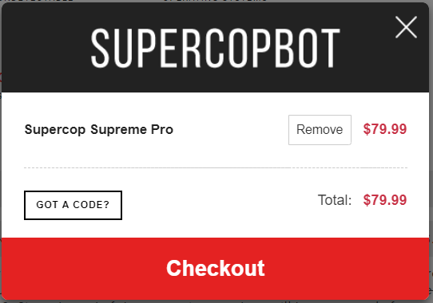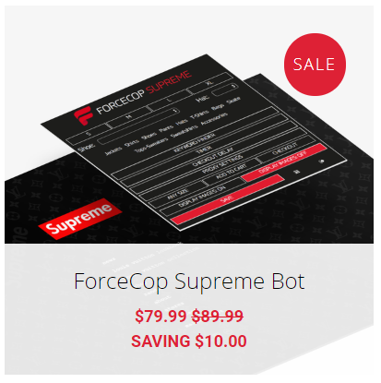To further my research, I have looked at the bots that my target market said worked best. These are also the most popular bots to be used:

The rough price of $80 for the whole season converts to about £62, this is a stupid price considering the reliability of bots, it should be priced a lot lower, and is clearly shown in the market research as 9/10 think that bots are “unnecessarily expensive”. The more appropriate price range was said to be around £20.

From 9/10 people I spoke to, they didn’t mind how elaborate the bot was, they only cared that it “attempted to buy the item quickly” and is priced much cheaper than the rest of the market. Most people have accepted that “a bot will never have a 100% success rate” but believe it is still much better than buying it manually.