Game Design Document

Fill up the following document

1. Write the title of your project.

Bubble Shooter

1. What is the goal of the game?

Shooting bubbles

1. Write a brief story of your game.

A witch has surronded the city of toran and the only way of to defeat

Her is by destroying all her bubble spells

1. Which are the playing characters of this game?

* Playing characters are the ones who respond to the user based on the input from the user.
* Cars, monkeys, dinos, wizards, etc., are the playing characters in the game.

|  |  |  |
| --- | --- | --- |
| Number | Character Name | What can this character do? |
| 1 | The Knight | Control the gun |
| 2 | The gun | Shoot the bubbles |
| 3 |  |  |
| 4 |  |  |
| 5 |  |  |
| 6 |  |  |
| 7 |  |  |
| 8 |  |  |

1. Which are the Non-Playing Characters of this game?

* Non-Playing characters are the ones that don't have an action or behavior when the user interacts with the game.
* Hurdles, stones, bananas, coins, etc., are non-playing characters in the game.

|  |  |  |
| --- | --- | --- |
| Number | Character Name | What can this character do? |
| 1 | Bubbles | Get attacked at |
| 2 | Witch | dialouges |
| 3 |  |  |
| 4 |  |  |
| 5 |  |  |
| 6 |  |  |
| 7 |  |  |
| 8 |  |  |

Draw your imagination of this game. What does this game look like?

* Draw the game either on your computer or on paper.
* Add images of the game scenes to show each of the playing and non-playing characters at least once.

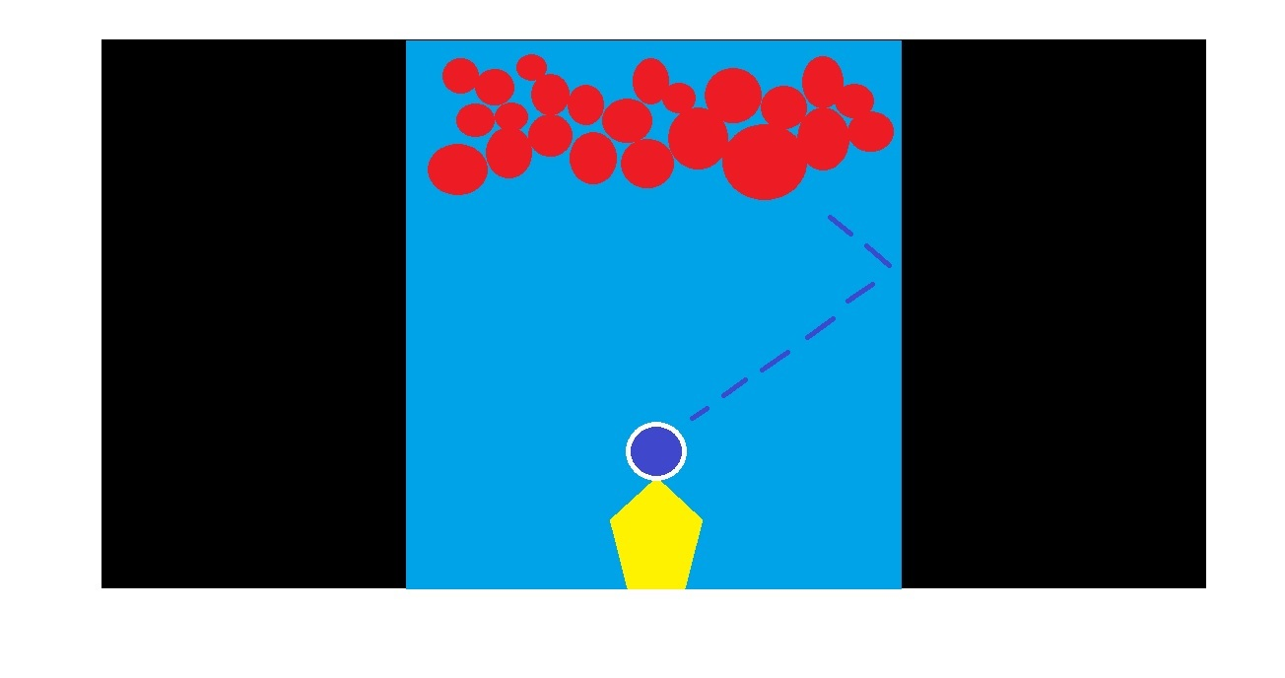

How do you plan to make your game engaging?

1. Difficulty balance :- More number of bubbles than the ammo . eg: 50 bubbles ,40 ammo

2. Feedback:- 1.Each bubble would disappear after getting hit

Score increased by 1

3. Skill vs Chance: this game is mostly based on skill to create trajectories but some chance of getting a lucky shot

4. Goals:- Destroy all bubbles

5. Rules: Limited shots

Limited Time