1.1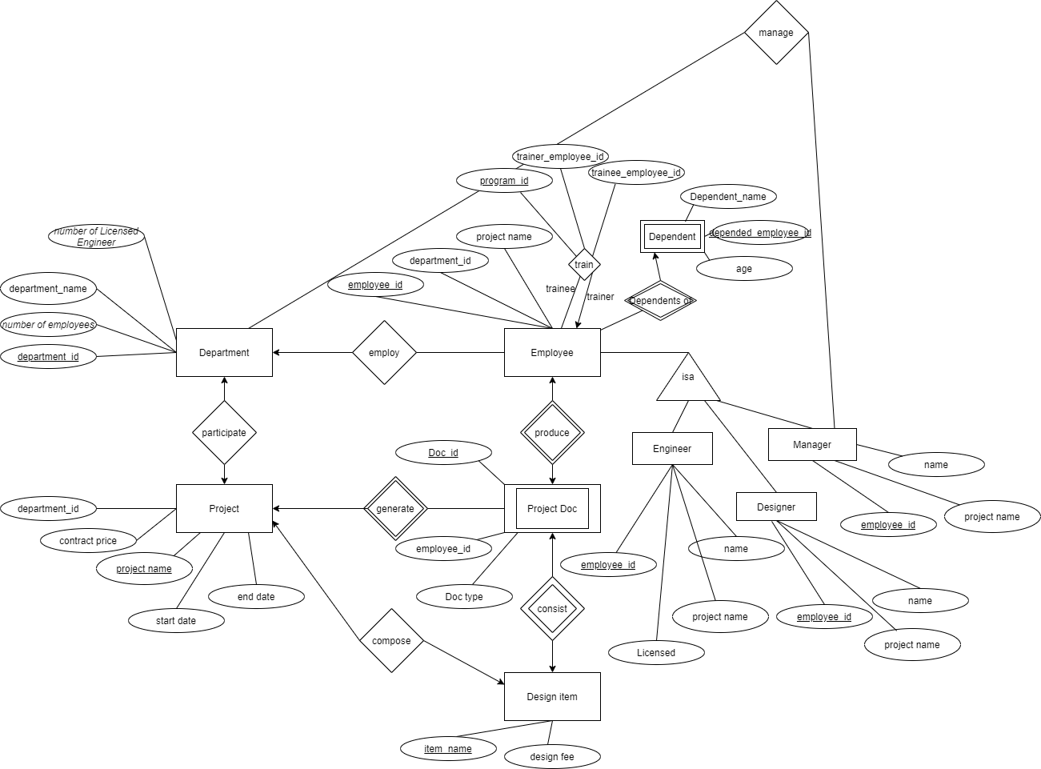

1.2

Department (department_id, number of employees, department name, number of Licensed Engineer)

Project (project name, start date, end date, contract price, department_id)

Employee (employee_id, department_id, project name)

Engineer (employee_id, Licensed, project name, name)

Designer (employee_id, project name, name)

Manager (employee_id, project name, name)

Design item (item_name, design fee)

Project Doc (Doc_id , employee_id, Doc type)

train (program_id,trainer_employee_id,trainee_employee_id)

Dependent (depended_employee_id, Dependent_name,age)

1.3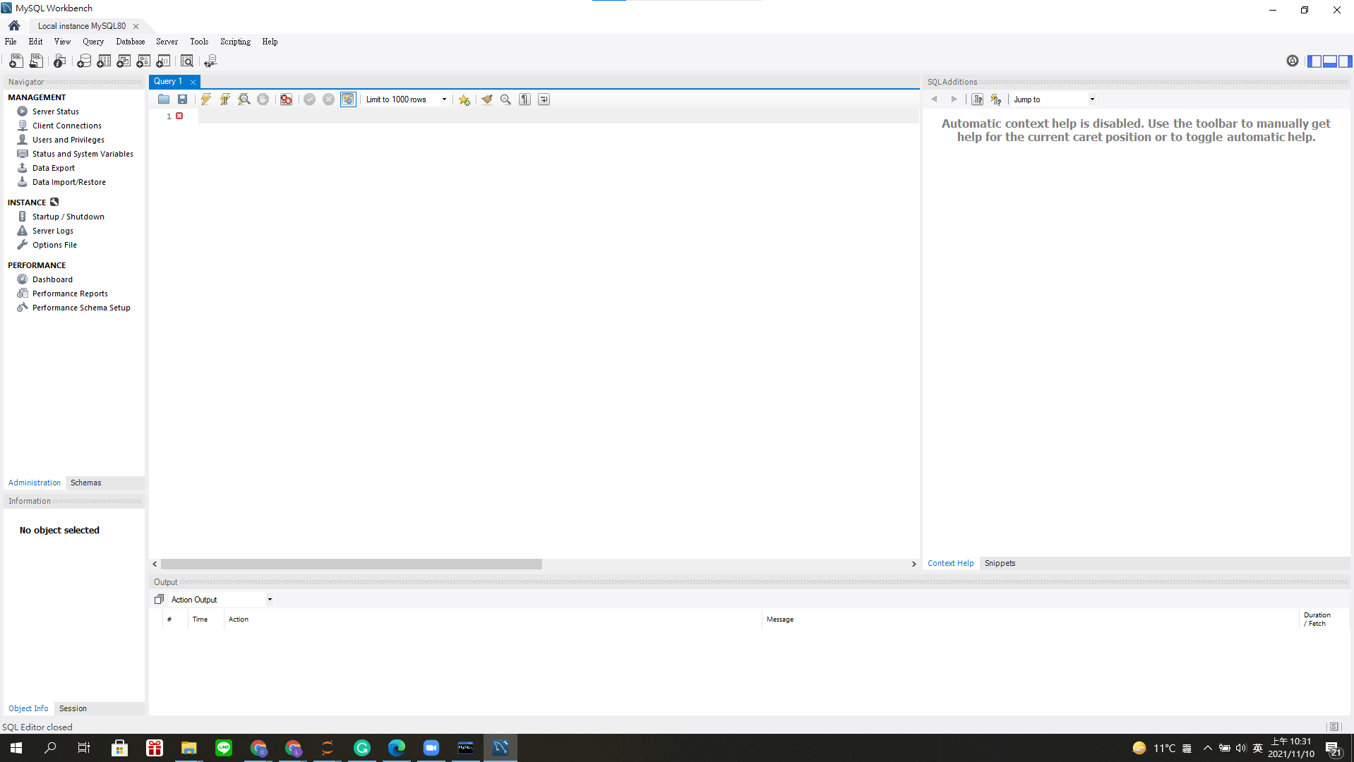

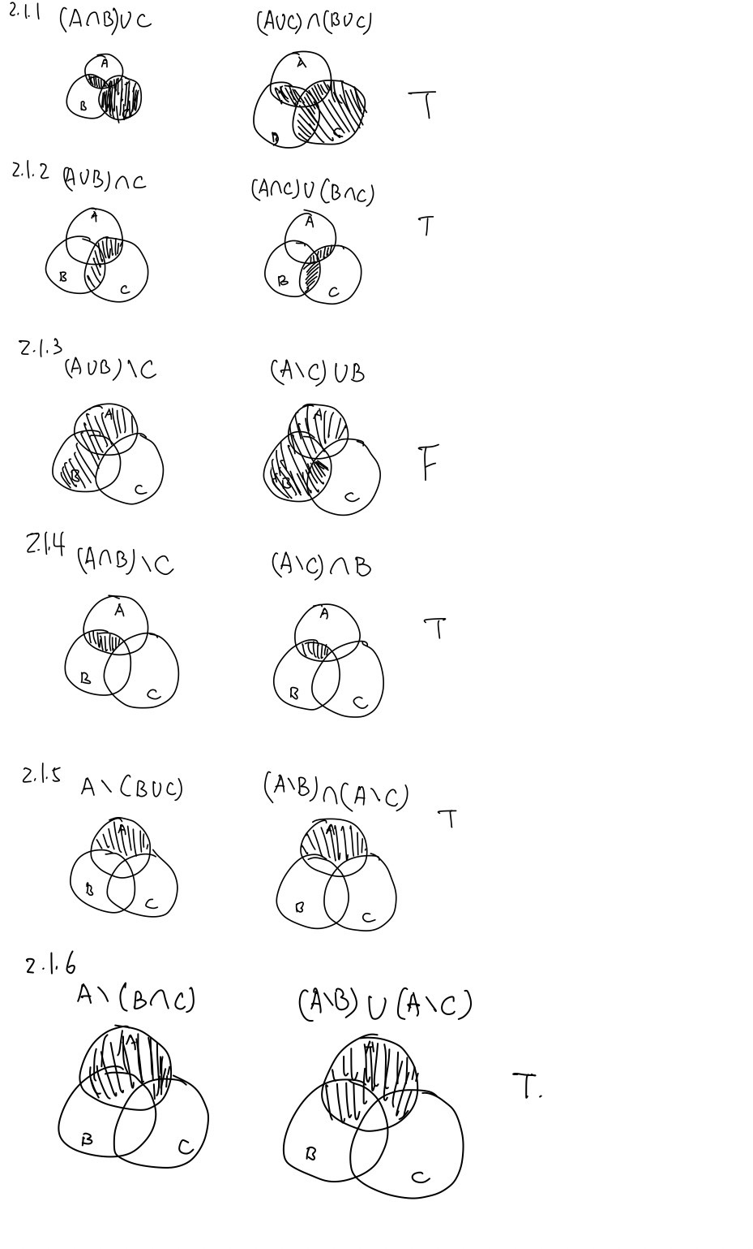

2.2

$$π_{name,Licensed}[σ_{start date>2012}(Project⋈engineer)]$$

$$π_{project name}(σ_{employee_{id}<10}({}_{project name}G_{count\left(empoyee_id\right)}\left(Employee\right))$$

