1

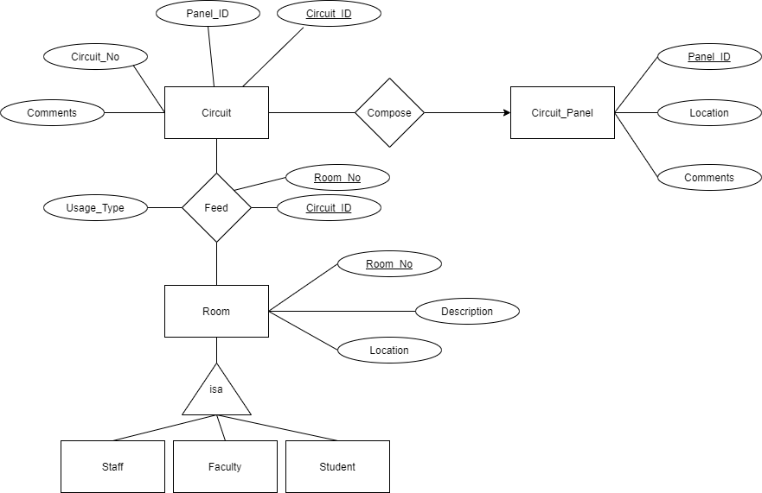

2.1

Circuit (Circuit_ID,Circuit_No, Panel_ID, Comments)

Circuit_ID=> Circuit_No, Panel_ID, Comments

Room (Room_No, Description, Location)

Room_No => Description, Location

Circuit_Panel (Panel_ID,Location,Comments)

Panel_ID => Location,Comments

Feed (Circuits_ID,Room_No, Usage_Type)

Circuits_ID,Room_No => Usage_Type

Staff (Room_No, Description, Location)

Room_No => Description, Location

Faculty (Room_No, Description, Location)

Room_No => Description, Location

Student (Room_No, Description, Location)

Room_No => Description, Location

Compose (Panel_ID,Circuit_ID)

2.2

No, it does not violate the BCNF because for all functional dependencies, the left-hand side is a key. Where a key is an attribute that determines all other attributes.

3.1

SELECT Description

FROM Room

WHERE Room_No = “118E”;

3.2

CREATE TABLE Circuit(

Circuit_ID INT NOT NULL PRIMARY KEY,

Circuit_No INT,

Comments VARCHAR(50),

Panel_ID INT

);

3.3

DELETE FROM Circuit_Panel

WHERE Comments = “TO BE DELETED”;

4.1  
(e)

First, create tables that do not contain foreign keys (Circuit_Panel, Room), then create tables that contains foreign keys but are strong entities (Circuit), lastly create tables that are relations (with composite primary keys) that depend on other strong entities (Feeds).

4.2

SELECT *

FROM Circuit

WHERE circuitComments LIKE “%old%”

ORDER BY Panel_ID, Circuit_No;

4.3

SELECT COUNT( DISTINCT Circuit_ID)

FROM Feeds

WHERE Room_No = 121;