DEED OF ABSOLUTE SALE

KNOW ALL MEN BY THESE PRESENTS:

This Deed of Absolute Sale, made and entered into this __ day of February, 2026, by and between:

Christopher David T. Verceles , of legal age, Filipino citizen, single; Lourdes Antonette Y. Tan, of legal age, Filipino citizen, single with address at 2518 One Rockwell East, Hidalgo Drive, Makati City and hereinafter referred to as the “SELLER”;

and

Dinah Imelda I. Ramos of legal age, Filipino citizen, single with address at 215 Gen Bautista St. Imus Cavite, and hereinafter referred to as the “BUYER”;

WITNESSETH: That –

WHEREAS, the SELLER is the legal and the registered owner of Unit 2518E, a three -bedroom flat residential unit, with an area of One Hundred Twenty Seven (127) square meters, with one (1) parking slot with parking reference no. 2518E, located at the 25th floor of the East Tower of One Rockwell, Hidalgo Drive, Makati City. More particularly described as follows (the “Subject Property”):
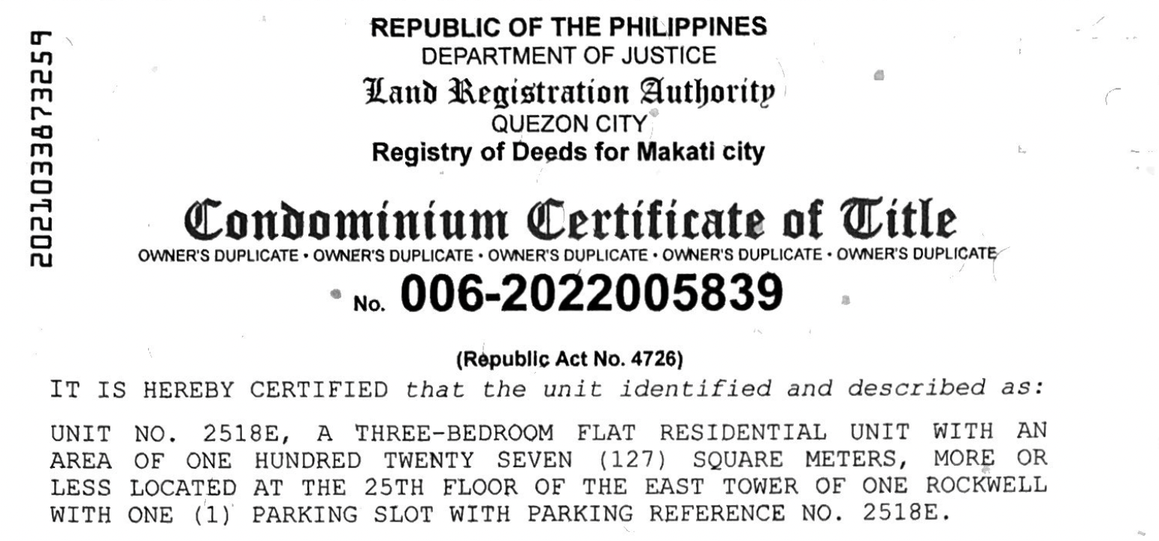

WHEREAS, the SELLER has offered to sell and the BUYER have agreed to buy the SUBJECT PROPERTY under such terms and conditions herein stipulated;

NOW, THEREFORE, for and in consideration of the foregoing premises, and the mutual terms and conditions hereinafter stipulated, the parties hereby agree as follows:

- For and in consideration of the total amount of FORTY MILLIONPESOS (P40,000,000.00), Philippine Currency, receipt of which is hereby acknowledged by the SELLER from the BUYER, the SELLER hereby absolutely and irrevocably sells, transfers and conveys unto the BUYERS all of her rights, interests, and participation in the said Subject Property;

- Upon the signing of this Deed, the SELLER shall deliver to the BUYER the following documents:
a) Original Owner’s copy of Transfer Certificate of Title No. 006-2022005839
b) Original Tax Declaration,
c) Original Tax Clearance 2026,
d) Certified True Copy of Condominum Certificate of Title
e) Certified True Copy of Tax Declaration
f) Original Real Property Tax payment for year 2026
g) Original Official Receipt for Association Dues for year 2025
h) Copy of Notice of Offer to Sell to Rockwell Residential Towers Condominum Corporation
i) Certificate of Ownership
j) Certificate of Non Delinquency
k) Letter to One Rockwell Administration notifying of Sale
l) Certificate of Non Tenancy
m) Certificate of Finished Posting
The following document will be surrendered after full payment:
Certificate of Management from One Rockwell East Condominum Association
- Capital Gains Tax, Creditable Withholding Tax, or Value Added Tax, if applicable shall be for the account of the SELLER while Documentary Stamp Tax, transfer tax and registration expenses to register the Deed of Absolute Sale and transfer the title of the Subject Property in favor of the BUYER, shall be for the account of the BUYER. The real property tax, association dues, utilities, back taxes if any, and special assessments on the Subject Property up to the date of the signing of the Deed of Absolute Sale are to be paid by the SELLER;

IN WITNESS WHEREOF, the parties hereto have set their hands to this instrument on this _____ day of May at Makati City, Metro Manila, Philippines.

___________________________________ ___________________________________
Christopher David T. Verceles Lourdes Antonette Y. Tan
SELLER SELLER

___________________________________
Dinah Imelda I. Ramos
BUYER

SIGNED IN THE PRESENCE OF:

____________________ _____________________

ACKNOWLEDGMENT

REPUBLIC OF THE PHILIPPINES)
MAKATI CITY, METRO MANILA ) S.S.

BEFORE ME, a Notary Public for and in Makati City, this _____________________ personally came and appeared:

NAME | IDENTITY NUMBER | EXPIRY DATE/PLACE ISSUED
Lourdes Antonette Y. Tan
Christopher David T. Verceles
Dinah Imelda I. Ramos

all known to me and to me known to be the same persons who executed the foregoing document, and they acknowledged to me that the same is their free and voluntary act and deed. This document refers to a Deed of Absolute Sale over a residential condominium known as 2518 One Rockwell East, Hidalgo Drive, Rockwell Center, Makati City, and consists of ___ (___) pages including the Acknowledgment is written, signed by the parties and their instrumental witnesses.

IN WITNESS WHEREOF, I have hereunto affixed my signature on the date and at the place first above-written.

NOTARY PUBLIC

Doc. No. ___;
Page No. ___;
Book No. ___;
Series of 2026.

