**Learning Styles**

All learning styles are different. Our team has a variety of learning styles, tests were taken online to determine our own unique styles. Here is an explanation of the tests, the results for our team and what that means for us as working together.

Learning styles are either Auditory, Visual or Kinesthetic. Depending on your style you will learn better either by listening, seeing or doing.

**Big Five Personality Test**

The big five personality test breaks up into five different sections, each with their own part of our personalities.

OCEAN

* [Openness](https://en.wikipedia.org/wiki/Openness_to_experience)- How open a person is to new ideas and experiences

Openness is the way a person thinks abstractly and in complex ways. High scores in openness mean that someone like to play with ideas and discover new things. They are good at expressing themselves but usually in strange and complex ways.

* [Conscientiousness](https://en.wikipedia.org/wiki/Conscientiousness)- How goal-directed, persistent, and organized a person is

This is the ability to exercise self-discipline or control in order to achieve a goal, and whether a person can forego immediate gratification for the sake of the long-term.

* [Extraversion](https://en.wikipedia.org/wiki/Extraversion_and_introversion)- How much a person is energized by the outside world

Extraversion is about how much a person seeks stimulation from the outside world, whether to earn friendships, admiration, power, status etc.

* [Agreeableness](https://en.wikipedia.org/wiki/Agreeableness)- How much a person puts others' interests and needs ahead of their own

* [Neuroticism](https://en.wikipedia.org/wiki/Neuroticism)- How sensitive a person is to stress and negative emotional triggers

**Myer-Briggs Test**

The Myer-Briggs test was test determines what personality type you have. There are many types of personalities so we will only discuss the types that our team have.

**Chris Hole - Myers-Briggs test - ISTP**

ISTP stands for Introverted, Sensing, Thinking and Perceiving. It is also known as the Craftsperson as people of this type have an innate mechanical ability and facility with tools.

ISTP’s are more common in men than women. 5% of the general population are ISTP’s and are 9% of the men's population but only make up 2% of the population of women. This puts me in a rather rare category of personality.

According to Myes-Briggs the ISTP personality type has an understanding of mechanics and an interest in troubleshooting. They approach tasks with logic and practical solutions. They are independent and adaptable, and are attentive to detail. They often see things others may not. ISTP’s are good in an emergency and respond quickly and calmly. ISTP’s are reserved but not withdrawn.

ISTP is a person who is energized by spending time alone (introverted), who focuses on facts and details rather than ideas and concepts (sensing), makes decisions based on logic and reason (thinking), and prefers to be spontaneous and flexible rather than planned and organised.

Personality max - Visual - 39%, Kinesthetic - 37%, Auditory - 24%

My primary learning style is visual. It means that I learn better from seeing rather than by listening or doing. A good visual learner is good at remembering faces and recognising body language, able to picture things in their mind, good at taking notes, understands charts and diagrams and notices small details others might miss.

My primary and secondary styles are similar in the percentage that I learn with. People who learn kinesthetically learn by doing the task or activity. Kinesthetic learners like to move around and enjoy their environment, like to touch objects and people, would rather participate than watch, get satisfaction from building with their hands however become bored easily and restless without physical activity.

Being that my learning styles are so close I am able to learn both ways and am still able to learn easily if one of the learning styles is not available.

Big Five personality test results

O - Openness - 69%

C - Conscientiousness - 48%

E - Extraversion - 62.5%

A - Agreeableness - 65%

N - Neuroticism - 6%

This means that I am easily able to connect seemingly unrelated concepts. I am also a “caretaker” being that I like to help people in everyday ways. I think logically and rationally, and think about ways I can improve systems.

All of these tests seem to be quite accurate. I am very logical and non-judgemental. I tend to put others before myself and do like to spend time on my own.

**Zhan Ruan - Myers-Briggs - ESFJ-A**

ESFJ-A stands for Extraverted(56%), Observant(54%), Feeling(60%), Judging(57%) and Assertive(63%).

To sum up, these three tests lets me have a better understanding of myself. All of these results show that I am an outgoing person and with good creativity. Just like the personality test mentioned, my result was ‘ESFJ-A’, which called consul personality.

Based on the introduction for 16 personalities website (NERIS Analytics Limited, n.d.), people with consuls personality are always good at creating and maintaining a stable relationship with their friends. Which means when I work in a team, I will try my best to consider everyone's ideas, and play a good role in maintaining a team. Meanwhile, from the learning style test, the result is ‘Visual’, when complete a project with a team, I will use my advantages to understand the project, visualize all the steps in my mind first, and describe what the whole project looks like. Then I will share my understanding with my teammates.

When building a team, the first word that comes to mind is balance. Maybe some people are good at communication, while others are good at programming or often have creative suggestions. However, in order to complete a project efficiently, our team needs diversity. The results of these tests can be good references, by choosing different personalities to maximize each person’s strength.

Creativity test

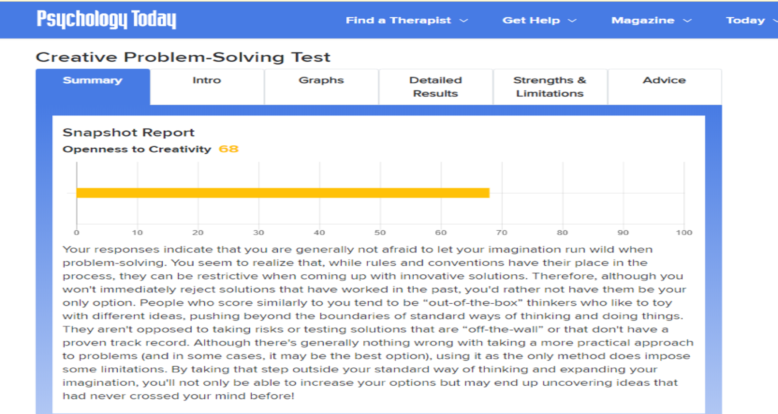

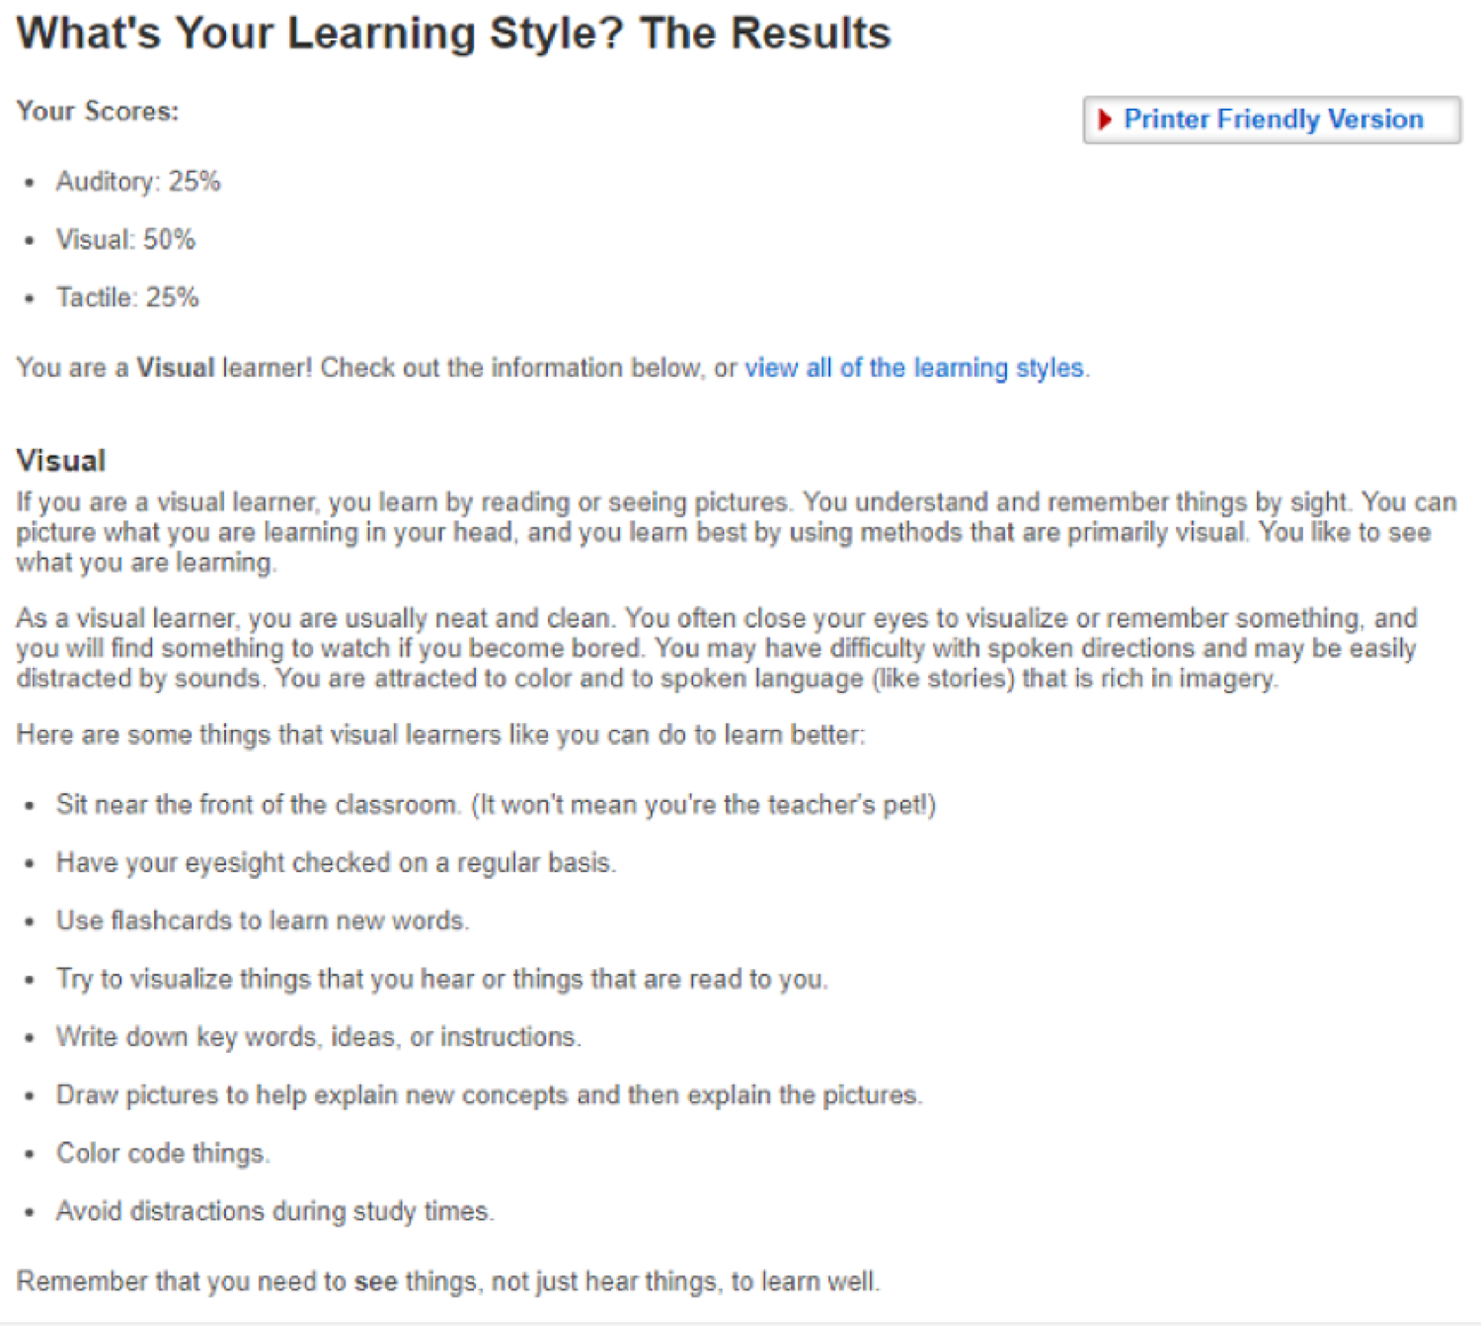

**Jennifer Sanderson**

According to my online Myer-Briggs personality test I am a Mediator Personality – INFP-A / INFP-T. Introverted, iNtuitive, Feeling and Perceiving. A true idealist, always looking for the best even in the worst of people and events. Perceived as calm, reserved or shy I can be easily misunderstood. When with like minded people there can be harmony, joy, inspiration and passion that can shine.

**Tony Mam**

Myers- Briggs - ENFJ

Learning style - Auditory: 25% Visual: 50% Tactile: 25%

Big five personality test -

These 3 types of test shows to a certain point in my character. Like the way I adapt to things, my type of learning curve, my personality, weakness, strong points, etc… These results may or may not depending on my abilities to overcome as the result does not define who you are but gives guidance on my character. However by knowing so, these results can or will impact on teamwork, ability to manage a team or drop a team’s morality. Managing a team or being in a team requires you to collaborate with each other effortlessly by sharing, caring, motivating, social and able to help one another. If none of these attributes apply it will be a bad environment for the team and not healthy nor sustainable. By knowing what your habits, strengths, weakness, strong attributes and nature characteristic is taking in consideration before forming a team is ideal. By knowing that the people around you is able to work in a team is a must, a passion towards their role, or their level of expertise. All these factors should be considered before a team is formed.

**Brodie Colvin**

Humanmetrics Jung Typology Test - ENFP - also known as the campaigner

Extravert(22%) iNtuitive(34%) Feeling(44%) Perceiving(38%)

People in this category are “idea” people and “people” people. They like to help others but also like to be admired and liked by others. They have strong and sometimes surprising views and tend to try to persuade others in favour of their viewpoint.

They are friendly and light-hearted, and can be quite silly at times.They like to socialise and dislike being on their own for long periods of time, they can be rash and quick to make decisions based on their own values and emotions.

In the workplace, ENFPs are pleasant and friendly, and interact in a positive and creative manner with both their co-workers and the public. ENFPs are also a major asset in brainstorming sessions; follow-through on projects can be a problem, however. ENFPs do get distracted, especially if another interesting issue comes along. They also tend towards procrastination, and dislike performing small, uninteresting tasks. ENFPs are most productive when working in a group.

I am an auditory learner meaning I learn better when I hear the information. Auditory learners make up only 30% of school-age children. According to this test I will remember 75% of what I hear in a lecture.

The major traits of an auditory learner are :

* Remembers what they say and what others say very well.
* Remembers best through verbal repetition and by saying things aloud.
* Prefers to discuss ideas they do not immediately understand.
* Remembers verbal instructions well.
* Enjoys the opportunities to present dramatically, including the use of music.
* Finds it difficult to work quietly for long periods of time.
* Easily distracted by noise, but also easily distracted by silence.
* Verbally expresses interest and enthusiasm.
* Enjoys class and group discussions.

**What this means for us as a team**

Our team has many different characteristics as seen above. We will work effectively because of this diversity. Our creative team members are good for designing, and helping others make things look and sound professional. We have members who are good at brain-storming ideas and others that are more logical and methodical.

All together it means we can communicate well and are able to work well together. What one member may not be able to do another can so we have all bases covered.