**Database design and implementation**

**Abstract:**

A New York based coffee shop chain is looking to expand nationally by opening a number of franchise locations and as a result they want to streamline operations and revamp their data infrastructure. This work is the stages of **RELATIONAL DATABASE DESIGN AND**

**IMPLEMENTATION SYSTEM** for improved operational efficiencies and for executives to make data driven decisions. Their data currently reside in accounting software, suppliers’ database, POS systems and spreadsheet. The data in all these systems was reviewed and I designed a central database to house all of the data. Created database objects and data subsets and loaded them into staging databases that uses different RDBMS.

**Software used**:

* PostgreSQL Database,
* IBM Db2 Database,
* MySQL Database

# Project Objectives

* Identify entities.
* Identity attributes.
* Create an entity relationship diagram (ERD) using the pgAdmin ERD Tool.
* Normalize tables.
* Define keys and relationships.
* Create database objects by generating and running the SQL script from the ERD Tool.
* Create a view and export the data.
* Create a materialized view and export the data.
* Import data into a Db2 database.
* Import data into a MySQL database.

# Database entities

* Staff entity
* Sales_outlet entity
* Sales_transaction entity
* customer entity
* Product entity

# Sales_transaction entity Attributes

* transaction_id
* transaction_date
* transaction_time
* sales_outlet_id
* staff_id
* customer_id
* product_id
* quantity
* price

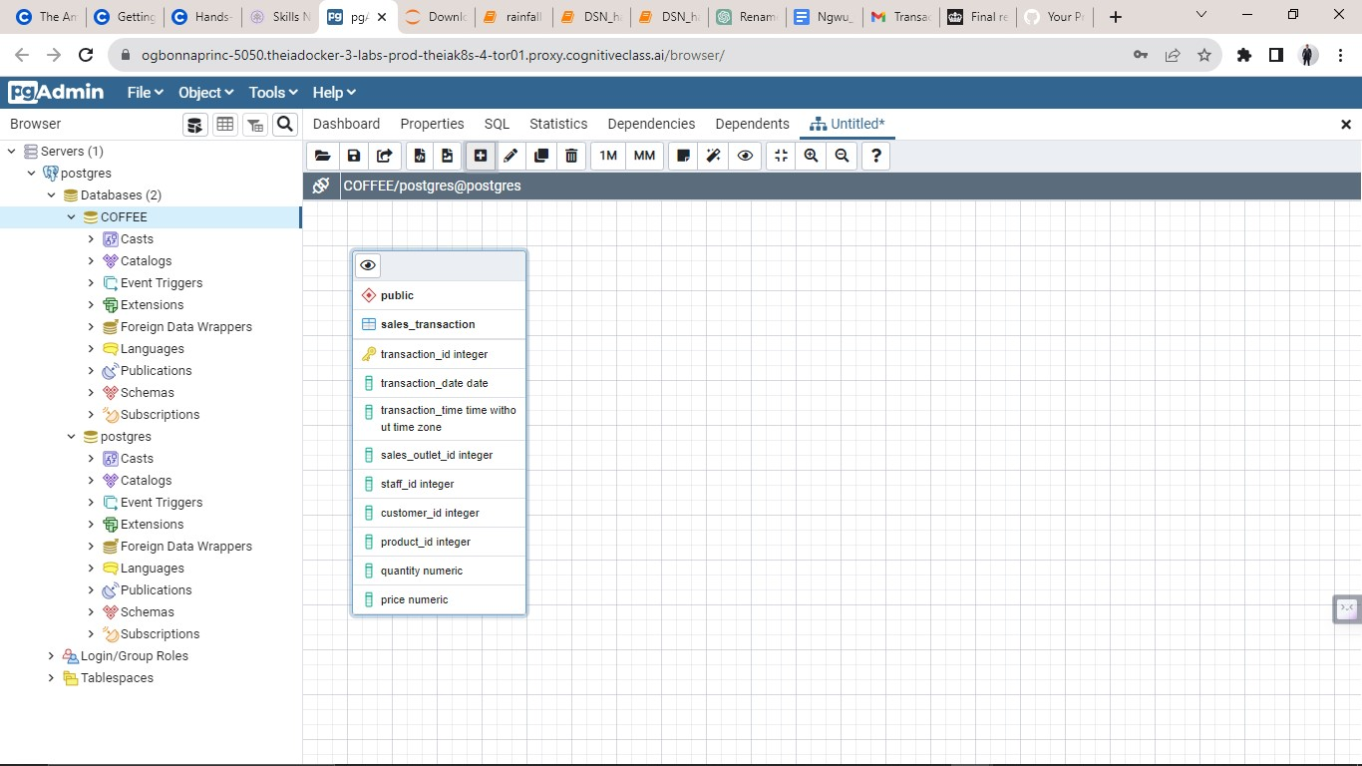**Sales_transaction entity added to ERD**

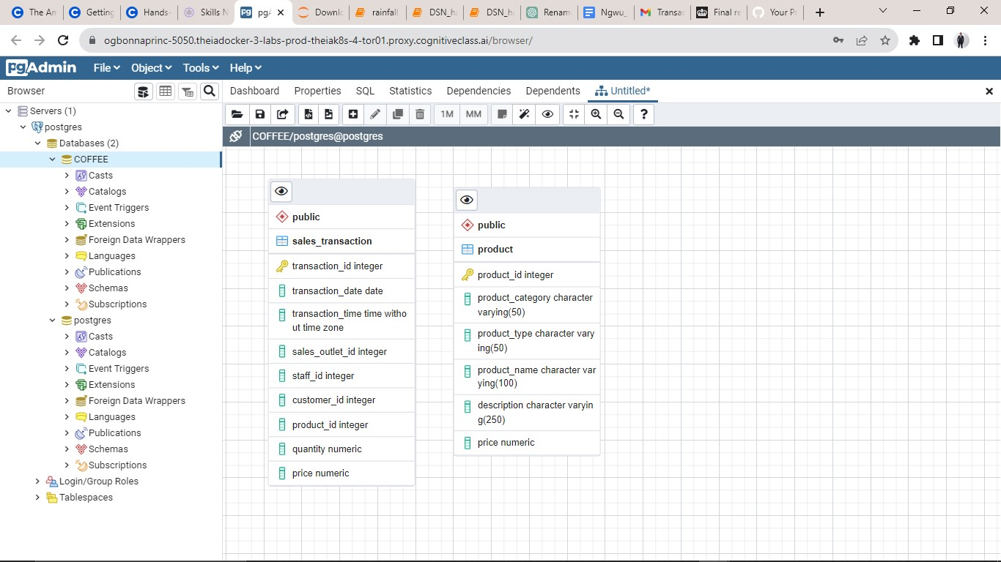**Product entity added to ERD**

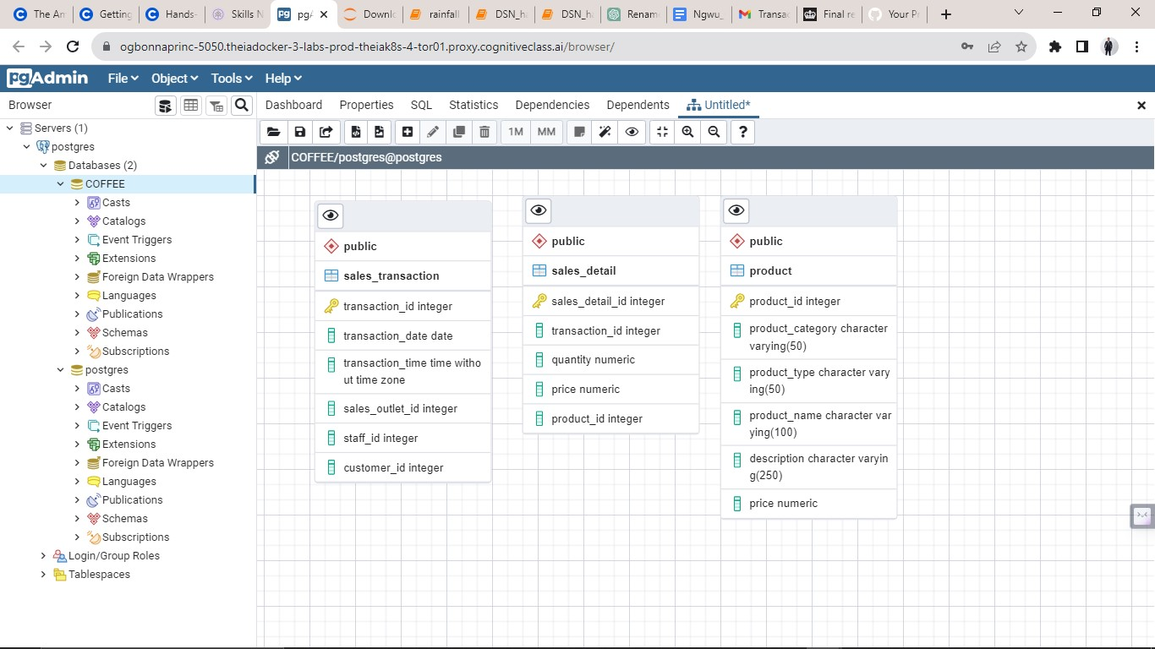**Database Normalisation :sales_details entity extracted from sales_transaction entity and added to ERD**

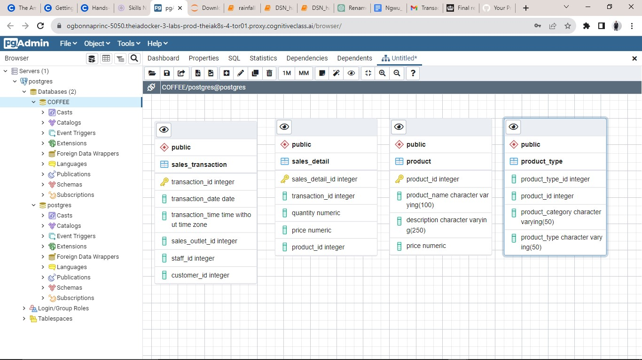**Database Normalisation: product_type entity extracted from product entity and added to ERD**

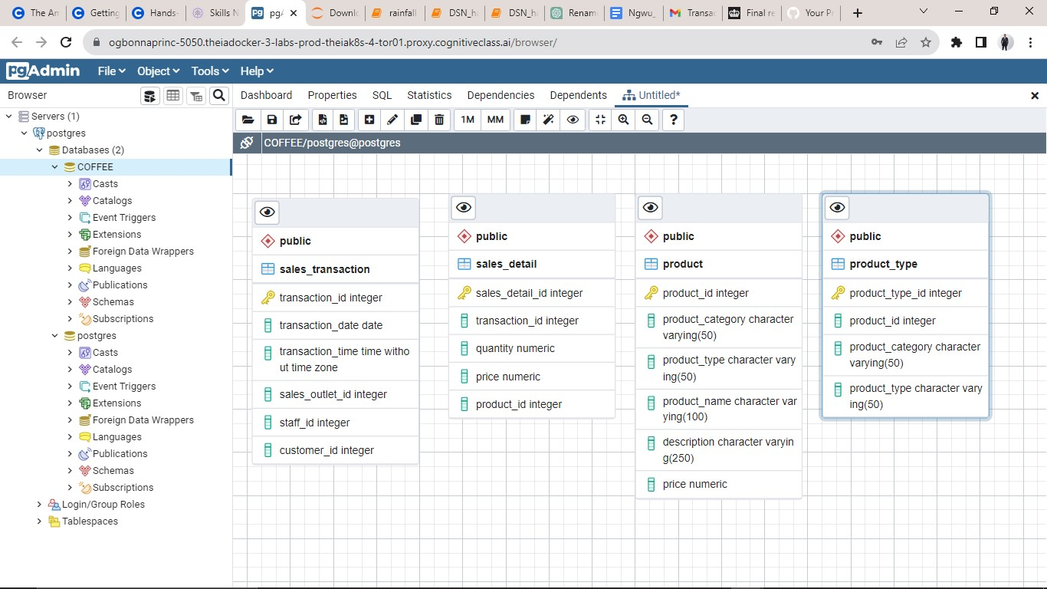**Database Normalisation: entity keys identified**

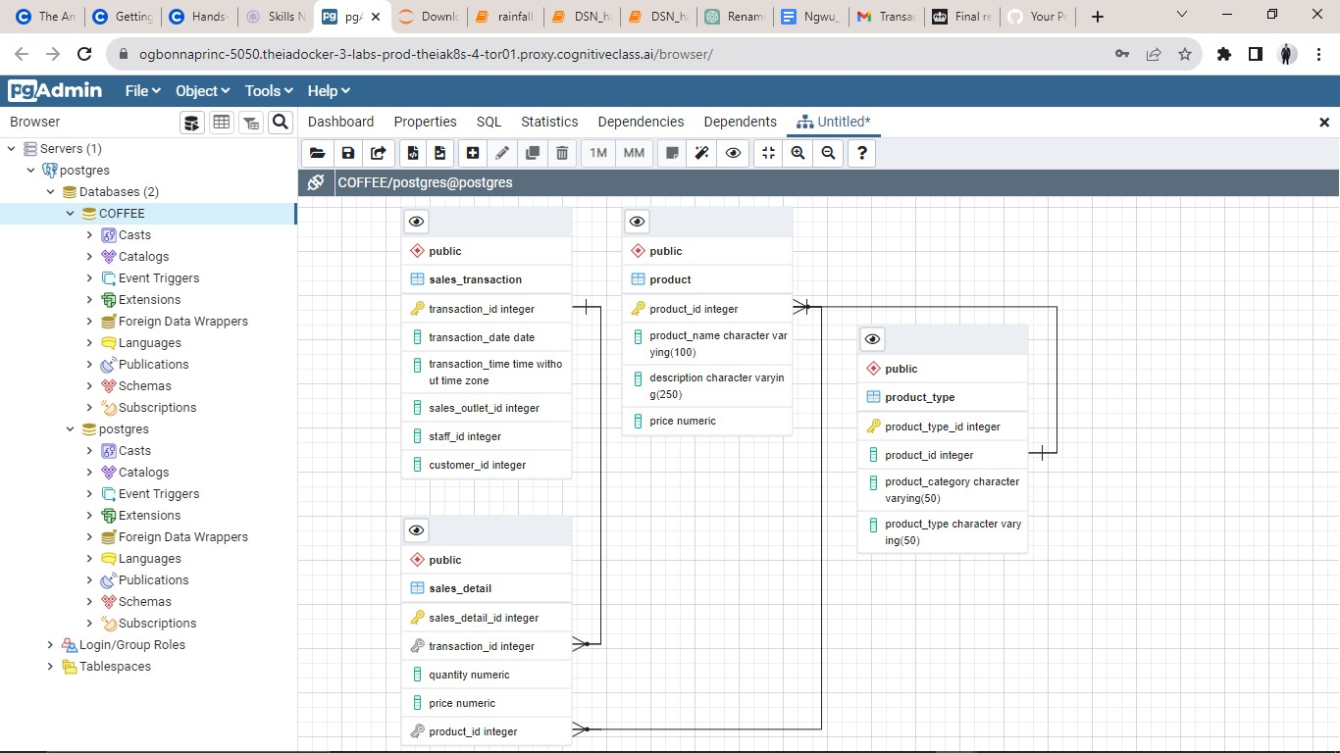**Entity Relationships identified in ERD and connections established**

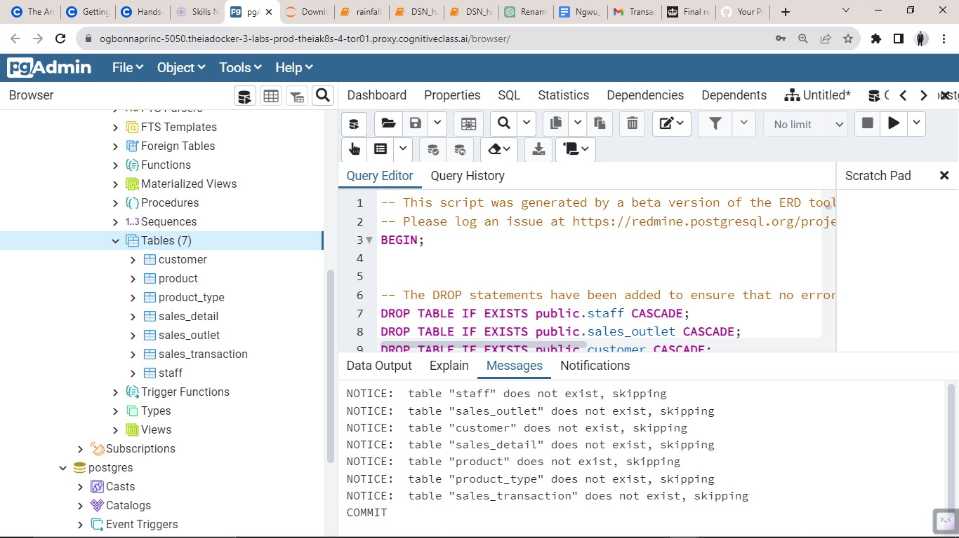**SQL script generated from the ERD tool. External SQL script imported and executed to create necessary DB entities and attributes**

**Database entities populated with data from imported and executed SQL script with Sales_detail entity first 100 rows**

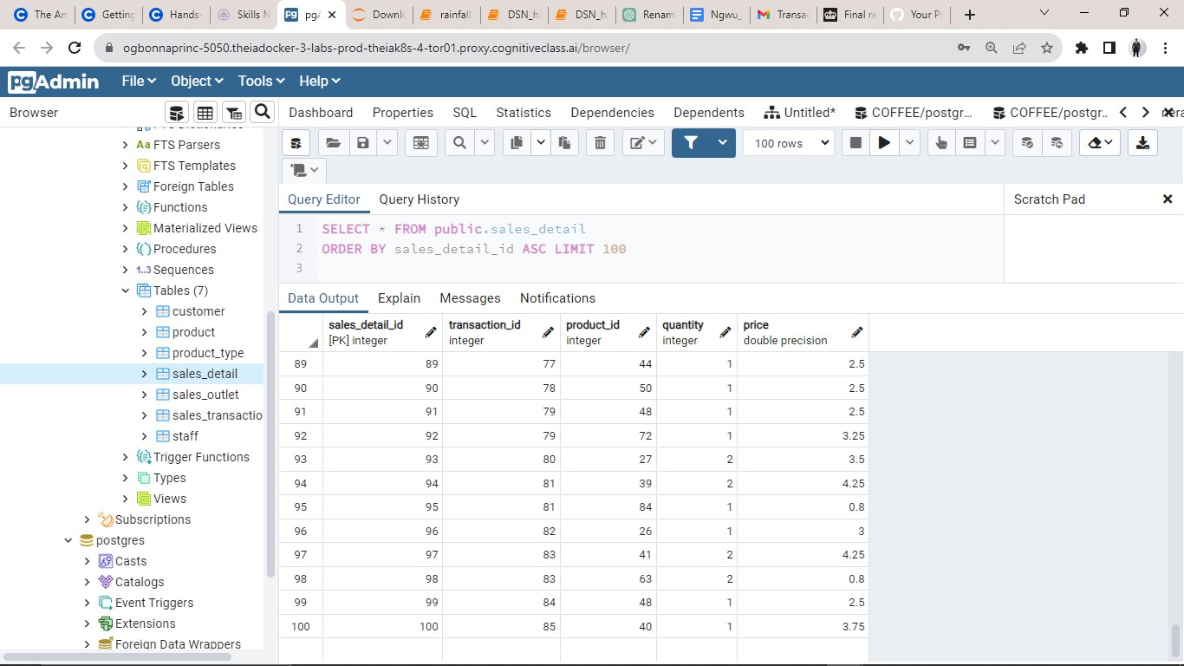**displayed**

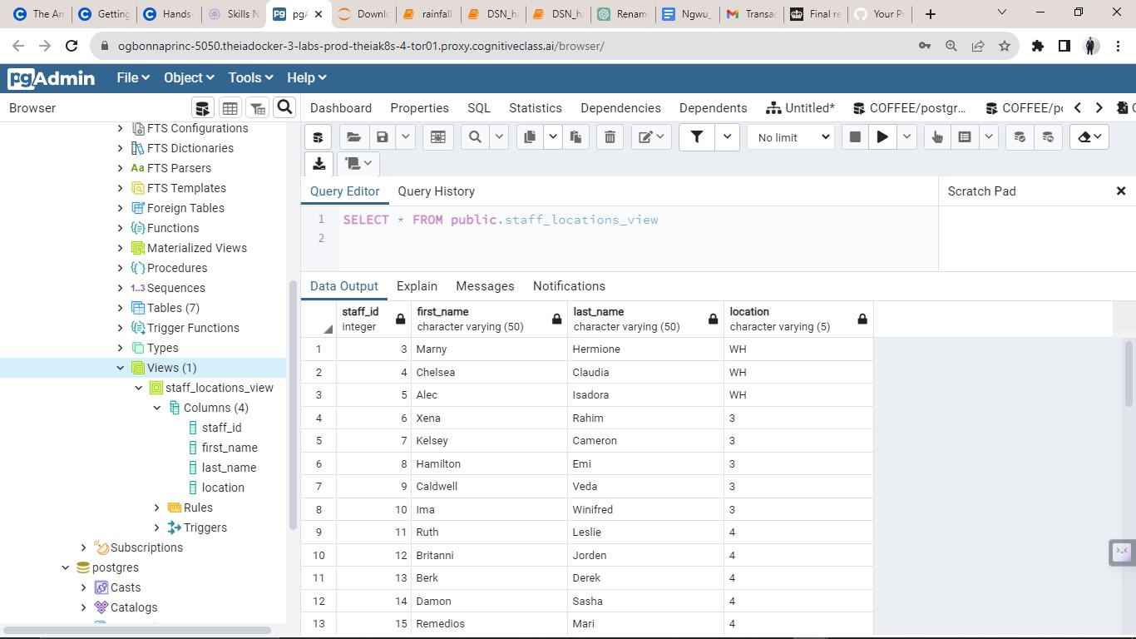**Created and exported a staff_location view entity from the staff entity to generate a data subset for a specific use case**

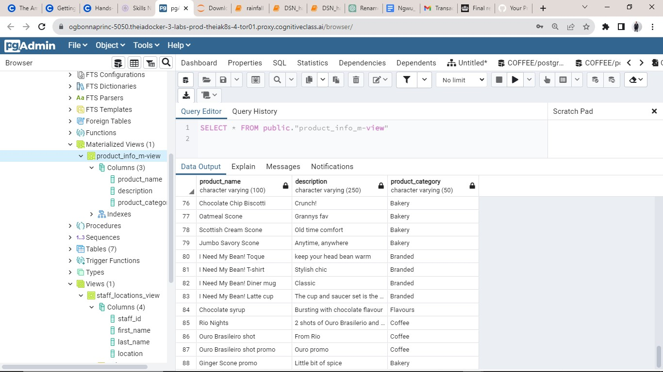**Created and exported a staff_location materialized view**

**entity from the product entity to generate a data subset for storage and future case.**

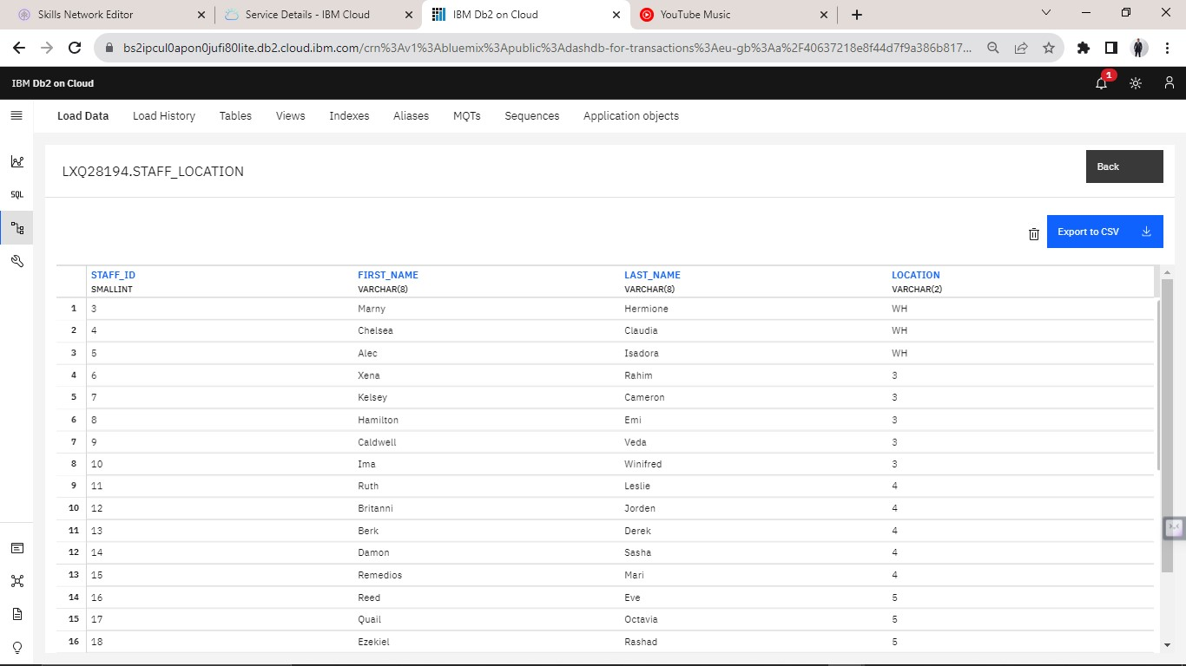**Imported staff_location data into IBM Db2 Database for external payroll company’s usage**

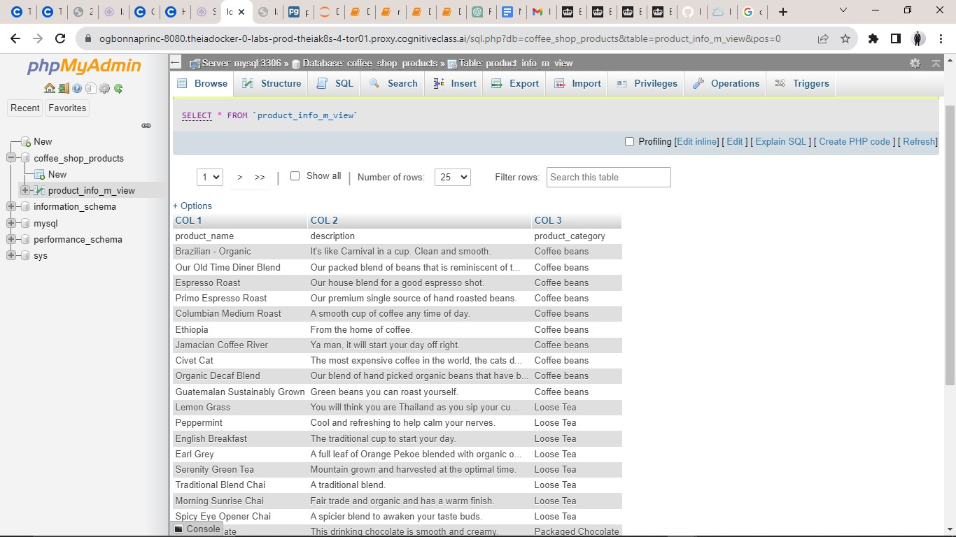**Imported the product_info to MySQL database for marketing consultant use**

Project Author:

Christian Nzeanorue

[**LinkedIn**](https://www.linkedin.com/in/christian-nzeanorue/)| [**My Github**](https://github.com/chrisCodeee)| [**My Portfolio**](https://www.datascienceportfol.io/nzeanorue_christian)

# Thank you