# Mike and Chris’s Super Forum

### Mike Fortner, Chris Newman

### http://web.engr.oregonstate.edu/~fortnerm/CS-275-Project/

### 1. Introduction

Our project is a computer programming and application development web forum. A web forum is an online discussion board where users can post messages, pose questions, and create new topics that users may discuss. In this particular case, users will be able to seek help with programming, post ideas and questions, and share code.

Our users will primarily consist of college and high school seeking help with their programming classes. The web forum is open to anyone, however, so programming professionals and hobbyists may use the forum as well.

### 2. Detailed Application Requirements

Our web forum must:

* Have a simple, easy to use interface. The forum should be usable to those who have no experience with web forums.
* Provide basic forum functionality.
  + Users will be able to create threads, which are topics of discussion.
  + Users will be able to create posts under threads. Posts are individual messages that belong to a certain thread/topic.
  + The posts and threads will be displayed in the form of a simple GUI.
* Users will be able to create individual user accounts based on their personal information.
  + Each user’s post will be assigned to each respective user. For instance, if Chris creates a post, the post belongs to Chris.
  + Threads also belong to the respective users who created them.
* The forum can be viewed by anyone. However, the forum can only be edited by individuals with user accounts.

### 3. Design

ER Diagram:

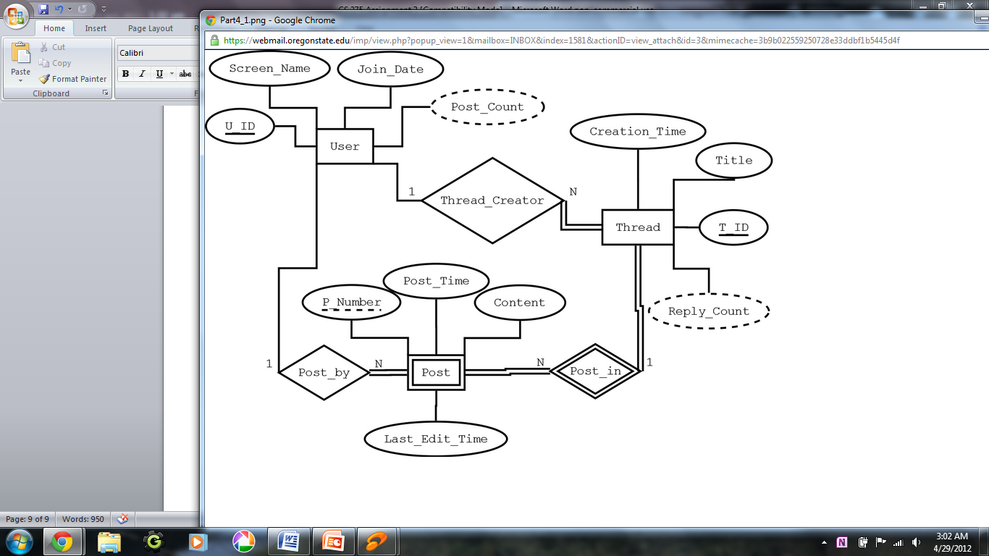

Our database consists of three types of entities: Users, threads, and posts. Post must belong to the users who created them, and the threads they were created in. Threads belong to the users who created them.

Our database can be accessed and edited from our website.

Homepage:

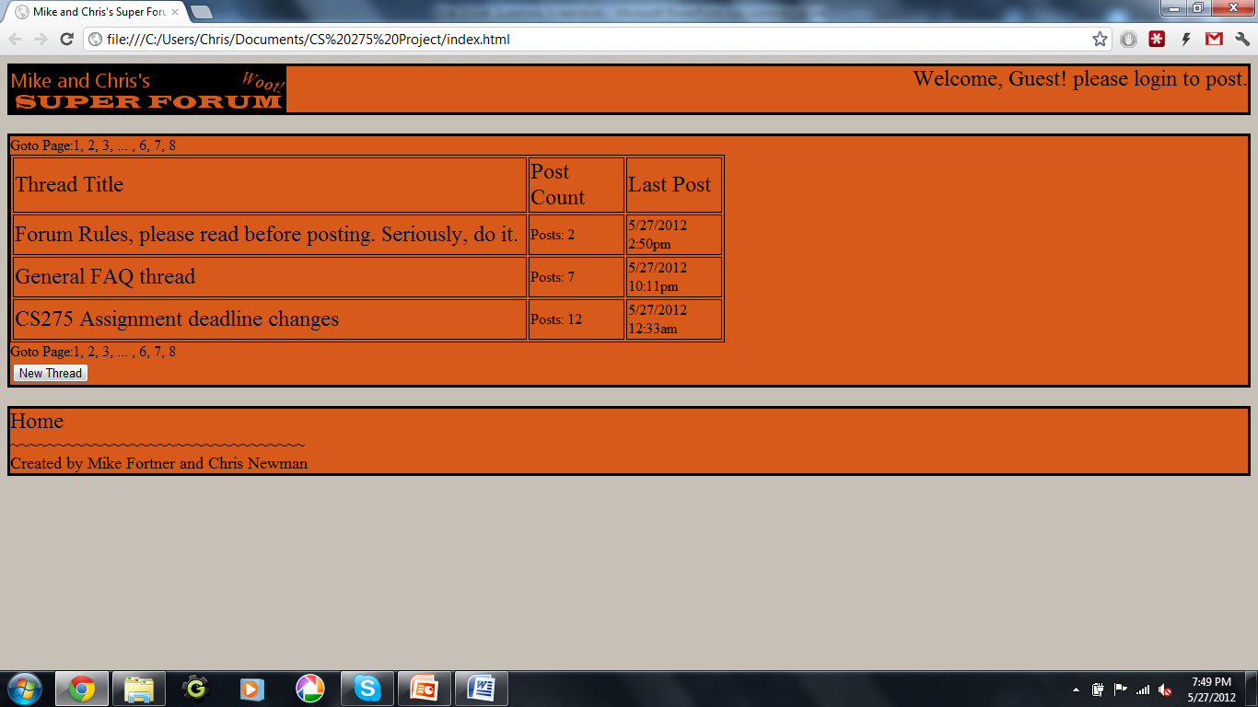

Each thread can be accessed from the table in the middle. Each thread’s number of posts and last post time are displayed. Users and guests can view threads by clicking on one of the thread titles. Only users can edit threads.

Thread Page:

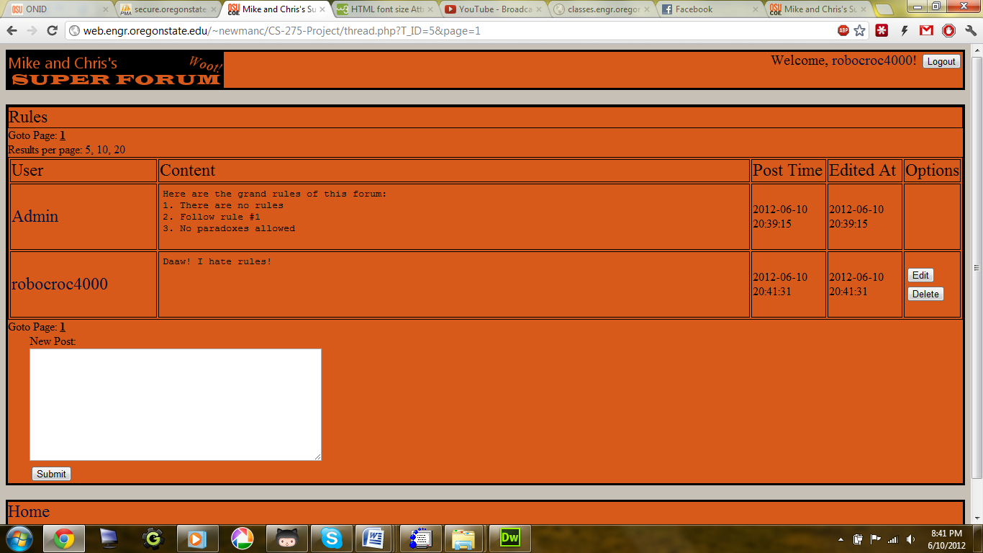

Each thread contains a table with each post. Each post displays the name of the user who created the post, the content of the post, the time the post was created and last edited, and options to edit and delete the post. Users (who have created an account) can create new posts in the text field at the bottom. Guests without an account will not see this text box.

If a guest wishes to create threads and posts, they may create a new account by clicking the link at the top right of the screen.

New user account page:

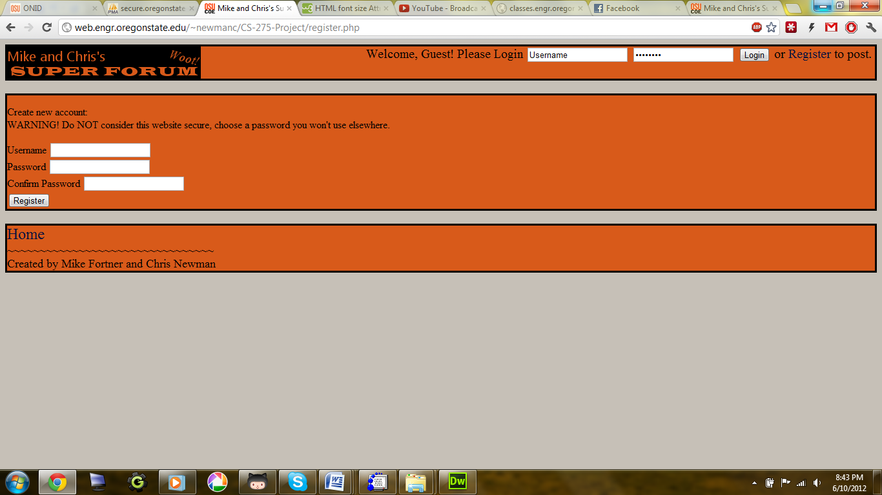

Here, guests can enter their desired username and password. When they click the “submit” button, their username and password are stored in the database. They will automatically be assigned a user ID so they can be identified by the database. Once a guest has created an account, they will gain user privileges such as editing and creating posts and threads.

Our website is stored on Oregon State’s Engineering website. Only the administrators of the forum, Mike and Chris, will have full control over the website and database. Users can edit and create posts and threads, and guests can view threads and posts.

For security reasons, passwords are stored on the database and encrypted. This is to ensure that the administrators will not have access to the user’s passwords.