Bashed

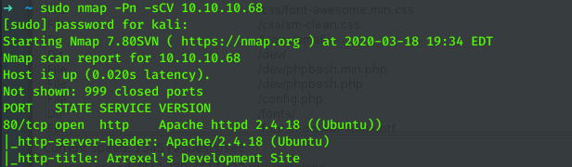
the first thing we do is run an nmap scan against the box
we see that port 80 is open

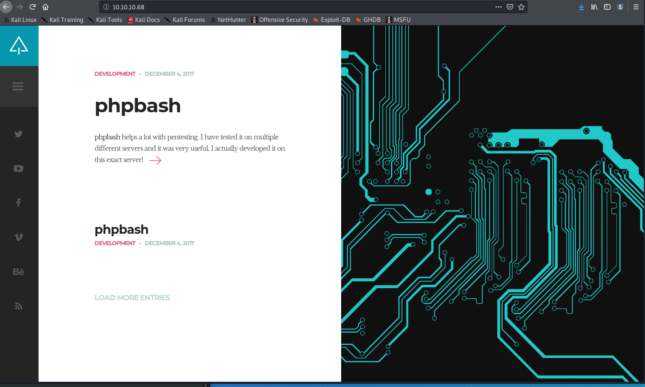
checking the website reveals that there is something called phpbash
now we move onto further enumeration using dirbuster

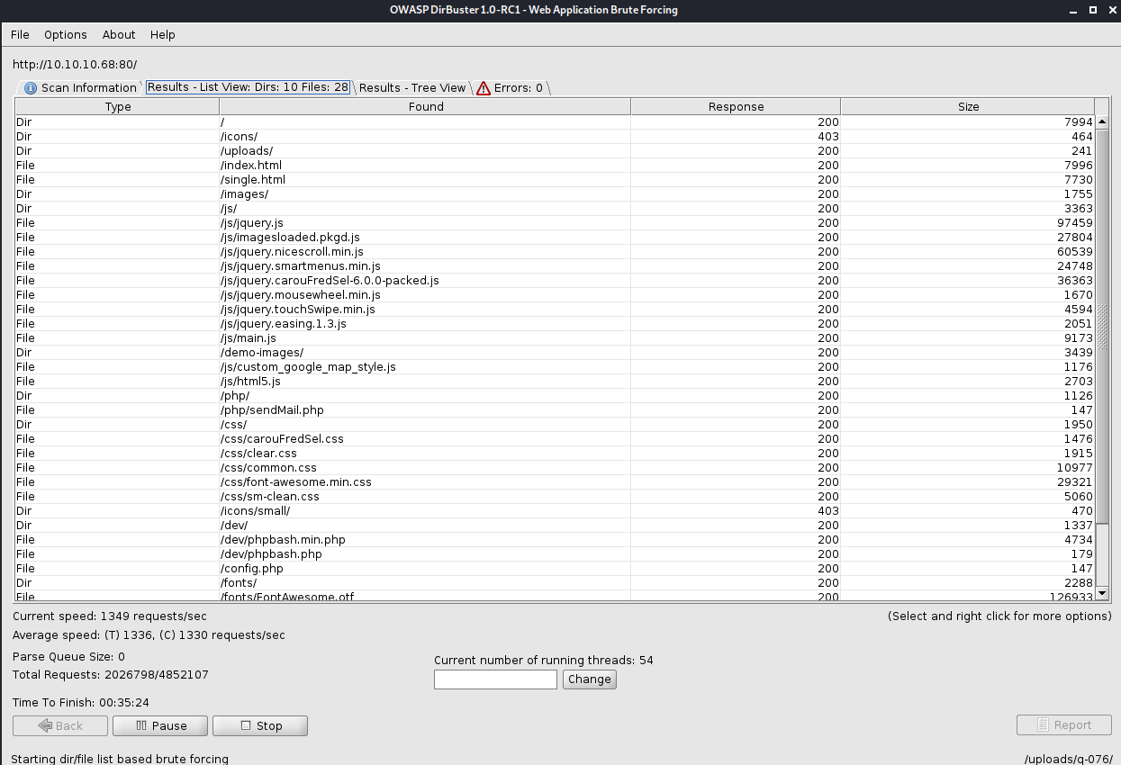
having brute forced the website we see that phpbash is the the dev directory
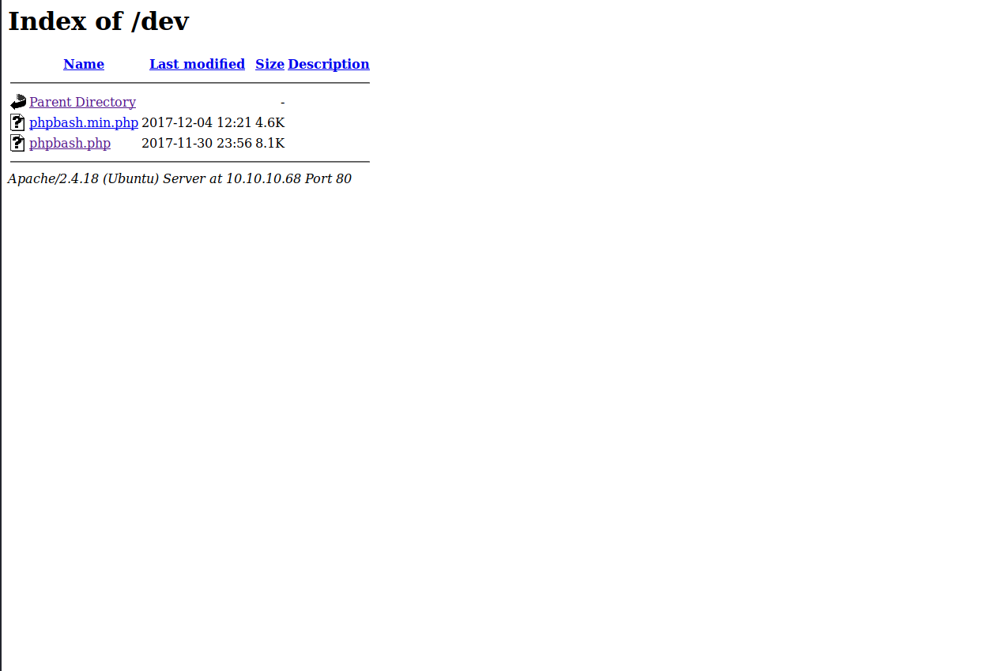

looking at the dev directory we see the php bash


now we have a shell into the box after clicking on them
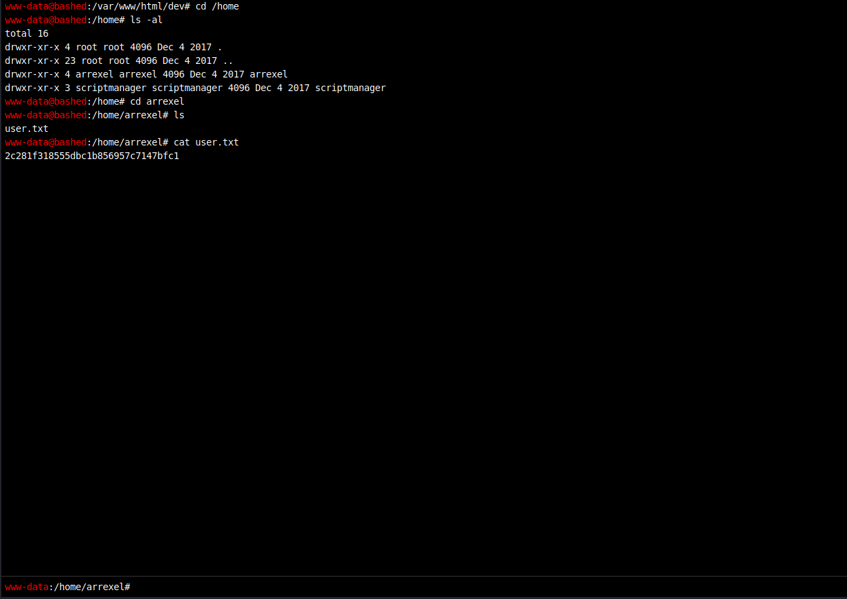
now we have user.txt
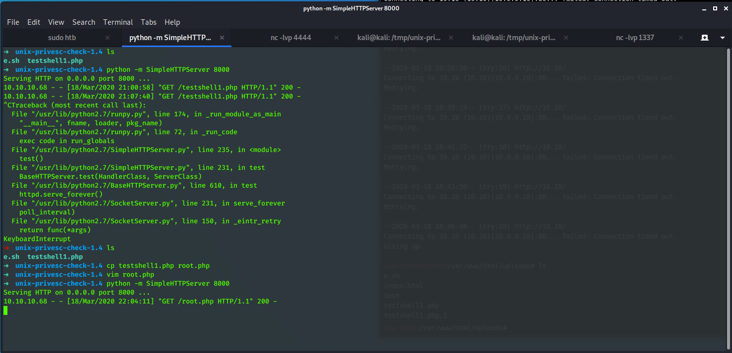

The next thing to do is to upload a webshell to the / var / www / html / uploads we can do this by hosting a http server using python and then using wget to download the the shell
once the webshell is uploaded to the server we can set up a netcat listener using nc -lvp 4444
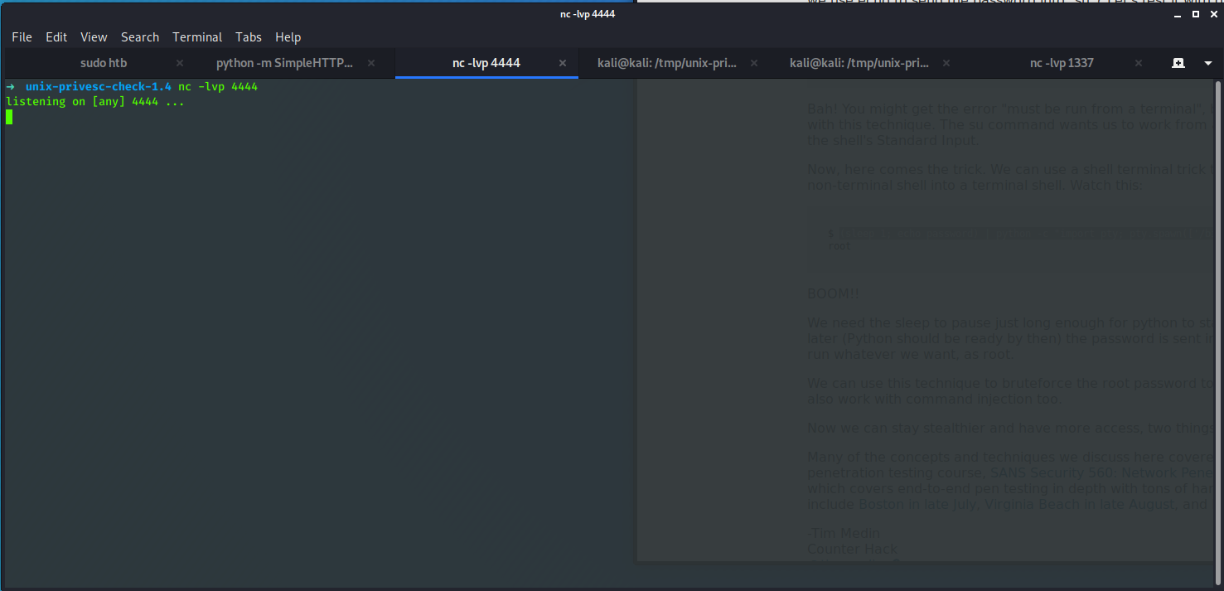
then we can execute the web shell from the server side with php testshell1.php
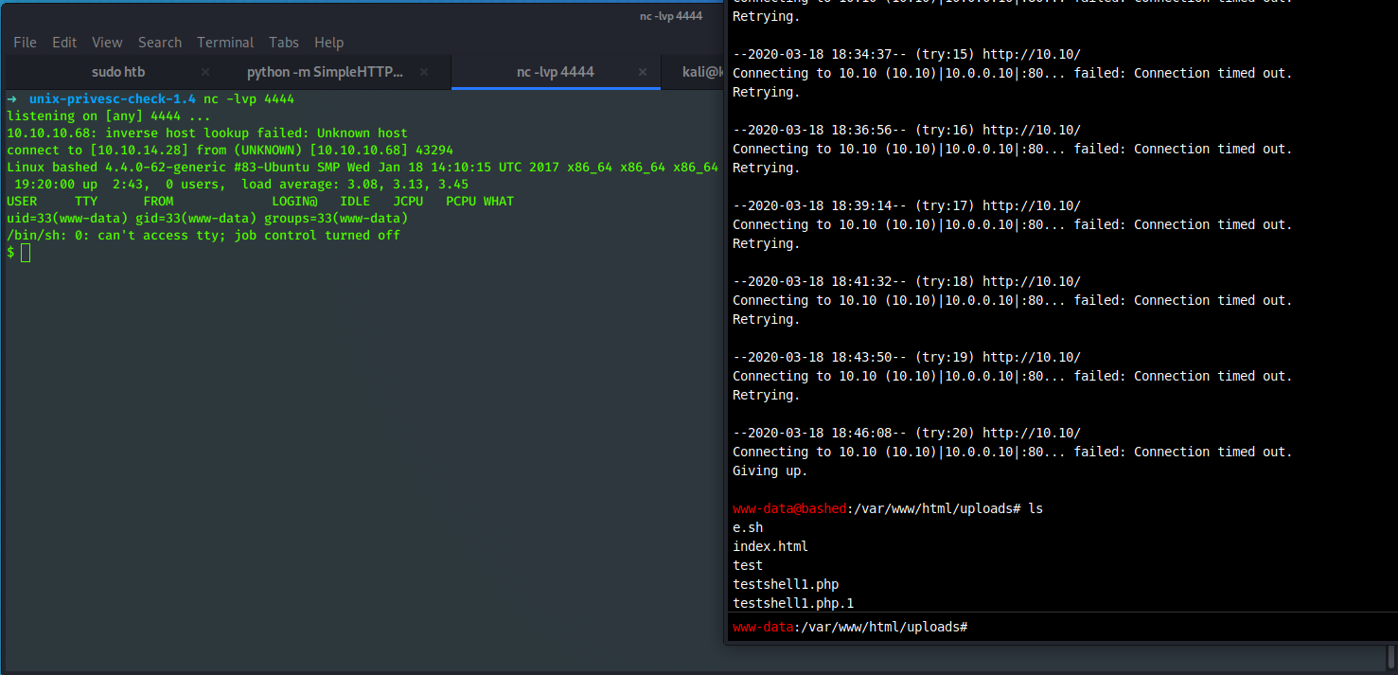

using sudo – l we find that www-data can execute commands as script manager with no password
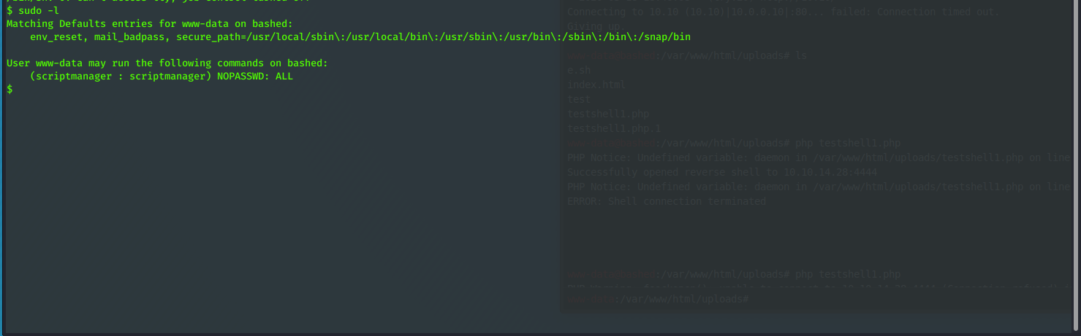
we get a shell as script manager using sudo – u scriptmanager bash -i
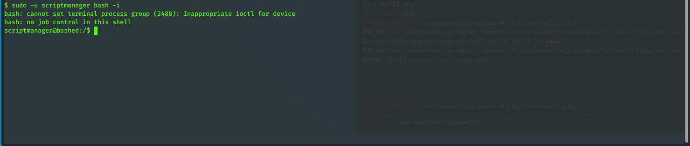
in the root directory there is a directory called scripts that is owned by scriptmanager
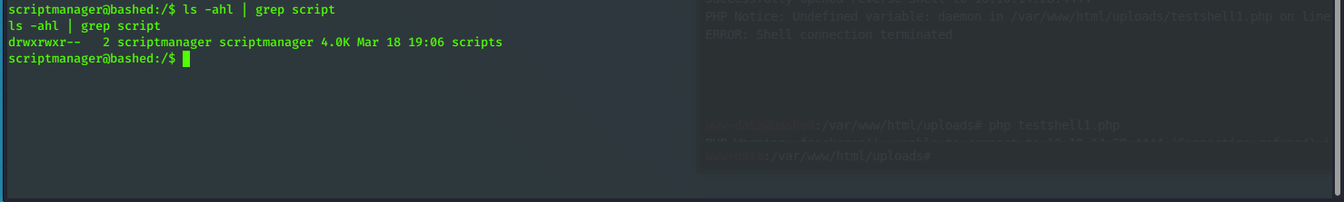
we can go into this directory and see that there is a python job running it writes a text file and the owner is root and the time stamp is updated from this we can assume it is a root cron job running so we can modify the test.py to do what we want it to do
we echo a python reverse shell into test.py

