Retired box – bleep

we begin with an nmap scan
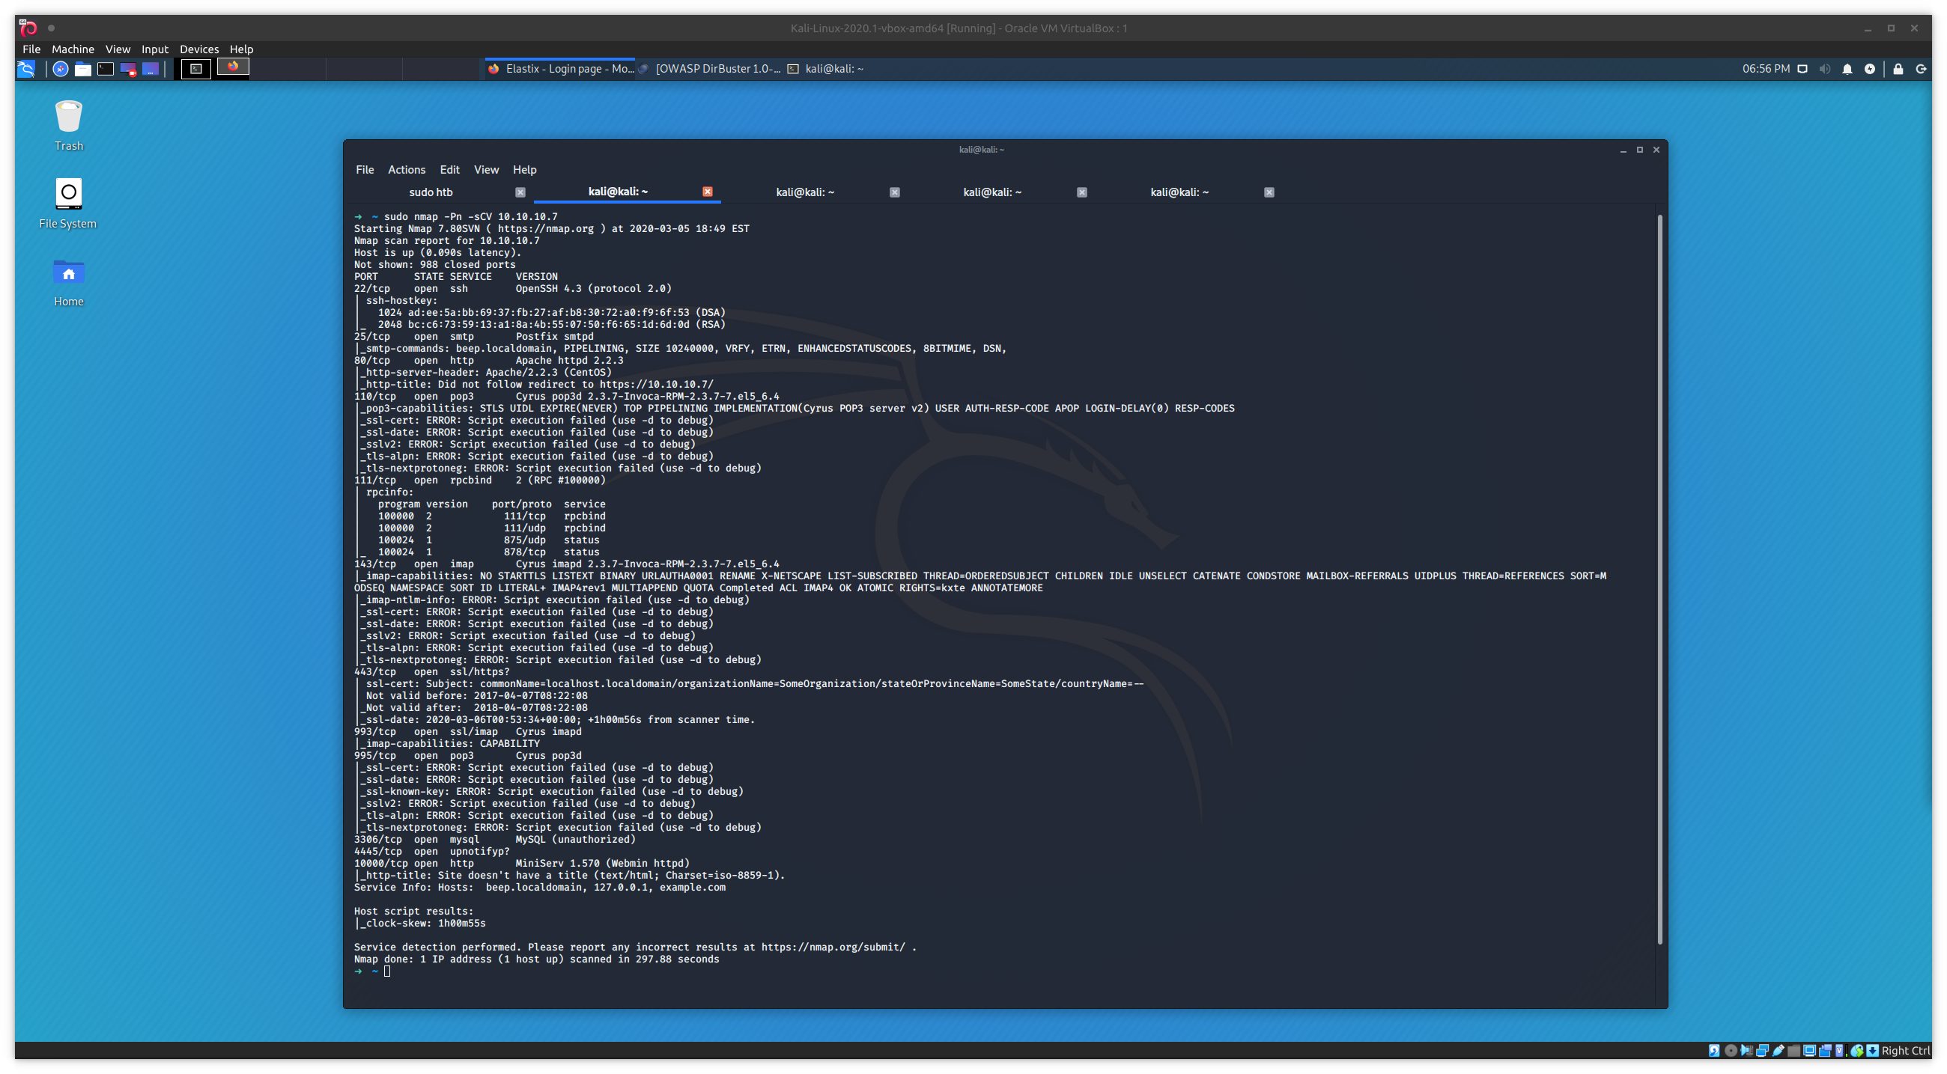

we found that port 80 is open looking at the website we find that elastix is run
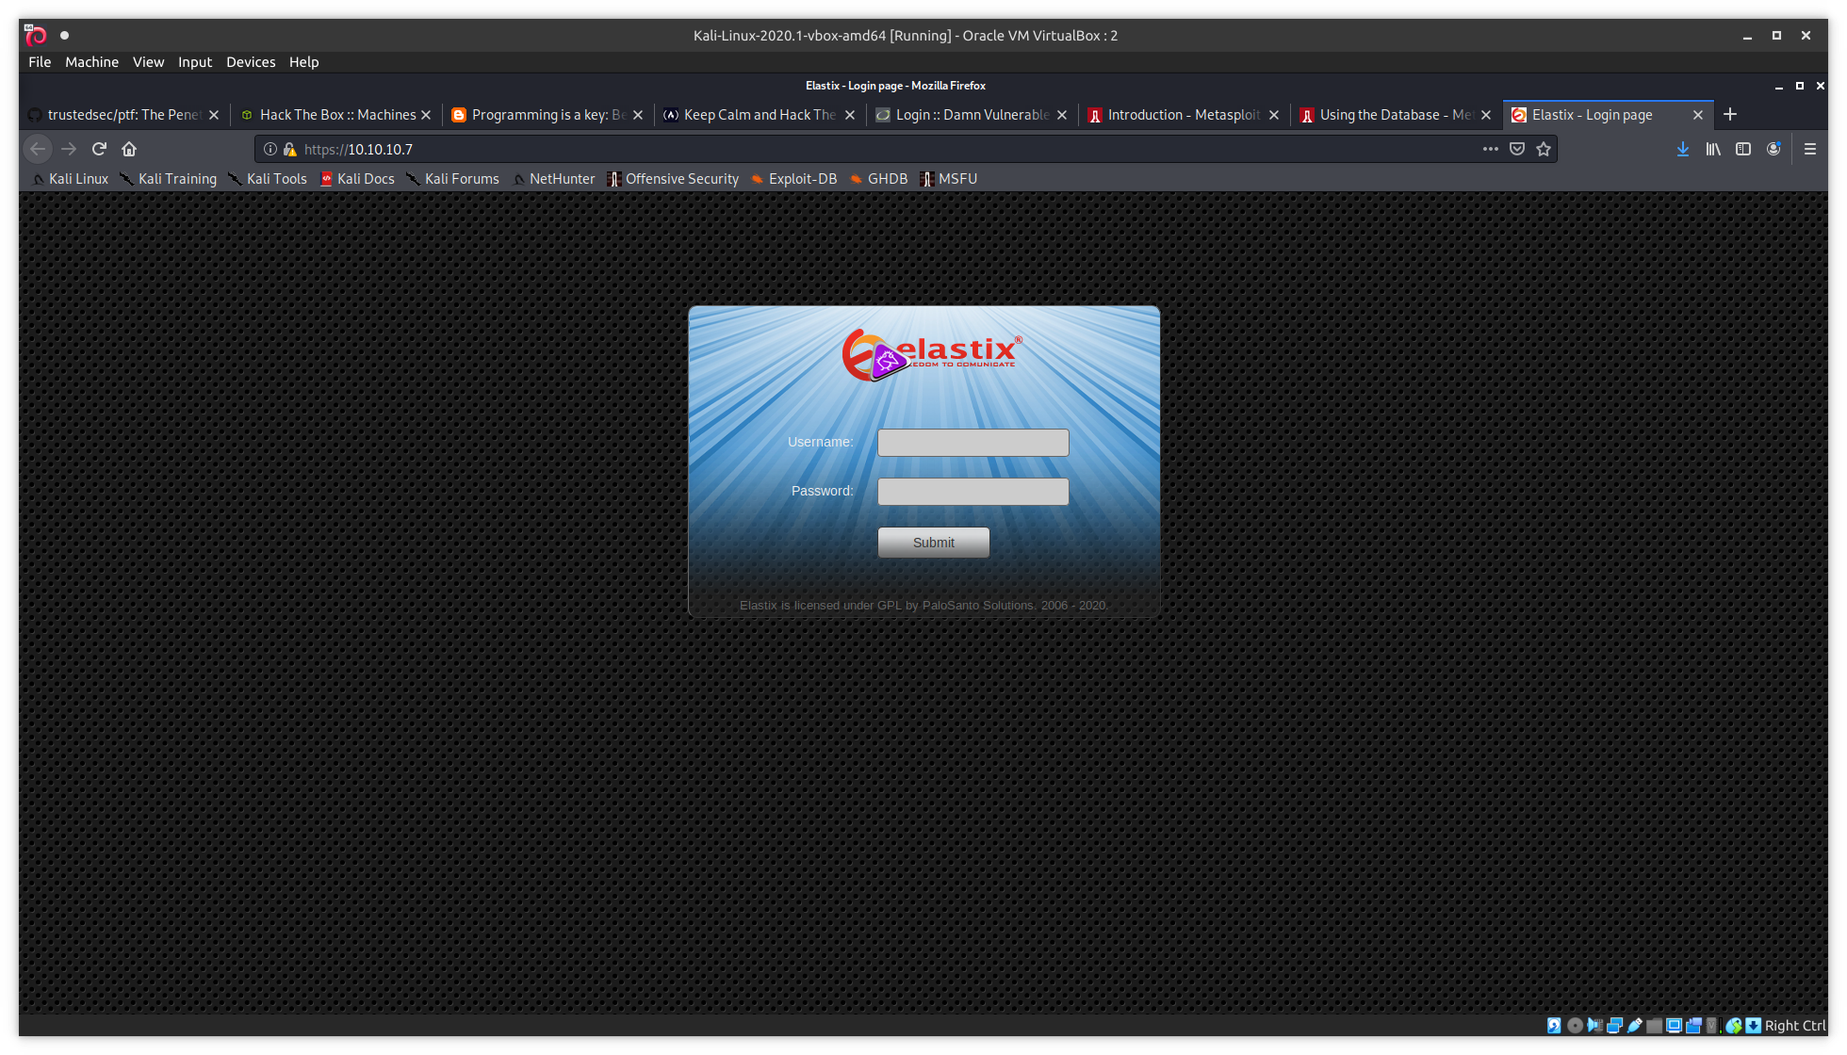

now we run elasix under searchsploit after finding that common username/password combinations fail
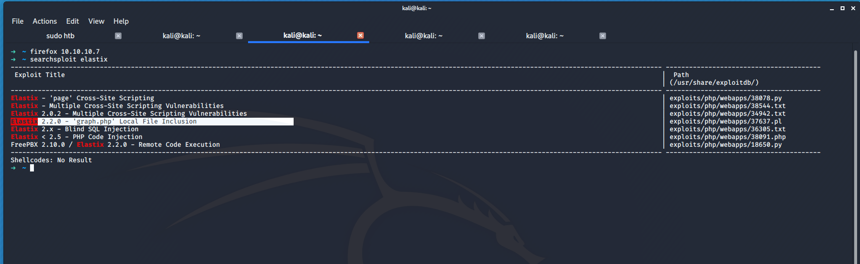
the most interesting result is the local file inclusion we can learn more with searchsploit -x

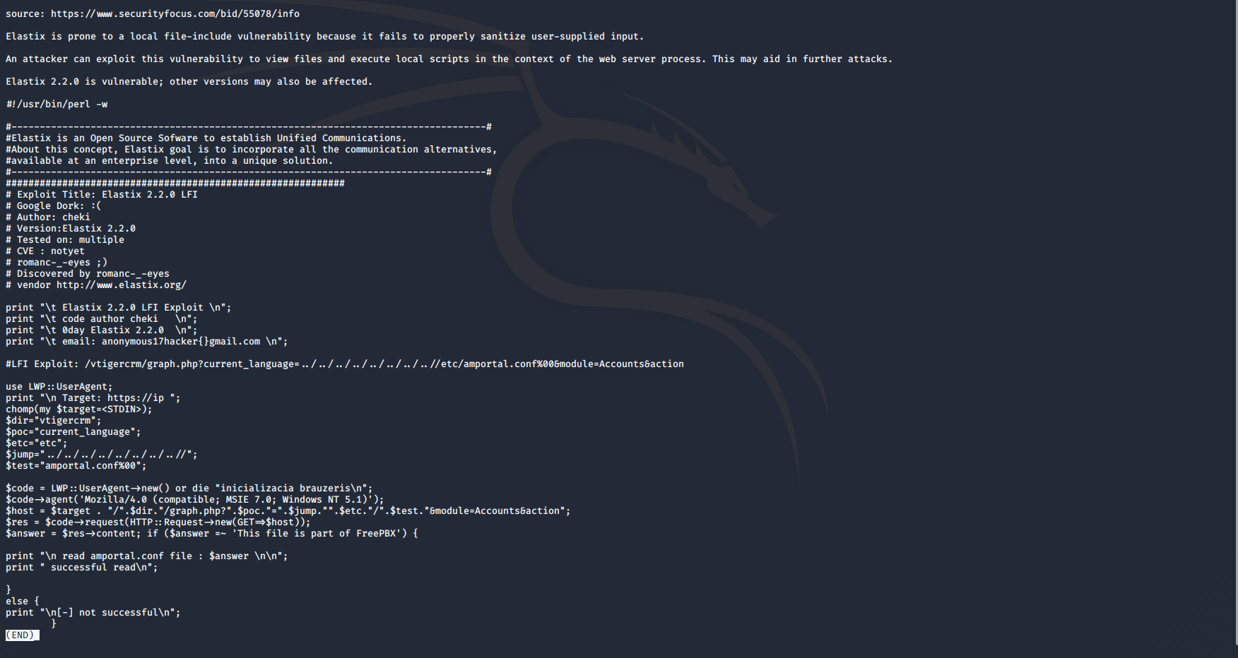

we find that we can use /vtigercrm/graph.php?current_language=../../../../../../../..//etc/amportal.conf%00&module=Accounts&action
attached to the ipaddress to exploit the LFI

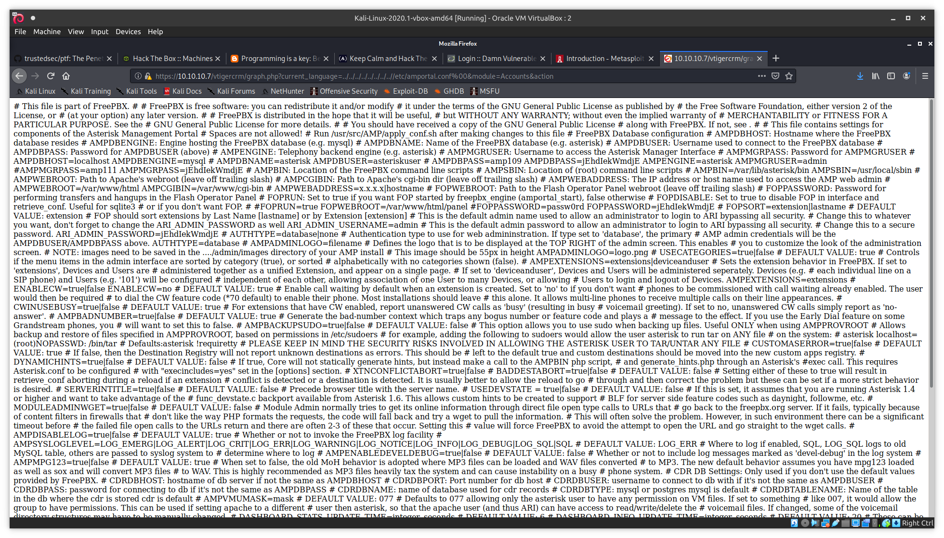
we can clean it up by right clicking and selecting view source
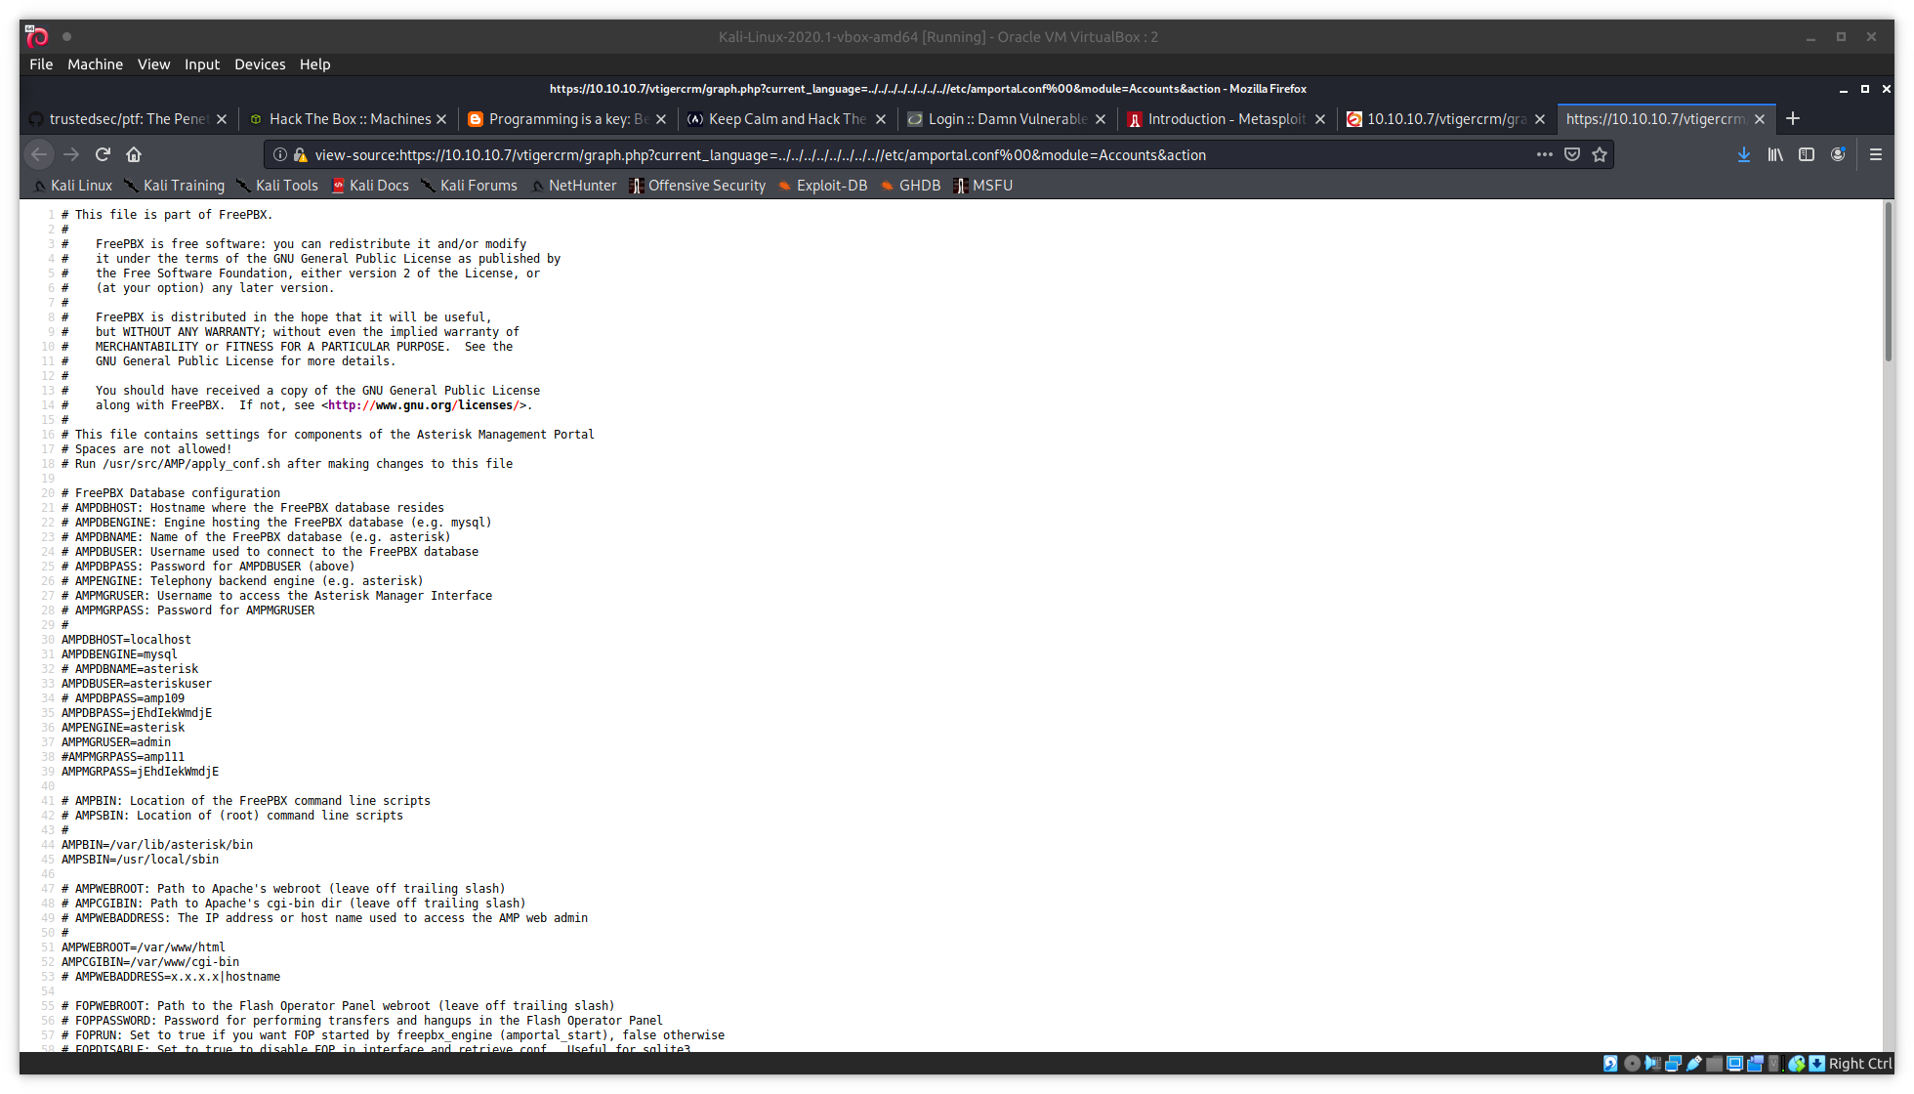

upon clean up we find credentials we will now try to ssh into the box

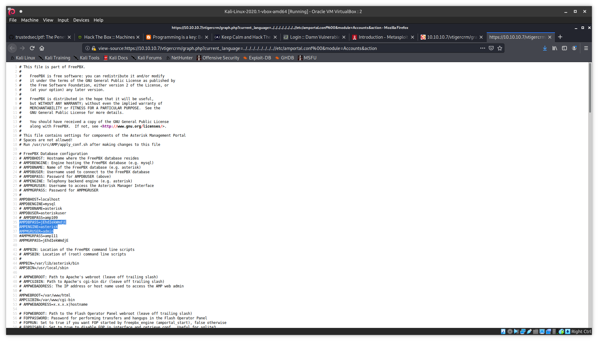
ssh
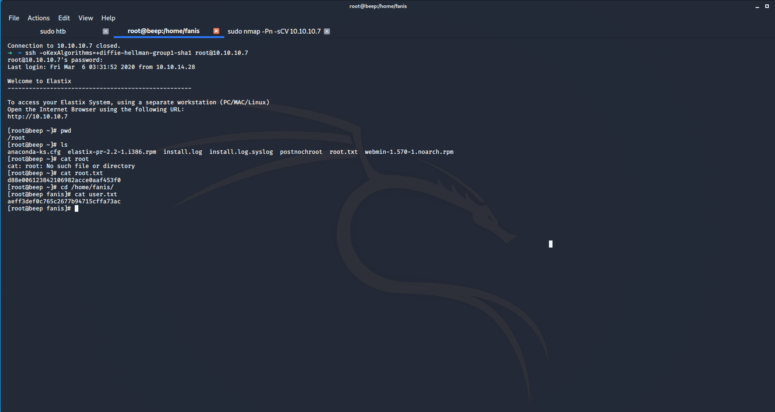
the password jEhdIekWmdjE lets us ssh in as root and we grab the flags

