Blue

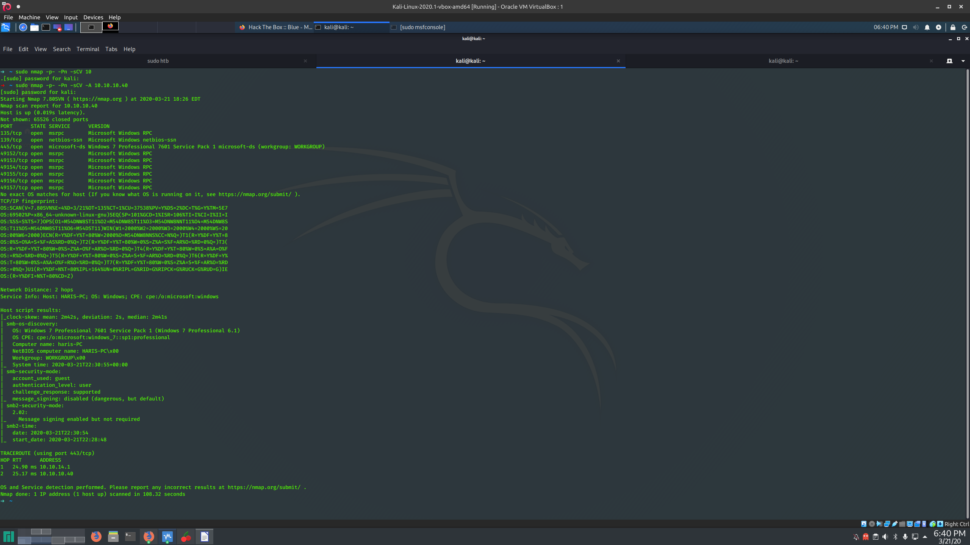
After running the nmap scan it was obvious that this computer was vulnerable to eternalblue

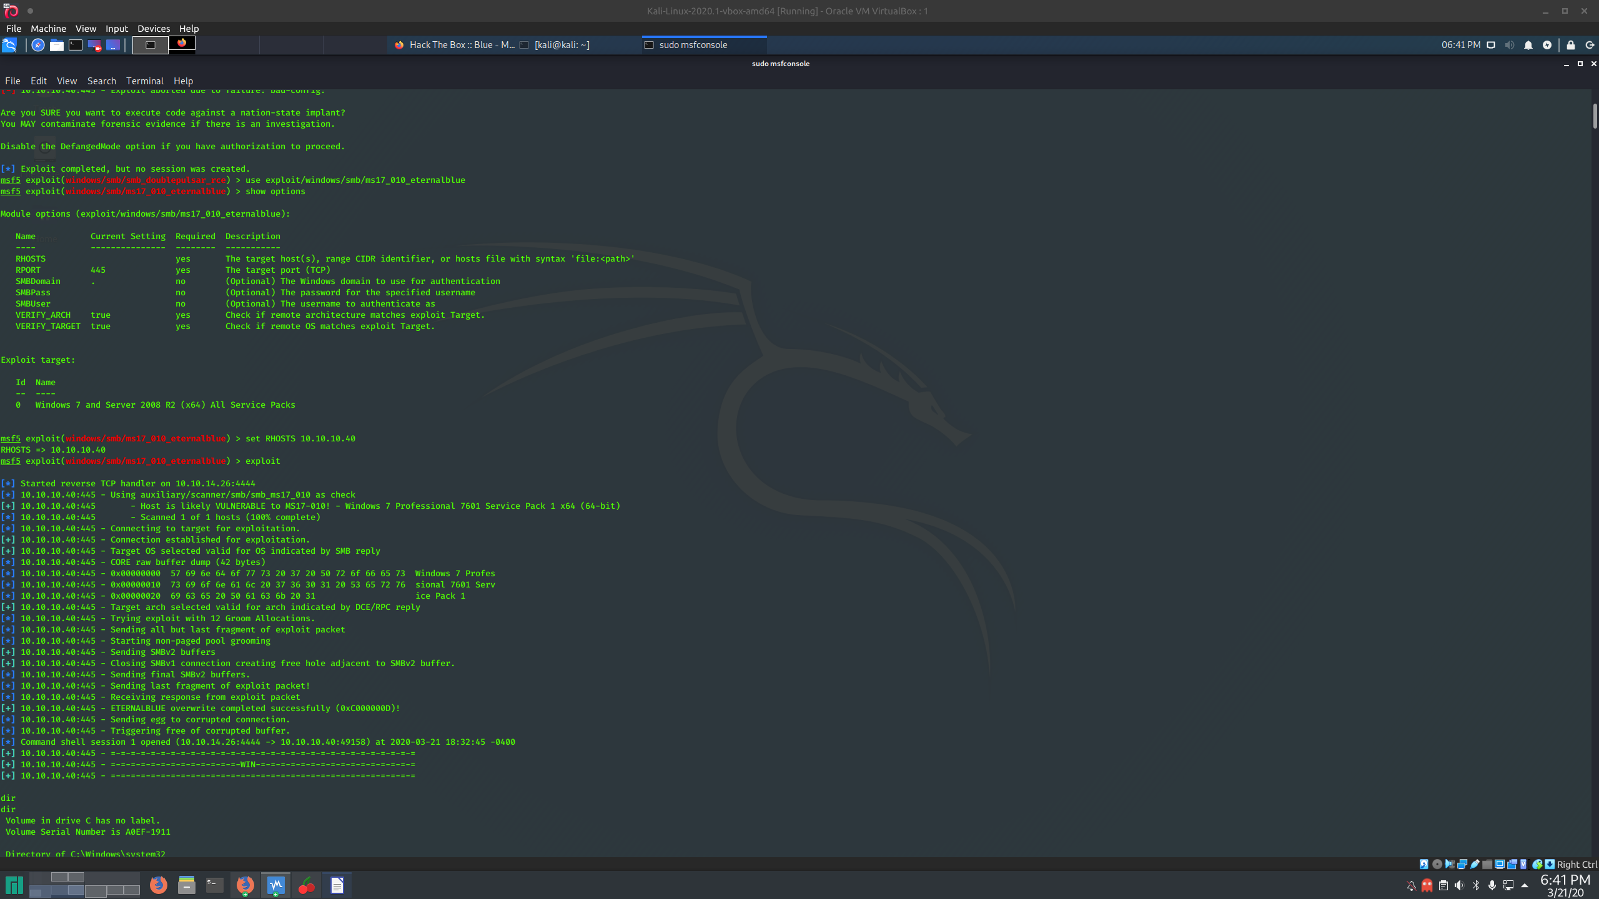
I open msfconsole and use exploit ms17_010_eternalblue
set the rhosts to the target machine and the exploit worked
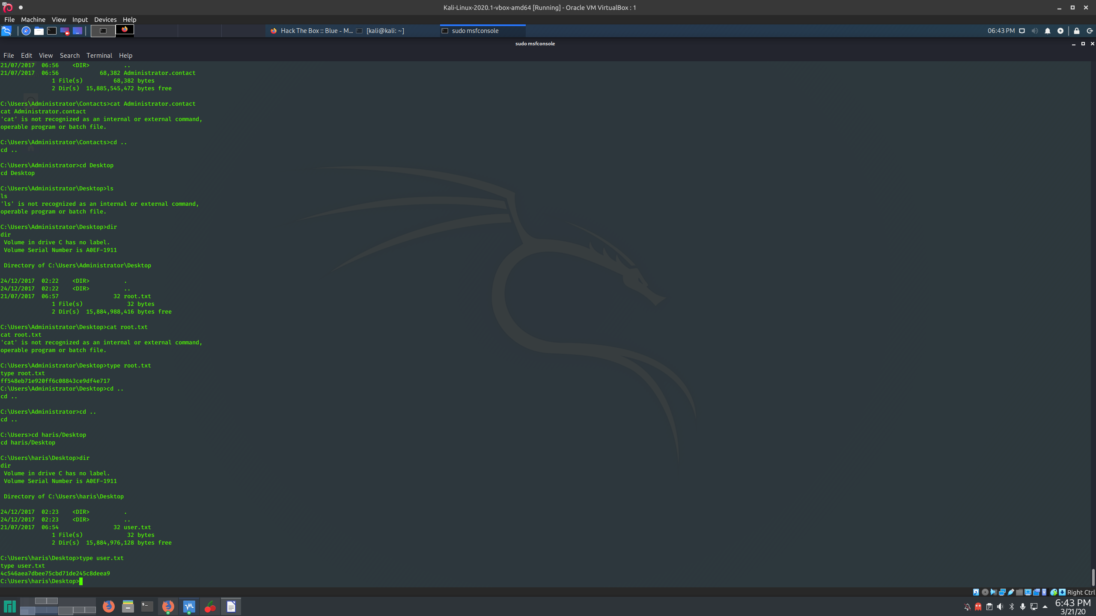
After getting root shell I found the flags in C:\Users\administator\desktop and C:\Users\haris\Desktop

