Retired Box – Lame

ran nmap -sC -sV -A 10.10.10.3
-sC runs a script scan
-sV runs a service/version scan
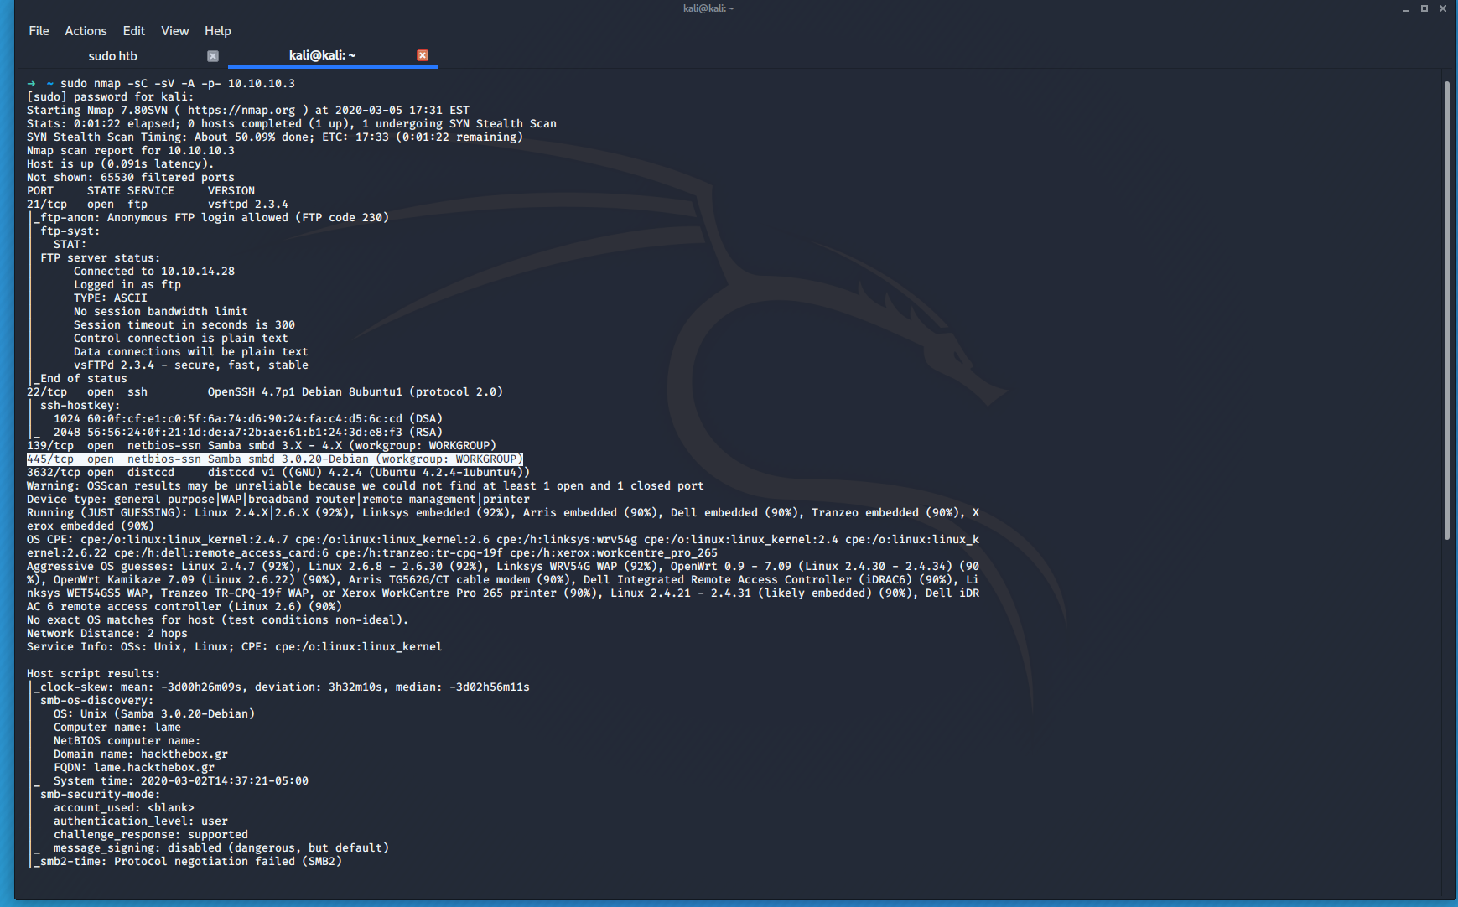
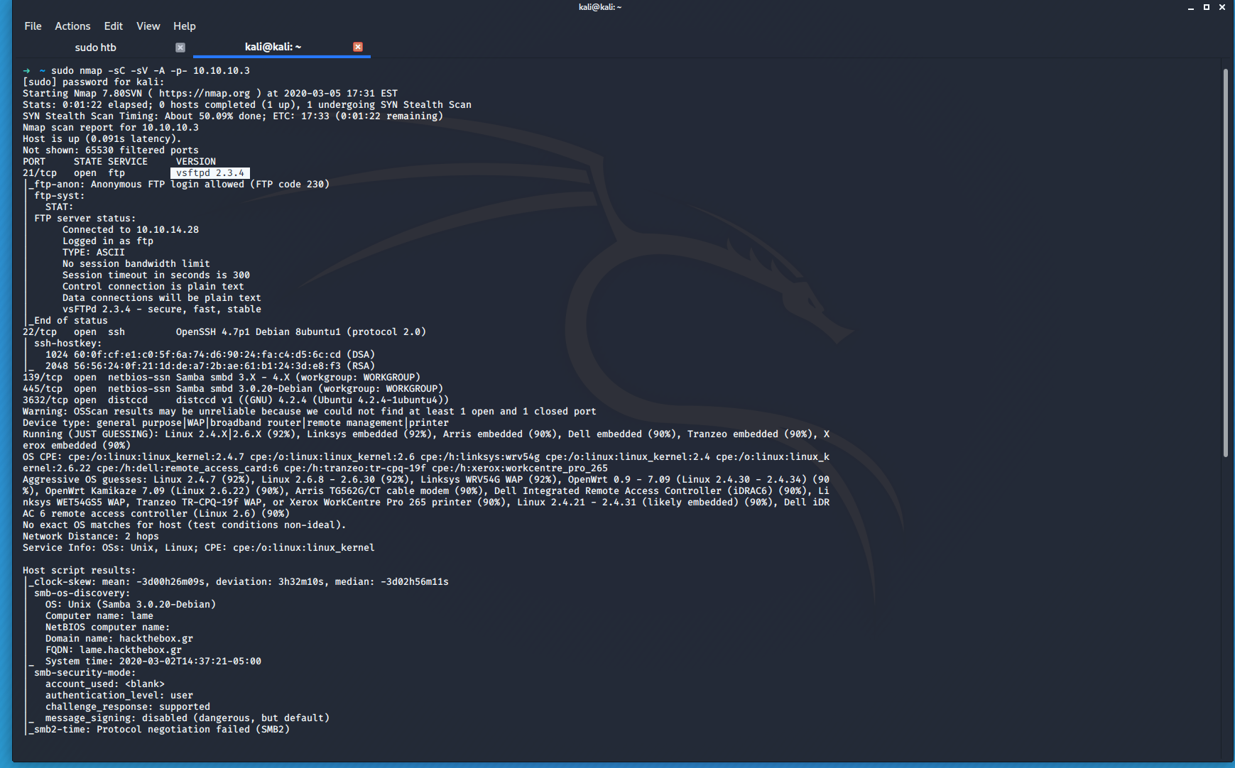
this is an output of the command
in the first screen shot we can see that tcp port 445 is open which shows that samba is running we can see that the version is 3.0.20 Debian & there is port 21 open vsftpd 2.3.4

now we can use the searchsploit command to lookup the services found
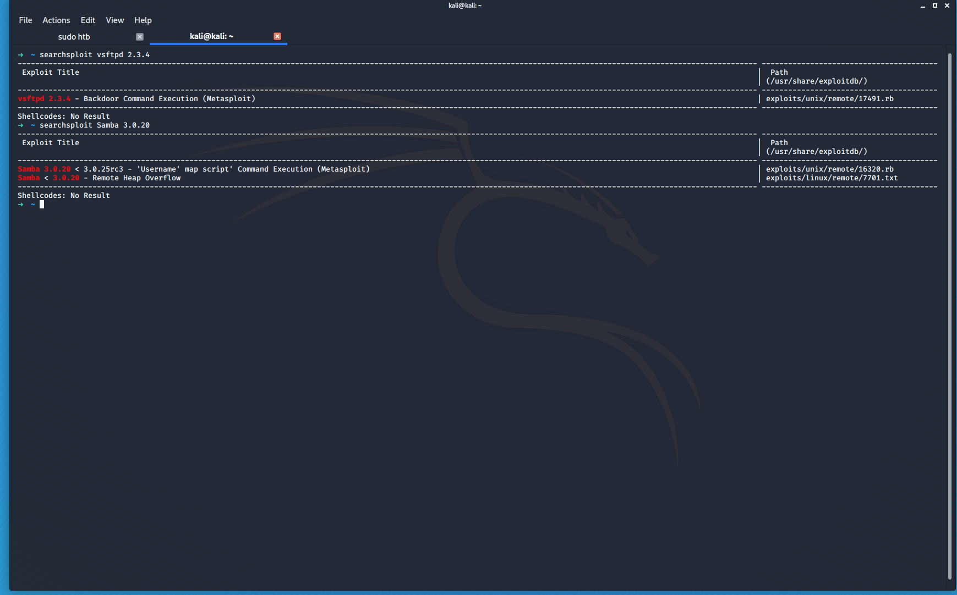
There are two exploits found for the servies found in the nmap scan

starting metasploit first start postgres
sudo systemctl start postgresql
mfsdb init
sudo msfconsole
db_status
its connected to postgresql

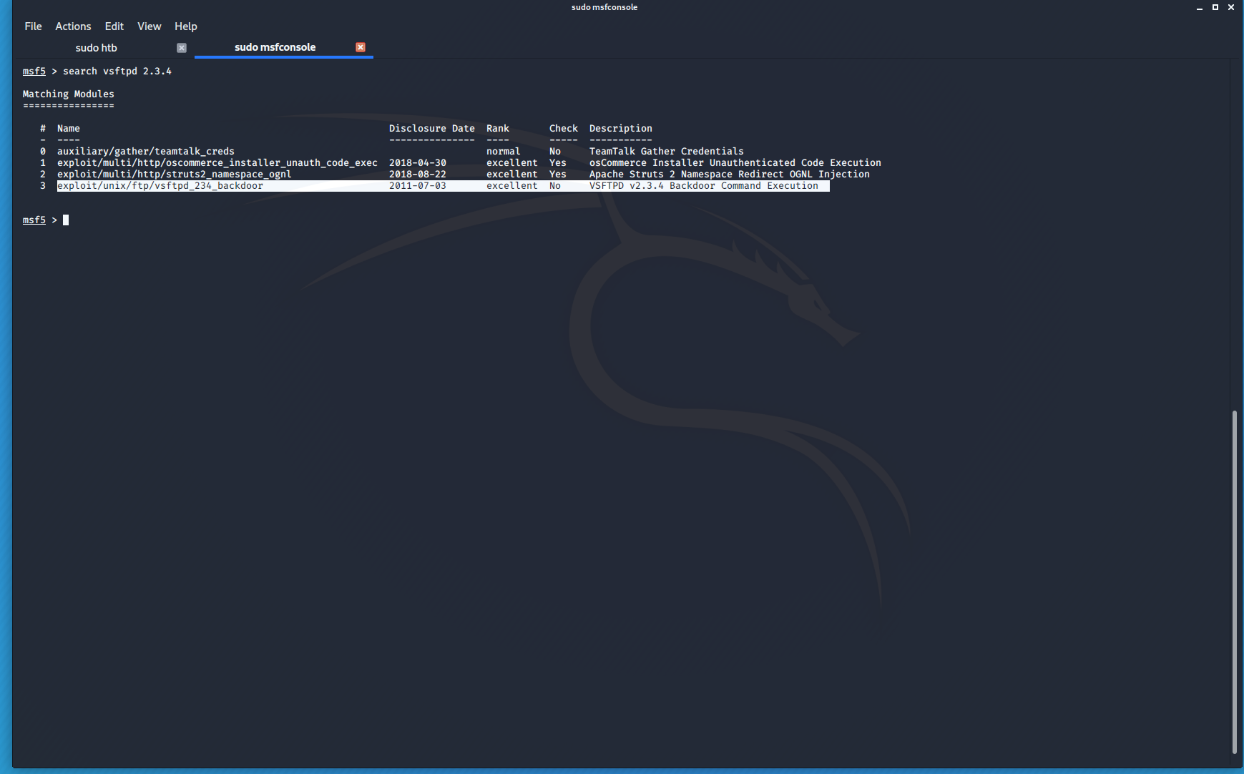
checked the first service and since the target is linux this is the one we are interested in
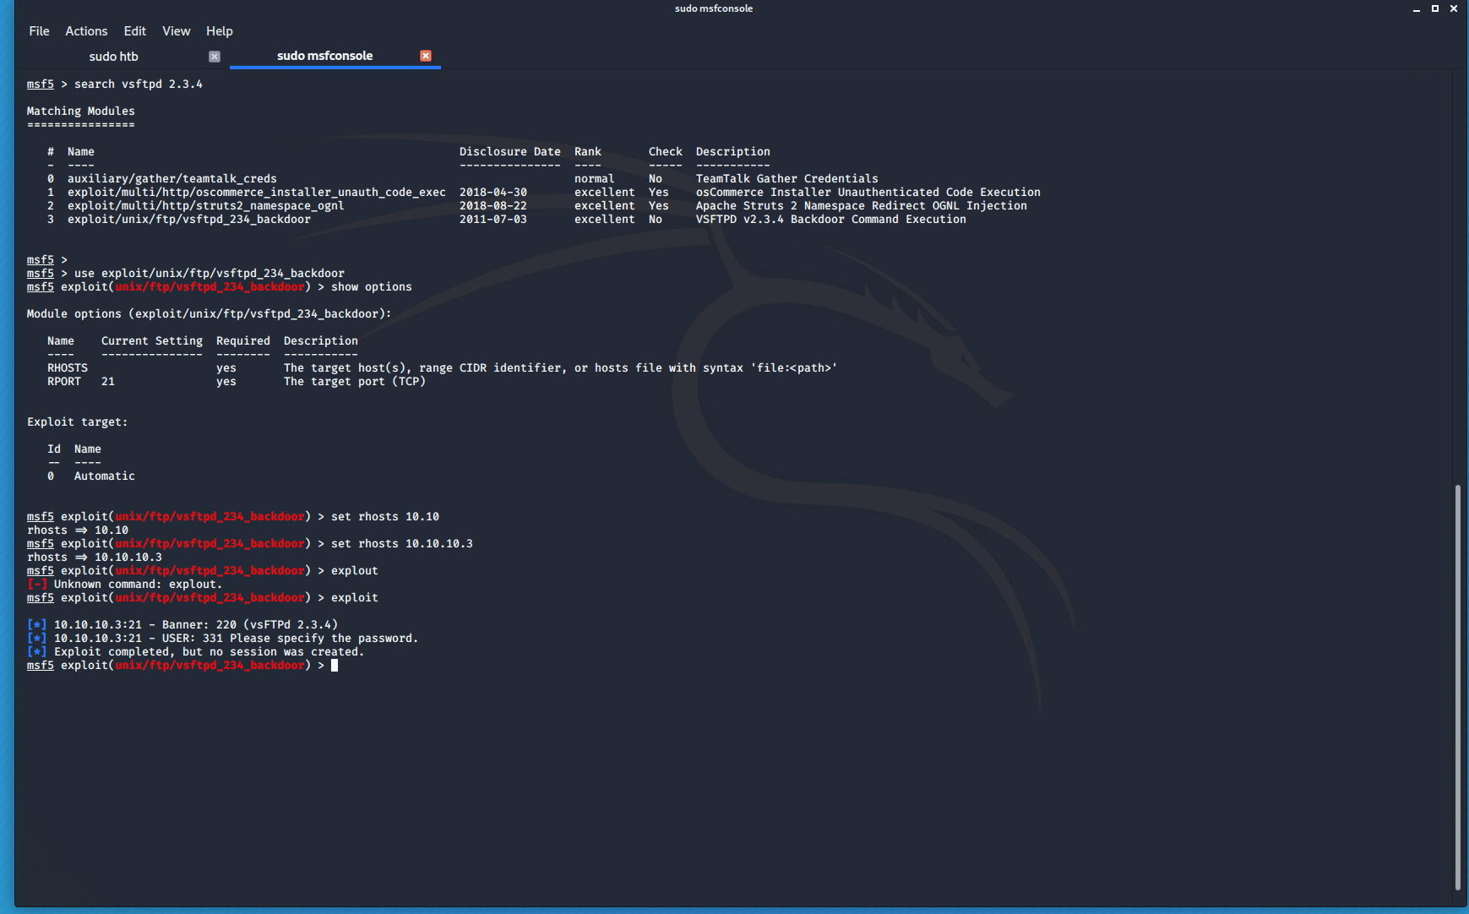
the exploit failed it was patched

Looking at the other service there is another metasploit module for the open samba service 3.0.20
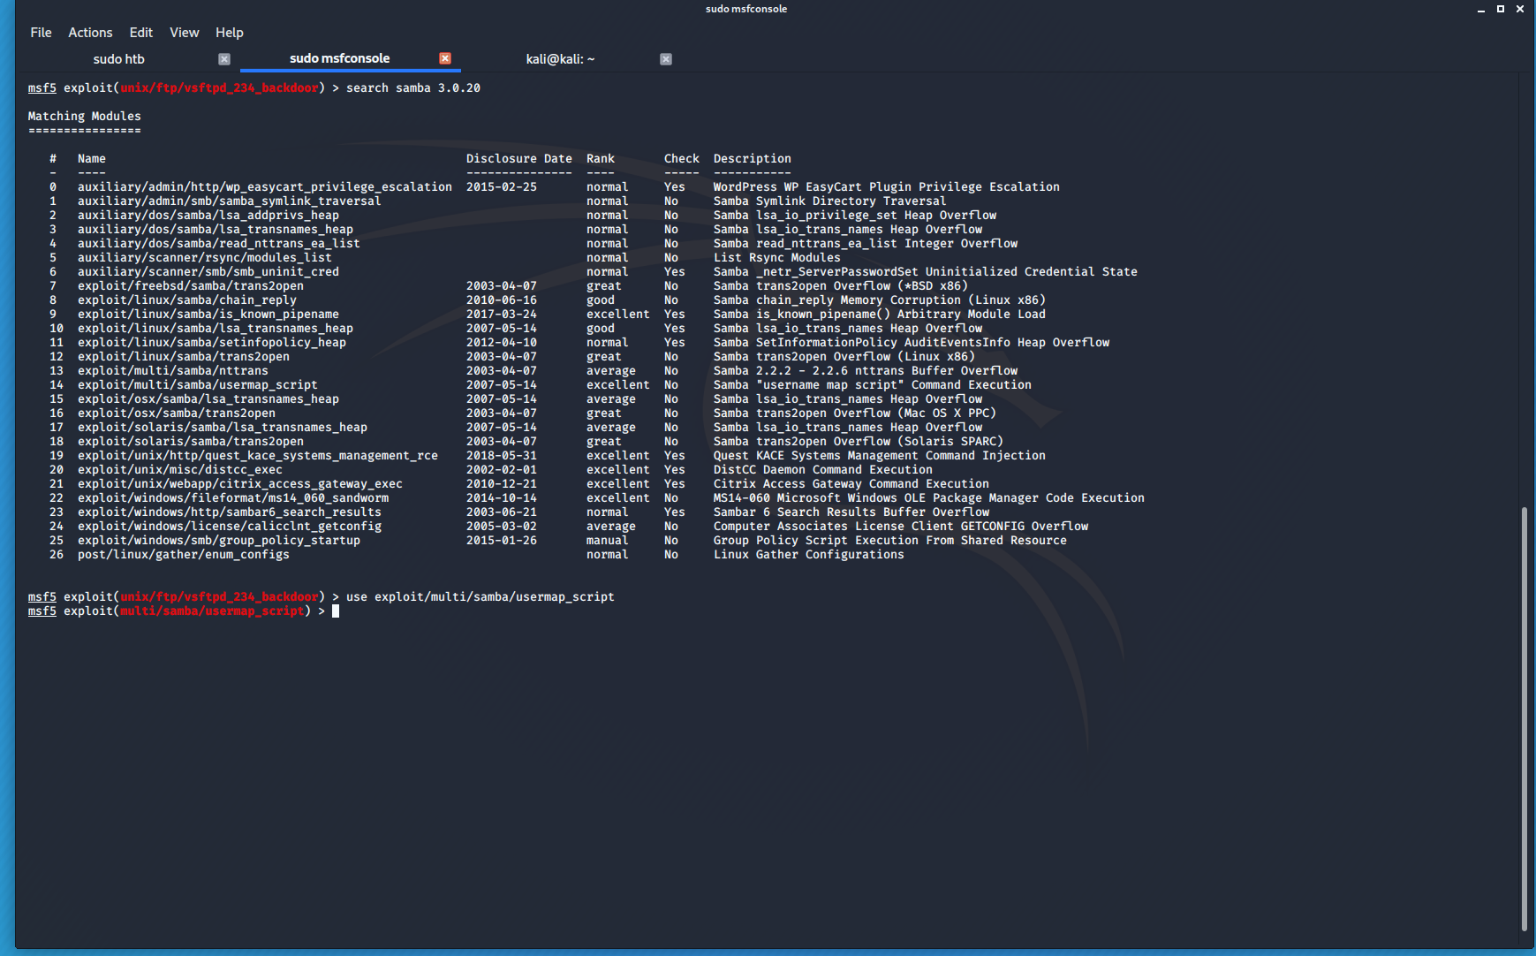
we use search in the msfconsole to show what exploit modules exist for samba 3.0.20 we know from the searchsploit that we want usermap_script and we enter that exploit with use exploit/multi/samba/usermap_script
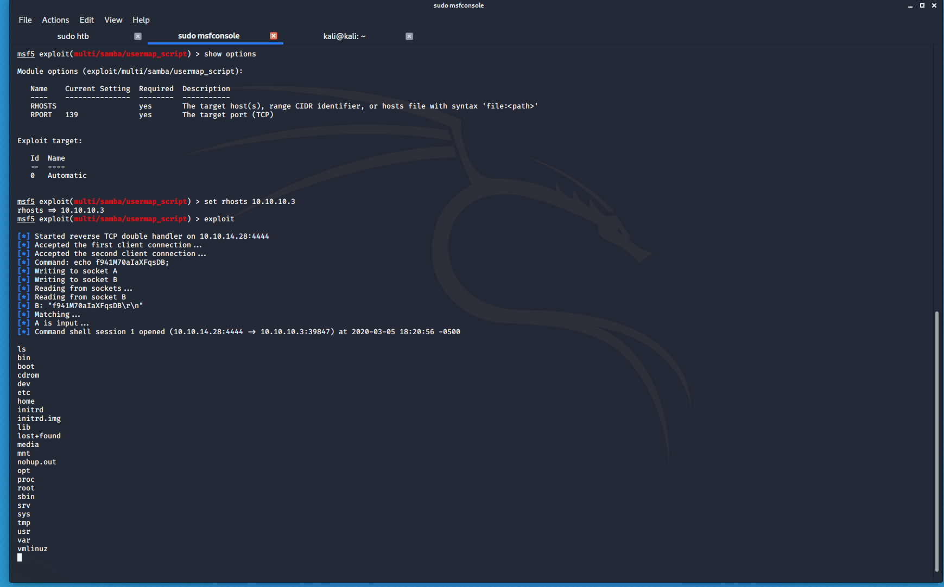
we check the options for the module we know that the IP address for the target machine is 10.10.10.3 we set that to rhosts
rhosts is short for remote hosts
then we run the command
we see that we are now in the machiene
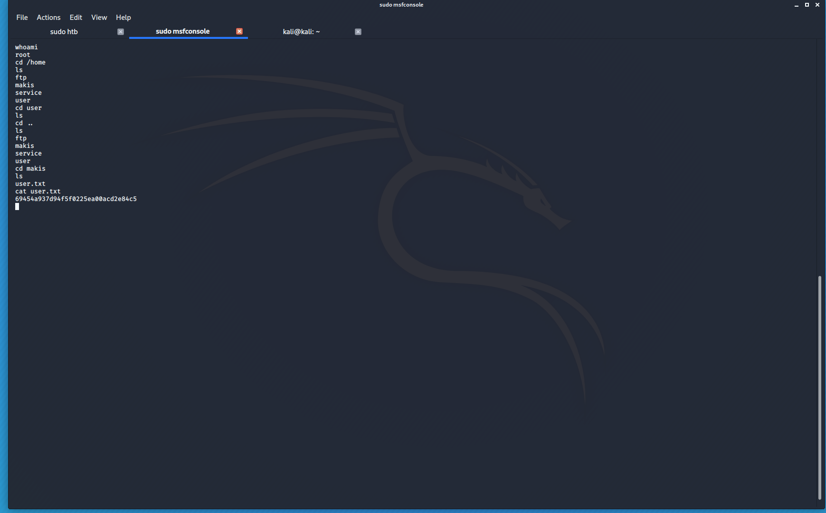

we have a root shell verified by the whoami command
next we check the folders we are looking for user.txt which is the first of the flags we are looking for

we find that it is in / home / makis / user.txt

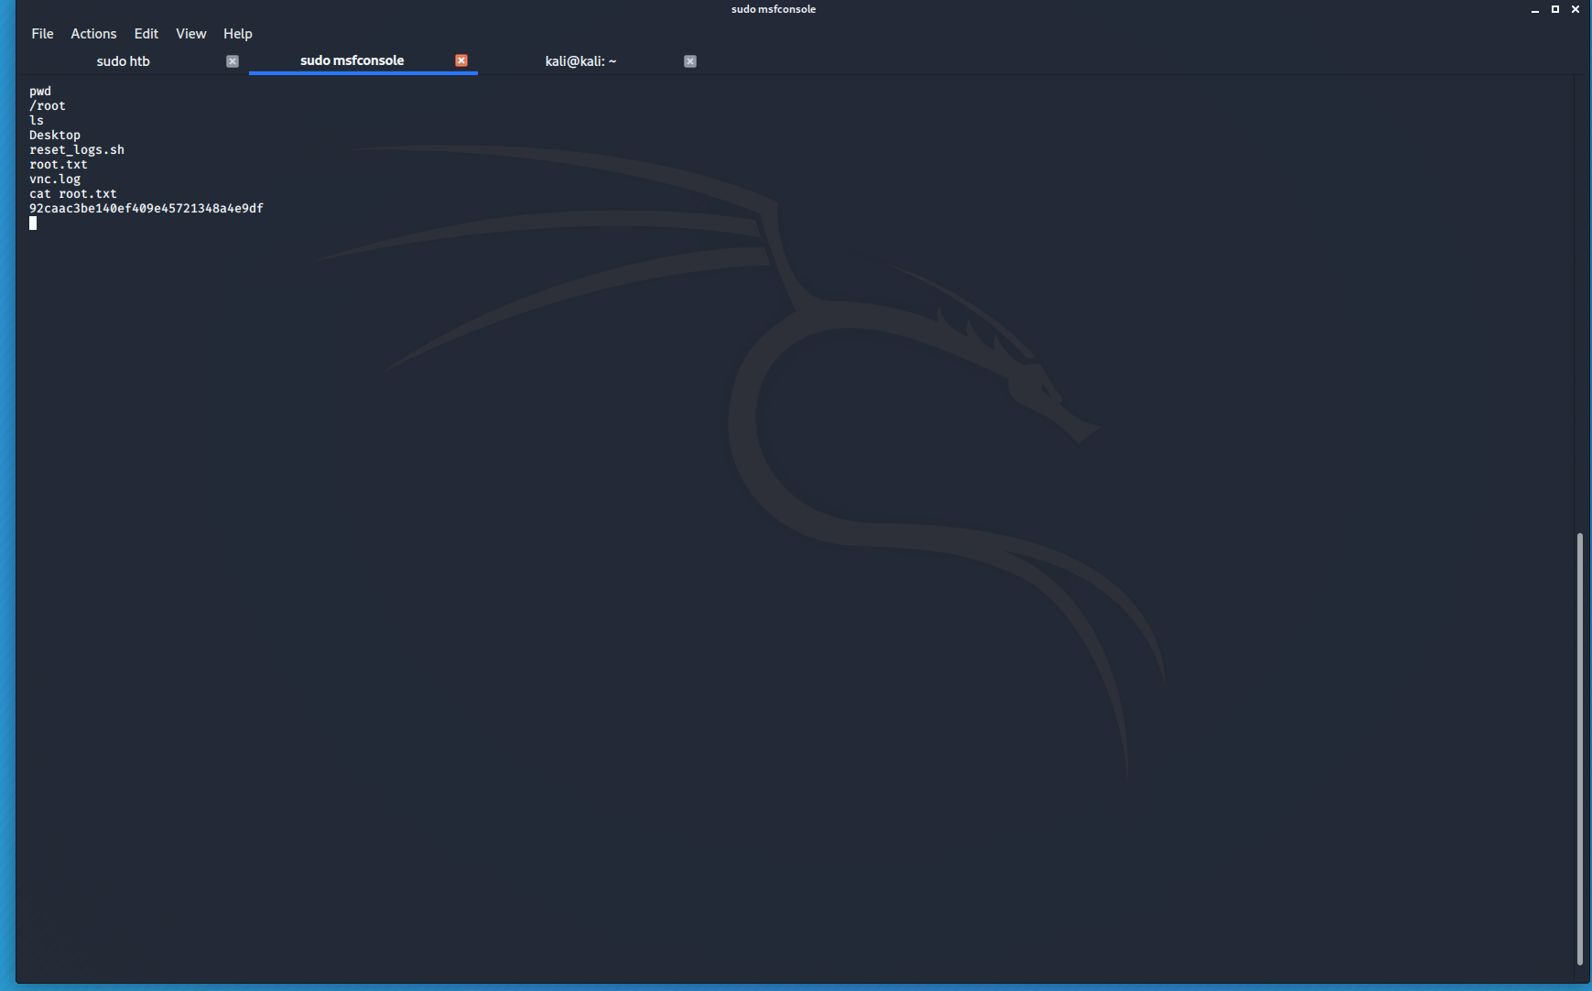
now we look for the root flag navigating back to / we look into / root for the flag having found it we have concluded this box

