Traceback

the first step is to scan the box
with an nmap scan

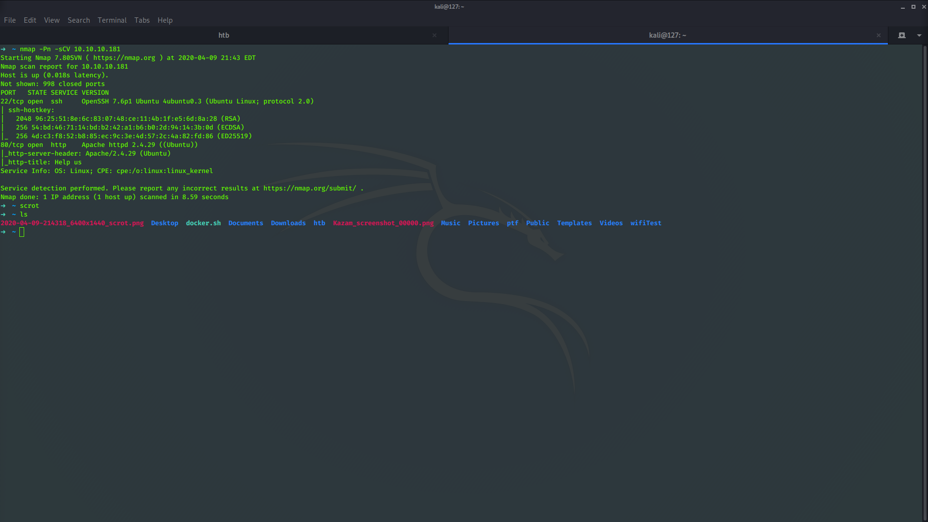

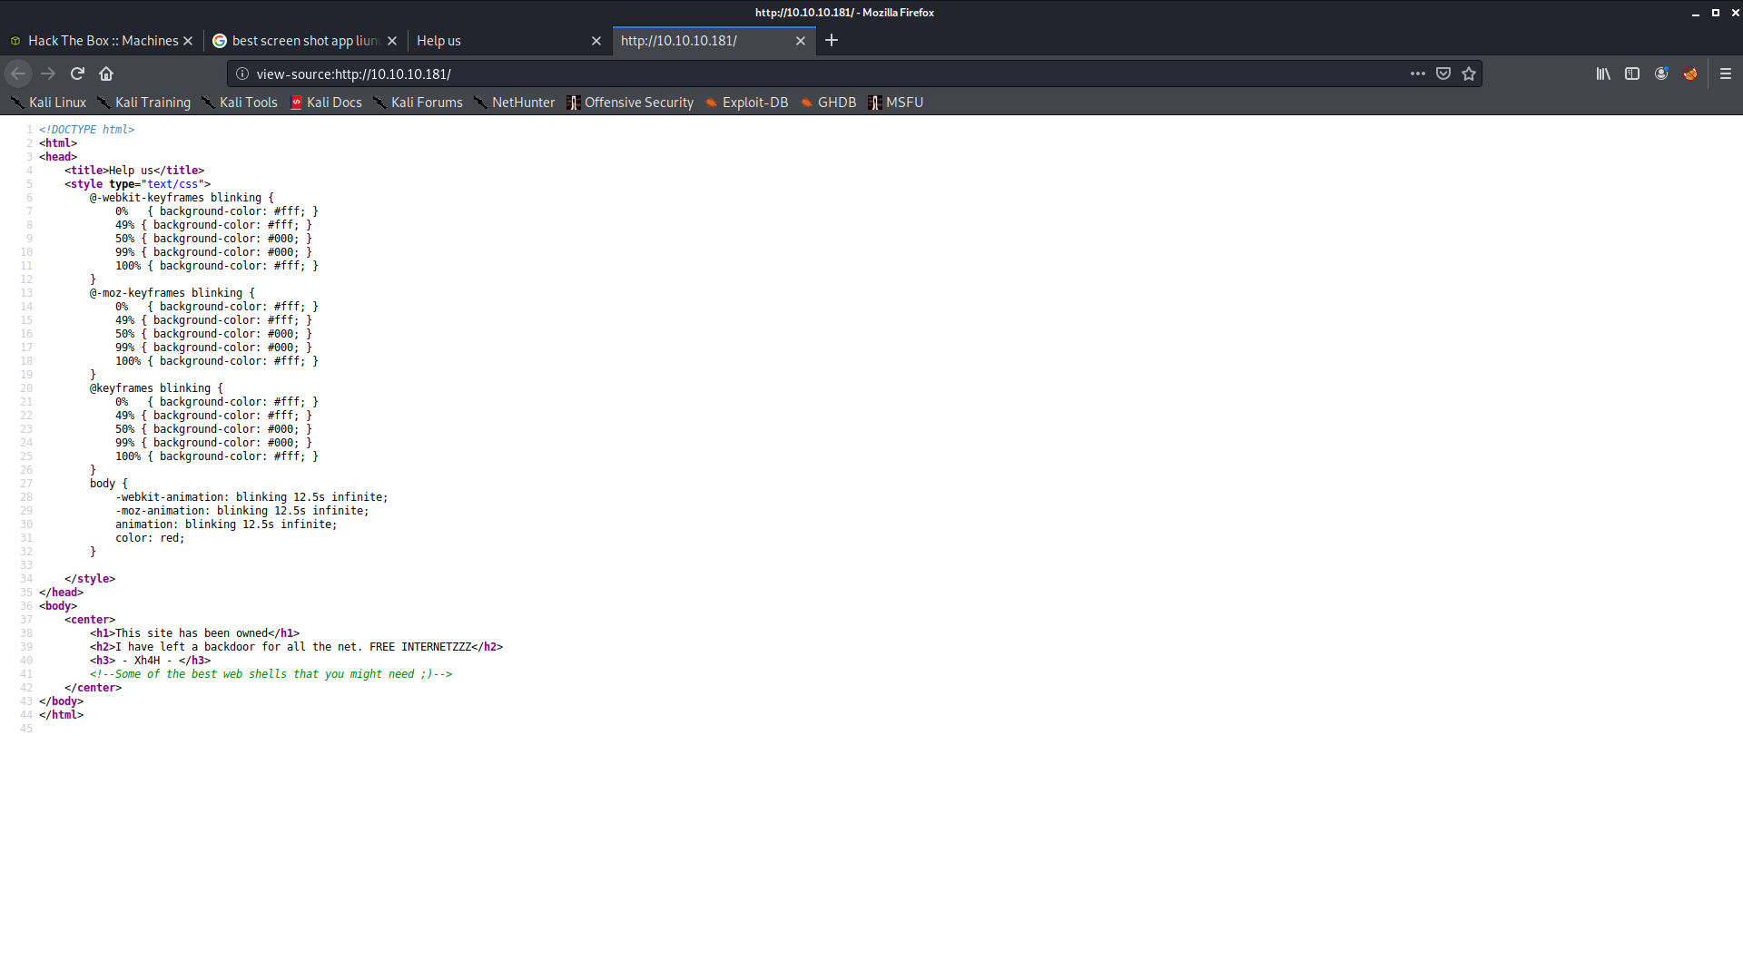
Then check port 80 there isnt much on the webpage but checking the source code shows something interesting

googling all the best web shells that you might need takes us to a github with a bunch of webshells

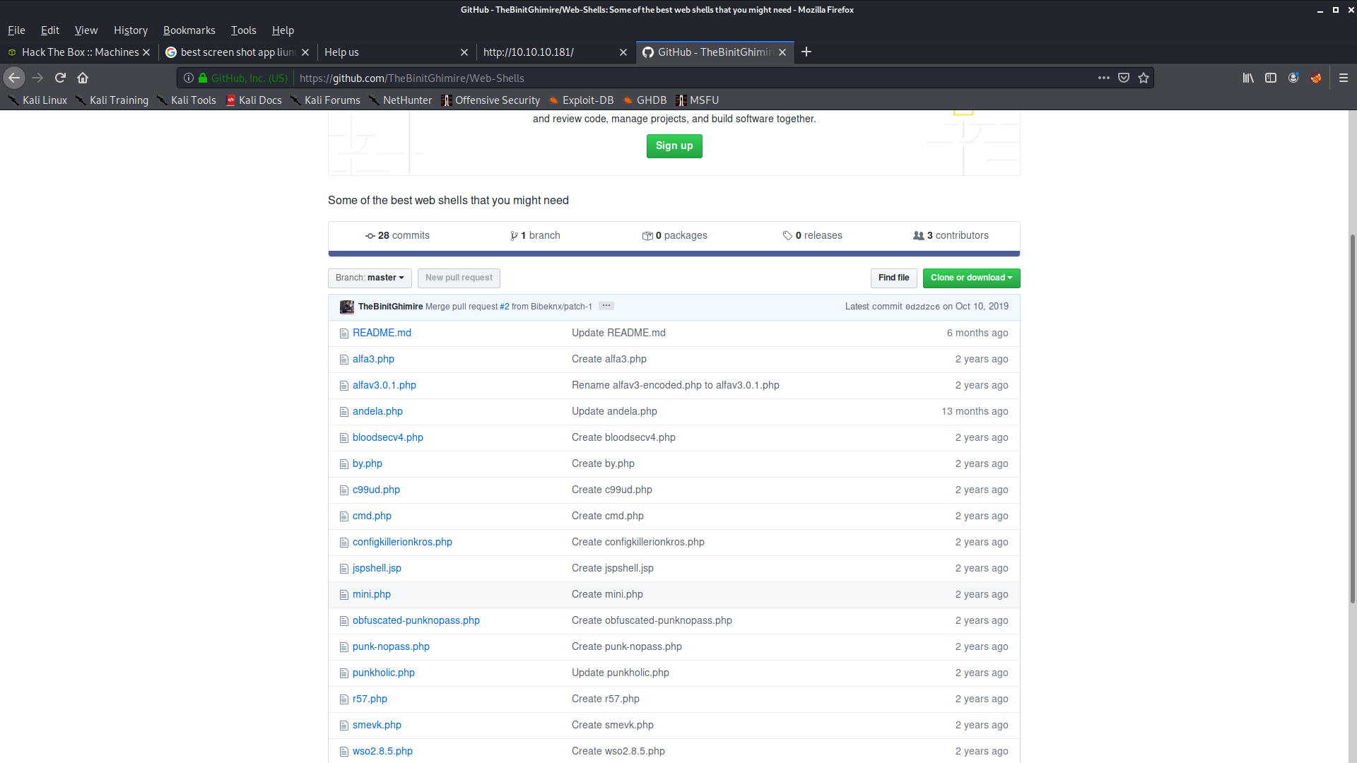
After trial an error we find the webshell is at 10.10.10.181/smevk.php
looking inside the github for the webpage shows that the default credentials are admin/admin after entering the default credentials it works and we have access to the webshell
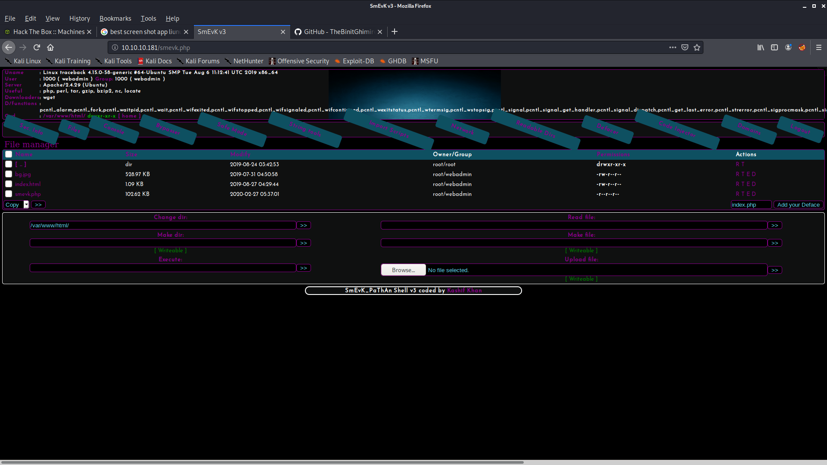
From here we can get a reverse shell back to our machine we use the webshell already in cali \usr\share\webshells\php\php-reverse-shell.php and modify it to suit our needs

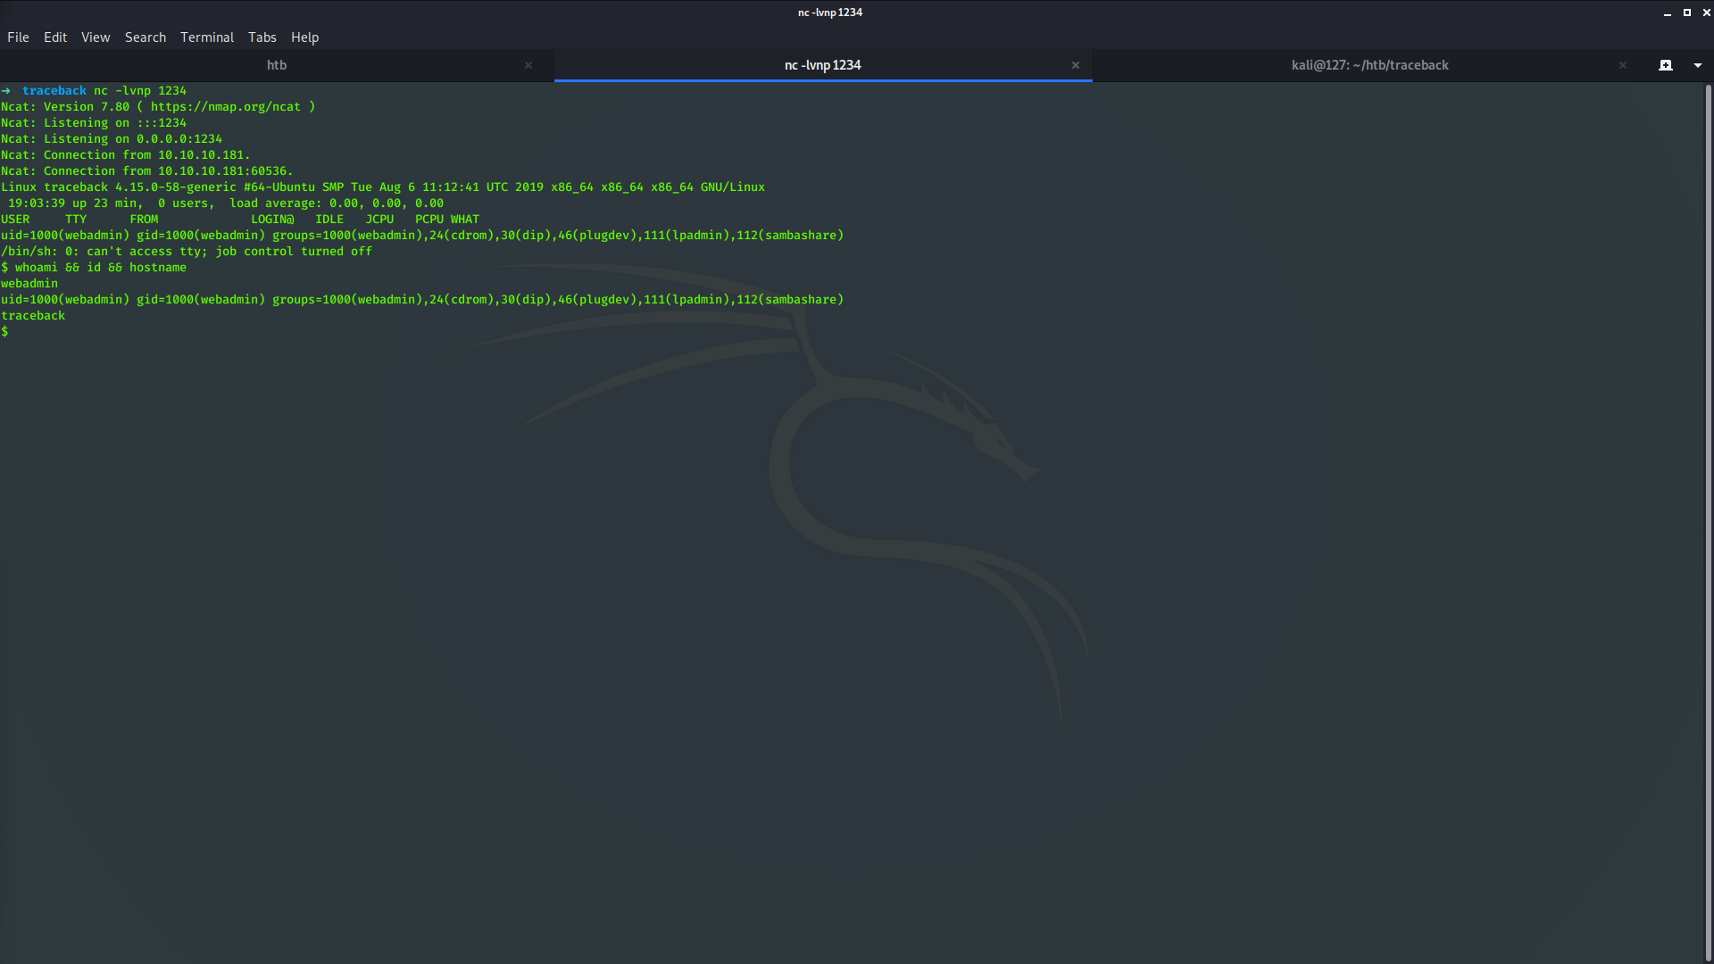

now that we have a webshell we find that there isnt a user.txt in the home directory but a note about a program that can interperit lua progamming language but first we can get a better shell using ssh

we can use ssh-keygen to make our own keys and then echo them into authorized keys in webadmins .ssh folder in their directory
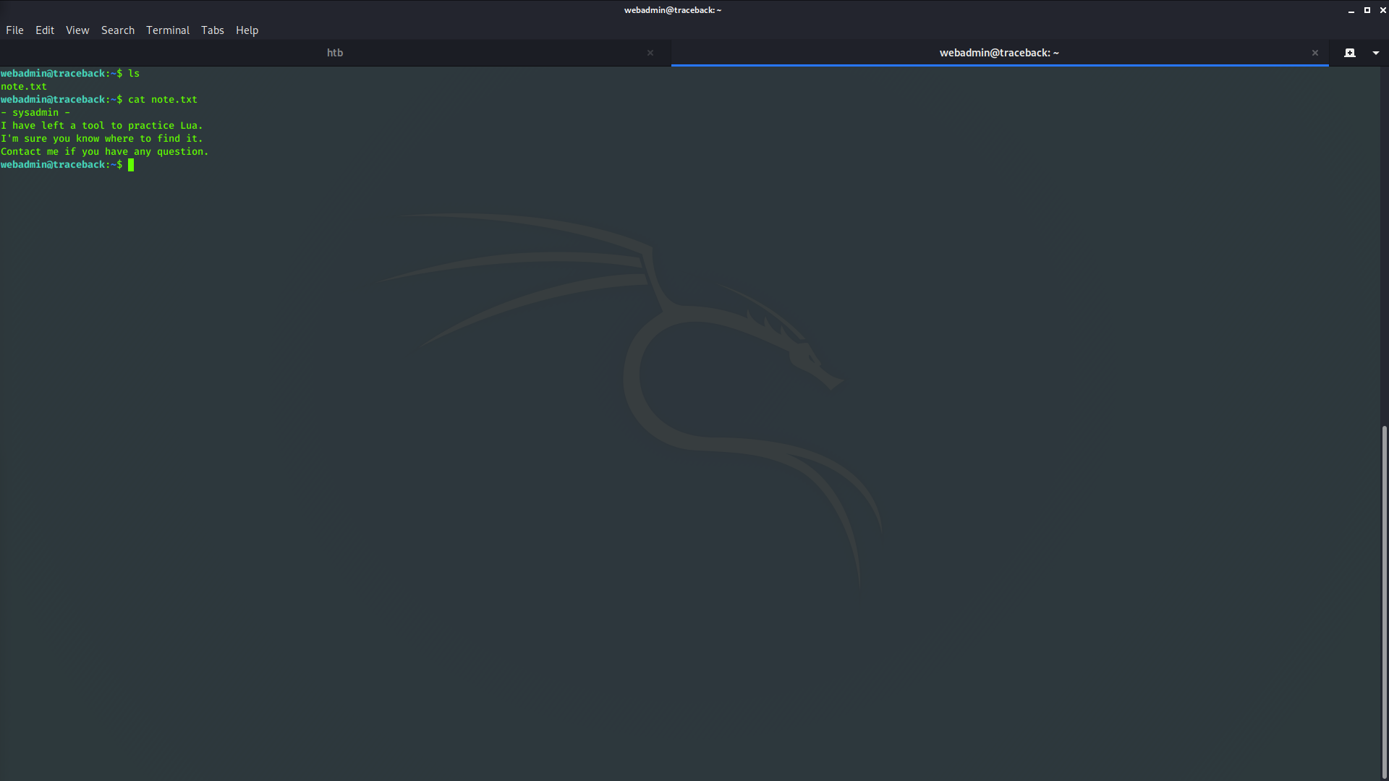
further enumeration of the home dirctory of webadmin shows .luvit_history & .bash_history
.luvit_history doesnt show anything interesting but .bash_history has some interesting commands left in the history

ls -la
sudo -l
nano privesc.lua
sudo -u sysadmin /home/sysadmin/luvit privesc.lua
rm privesc.lua
logout

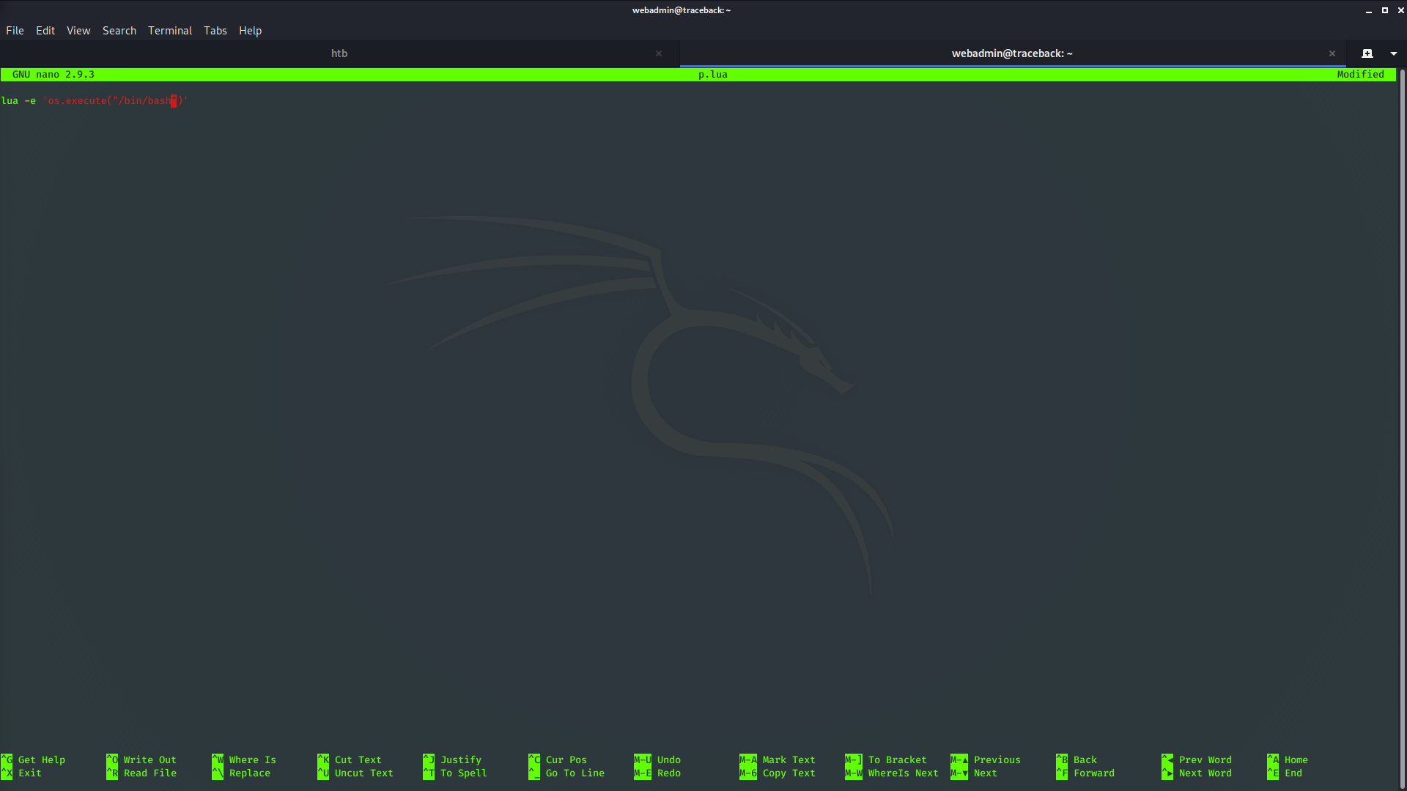

running this file with sudo -u sysadmin should give us the next shell
removing lua -e gave us the sysadmin shell
using pspy we find that the motd is vulerable

2020/03/23 21:11:01 CMD: UID=0 PID=2273 | sleep 30
2020/03/23 21:11:01 CMD: UID=0 PID=2272 | /bin/sh -c sleep 30 ; /bin/cp /var/backups/.update-motd.d/* /etc/update-motd.d/
2020/03/23 21:11:01 CMD: UID=0 PID=2271 |
2020/03/23 21:11:01 CMD: UID=0 PID=2270 | /usr/sbin/CRON -f
2020/03/23 21:11:01 CMD: UID=0 PID=2269 | /usr/sbin/CRON -f
2020/03/23 21:11:31 CMD: UID=0 PID=2275 | /bin/cp /var/backups/.update-motd.d/00-header /var/backups/.update-motd.d/10-help-text /var/backups/.update-motd.d/50-motd-news /var/backups/.update-motd.d/80-esm
/var/backups/.update-motd.d/91-release-upgrade /etc/update-motd.d/
2020/03/23 21:12:02 CMD: UID=0 PID=2281 | sleep 30
2020/03/23 21:12:02 CMD: UID=0 PID=2278 | /bin/sh -c sleep 30 ; /bin/cp /var/backups/.update-motd.d/* /etc/update-motd.d/
2020/03/23 21:12:02 CMD: UID=0 PID=2277 |
2020/03/23 21:12:02 CMD: UID=0 PID=2276 | /usr/sbin/CRON -f
2020/03/23 21:12:32 CMD: UID=0 PID=2282 | /bin/cp /var/backups/.update-motd.d/00-header /var/backups/.update-motd.d/10-help-text /var/backups/.update-motd.d/50-motd-news /var/backups/.update-motd.d/80-esm
/var/backups/.update-motd.d/91-release-upgrade /etc/update-motd.d/
using the ssh credentials we put on the server already and seeing that we have write priv to the update-motd.d we can echo ‘cat root\root.txt\ >> 00-header and get the root flag

