**Overview of all tables (135 total rows of data)**

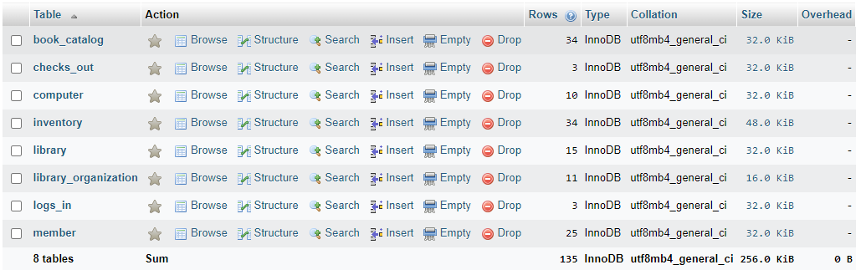

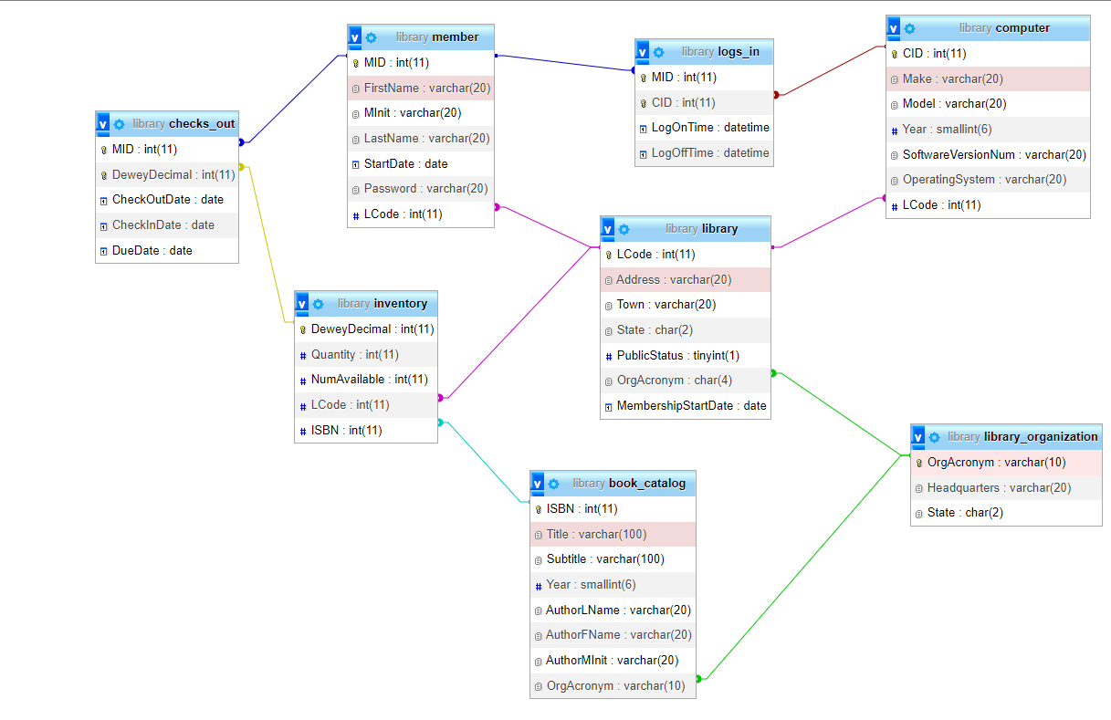

**Book_Catalog Table**

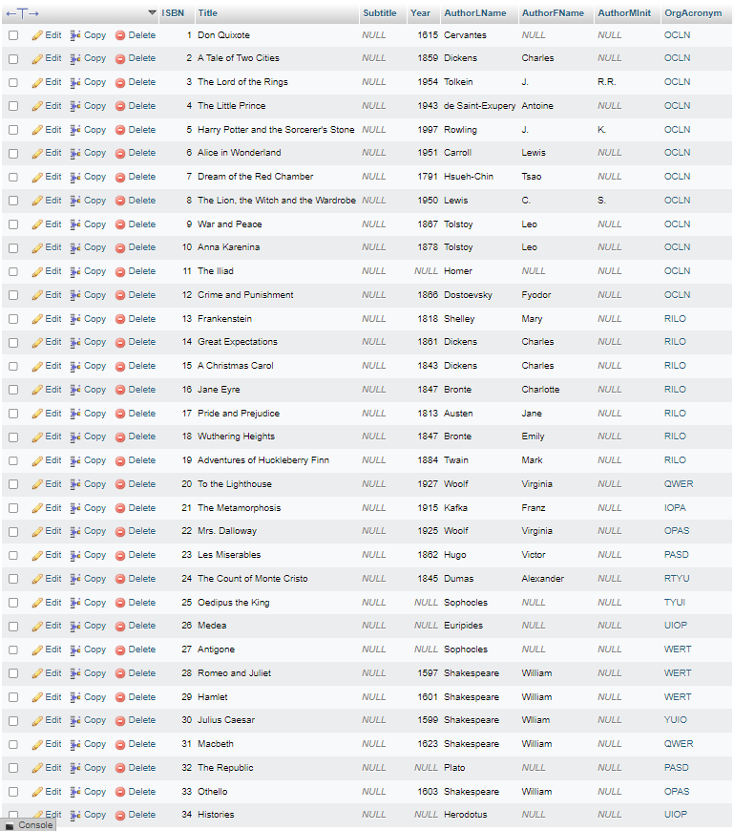

**Checks_Out Table**

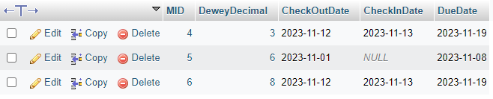

**Computer Table**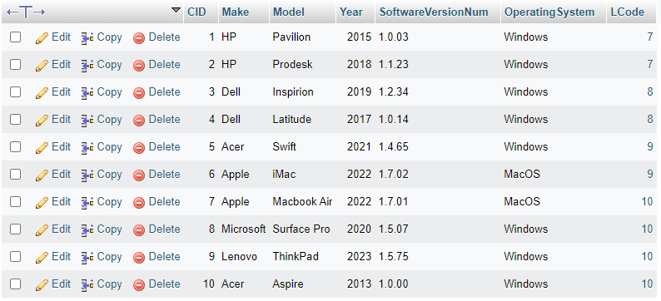

**Inventory Table**

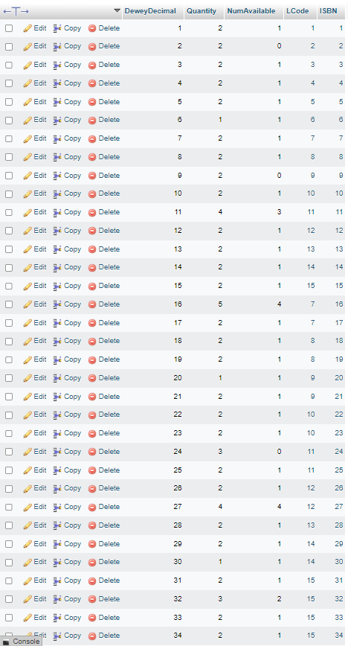

**Library Table**

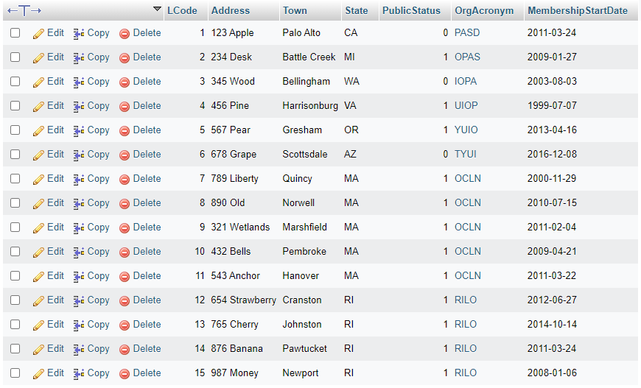

**Library Organization Table**

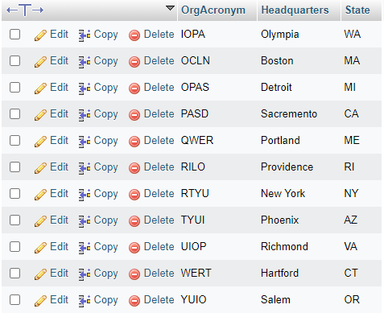

**Logs_In Table**

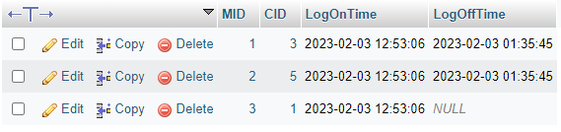

**Members Table **(I know a password should not be stored in plain text like this but I’m not sure how to encrypt it)\*\***

