**Final Project – Phase #5**

1. **How many books does each library have?**

SELECT library.Lcode AS Library_Code, library.Address AS Address, library.Town AS Town, library.State AS State, SUM(inventory.Quantity) AS Total_Books

FROM library, inventory

WHERE library.Lcode = inventory.Lcode

GROUP BY Library_Code

ORDER BY Total_Books DESC;

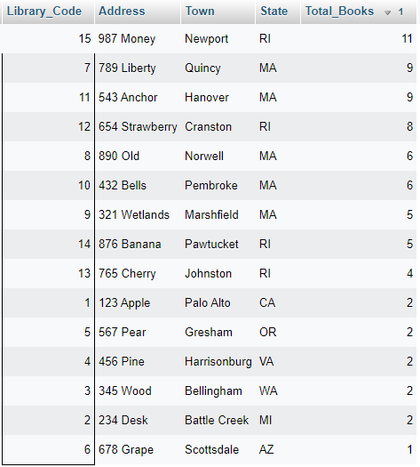

1. **How many members does each library have?**

SELECT library.Lcode AS Library_Code, library.Address AS Address, library.Town AS Town, library.State AS State, COUNT(member.MID) AS Num_Members

FROM library, member

WHERE library.Lcode = member.Lcode

GROUP BY Library_Code

ORDER BY Num_Members DESC;

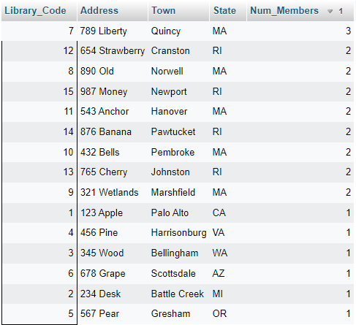

1. **How many computers does each library have?**

SELECT library.Lcode AS Library_Code, library.Address AS Address, library.Town AS Town, library.State AS State, COUNT(computer.CID) AS Total_Computers

FROM library, computer

WHERE library.Lcode = computer.Lcode

GROUP BY Library_Code

ORDER BY Total_Computers DESC;

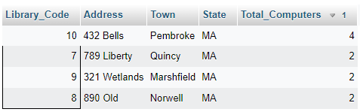

1. **Is there anyone currently logged into a computer (where LogOnTime != NULL & LogOffTime == NULL)?**

SELECT member.FirstName, member.LastName, member.MID

FROM member, logs_in

WHERE member.MID = logs_in.MID AND LogOnTime IS NOT NULL AND LogOffTime IS NULL;



1. **How many computers are there of each make?**

SELECT computer.Make, COUNT(computer.Make) AS Num

FROM computer

GROUP BY computer.Make;

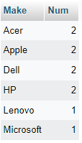

1. **What is the most popular operating system and what percentage of computers are that operating system?**

SELECT computer.OperatingSystem, MAX(XX.num) AS Count, ((MAX(XX.num)/YY.total) * 100) AS Percentage

FROM computer,

(SELECT COUNT(computer.OperatingSystem) AS Num

FROM computer

GROUP BY computer.OperatingSystem) AS XX,

(SELECT COUNT(*) AS total

FROM computer) AS YY;



1. **What books are fully checked out (NumAvailable = 0)? Inlcude ISBN, book title, and LCode.**

SELECT inventory.ISBN, book_catalog.Title, library.Lcode

FROM inventory, book_catalog, library

WHERE inventory.NumAvailable = 0 AND inventory.ISBN = book_catalog.ISBN AND inventory.Lcode = library.Lcode;

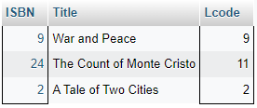

1. **What books need to be returned and by whom?**

SELECT member.FirstName, member.LastName, book_catalog.title, library.Lcode, inventory.DeweyDecimal

FROM book_catalog, member, library, inventory, checks_out

WHERE checks_out.CheckInDate IS NULL AND checks_out.MID = member.MID AND checks_out.DeweyDecimal = inventory.DeweyDecimal AND inventory.Lcode = library.Lcode AND inventory.ISBN = book_catalog.ISBN;



1. **How many member libraries does each Library Organization have?**

SELECT library_organization.OrgAcronym, COUNT(library.Lcode) AS Num_Libraries

FROM library_organization, library

WHERE library.OrgAcronym = library_organization.OrgAcronym

GROUP BY library_organization.OrgAcronym

ORDER BY Num_Libraries DESC;

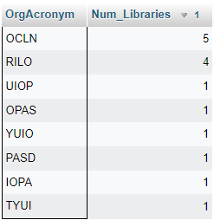

1. **What books have not been returned before the due date, i.e. are past due? Include book title, Dewey Decimal number, Lcode, and member name.**

SELECT member.FirstName, member.LastName, book_catalog.title AS Title, library.Lcode, inventory.DeweyDecimal

FROM book_catalog, member, library, inventory, checks_out

WHERE checks_out.CheckInDate IS NULL AND checks_out.DueDate < CURRENT_DATE AND checks_out.MID = member.MID AND checks_out.DeweyDecimal = inventory.DeweyDecimal AND inventory.Lcode = library.Lcode AND inventory.ISBN = book_catalog.ISBN;



1. **When did the first member join every library organization?**

SELECT library_organization.OrgAcronym, MIN(MembershipStartDate) AS MembershipStartDate

FROM library, library_organization

WHERE library.OrgAcronym = library_organization.OrgAcronym

GROUP BY library_organization.OrgAcronym;

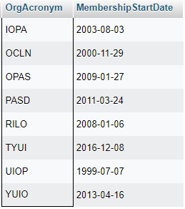

1. **When did the first member join every library (oldest member start date for each library)?**

SELECT library.Lcode, MIN(member.StartDate) AS StartDate

FROM library, member

WHERE library.Lcode = member.Lcode

GROUP BY library.Lcode;

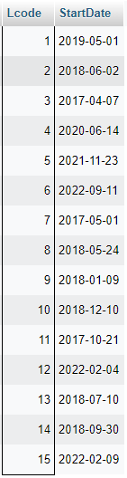

1. **When did the newest member join every library (newest member start date for each library)?**

SELECT library.Lcode, MAX(member.StartDate) AS StartDate

FROM library, member

WHERE library.Lcode = member.Lcode

GROUP BY library.Lcode;

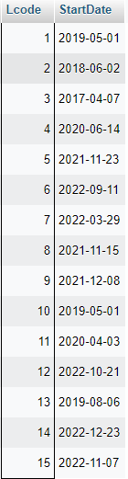

1. **When did the newest member join every library organization?**

SELECT library_organization.OrgAcronym, MAX(MembershipStartDate) AS MembershipStartDate

FROM library, library_organization

WHERE library.OrgAcronym = library_organization.OrgAcronym

GROUP BY library_organization.OrgAcronym;

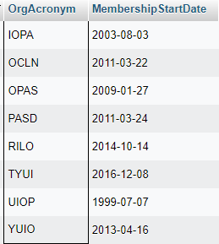

1. **What is the oldest book by publication year for each library? Replace libraries with books of only NULL year as "Unknown."**

SELECT library.Lcode, coalesce(MIN(book_catalog.Year), 'Unknown') AS PublicationYear

FROM library, book_catalog, inventory

WHERE library.Lcode = inventory.Lcode AND inventory.ISBN = book_catalog.ISBN

GROUP BY library.Lcode;

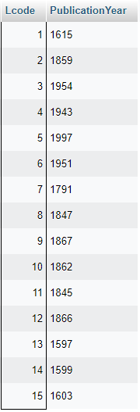

1. **What is the newest book by publication year for each library? Replace libraries with books of only NULL year as "Unknown."**

SELECT library.Lcode, coalesce(MAX(book_catalog.Year), 'Unknown') AS PublicationYear

FROM library, book_catalog, inventory

WHERE library.Lcode = inventory.Lcode AND inventory.ISBN = book_catalog.ISBN

GROUP BY library.Lcode;

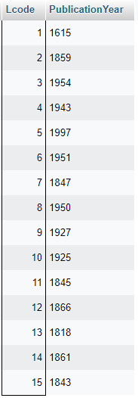

1. **What books have authors with a middle initial and what is it?**

SELECT book_catalog.ISBN, book_catalog.Title, book_catalog.AuthorMInit

FROM book_catalog

WHERE book_catalog.AuthorMInit IS NOT NULL;

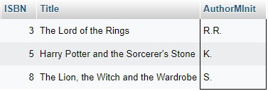

1. **How many authors have two or more books in the catalog and what are their names?**

SELECT book_catalog.AuthorFname AS FirstName, coalesce(book_catalog.AuthorMInit, '') AS Minit, book_catalog.AuthorLname AS LastName, COUNT(book_catalog.ISBN) AS Num_Books

FROM book_catalog

GROUP BY book_catalog.AuthorFname, coalesce(book_catalog.AuthorMInit, ''), book_catalog.AuthorLname

HAVING Num_Books >= 2;

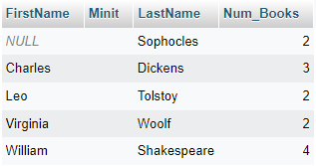

1. **What library members have a middle initial and what is it?**

SELECT member.MID, member.Lcode, member.MInit

FROM member

WHERE member.MInit IS NOT NULL;

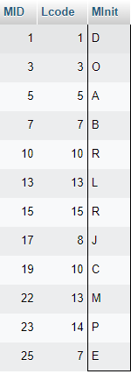

1. **What is the average number of days that library members check out a book?**

SELECT AVG(CheckInDate - CheckOutDate) AS Avg_Days_Checked_Out

FROM checks_out;

