**Final Project - Phase #6**

***Home Page:***

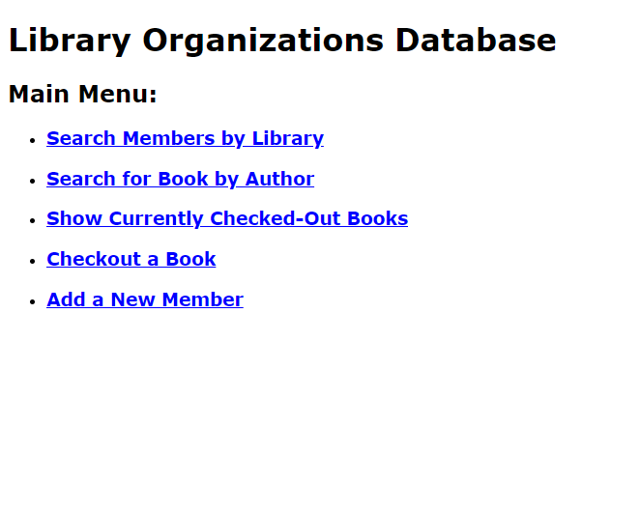

***View Data #1***

**Search Members by Library #1:**

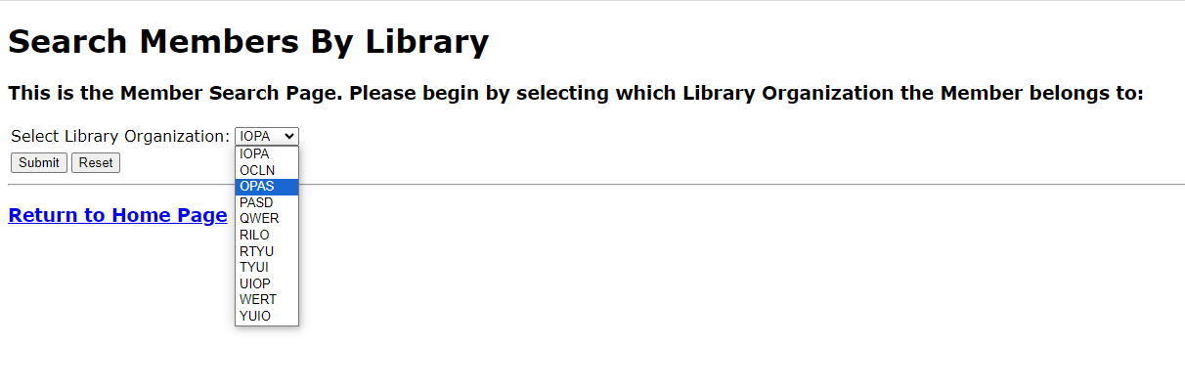

**Search Members by Library #2:**

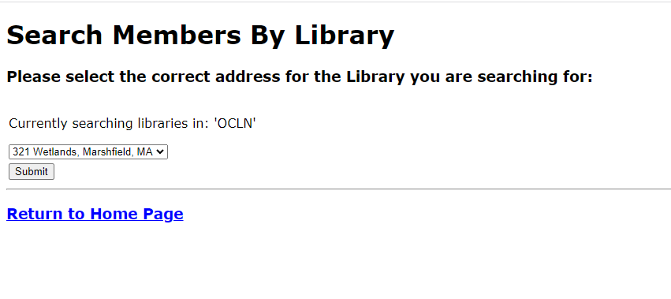

**Search Members by Library #3:**

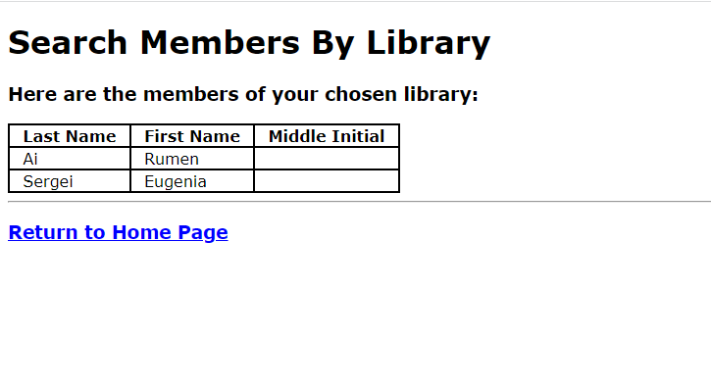

***View Data #2***

**Search Book by Author #1:**

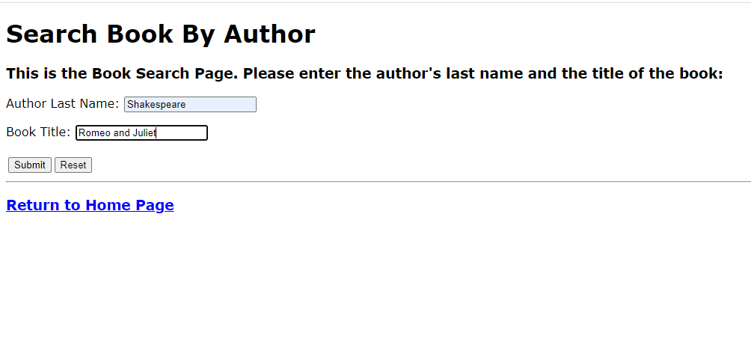

**Search Book by Author #2:**

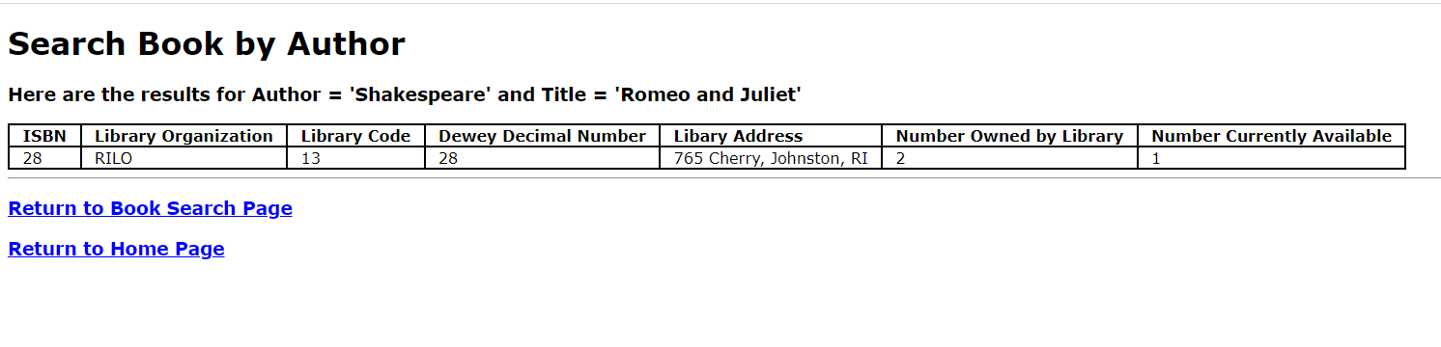

***View Data #3***

**Show Currently Checked-out Books:**

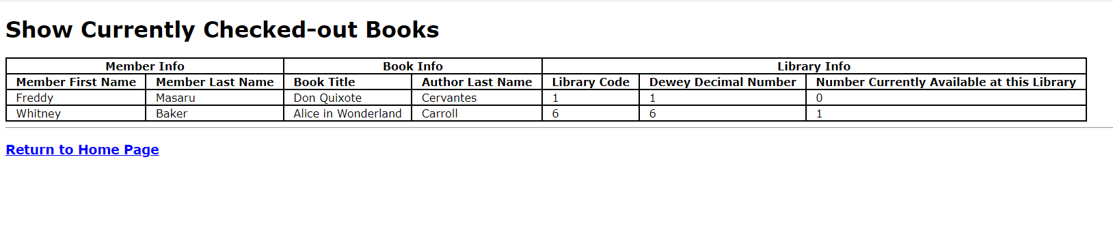

***Insert Data #1***

**Checkout a Book #1:**

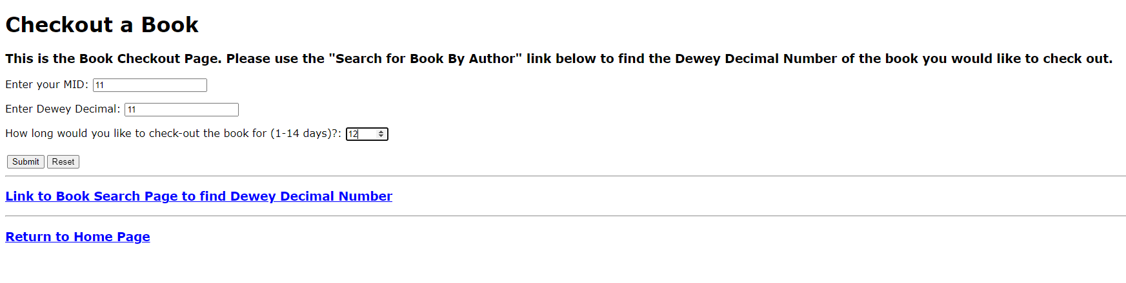

**Checkout a Book #2:**

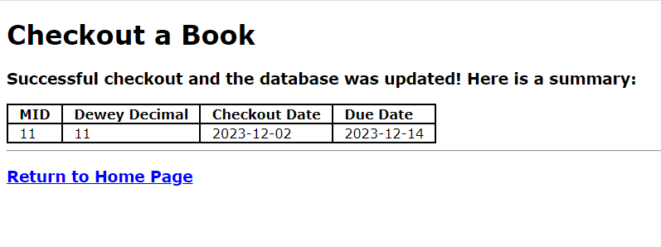

**Checkout a Book Failure (NumAvailable = 0):**

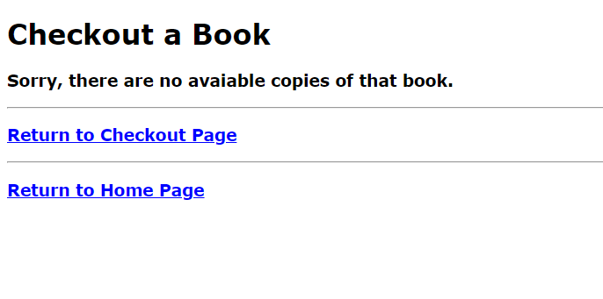

***Insert Data #2***

**Add a Member #1:**

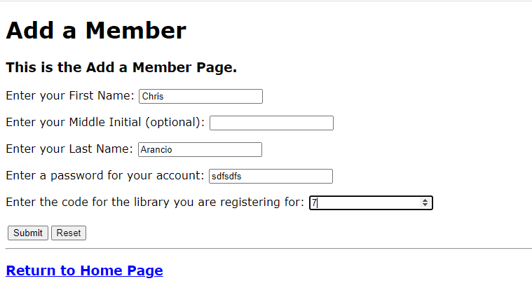

**Add a Member #2:**

