**Analysis of Successful – and unsuccessful – Kickstarter Campaigns**

Chris Arkenberg 2.05.2018

**Executive Summary**

*Given the limited data, it appears that the most successful Kickstarter campaigns focus on media projects like plays and music that are launched in late Spring. The lowest funding goals have the highest rate of success. Almost all successful Kickstarter campaigns are based in the United States, followed distantly by Britain and Canada.*

**About the Data**

The data source is unknown. Thus, it may be erroneous, fake, and/or incomplete. The data is also limited.

**What’s Missing?**

*Historic data is sparse.* Kickstarter has only been in existence since 2009 and real adoption began in 2014. Furthermore, the data set only has partial data for 2017. Notably 2015 had higher numbers than 2016 – a trend worth watching when 2017 numbers are available. (See Chart4)

*The metrics are narrow.* The metrics for success within this data set are essentially category & sub-category, country of origin, and date of launch. There is no data regarding other meaningful factors like length & quality of the campaign video, tone of campaign descriptors, or the size and reach of social media marketing. Likewise, there is no information about campaign backers beyond the number per campaign. It would be worth understanding their geographic, age, and professional distribution.

*Kickstarter is not broadly popular.* Globally, Kickstarter is mostly a phenomenon in the US and Great Britain with some activity in Canada. There’s little-to-no activity elsewhere. As such, the following analysis mostly applies to these top-three geographies. (See Chart 5)

**Success by Category – Chart 1**

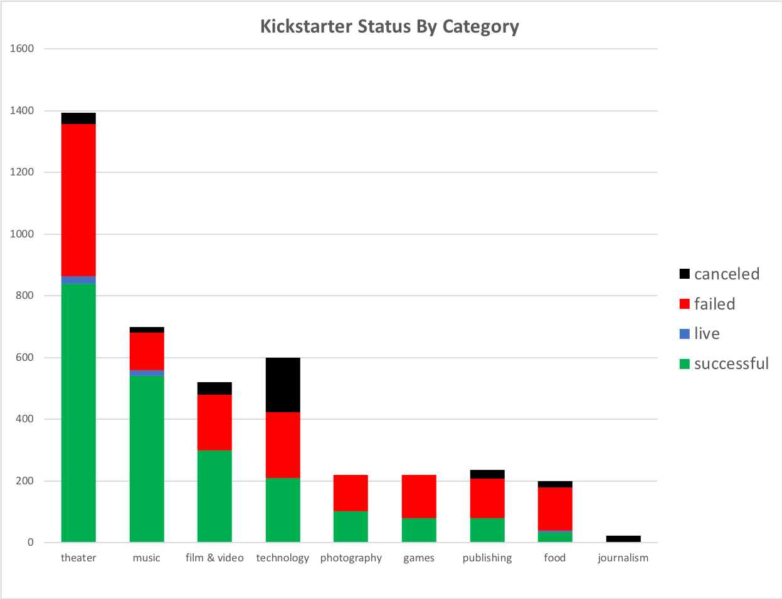

*Everybody loves good media.*

Overall, media is the most successful type of Kickstarter. Notably, theater dominates as the most successful category in the data set with the most campaigns by far, followed by music, film & video, and technology, in that order.

However, the music category has the highest percentage of successes.

Technology has the highest percentage of failures and cancellations. This is in part due to the routine failure of campaigns to build wearables (see Chart 2). A safe assumption is that people under-estimate the scope of wearable technology projects in spite of high-flying successes like the Pebble watch. Notably, the hardware sub-category shows near-universal success.

Sadly, few people are using Kickstarter for journalism – it’s the smallest category, and with no successes.

**Chart 2 – Success by Sub-Category**

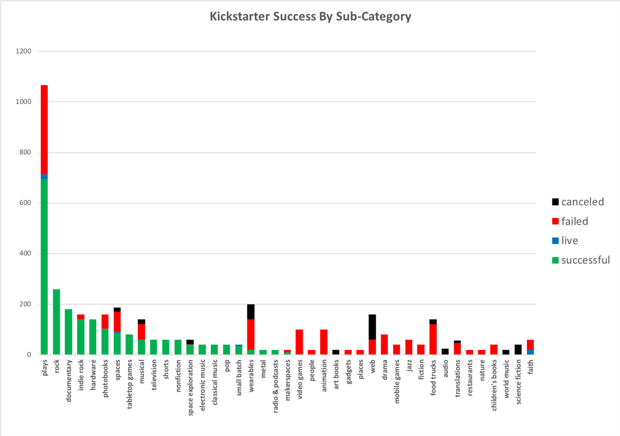

*Launch a play, an album, or a documentary.*

Following the category distribution, the most successful sub-categories are plays by far, followed by rock and indie music, documentaries, and hardware.

Strong failures and cancellations are found in the relatively large sub-categories of wearables, web, video games (compared to the strong success of tabletop games), translations, food trucks, animation, drama, and musicals.

There are many other sub-categories in the long tail but their total numbers are small compared to the rest, and most of these fail or are cancelled. It would be worth looking more in-depth at the country distribution to see which categories are most common in a given region, and then using this info to help shape those markets towards greater success.

**Chart 3 – Success by Month Launched**

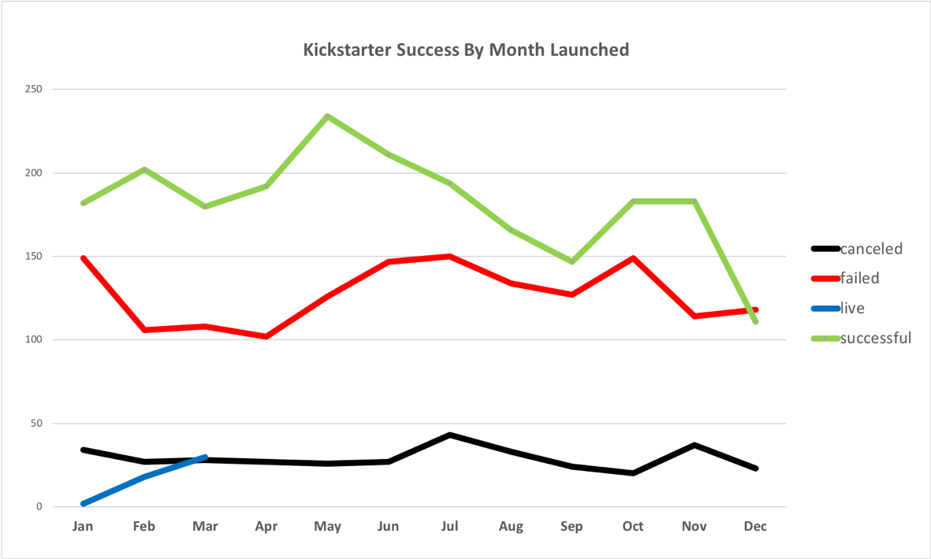

*Launch in late Spring.*

If we flatten out the years to control for Kickstarter’s relatively young lifespan so far, the average year shows about what you might expect. Successes are highest between April and July, dipping towards September as people spend more on school, followed by a brief bump in October and November, then declining precipitously across the winter holiday (Christmas and vacation spending) and through the new year.

**Chart 4 – Number of Campaigns Launched by Year**

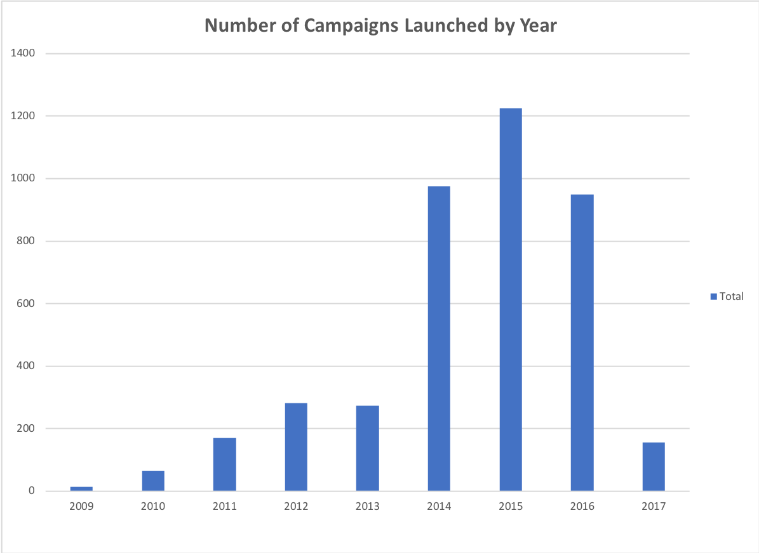

*Kickstarter hasn’t been around that long.*

This chart illustrates the relatively young life of Kickstarter, as well as the ramp up from launch of the service to strong adoption. The decline of campaign starts from 2015 to 2016 deserves more investigation.

**Chart 5 – Campaigns by Country**

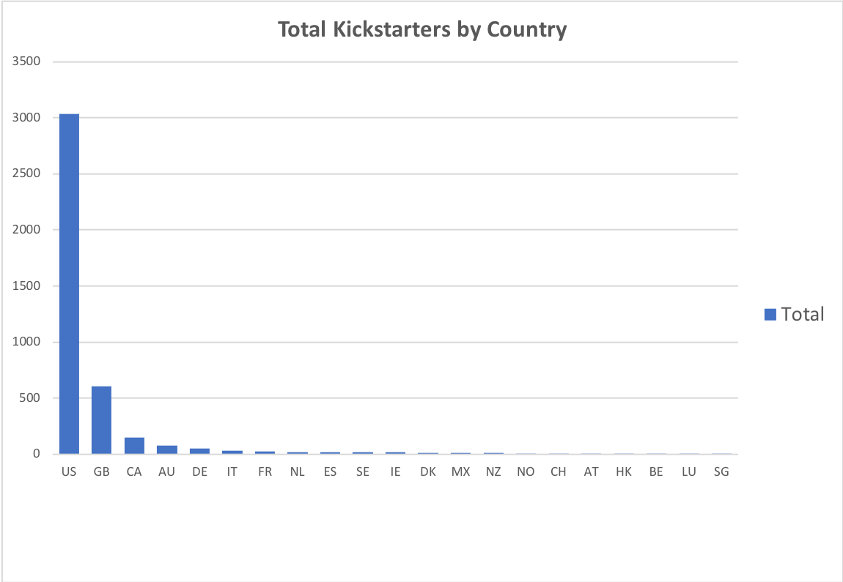

*Kickstarter is mainly a US phenomenon.*

This chart illustrates the narrow geographic distribution of the Kickstarter service, being primarily active in the US, followed by a distant second and third in Great Britain and Canada. One consequence is that most campaigns in other countries seem to fail or are cancelled, perhaps due to lack of engagement with funders (and lack of awareness in these markets). The global expansion of Kickstarter would benefit from exploring this long tail of market potential.

**BONUS: Chart 6 – Success by Funding Goal**

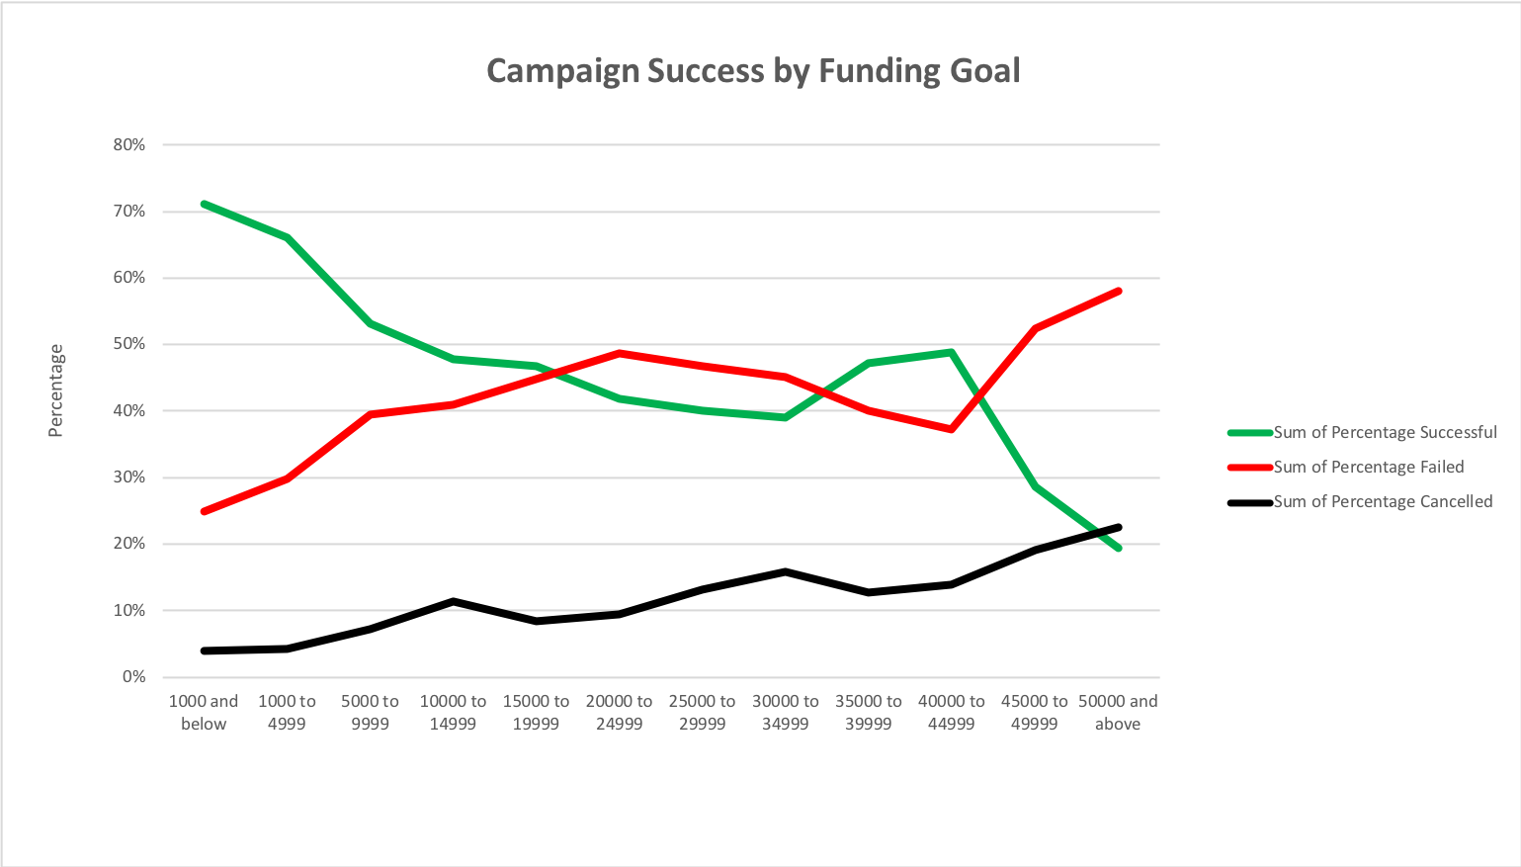

*The lowest goals have the highest rates of success.* This makes sense since it’s easier to crowdfund lower amounts of money, and also since the majority of campaigns are clustered at the low end of funding goals. Thus, it may be that more Kickstarters seek lower funding since there are more successes there. Or maybe these are just the easiest projects overall.

It should be noted that projects with funding goals between $20,000 and $40,000 enjoy a statistical bump in success rates. Cancellation rates are positively linear with higher funding goals.