Data Quality Report: Credit Card Payment

Bryce Charette

## Clean data

# Adjust column names  
colnames(dat) <- c("rec_num","card_num","date","merch_num","merch_desc",  
 "merch_state","merch_zip","trans_type","amount","fraud")  
  
# Adjust data types  
dat$rec_num <- as.character(dat$rec_num)  
dat$card_num <- as.character(dat$card_num)  
  
# Save data  
# saveRDS(dat, "card_payments.rds")

## Statistics & Distributions

### rec_num

* **Interpretation:** Unique ID for each record in the data set.
* **Type:** ID
* **Unique Values:** 95,484
* **Missing Values:** 0 (0.00%)
* **Mean:** NA
* **Standard Deviation:** NA
* **Distribution:** NA

### card_num

* **Interpretation:** Credit card number of credit card holder.
* **Type:** ID
* **Unique Values:** 1,638
* **Missing Values:** 0 (0.00%)
* **Mean:** NA
* **Standard Deviation:** NA
* **Distribution:** NA

### date

* **Interpretation:** Transaction date
* **Type:** Date
* **Unique Values:** 365
* **Missing Values:** 0 (0.00%)
* **Mean:** NA
* **Standard Deviation:** NA
* **Distribution:**  
  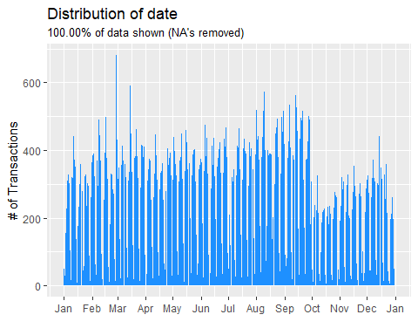

### merch_num

* **Interpretation:** Merchant ID
* **Type:** ID
* **Unique Values:** 13,091
* **Missing Values:** 3,351 (3.51%)
* **Mean:** NA
* **Standard Deviation:** NA
* **Distribution:**  
  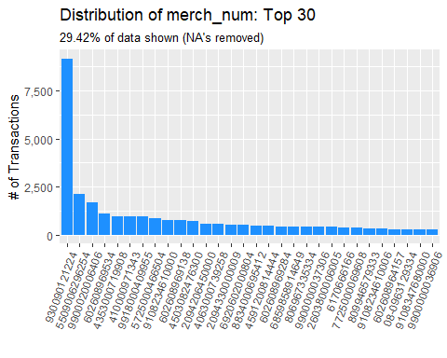

### merch_desc

* **Interpretation:** Merchant description
* **Type:** ID
* **Unique Values:** 13,125
* **Missing Values:** 0 (0.00%)
* **Mean:** NA
* **Standard Deviation:** NA
* **Distribution:**  
  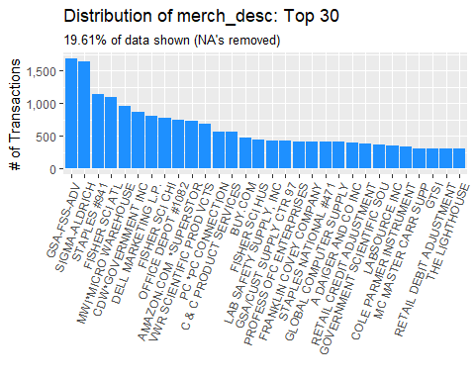

### merch_state

* **Interpretation:** Merchant state
* **Type:** Categorical
* **Unique Values:** 228
* **Missing Values:** 1,191 (1.25%)
* **Mean:** NA
* **Standard Deviation:** NA
* **Distribution:**

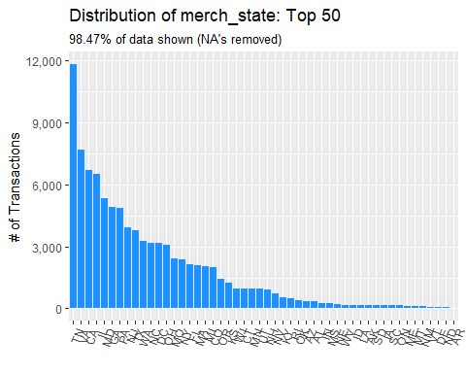

### merch_zip

* **Interpretation:** Merchant zipcode
* **Type:** Categorical
* **Unique Values:** 4,568
* **Missing Values:** 4,639 (4.86%)
* **Mean:** NA
* **Standard Deviation:** NA
* **Distribution:**

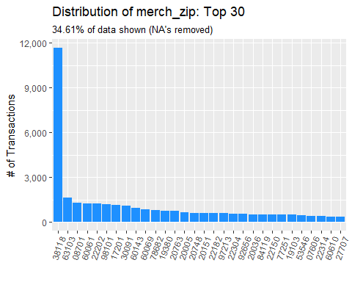

### trans_type

* **Interpretation:** Transaction type
* **Type:** Categorical
* **Unique Values:** 4
* **Missing Values:** 0 (0.00%)
* **Mean:** NA
* **Standard Deviation:** NA
* **Distribution:**

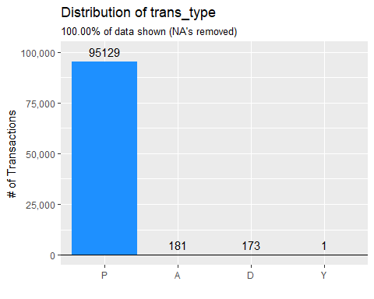

### amount

* **Interpretation:** Transaction amount in US dollars ($)
* **Type:** Numeric
* **Unique Values:** 34,190
* **Missing Values:** 0 (0.00%)
* **Mean:** $414.38
* **Standard Deviation:** $10,066.23
* **Min:** $0.01
* **Max:** $3,102,045.53
* **Distribution:**

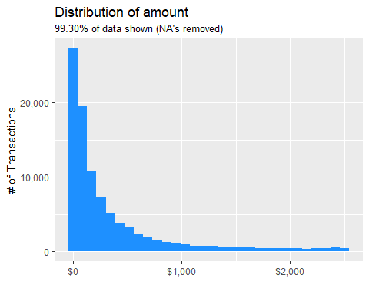

### fraud

* **Interpretation:** Indicator whether transaction is fraudulent
* **Type:** Categorical
* **Unique Values:** 2
* **Missing Values:** 0 (0.00%)
* **Mean:** NA
* **Standard Deviation:** NA
* **Distribution:**

