Question 6:

6.1

6.2

6.3

6.4

6.5

Question 7:

7.1

Mean:

[3.17942405 5.75373796]

7.2

Covariance:

[[9.23478745 5.32353749]

[5.32353749 7.34023779]]

7.3

Eigenvalues:

[13.69467278 2.88035245]

Eigenvectors:

[[ 0.76654712 -0.64218807]

[ 0.64218807 0.76654712]]

7.4

7.5

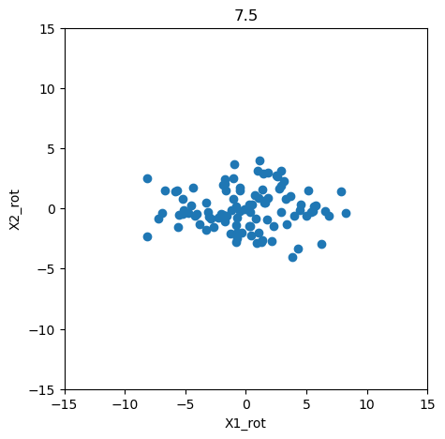

Question 8:

8.1

8.2

8.3a

8.3b

8.3c

LDA seemed to perform marginally between than QDA. Most likely because of the simplistic nature of numbers may be better suited towards numbers.

8.3d

QDA

LDA:

8.4

Kaggle Username: Christopher Avakian

Kaggle Score: 0.845

8.5

Kaggle Username: Christopher Avakian

Kaggle Score: 0.375 (Yeah I don’t know how I did that)

