Chris Baglieri
Homework #3 Part II

Sub-network #1 Analysis

Number of Nodes: 43
Number of Edges: 42
Cytoscape Image:

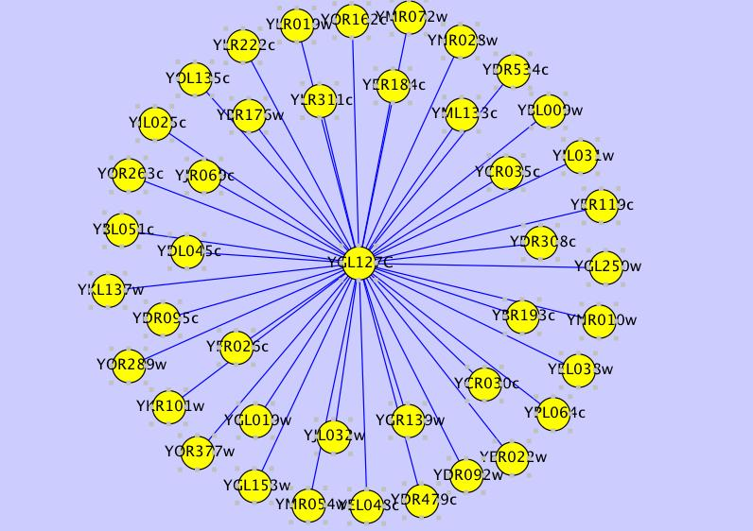

SGD Results:

Entering in the relevant genes, it was found that this network was composed of many Y2H data entries of low confidence (e.g. IST hits less than 4). There was a subset of genes that showed high relevance in Y2H data, with IST hits well over the threshold. Removing these specific genes yielded a much more accurate graph; though admittedly, given the amount of interactions removed from the data set, it’s likely that the original graph was formulated mostly on inaccurate data. In general, this cluster did not yield results that showed the same level of accordance as the second sub-network analyzed.

Sub-network #2 Analysis

Number of Nodes: 100
Number of Edges: 101
Cytoscape Image:

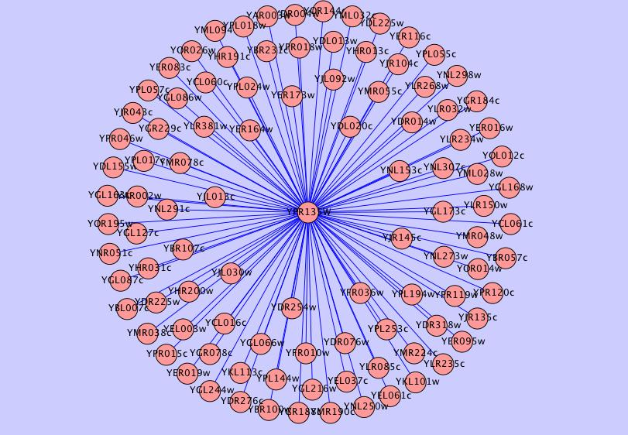

SGD Results:
As compared with the previous sub-network, this collection or PPIs seemed to exhibit much more favorable behavior. Even though the majority of the genes in this network were determined genetically, the function for most seem to be involved with DNA repair and chromatin manipulation. The hub gene of this network appears to be at the core of DNA repair functionality as further documented in the GO ontology:

YPR135W CTF4 2784 DNA repair* DNA binding nucleus*

Considering the relevance of the majority of the genes in this network, I deemed it unnecessary to remove some of the false positives (e.g. Y2H data with IST hits less than the threshold of 4).

