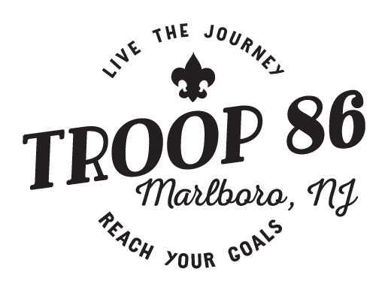

TROOP RESOURCE SURVEY

Boy Scouting is for adults as well as boys. We invite you to share your skills and interests so the best possible program can be developed for the Boy Scouts in this troop. In making this survey, the committee wishes to find ways you can enjoy using your talents to help our Scouts. Your cooperation is greatly appreciated.

Are you currently registered with the Boy Scouts of America? Yes ____ No ____

NAME: ______________________________________________________________
ADDRESS: ___________________________________________________________
E-MAIL: ______________________________________________________________
PHONE: (Home or Cell) __________________________________________________

- What is your favorite hobby?: __________________________________________

- In what Sports do you take an active part?: ________________________________

- Would you be willing to assist the Troop Leaders/Committee occasionally?: _______

4. Please check the areas in which you would be willing to help.
General Activities Special Program Assistance
Campouts I can participate in boards of review.
Hikes I have an SUV or truck. Model:
Outdoor activities I have a workshop.
Troop meetings I have family camping gear.
Swimming supervision
Accounting I have access to camping property.
Web management/design I can make contacts for special trips and activities.
Drawing/art I can help with troop equipment.
Transportation of Scouts Other: ______________________________
Transportation of equipment

5. Please check any Scouting skills you would be willing to teach.

Rope work (knots and lashings)
Conservation
Outdoor cooking
Aquatics
First aid
Knife and ax handling
Star study
Citizenship
Map and compass use
Camping

Other: __________________________________________________________

MERIT BADGES

(Check the merit badges that you can help Boy Scouts earn)

American Business
American Cultures
American Heritage
American Labor
Animal Science
Archeology
Archery
Architecture
Art
Astronomy
Athletics
Atomic Energy
Auto Mechanics
Aviation
Backpacking
Basketry
Bird Study
Bugling
Camping
Canoeing
Chemistry
Cinematography
Citizenship in the Community
Citizenship in the Nation
Citizenship in the World
Climbing
Coin Collecting
Collections
Communications
Computers
Cooking
Crime Prevention
Cycling¹
Dentistry
Disability Awareness
Dog Care
Drafting
Electricity
Electronics
Emergency Preparedness²
Energy
Engineering
Entrepreneur
Environmental Science
Family Life
Farm Mechanics
Fingerprinting
Fire Safety
First Aid
Fish and Wildlife Management
Fishing
Forestry
Gardening
Genealogy
Geology
Golf
Graphics Arts
Hiking¹
Home Repairs
Horsemanship
Indian Lore
Insect Study
Journalism
Landscape Architecture
Law
Leatherwork
Lifesaving²
Mammal Study
Medicine
Metalwork
Model Design
Motorboating
Music
Nature
Oceanography
Orienteering
Painting
Personal Fitness
Personal Management
Pets
Photography
Pioneering
Plant Science
Plumbing
Pottery
Public Health
Public Speaking
Pulp and Paper
Radio
Railroading
Reading
Reptile/Amphibian Study
Rifle Shooting
Rowing
Safety
Salesmanship
Scholarship
Sculpture
Shotgun Shooting
Skating
Skiing
Small Boat Sailing
Soil and Water Conservation
Space Exploration
Sports
Stamp Collecting
Surveying
Swimming¹
Textile
Theater
Traffic Safety
Truck Transportation
Veterinary Medicine
Water Skiing
Weather
Whitewater
Wilderness Survival
Wood Carving
Woodwork

Other skills and activities I could assist in for the older-Scout program:

Backpacking
Basketball
Bowling
Business
Cross-country skiing
Cycling
Downhill skiing
Fishing
Free-style biking
Golf
Hockey
Kayaking
Mechanics
Mountain man
Orienteering
Rafting
Rappelling
Sailing
Scuba diving
Shooting sports
Slow-pitch softball
Volleyball
Snow camping
Soccer
Spelunking
Survival
Swimming
Tennis
Video/photography
Whitewater canoeing
Windsurfing

