Doppel Voice Platform Strategy
Author: SPOK (Co-CEO) Date: January 11, 2026 Status: Strategic Planning Document Last Updated: January 11, 2026

Executive Summary
Doppel is a unified voice platform powered by Chatterbox (open-source voice cloning). All voices - both “house voices” and user-uploaded clones - run through the same engine, giving every voice full emotion and pacing controls.
Key Insight: We don’t need Polly/Twilio as runtime providers. We use Chatterbox for everything, with curated voice samples as the “off-the-shelf” options.

Architecture Evolution

Before: Fragmented Architecture (V1)
Our platform started with three separate voice backends - a maintenance nightmare with inconsistent capabilities and redundant costs.
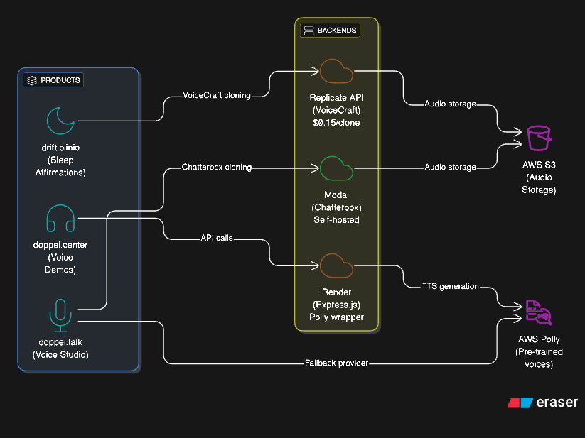
V1 Original Architecture - Fragmented
Problems with V1: - 3 different voice backends to maintain - Paying for both Replicate AND Modal - doppel.center was redundant - No shared infrastructure - Inconsistent capabilities across products

After: Unified Architecture (V2)
We consolidated everything into a single Chatterbox-powered backend on Modal.
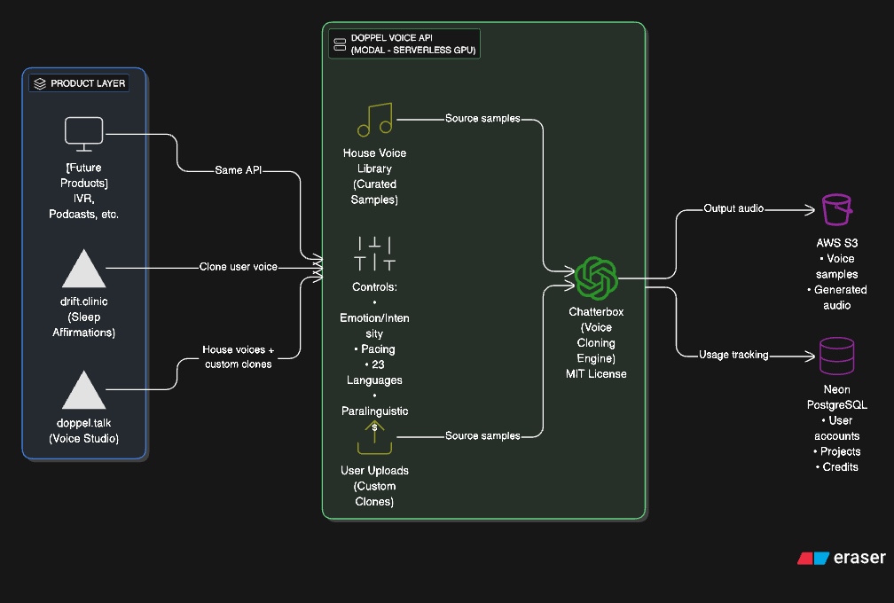
V2 Unified Architecture
V2 Benefits: - ALL products use the same Chatterbox API on Modal - House voice library with curated samples and full controls - User uploads with custom clones and full controls - Retired: VoiceCraft, Replicate, doppel.center API, Polly runtime

Part 1: The Product Layer Concept

Philosophy
Multiple products can serve different market needs while sharing a single, scalable voice infrastructure. Product teams focus on UX and market fit; the voice API handles the heavy lifting.

Why This Works
- Product teams stay focused - drift.clinic only cares about sleep affirmations, not GPU infrastructure
- Backend scales independently - Modal handles auto-scaling, cold starts, GPU allocation
- Shared R&D - Improvements to voice quality benefit all products simultaneously
- Cost efficiency - One infrastructure to maintain, not three
- Consistent capabilities - Every voice (house or custom) has emotion/pacing controls

Product Examples
Product | Market Problem | Voice Feature Used
drift.clinic | Self-talk affirmations feel fake in someone else’s voice | Clone user’s voice → affirmations feel authentic
doppel.talk | Content creators need quick, quality voiceovers | House voices + custom cloning, all with emotion controls
[Future] | Podcasters want consistent AI co-hosts | Clone a persona, generate episodes
[Future] | IVR systems need accessible, adjustable voices | House voices with pace/diction controls for accessibility

Part 2: Voice Engine Architecture

Single Engine, Two Voice Sources
ALL voice generation runs through Chatterbox. The difference is where the voice sample comes from:

Source 1: House Voice Library (Pre-loaded)
Curated voice samples stored in S3. Users pick from a dropdown.
- 9 voices currently loaded (Matthew, Joanna, Ruth, Stephen, Amy, Brian, Emma, Ivy, Joey)
- Full emotion/pacing controls on every voice
- No upload required - instant access
- Use case: Quick generation, professional content, demos

Source 2: User Voice Uploads (Custom)
Users upload their own voice sample. Chatterbox clones it.
- 10-15 second sample is all that’s needed
- Full emotion/pacing controls (same as house voices)
- Personal/brand voices - user owns the source
- Use case: Personalized content, brand voices, accessibility

Why NOT Polly/Twilio as Runtime Providers
We originally planned to offer Polly/Twilio as fallback options. We’re not doing that anymore.
Aspect | Polly/Twilio Direct | Chatterbox from Sample
Emotion control | No | Yes
Pacing control | Limited (SSML) | Yes - native slider
Voice consistency | Fixed | You control the source
Licensing | Gray area if cloning | Clean (own your samples)
Cost | Per-character API fees | Self-hosted GPU
Decision: Use Polly-generated samples as seed recordings for house voices, then retire the runtime dependency. Eventually replace with royalty-free/open-source samples for cleaner licensing.

Part 3: Tech Evolution - VoiceCraft to Chatterbox

Why We Started with VoiceCraft
VoiceCraft (2024) was a breakthrough academic paper demonstrating: - Zero-shot voice cloning from seconds of audio - Speech editing (surgically changing words in recordings) - State-of-the-art quality on “in-the-wild” audio
drift.clinic was prototyped using VoiceCraft via Replicate API (~$0.15/clone).

Why We Moved to Chatterbox
Chatterbox (Resemble AI, 2025) is the production-grade evolution:
Aspect | VoiceCraft | Chatterbox
Origin | Academic research | Commercial open-source
Speed | Multi-step diffusion (slow) | Single-step Turbo model (fast)
Emotion Control | No | Yes - intensity slider
Languages | Limited | 23 out of the box
Paralinguistics | No | [laugh], [cough], [sigh]
Watermarking | No | Built-in (Perth)
License | Research/academic | MIT (fully commercial)
Production-ready | Needs work | Yes
Maintenance | Minimal updates | Active development

What We Lose
VoiceCraft’s unique speech editing capability - changing specific words in existing audio while preserving voice. Chatterbox doesn’t do this.
Assessment: None of our current products need speech editing. We generate fresh audio, we don’t edit existing recordings. Acceptable tradeoff.

Decision
Standardize on Chatterbox. Retire VoiceCraft dependency.

Part 4: Current Stack & What Gets Retired

Current State
Component | Status | Details
doppel.talk | ✅ Working | Chatterbox on Modal, 9 house voices in S3, user upload supported
drift.clinic | Needs migration | VoiceCraft via Replicate (paid API)
doppel.center | To be retired | Express.js on Render, AWS Polly only

Target State
All products route through a single Doppel Voice API on Modal, with AWS S3 for storage and Neon PostgreSQL for usage tracking.

What Gets Retired
Asset | Current Use | Action
doppel.center API | Polly wrapper on Render | Retire - redundant
voice-demos.doppel.center | Demo frontend | Keep or migrate - samples now in doppel.talk S3
VoiceCraft/Replicate | drift.clinic voice | Retire - migrate to Chatterbox
Polly/Twilio runtime | doppel.talk fallback | Retire - not needed, Chatterbox handles all

Part 5: Migration Plan

Phase 1: Stabilize doppel.talk ✅ COMPLETE
Status: Done (January 11, 2026)
- Fix Modal proxy auth credentials
- Redeploy Modal backend
- Verify Chatterbox endpoint works
- Upload house voice samples to S3 (9 voices)
- Update UI to use new voice samples
- Enable S3 public read access for audio playback
- Test end-to-end voice generation in browser
- Verify playback and download work
Outcome: doppel.talk fully functional with voice cloning

Phase 2: Expand House Voice Library
Goal: Build a proper voice library with clean licensing
- Source royalty-free voice samples (LibriVox, Common Voice, etc.)
- Curate 15-20 diverse voices (gender, accent, tone variety)
- Upload to S3 and update UI
- Remove Polly-sourced samples (licensing gray area)
- Add voice preview/audition feature
Outcome: Professional voice library with clean licensing

Phase 3: Expose Unified API
Goal: Make the Modal endpoint a proper API that any product can call
- Document API endpoints and auth
- Add rate limiting / usage tracking
- Create API keys for different products
- Set up monitoring/alerting
Outcome: api.doppel.talk or similar - single voice API

Phase 4: Migrate drift.clinic
Goal: Move drift.clinic from VoiceCraft/Replicate to Chatterbox/Modal
- Update drift.clinic to call Doppel Voice API
- Test voice cloning quality matches expectations
- Remove Replicate dependency
- Update cost projections (Modal vs Replicate)
Outcome: drift.clinic running on shared infrastructure

Phase 5: Retire doppel.center
Goal: Shut down redundant infrastructure
- Verify no active users/integrations depend on doppel.center API
- Archive voice-demos frontend (samples already migrated)
- Shut down Render deployment
- Update DNS / retire domain or redirect
Outcome: One less thing to maintain

Phase 6: Documentation & Handoff
Goal: Anyone can understand and extend the platform
- Architecture documentation
- API reference
- “How to add a new product” guide
- Cost analysis and projections

Part 6: Technical Reference

API Endpoint
URL: https://chris-9774--doppel-talk-texttospeechserver-generate-speech.modal.run
Auth Headers:
Modal-Key: [REDACTED - See credentials store]
Modal-Secret: [REDACTED - See credentials store]
Provider: chatterbox (only provider needed now)

Request Schema
{
"text": "Hello world",
"provider": "chatterbox",
"language": "en",
"voice_s3_key": "samples/voices/polly-matthew-neural.mp3",
"exaggeration": 0.5,
"cfg_weight": 0.5
}

Response Schema
{
"success": true,
"s3_Key": "tts/uuid.wav",
"audioUrl": "https://doppel-talk.s3.us-east-1.amazonaws.com/tts/uuid.wav",
"provider": "chatterbox",
"voiceId": null,
"duration": 3.5,
"error": null,
"code": null
}

S3 Bucket Structure
s3://doppel-talk/
├── samples/voices/ # House voice library (source samples)
├── tts/ # Generated audio output
└── uploads/ # User-uploaded voice samples

Infrastructure
Component | Service | Cost Model
Voice API | Modal | GPU-seconds (~$0.0003/sec on L40S)
Frontend (doppel.talk) | Vercel | Free tier / usage
Frontend (drift.clinic) | Vercel | Free tier / usage
Audio Storage | AWS S3 | ~$0.023/GB/month + public read
Database | Neon PostgreSQL | Free tier / usage

Current House Voices
Name | Gender | Accent
Matthew | Male | American
Joanna | Female | American
Ruth | Female | American
Stephen | Male | American
Amy | Female | British
Brian | Male | British
Emma | Female | British
Ivy | Female | American
Joey | Male | American

Appendix: Glossary
Term | Definition
Voice Cloning | Creating a synthetic voice from a sample recording
TTS (Text-to-Speech) | Converting written text to spoken audio
Chatterbox | Open-source voice cloning model by Resemble AI (MIT license)
VoiceCraft | Academic voice cloning model (predecessor tech, being retired)
House Voice | Pre-loaded voice sample in our library (not user-uploaded)
Modal | Serverless GPU platform for ML workloads
Zero-shot | No training required - works from a single sample
Exaggeration | Chatterbox parameter controlling emotional intensity
CFG Weight | Chatterbox parameter controlling generation accuracy vs creativity

Document generated by SPOK. Review and update as architecture evolves.
Last converted for publication: January 11, 2026

