# Modern Defence Strat

# Defaults

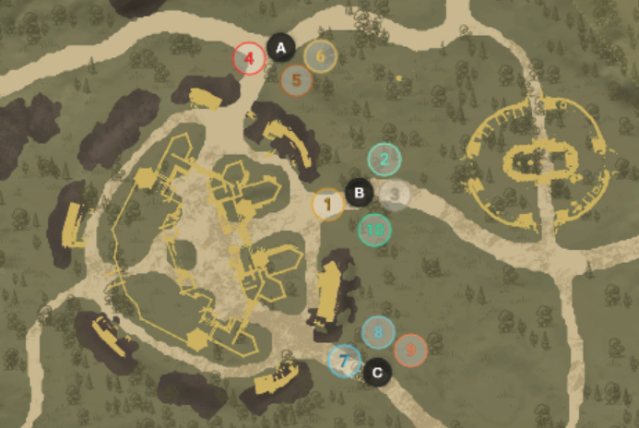

A

* Group 4 – anchor group consists of 2 healers, 1 heavy, 2 dps (one dps being void/ice); if A is empty 1 healer and 1 heavy are the “anchors” they will call # of enemies and are free to call for group 4 if there is five enemies, group 4 & 5 is there is ten enemies or they can call A defaults which means group 4-6 should be on A; If A needs more help they will call the # of flex groups needed
* Group 7 – anchor group consists of 2 healers, 1 heavy, 2 dps (one dps being void/ice); if C is empty 1 healer and 1 heavy are the “anchors” they will call # of enemies and are free to call for group 7 if there is five enemies, group 7 & 8 is there is ten enemies or they can call C defaults which means group 7-9 should be on C; If C needs more help they will call the # of flex groups needed
* Group 1 – consists of 1 healer & 1 heavy that are “anchors” the other 3 members are dps and considered flex 1; B calls how many are there but let the main shot caller say which groups go where
* Group 2 – default B, but known as flex 2
* Group 3 – default B, but known as flex 3
* Group 10 – dex users / one shot builds, maybe one healer; rotate as needed
* Main shot caller will listen to number called by A & C anchors and will rotate flex as needed or call for some of A & C defaults to help B if needed
* If the main shot caller said every go to defaults it would like the picture above
* Main shot caller relied on good information from point callers to ensure we had the numbers where they were
* The anchors for A & C (healer and heavy) were the ones to grab repair parts, 300 parts are available as the match starts and as you die they would make sure to grab them periodically

# Comp (server dependent)

* 11-13 healers; typically 12 on defence
  + 1 in each group and 2 in the anchor groups of A & C
* 0-3 dex; they hated dex for a long time but started slotting 1-2 muskets and maybe 1 bow at the end
* 3-5 FS/IG mages
* 9-12 VG/IG mages (2-3 were heavy and on point)
* 16-20 Bruiser (with 2-3 heavy)
* 0-4 One shot builds (bb/sns, hammer/sns, hatchet/sns, etc)

# Fort

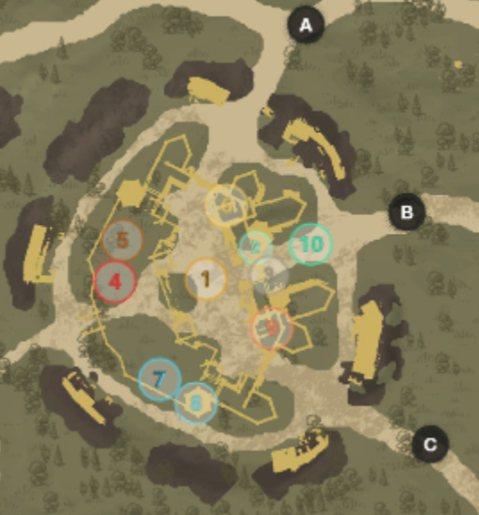

* Group 1 – would stay on point 100% if there was influence
* Group 2 & 3 – would fight up top or around point if needed, as well as assist on front respawns if close
* Group 4 & 5 – responsible for back ramparts and A anchors would try and keep that door up as much as possible and maybe repair front gates if able
* Group 6 – front respawns
* Group 7 & 8 - responsible for back ramparts and C anchors would try and keep that door up as much as possible and maybe repair front gates if able
* Group 9 – front respawns
* Group 10 – upper ramparts killing range & healers
* The back ramparts seem to have the most people so we had two groups at each
* If there was point presence some people would leave respawns as needed to get influence down but you never want to leave respawns unattended (fort is taken with 1-2 good respawns kills especially later on with longer respawns)