2kDrive –a quick SUMMARY with examples
2kDrive is a mobile application and game (currently on soft launch in the Netherlands and the United Arab Emirates). Whilst all 3D game functionality is running in native code, career paths, shopping baskets, user profiles, news feeds, news articles are all buillt in HTML5/CSS3/Javascript. Often the HTML will overlay a view the game (for instance in the garage and showroom) allowing the user to both gesture navigate through the 3d engine (e.g. rotate a vehicle) and interface with, for instance, a shopping cart or simply make choices from HTML menu’s etc (see Figure 1).
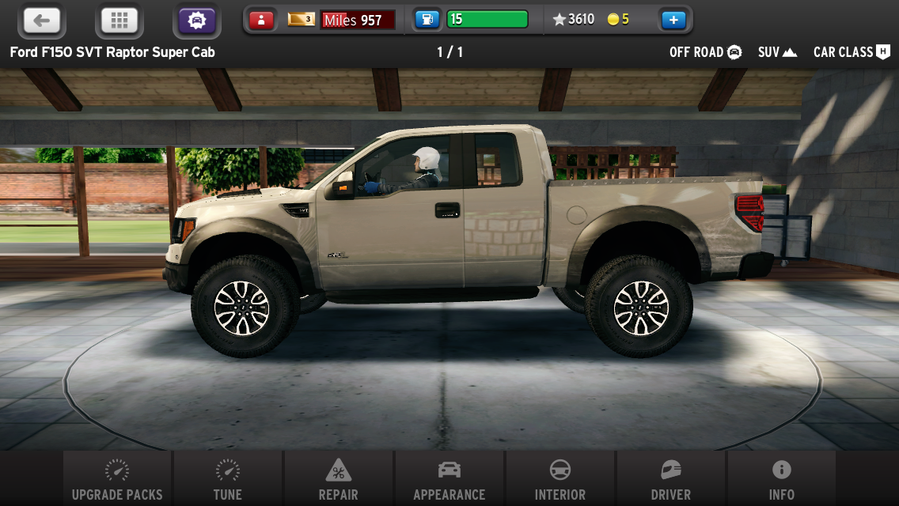
Figure 1: The ‘garage’ view: The user can rotate/zoom/manipulate the car in the foreground. Which is running in the game’s 3d engine. The navigation, profile bar and vehicle summary at the top as well as the ‘main’ actions bar at the bottom are all HTML overlaid above the game layer. Communication takes place via an asynchronous json bridge between the WebView and the game/game database
The project itself had the advantage of targeting iOS and subsequently Android devices and thus allowed for extensive use of the latest web technologies available in browsers such as Safari/Chrome (webkit) and Firefox. Since the game is ultimately going to be available on a number of platforms running in a variety of resolutions a responsive approach was to be taken additionally down the line it was possible that a variety of ‘skins’ might be used.
This resulted in maximizing the use of CSS3 gradients, borders, multiple background-images, background-image scaling and SVG images:
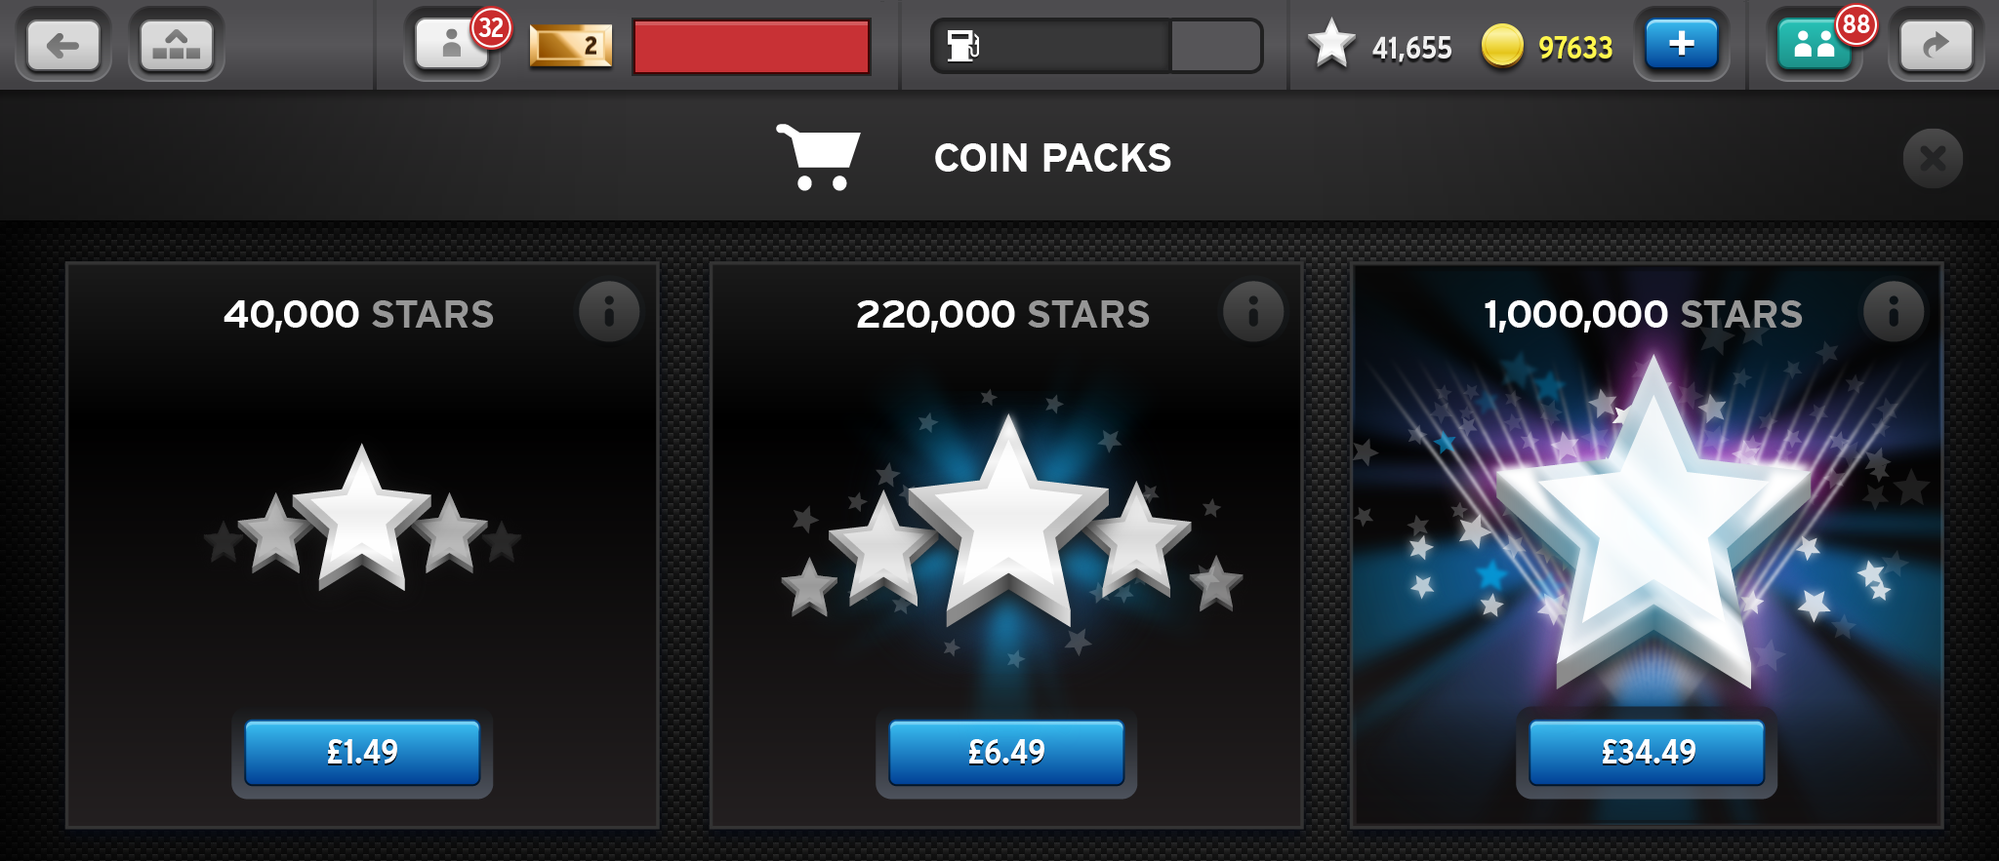
Figure 2: A pure ‘HTML’ view, there are very few bitmap images in this shopping cart view. The buttons are all created using CSS3 gradient, borders, blurs and drop shadows .The icons are all SVGs placed with CSS. The large pronounced stars are single SVGs with bitmaps embedded in this instance – originally they were built using CSS3 and simple SVGS but the end result was a little too flat/Web 2.0 for one of the game’s most important call to actions.
Of course developing for mobile platforms may release the HTML developer from plenty of cross-browser issues but it introduces new problems often at the platform level. One little problem we experienced (and not uncommon) is that due to the order of touch events on iOS clicks are the last event to be fired (after touch start, move and end) thus in many places a web app can feel unresponsive, buttons clicked twice by the impatient and the screen twitching scrolling when a finger presses down at a slight angle.
A number of strategies are employed to solve this – google use a specific class on their elements to force a quick click (that fires on touch start) and other third party tools jquery mobile and sencha touch have different solutions. However I wanted a ‘catch all’ solution that wouldn’t require constant adjustment depending on the context and tools in place. So I came up with an event capturing approach at the top level that blocked/adjusted and released events to the application in a more consistent fashion. It also created a new event – touchhold for when a user presses and holds on a particular element (this could be used for drag and drop behavior or overriding the native platform behavior of press hold (context menu appearance usually).
The basic logic of the code was that if a user touches and releases the pad at high speed/and or with little movement the click event is dispatched immediately and the click that would usually occur after a 20-200ms delay is suppressed. My first run at the code is below but the end code is a little more sophisticated. For instance its tolerances for movement are based on the orientation/aspect ratio of the device and it introduces some compensation for differences in motion detection on a phone size device against a larger tablet.

function TouchTracker(target) {
this.target = target||this.target;
this.target.addEventListener("touchstart", this,true);
this.target.addEventListener("touchend", this,true);
this.target.addEventListener("click", this,true);
this.target.addEventListener("touchmove", this,true);
}
TouchTracker.prototype = {
cancelClickDistance: 80,
pressLength: 1000,
currentDistance: 0,
moving: false,
handleEvent: function (event) {
switch (event.type) {
case "touchmove": this.checkMove(event); break;
case "touchstart" : this.addStartTouch(event); break;
case "touchend" : this.addEndTouch(event); break;
case "click": if (this.clicked) {
event.stopPropagation();
event.preventDefault()
}
}
return false
},
addStartTouch: function (touchStartEvent) {
this.startX = this.currentX = touchStartEvent.changedTouches[0].clientX;
this.startY = this.currentY = touchStartEvent.changedTouches[0].clientY;
this.currentElement = touchStartEvent.target;
this.clicked = false;
this.touchStartEvent = touchStartEvent;
this.touchEndEvent
this.startTime = touchStartEvent.timeStamp
},
addEndTouch: function (touchEndEvent) {
this.currentX = touchEndEvent.changedTouches[0].clientX;
this.currentY = touchEndEvent.changedTouches[0].clientY;
if (this.insideTolerance()) {
this.simulateClick(touchEndEvent);
if (this.touchStartEvent.timeStamp+this.pressLength<=touchEndEvent.timeStamp) {
this.dispatchTouchHold(touchEndEvent.changeTouches[0])
}
} else {
this.dispatchBespokeTouchEnd(touchEndEvent.changeTouches[0]);
}
this.clicked = false;
this.moving = false;
this.touchEndEvent = touchEndEvent;
},
insideTolerance: function () {
var x = this.currentX-this.startX,
y = this.currentY-this.startY;
return this.cancelClickDistance > Math.sqrt((x*x)+(y*y))
},

checkMove: function (event) {
this.currentX = event.changedTouches[0].clientX;
this.currentY = event.changedTouches[0].clientY;
if (this.insideTolerance()) {
this.moving = false
} else if (!this.moving) {
var evt = document.createEvent("MouseEvents");
evt.initMouseEvent("touchtracker.movestart", true, true, window, event.detail, event.screenX, event.screenY, event.clientX, event.clientY, false, false, false, false, 0, null);
this.currentElement.dispatchEvent(evt);
this.moving = true;
}
},
simulateClick: function (event) {
this.clicked = true;
var evt = document.createEvent("MouseEvents");
evt.initMouseEvent("click", true, true, window, event.detail, event.screenX, event.screenY, event.clientX, event.clientY, false, false, false, false, 0, null);
this.currentElement.dispatchEvent(evt);
this.moving = false;
},
dispatchBespokeTouchEnd: function (event) {
var evt = document.createEvent("MouseEvents");
evt.initMouseEvent("touchtracker.touchend", true, true, window, event.detail, event.screenX, event.screenY, event.clientX, event.clientY, false, false, false, false, 0, null);
this.currentElement.dispatchEvent(evt);
},
dispatchTouchHold: function (event) {
var evt = document.createEvent("MouseEvents");
evt.initMouseEvent("touchtracker.touchhold", true, true, window, event.detail, event.screenX, event.screenY, event.clientX, event.clientY, false, false, false, false, 0, null);
this.currentElement.dispatchEvent(evt);
},
destroy: function () {
this.target.removeEventListener("touchstart", this);
this.target.removeEventListener("touchend", this);
this.target.removeEventListener("click", this);
this.target.removeEventListener("touchmove", this);
}
}
Code 1: A code spike to create an object that can tweak touch events to allow for a more responsive experience on touch devices. Shows a disappointing lack of comments it was simply proof of concept

A very different and more critical problem that required a lot of research and investigation can be summarized thus:
The ipad and iphone has some major issues of memory management and rendering performance when it comes to image rendering (due to their high resolution displays). In fact resources are used to render images even when they are off screen. There is also a ‘canvas’ size that you should avoid your code to exceed. The browsers natively compensate by blanking out images after a certain threshold is reached but this only occurs for img tags. Applying images via background image CSS is not memory managed at all and its relatively easy to crash things simply by having a few photo quality images in the same area. There are also a number of issues regarding flickering, GPU/CPU rendering and simple size of the DOM that need to be borne in mind. We came up with a number of strategies to deal with /avoid these problems but it’s worth noting that many projects have moved from HTML5 to native implementations when hitting these problems.

Finally, besides introducing a number of more OO/Design pattern based approaches and refactoring the codebase considerably, I introduced a template based approach (using ejs but I’d probably use underscore/backbone in the future) for markup to allow a simple MV* approach to the app by combining this with some nice CSS etc we created some nice reusable ‘widgets’ that could be dropped in anywhere across the app. If you look at the three figures in this document you’ll see they all have a profile/wallet element in the header (look for the fuel symbol the gold ingot, the stars and coins counters and the large blue plus button (‘buy’). You’ll note that in different contexts they are varied in size and which elements are visible or exaggerated etc this is purely controlled through CSS. Not rocket science of course but, when real estate is a premium, developing responsive/reusable/resizeable/context sensitive widgets always feels an achievement.

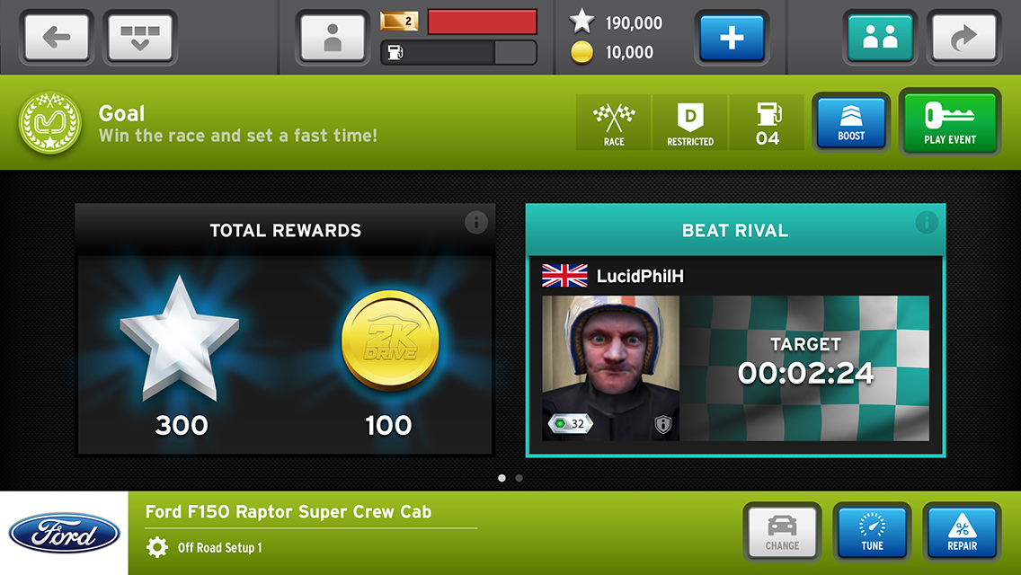
Figure 3: Another screen shot with a lot more CSS buttons, SVG icons, re-used components and how just because you have a camera in your phone or table you shouldn’t necessarily use it.

