**Summative Assessment | Kickstarter**

**Q25 Template**

Based on your analysis of the Kickstarter dataset, and within the given scenario, record your most interesting finding in the following format:

1. Finding
2. Supporting Visualisation
3. Explanation
4. Relevance
5. Context/Assumptions

**Example:**

**Finding**: The most successful year for Kickstarter projects was 2015

**Explanation:**

The success rate peaked in 2013 at 30.99% before dropping the next two years to 20.45% in 2015, before rising slightly in 2016. The success rate in 2016 at 22.92% is still lower than the average of 24.28% for 2012-2016, which indicates the overall success rate is dropping over time.

**Relevance.** It is important for both owners and backers for projects over USD 10,000 to get a sense of the likelihood of success and how this has changed over time.

**Context/Assumptions:** Perhaps further analysis is required to determine why the success rate for 2013 was so high. e.g. economic factors, the quality of the launched projects. Note that as per the given dataset, this is for projects with the goal amount of over $10,000 USD. Projects with goal amounts under $10K may have a higher rate of success.

**Please provide your finding below:**

**Finding:**

Amount of money pledged and the number of successful Kickstarters has a high degree of correlation with a sharp drop of both in December.

**Visualisation**

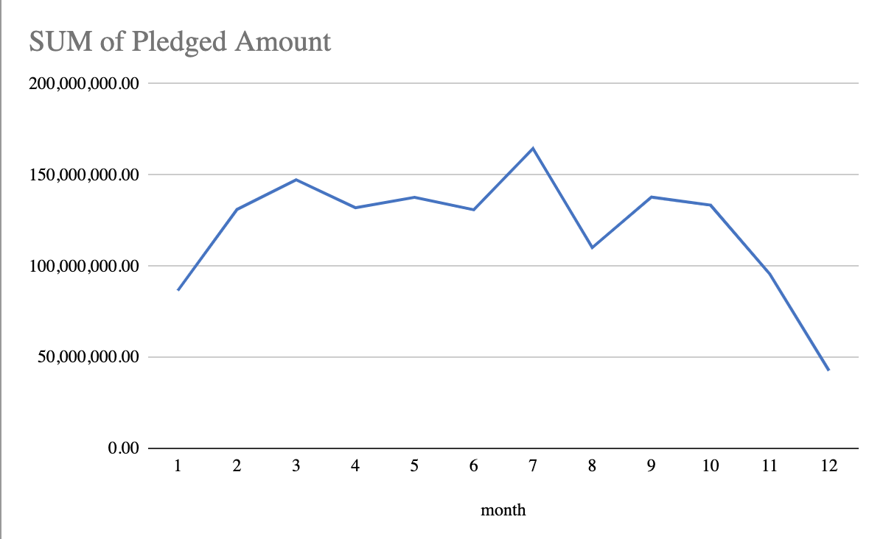

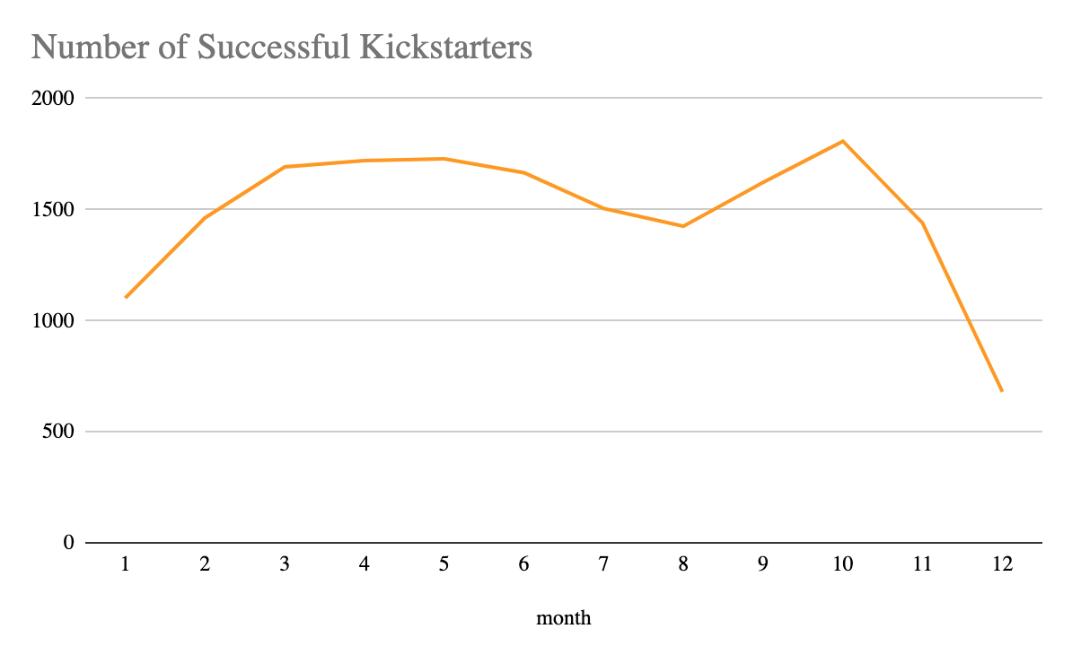

**Explanation:**

There is a very large spike in the amount pledged in July, as the number of successful Kickstarter campaigns is actually decreasing. Suggesting that while fewer Kickstarter campaigns are being funded, those that are successful receive a large amount of funds per campaign versus the rest of the year.

**Relevance:**

The spike in actual dollars pledged in July versus the lower number of successful Kickstarter campaigns could point to the summer being an advantageous time to launch a high-profile Kickstarter that requires a large goal dollar amount in order to succeed.

**Context/Assumptions:**

As the data is drawn from the US we can make assumptions that during the mid-summer months children are less likely to be in school or organized sports. This gives parents more spending power as they aren’t devoting resources to things like school and sports supplies. Further analysis and data showing consensus data of who is contributing to the Kickstarter campaigns would be invaluable.