**The faithfull Shepheardesse.**

**Actus primi, Scena prima.**

*Enter Cl•rin a Shepheardesse hauing buried her loue in an Arbour.*

HAile holy earth, whose colde armes do embrace  
The truest man that euer fed his flockes:  
By the fat plaines of fruitfull Thessaly,  
Thus I salute thy graue, thus do I pay  
My early vowes and tribtute of mine eies,  
To thy still loued ashes: thus I free  
My selfe from all ensuing heates and fires  
Of loue, all sports, delights and games,  
That Shepheards hold full deares thus put I off.  
Now no more shall these smooth browes be gi•t,  
With youthfull coronals, and lead the dance,  
No more the company of fresh faire Maids  
And wanton shepheards be to me delightfull.  
Nor the shrill pleasing sound of merry pipes,  
Vnder some shady dell• when the coole winde  
Plaies on the leaues, all be farre away:  
Since thou art farre away: by whose deare side,  
How often haue I sat crownd with fresh flowers  
For Summers queene, whilst euery Shepheards boy•  
Puts on his lustly greene with gaudy hooke,  
And hanging scrippe o• finest cordeuan:  
But thou art gone, and these are gone with thee,  
And all are dead but thy deare memorie:  
That shall outliue thee, and shall euer spring,  
Whilst there are pipes, or Iolly shepheards sing.

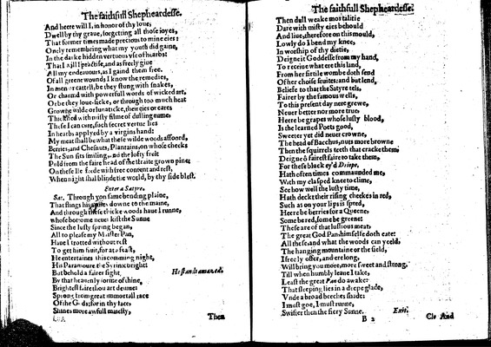

Image 6 (unnumbered page)

And heere will I, in honor of thy loue,  
Dwell by thy graue, forgetting all those ioyes,  
That former times made precious to mine eies:  
Onely remembring what my youth did gaine,  
In the darke hidden vertuous vse of hearbs:  
That I will I practise, and as freely giue  
All my endeauours, as I gaind them free.  
Of all greene wounds I know the remedies,  
In men or cattell, be they stung with snakes,  
Or charmd with powerfull words of wicked art,  
Or be they loue-sicke, or through too much heat  
Growne wilde or lunaticke, their eies or eares  
Thickned with misty filme of dulling rume,  
These I can cure, such secret vertue lies  
In hearbs applyed by a virgins hand:  
My meat shall be what these wilde woods affoord,  
Berries, and Chesnuts, Plantains, on whose cheeks  
The Sun sits smiling, and the lofty fruit  
P•ld from the faire head of the straite grown pine:  
On these Ile feede with free content and rest,  
When night shal blinde the world, by thy side blest.

*Enter a Satyre.*

***Sat.***

Through yon same bending plaine,  
That flings his armes downe to the maine,  
And through these thicke woods haue I runne,  
whose bot•ome neue• kist the Sunne  
Since the lusty spring began,  
All to please my M•ister Pan,  
Haue I trotted without rest  
To get him fruit, for at a feast,  
He entertaines this comming night,  
His Paramoure the Syrinx bright:  
But behold a fairer sight•

*He stands amazed.*

By that heauenly forme of thine,  
Brightest faire thou art deuine:  
Sp•ong from great immortall race  
Of the G•ds: for in thy face,  
Shines more awfull maiesty,

Unnumbered page  
  
Then dull weake mortalitie  
Dare with misty eies behould  
And liue, therefore on this mould,  
Lowly do I bend my knee,  
In worship of thy dietie,  
Deigne it Goddesse from my hand,  
To receiue what ere this land,  
From her firtile wombe doth send  
Of her choise fruites: and but lend,  
Beliefe to that the Satyre tels,  
Fairer by the famous wells,  
To this present day nere grewe,  
Neuer better nor more true,  
Heere be grapes whose lusty blood,  
Is the learned Poets good,  
Sweeter yet did neuer crowne,  
The head of Bacchus, nuts more browne  
Then the squirrels teeth that cracke them,  
Deigne ô fairest faire to take them,  
For these black ey'd *Driope,*  
Hath often times commaunded me,  
With my clasped knee to clime,  
See how well the lusty time,  
Hath deckt their rising cheekes in red,  
Such as on your lips is spred,  
Heere be berries for a Queene,  
Some be red, some be greene:  
These are of that lussious meat,  
The great God Pan, himselfe doth eate:  
All these, and what the woods can yeeld,  
The hanging mountaine or the field,  
I freely offer, and ere long,  
Will bring you more, more sweet and strong.  
Till when humbly leaue I take,  
Least the great *Pan* do awake:  
That sleeping lies in a deepe glade,  
Vnde a broad beeches shade:  
I must goe, I must runne,  
Swifter then the fiery Sunne.

*Exit.*

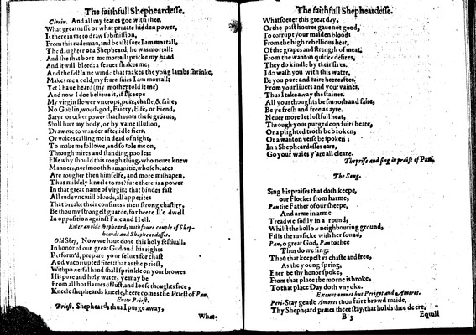

Image 7 (unnumbered page)

***Clorin.***

And all my feares goe with thee.  
What greatnesse or what priuate hidden power,  
Is there in me to draw submission,  
From this rude man, and beast? sure I am mortall,  
The daughter of a Shepheard, he was mortall:  
And she that bore me mortall: pricke my hand  
And it will bleed: a feauer shakes me,  
And the selfsame winde that makes the yoūg lambs shrinke,  
Makes me a cold, my feare saies I am mortall:  
Yet I haue heard (my mother told it me)  
And now I doe belieue it, if I keepe  
My virgin flower vncropt, pure, chaste, & faire,  
No Goblin, wood-god, Faiery, Elfe, or Fiend,  
Satyr or other power that haunts these groaues,  
Shall hurt my body, or by vaine illusion,  
Draw me to wander after idle •iers.  
Or voices calling me in dead of night,  
To make me followe, and so tole me on,  
Through mires and standing pooles:  
Else why should this rough thing, who neuer knew  
Manners, nor smooth humanitie, whose heates  
Are rougher then himselfe, and more mishapen,  
Thus mildely kneele to me? sure there is a power  
In that great name of virgin; that bindes fast  
All rude vnciuill bloods, all appetites  
That breake their confines: then strong chastity,  
Be thou my strongest guarde, for heere Il'e dwell  
In opposition against Fate and Hell.

*Enter an olde shepheard, with foure couple of Shepheards and Shepheardess•s.*

***Old Shep.***

Now we haue done this holy festiuall,  
In honour of our great God, and his rights  
Perform'd, prepare your selues for chast  
And vncorrupted fires: that as the priest,  
With powerful hand shall sprinkle on your browes  
His pure and holy water, ye may be  
From all hot flames of lust, and loose thoughts free,  
Kneele shepheards kneele, heere comes the Priest of *Pan.*

*Enter Priest.*

***Priest.***

Shepheards thus I purge away,

Unnumbered page  
  
Whatsoeuer this great day,  
Or the past houres gaue not good,  
To corrupt your maiden blood:  
From the high rebellious heat,  
Of the grapes and strength of meat.  
From the wanton quicke desires,  
They do kindle by their fires.  
I do wash you with this water,  
Be you pure and faire heereafter.  
From your liuers and your vaines,  
Thus I take away the staines.  
All your thoughts be smooth and faire,  
Be ye fresh and free as ayre.  
Neuer more let lustfull heat,  
Through your purged conduits beate,  
Or a plighted troth be broken,  
Or a wanton verse be spoken:  
In a Shepheardesses eare,  
Go your waies y'are all cleare.

*They rise and sing in praise of Pan.*

**The Song.**

Sing his praises that doth keepe,  
our Flockes from harme,  
*Pan* the Father of our sheepe,  
And arme in arme  
Tread we softly in a round,  
Whilst the hollow neighbouring ground,  
Fills the musicke with her sound,  
*Pan,* o great God, *Pan* to thee  
Thus do we sing:  
Thou that keepest vs chaste and free,  
As the young spring,  
Euer be thy honour spoke,  
From that place the morne is broke,  
To that place Day doth vnyoke.

*Exeunt omnes but Perigot and Amoret.*

***Peri.***

Stay gentle *Amoret* thou faire browd maide,  
Thy Shepheard praies theee stay, that holds thee de ere.

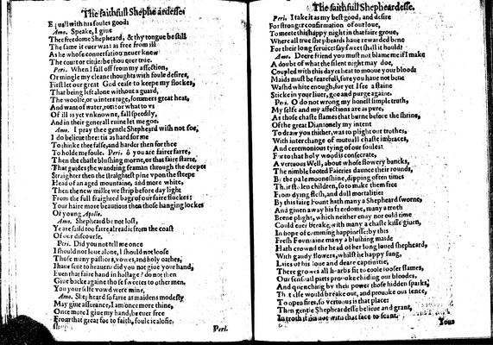

Image 8 (unnumbered page)

Equall with his soules good:

***Amo.***

Speake, I giue  
Thee freedome Shepheard, & thy tongue be still  
The same it euer was: as free from ill  
As he whose conuersation neuer knew  
The court or cittie: be thou euer true.

***Peri.***

When I fall off from my affection,  
Or mingle my cleane thoughts with foule desires,  
First let our great God cease to keepe my flockes,  
That being left alone without a guard,  
The woolfe, or winters rage, sommers great heat,  
And want of water, ro•s: or what to vs  
Of ill is yet vnknowne, fall speedily,  
And in their generall ruine let me goe.

***Amo.***

I pray thee gentle Shepheard wish not soe,  
I do belieue thee: tis as hard for me  
To thinke thee false, and harder then for thee  
To holde me foule.

***Peri.***

ô you are fairer farre,  
Then the chaste blushing morne, or that faire starre,  
That guides the wandring seaman through the deepe•  
Straighter then the straightest pine vpon the steepe  
Head of an aged mountaine, and more white,  
Then the new milke we strip before day light  
From the full fraighted bag• of our faire flockes:  
Your haire more beautious then those hanging lockes  
Of young *Apollo.*

***Amo.***

Shepheard be not lost,  
Ye are saild too farre alreadie from the coast  
Of our discourse.

***Peri.***

Did you not tell me once  
I should not loue alone, I should not loose  
Those many passions, vowes• and holy oathes,  
I haue sent to heauen: did you not giue your hand,  
Euen that faire hand in hostage? do not then  
Giue backe againe those sweetes to other men.  
You your selfe vowd were mine,

***Amo.***

Shepheard so farre as maidens modesty  
May giue assurance, I am once more thine,  
Once more I giue my hand, be euer free  
From that great foe to faith, foule iealosie.

Unnumbered page

***Peri.***

I take it as my best good, and desire  
For stronger confirmation of our loue,  
To meete this happy night in that faire groue,  
Where all true shepheards haue rewarded bene  
For their long seruice: say sweet shall it hould?

***Amo.***

Deere friend you must not blame me if I make  
A doubt of what the silent night may doe,  
Coupled with this dayes heat to mooue your blood:  
Maids must be fearefull, sure you haue not bene  
Washd white enough, for yet I see a staine  
Sticke in your liuer, goe and purge againe.

***Peri.***

O do not wrong my honest simple truth,  
My selfe and my affections are as pure,  
As those chaste flames that burne before the shrin•,  
Of the great Dian: onely my intent  
To draw you thither, was to plight our trothes,  
With interchange of mutuall chaste imbraces,  
And ceremonious tying of our soules:  
For to that holy wood is consecrate,  
A vertuous Well, about whose flowery bancks,  
The nimble footed Faieries daunce their rounds,  
B• the pale mooneshine, dipping often times  
Th•ir st•len children, so to make them free  
From dying flesh, and dull mortalitie:  
By this faire Fount hath many a Shepheard sworne,  
And giuen away his freedome, many a troth  
Beene plight, which neither enuy nor ould time  
Could euer breake, with many a chaste kisse giuen,  
In hope of comming happinesse: by this  
Fresh Foun•aine many a blushing maide  
Hath crownd the head of her long loued shepheard,  
With gaudy flowers, whilst he happy sung,  
Laies of his loue and deare captiuitie,  
There growes all h•arbs fit to coole looser flames,  
Our sensuall parts pro•oke chiding our bloodes,  
And quenching by thei• power those hidden sparks,  
Th•t else would breake out, and prouoke our sence,  
To open fires, so vertuous is that place:  
Then gentle Shepheardesse belieue and grant,  
In troth it 〈◊〉 not with that face to scant.

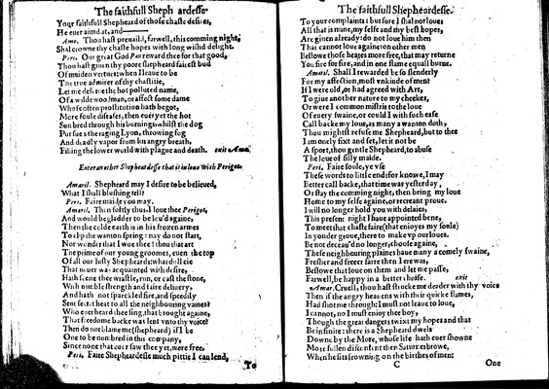

Image 9 (unnumbered page)

Your faithfull Shepheard of those chaste desi•es,  
He euer aimd at, and—

***Amo.***

Thou hast preuaild, farwell, this comming night,  
Shal crowne thy chaste hopes with long wishd delight.

***Peri.***

Our great God *Pan* reward thee for that good,  
Thou hast giuen thy poore shepheard fairest bud  
Of maiden vertues: when I leaue to be  
The true admirer of thy chastitie,  
Let me des•rue the hot polluted name,  
Of a wilde woodman, or affect some dame  
Whose often prostitution hath begot,  
More foule diseases, then euer yet the hot  
Sun bred through his burnings, whilst the dog  
Pursues the raging Lyon, throwing fog  
And deadly vapor from his angry breath.  
Filling the lower world with plague and death.

*exit Am••*

*Enter an other Shepheardesse that is in loue wi•h Perigot.*

***Amaril.***

Shepheard may I desire to be belieued,  
What I shall blushing tell?

***Peri.***

Faire maide you may.

***Amaril.***

Then softly thus, I loue thee *Perigot,*  
And would be gladder to be leu'd againe,  
Then the colde earth is in his frozen armes  
To •l•p the wanton spring: nay do not start,  
Nor wonder that I woe thee! thou that art  
The prime of our young groomes, euen the top  
Of all our lusty Shepheards: what dull eie  
That n•uer was acquainted with desire,  
Hath s•ene thee wrastle, run, or cast the stone,  
Wi•h nimble strength and faire deliuery,  
And hath not sparckled fire, and speedily  
Sent secret heat to all the neighbouring vaines?  
Who euer heard thee sing, that brought againe,  
That freedome backe was lent vnto thy voice?  
Then do not blame me (shepheard) if I be  
One to be numbred in this company,  
Since none that euer saw thee yet, were free.

***Peri.***

Faire Shepheardesse much pittie I can lend,

Unnumbered page  
  
To your complaints: but sure I shal not loue:  
All that is mine, my selfe and my best hopes,  
Are giuen already: do not loue him then  
That cannot loue againe: on other men  
Bestowe those heates more free, that may returne  
You fire for fire, and in one flame equall burne.

***Amaril.***

Shall I rewarded be so slenderly  
For my affection, most vnkinde of men?  
If I were old, or had agreed with Art,  
To giue another nature to my cheekes,  
Or were I common mistris to the loue  
Of euery swaine, or could I with such ease  
Call backe my loue, as many a wanton doth,  
Thou mightst refuse me Shepheard, but to thee  
I am onely fixt and set, let it not be  
A sport, thou gentle Shepheard, to abuse  
The loue of silly maide.

***Peri.***

Faire soule, ye vse  
These words to little end: for knowe, I may  
Better call backe, that time was yesterday,  
Or stay the comming night, then bring my loue  
Home to my selfe againe, or recreant proue.  
I will no longer hold you with delaies,  
This present night I haue appointed bene,  
To meet that chaste faire (that enioyes my soule)  
In yonder groue, there to make vp our loues.  
Be not deceau'd no longer, choose againe,  
These neighbouring plaines haue many a comely swaine,  
Fresher and freeer farre then I ere was,  
Bestowe that loue on them and let me passe,  
Farwell, be happy in a better choise.

*exit*

***Amar.***

Cruell, thou hast strucke me deader with thy voice  
Then if the angry heauens with their quicke flames,  
Had shot me through: I must not leaue to loue,  
I cannot, no I must enioy thee boy,  
Though the great dangers twixt my hopes and that  
Be infinite: there is a Shepheard dwels  
Downe by the More, whose life hath euer showne  
More fullen discontent then Saturnes browe,  
When he sits frowning on the birthes of men:

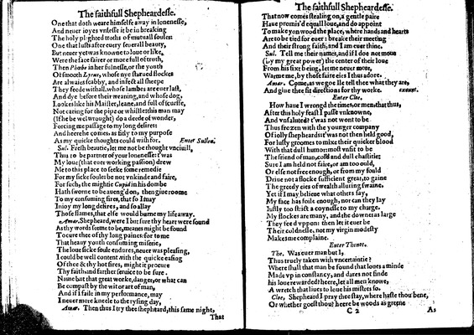

Image 10 (unnumbered page)

One that doth weare himselfe away in lonenesse,  
And neuer ioyes vnlesse it be in breaking  
The holy pl•ghted troths of mutuall soules:  
One that lusts after euery seuerall beauty,  
But neuer yet was knowne to loue or like,  
Were the face fairer or more full of truth,  
Then *Phoebe* in her fulnesse, or the youth  
Of smooth *Lyeus,* whose nye starued flockes  
Are alwaies scabby, and infect all sheepe  
They feede withall, whose lambes are euer last,  
And dye before their weaning, and whose dog,  
Lookes like his Maister, leane, and full of scurffe,  
Not caring for the pipe or whistle: this man may  
(If he be wel wrought) do a deede of wonder,  
Forcing me passage to my long desires:  
And heere he comes, as fitly to my purpose  
As my quicke thoughts could wish for.

*Enter Sullen.*

***Sul.***

Fresh beautie, let me not be thought vnciuill,  
Thus to be partner of your lonenesse: t'was  
My loue (that euer working passion) drew  
Me to this place to seeke some remedie  
For my sicke soule: be not vnkinde and faire,  
For such, the mightie *Cupid* in his dombe  
Hath sworne to be aueng'd on, then giue roome  
To my consuming fires, that so I may  
Inioy my long desires, and so allay  
Those flames, that else would burne my life away.

***Amar.***

Shepheard, were I but sure thy heart were sound  
As thy words seeme to be, meanes might be found  
To cure thee of thy long paines: for to me  
That heauy youth consuming miserie,  
The loue sicke soule endures, neuer was pleasing,  
I could be well content with the quicke easing  
Of thee & thy hot fires, might it procure  
Thy faith, and farther seruice to be sure.  
Name but that great worke, danger, or what can  
Be compast by the wit or art of man,  
And if I faile in my performance, may  
I neuer more kneele to the rysing day,

***Amar.***

Then thus I try thee shepheard, this same night,

Unnumbered page  
  
That now comes stealing on, a gentle paire  
Haue promis'd equall loue, and do appoint  
To make yon wood the place, where hands and hearts  
Are to be tied for euer: breake their meeting  
And their strong faith, and I am euer thine.

***Sul.***

Tell me their names, and if I doe not moue  
(•y my great power) the center of their loue  
From his sixt being, let me neuer more,  
Warme me, by those faire eies I thus adore.

***Amar.***

Come, as we goe Ile tell thee what they are,  
And giue thee fit directions for thy worke.

*exeunt.*

*Enter Cloe.*

How haue I wrongd the times, or men, that thus,  
After this holy feast I passe vnknowne,  
And vnsaluted? t'was not wont to be  
Thus frozen with the younger company  
Of iolly shepheards: t'was not then held good,  
For lusty groomes to mixe their quicker blood  
With that dull humor: most vnfit to be  
The friend of man, cold and dull chastitie:  
Sure I am held not faire, or am too ould,  
Or else not free enough, or from my fould  
Driue not a flocke sufficient great, to gaine  
The greedy eies of wealth alluring swaine.  
Yet if I may belieue what others say,  
My face has foile enough, nor can they lay  
Iustly too strict a coynesse to my charge.  
My flockes are many, and the downes as large  
They feed vppon: then let it euer be  
Their coldnesse, not my virgin modesty  
Makes me complaine.

*Enter Thenot.*

***The.***

Was euer man but I,  
Thus truely taken with vncertaintie?  
Where shall that man be found that loues a minde  
Made vp in constancy, and dares not finde  
his loue rewarded? heere, let all men knowe,  
A wretch that liues to loue his mistres so.

***Cloe,***

Shepheard I pray thee stay, where haste thou bene,  
Or whether goest thou? heere be woods as greene

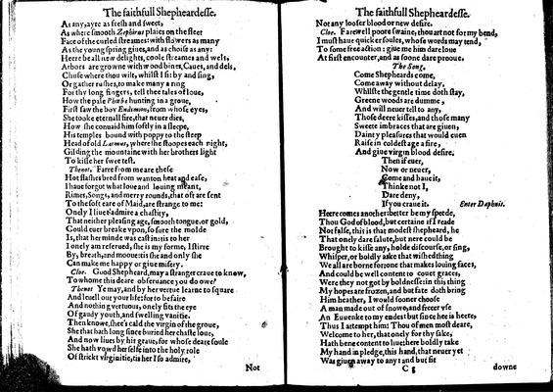

Image 11 (unnumbered page)

As any, ayre as fresh and sweet,  
As where smooth *Zephirus* plaies on the fleet  
Face of the curled streames: with flowers as many  
As the young spring giues, and as choise as any:  
Heere be all new delights, coole streames and wels,  
Arbors are growne with wood bines, Caues, and dels,  
Chuse where thou wilt, whilst I sit by and sing,  
Or gather rushes, to make many a ring  
For thy long fingers, tell thee tales of loue,  
How the pale *Phoebe* hunting in a groue,  
First saw the boy *Endimion,* from whose eyes,  
She tooke eternall fire, that neuer dies,  
How she conuaid him softly in a sleepe,  
His temples bound with poppy to the steep  
Head of old *Latmus,* where she stoopes each night,  
Gilding the mountaine with her brothers light  
To kisse her sweetest.

***Thenot.***

Farre from me are these  
Hot flashes bred from wanton heat and ease,  
I haue forgot what loue and louing meant,  
Rimes, Songs, and merry rounds, that oft are sent  
To the soft eare of Maid, are strange to me:  
Onely I liue t'admire a chastity,  
That neither pleasing age, smooth tongue, or gold,  
Could euer breake vpon, so sure the molde  
Is, that her minde was cast in: tis to her  
I onely am reserued, she is my forme, I stirre  
By, breath, and mooue: tis she and only she  
Can make me happy or giue misery.

***Cloe.***

Good Shepheard, may a stranger craue to know,  
To whome this deare obseruance you do owe?

***Thenot***

Ye may, and by her vertue learne to square  
And leuell out your life: for to be faire  
And nothing vertuous, onely fits the eye  
Of gaudy youth, and swelling vanitie.  
Then knowe, shee's cald the virgin of the groue,  
She that hath long since buried her chaste loue,  
And now liues by his graue, for whose deare soule  
She hath vowd her selfe into the holy role  
Of strickt virginitie, tis her I so admire,

Unnumbered page  
  
Not any looser blood or new de•ire.

***Cloe.***

Farewell poore swaine, thou art not for my bend,  
I must haue quicker soules, whose words may tend,  
To some free action: giue me him dare loue  
At first encounter, and as soone dare prooue.

**The Song.**

Come Shepheards come,  
Come away without delay,  
Whilste the gentle time doth stay,  
Greene woods are dumme,  
And will neuer tell to any,  
Those deere kisses, and those many  
Sweete imbraces that are giuen,  
Dainty pleasures that would euen  
Raise in coldest age a fire,  
And giue virgin blood desire.  
Then if euer,  
Now or neuer,  
Come and haue it,  
Thinke not I,  
Dare deny,  
If you craue it.

*Enter Daphnis.*

Heere comes another: better be my speede,  
Thou God of blood, but certaine if I reade  
Not false, this is that modest shepheard, he  
That onely dare salute, but nere could be  
Brought to kisse any, holde discourse, or sing,  
Whisper, or boldly aske that wished thing  
We all are borne for: one that makes louing faces,  
And could be well content to couet graces,  
Were they not got by boldnesse: in this thing  
My hopes are frozen, and but fate doth bring  
Him heather, I would sooner choose  
A man made out of snowe, and frecer vse  
An Euuenke to my endes: but since hee is heere,  
Thus I attempt him: Thou of men most deare,  
Welcome to her, that onely for thy sake,  
Hath bene content to liue: here boldly take  
My hand in pledge, this hand, that neuer yet  
Was giuen away to any: and but •it

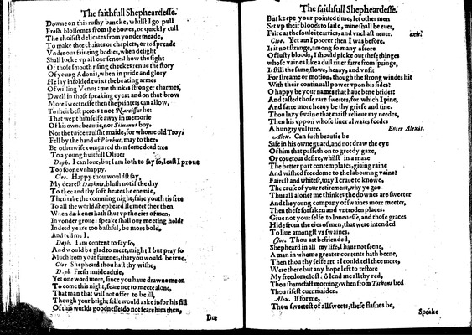

Image 12 (unnumbered page)

Downe on this rushy bancke, whilst I go pull  
Fresh blossomes from •he bowes, or quickly cull  
The choisest delicates from yonder meade,  
To make thee chaines or chaplets, or to spreade  
Vnder our fainting bodies, when delight  
Shall locke vp all our sences• how the sight  
Of those smooth rising cheekes renue the story  
Of young Adonis, when in pride and glory  
He lay infolded twixt the beating armes  
Of willing Venus: me thinkes stronger charmes,  
Dwell in those speaking eyes: and on that brow  
More sweetnesse then the painters can allow,  
To their best peeces: not *Narcissus* he:  
That wept himselfe away in memorie  
Of his owne beautie, nor *Siluanus* boy,  
Nor the twice rauisht maide, for whome old Troy,  
Fell by the hand of *Pirrhus,* may to thee,  
Be otherwise compared then some dead tree  
To a young fruitfull Oliue:

***Daph.***

I can loue, but I am loth to say so, least I proue  
Too soone vnhappy.

***Cloe.***

Happy thou wouldst say,  
My dearest *Daphnis,* blush not if the day  
To thee and thy soft heates be enemie,  
Then take the comming night, faire youth tis fre•  
To all the world, shepheard Ile meet thee then  
W•en darkenes hath shut vp the eies of men,  
In yonder gro•e: speake shall ou• meeting hold?  
Indeed ye are too bashful, be more bold,  
And tell me I.

***Daph.***

I am content to say so,  
And would be glad to meet, might I but pray so  
Much from your fairenes, that you would be true.

***Cloe***

Shepheard thou hast thy wishe,

***D•ph•***

Fresh maide aduie,  
Yet one word more, since you haue drawne me on  
To come this night, feare not to meete alone,  
That man that will not offer to be ill,  
Though your bright selfe would aske it• for his fill  
Of this worlds goodnesse: do not feare him then,

Unnumbered page  
  
But keepe your pointed time, let other men  
Set vp their bloods to saile, mine shall be euer,  
Faire as the soule it carries, and vnchast neuer.

*exit.*

***Cloe.***

Yet am I poorer then I was before.  
Is it not strange, among so many ascore  
Of lusty bloods, I should picke out these thinges  
whose vaines like a dull riuer farre from springs,  
Is still the same, slowe, heauy, and vnfit  
For streame or motion, though the strong windes hit  
With their continuall power vpon his sides?  
O happy be your names that haue bene brides:  
And tasted those rare sweetes, for which I pine,  
And farre more heauy be thy griefe and tine.  
Thou lazy swaine that maist relieue my needes,  
Then his vppon whose liuer alwaies feedes  
A hungry vulture.

*Enter Alexis.*

***Alex.***

Can such beautie be  
Safe in his owne guard, and not draw the eye  
Of him that passeth on to greedy gaze,  
Or couetous desire, whilst in a maze  
The better part contemplates, giuing raine  
And wished freedome to the labouring vaine?  
Fairest and whitest, may I craue to knowe,  
The cause of your retirement, why ye goe  
Thus all alone? me thinkes the downes are sweeter  
And the young company of swaines more meeter,  
Then these forsaken and vntroden places.  
Giue not your selfe to lonenesse, and those graces  
Hide from the eies of men, that were intended  
To liue amongst vs swaines.

***Cloe.***

Thou art befriended,  
Shepheard in all my life, I haue not seene,  
A man in whome greater contents hath beene,  
Then thou thy selfe art: I could tell thee more,  
Were there but any hope left to restore  
My freedome lost: ô lend me all thy red,  
Thou shamefast morning, when from *Tithons* bed  
Thou risest euer maiden.

***Alex.***

If for me,  
Thou sweetest of all sweets, these flashes be,

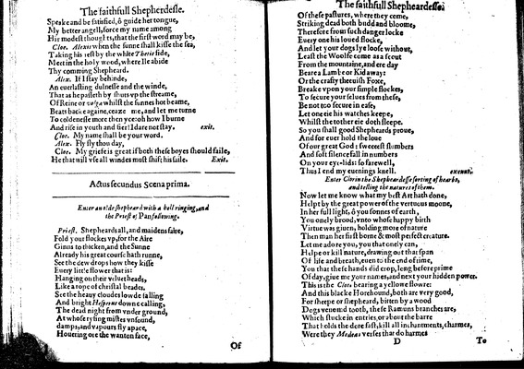

Image 13 (unnumbered page)

Speake and be satisfied, ô guide her tongue,  
My better angell, force my name among  
Hir modest thoughts, that the first word may be,

***Cloe.***

*Alexis* when the sunne shall kisse the sea,  
Taking his •est by the white *Thetis* side,  
Meet in the holy wood, where Ile abide  
Thy comming Shepheard.

***Alex.***

If I stay behinde,  
An euerlasting dulnesse and the winde,  
That as he passeth by shuts vp the streame,  
Of Reine or *volga* whilst the sunnes hot beame,  
Beats backe againe, ceaze me, and let me turne  
To coldenesse more then yce: oh how I burne  
And rise in youth and fier! I dare not stay.

*exit.*

***Cloe.***

My name shall be your word.

***Alex.***

Fly fly thou day,

***Cloe.***

My griefe is great if both these boyes should faile,  
He that will vse all windes must shift his saile.

*Exit.*

**Actus secundus Scena prima.**

*Enter an olde shepheard with a bell ringing, and the Priest of Pan following.*

***Priest.***

Shepheards all, and maidens faire,  
Fold your flockes vp, for the Aire  
Ginns to thicken, and the Sunne  
Already his great course hath runne,  
See the dew drops how they kisse  
Euery little flower that is:  
Hanging on their veluet heads,  
Like a rope of christal beades.  
See the heauy cloudes lowde falling  
And bright *Hesperus* downe calling,  
The dead night from vnder ground,  
At whose rysing mistes vnsound,  
damps, and vapours fly apace,  
Houering ore the wanton face,

Unnumbered page  
  
Of these pastures, where they come,  
Striking dead both budd and bloome,  
Therefore from such danger locke  
Euery one his loued flocke,  
And let your dogs lye loose without,  
Least the Woolfe come as a scout  
From the mountaine, and ere day  
Beare a Lambe or Kid away:  
Or the crafty theeuish Foxe,  
Breake vpon your simple flockes,  
To secure your selues from these,  
Be not too secure in ease,  
Let one eie his watches keepe,  
Whilst the tother eie doth sleepe.  
So you shall good Shepheards proue,  
And for euer hold the loue  
Of our great God: sweeeest slumbers  
And soft silence fall in numbers  
On your eye-lids: so farewell,  
Thus I end my euenings knell.

*exeunt.*

*Enter Clorin the Shepheardesse sorting of hearbs, and telling the natures of them.*

Now let me know what my best Art hath done,  
Helpt by the great power of the vertuous moone,  
In her full light, ô you sonnes of earth,  
You onely brood, vnto whose happy birth  
Virtue was giuen, holding more of nature  
Then man her first borne & most perfect creature.  
Let me adore you, you that onely can,  
Helpe or kill nature, drawing out that span  
Of life and breath, euen to the end of time,  
You that these hands did crop, long before prime  
Of day, giue me your names, and next your hidden power.  
This is the *Clo••* bearing a yellowe flowre:  
And this blacke Horehound, both are very good,  
For sheepe or shepheard, bitten by a wood  
Dogs venomd tooth, these Ramuns branches are,  
Which stucke in entries, or about the barre  
That holds the dore fast, kill all the inchantments, charmes,  
Were they *Medea•* verses that do harmes

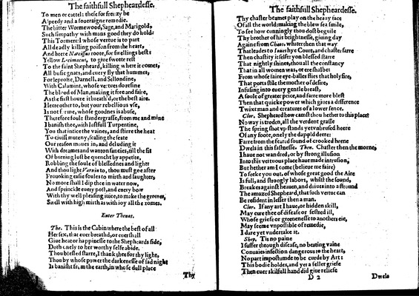

Image 14 (unnumbered page)

To men or cattel: these for frenzy be  
A •peedy and a soueraigne remedie.  
The bitter Wormewood, Sage, and Marigold,  
Such simpathy with mans good they do hold:  
This Tormen•l whose vertue is to part  
All deadly killing poison from the heart,  
And heere *Narcissus* roote, for swellings best:  
Yellow *L•cimacus,* to giue sweete rest  
To the faint Shepheard, killing where it comes,  
All busie gnats, and euery fly that hummes,  
For leprosie, Darnell, and Sellondine,  
With Calamint, whose ve•tues do resine  
The blood of Man, making it free and faire,  
As the first houre it breath'd, or the best aire.  
Heere other to, but your rebellious vse,  
Is not f•rme, whose goodnes is abuse,  
Therefore foule standergrasse, from me and mine  
I banish thee, with lustfull Turpentine,  
You that intice the vaines, and stirre the heat  
To ciuill muteny, scaling the seate  
Our reason moues in, and deluding it  
With dreames and wanton fancies, till the fit  
Of burning lust be quencht by appetite,  
Robbing the soule of blessednes and light:  
And thou light *Var•in* to, thou must goe after  
Prouoking easie soules to mirth and laughter,  
No more shall I dip thee in water now,  
And sprinckle euery post, and euery bow  
With thy well pleasing iuice, to make the gromes,  
Swell with high mirth as with ioy all the romes.

*Enter Thenot.*

***The.***

This is the Cabin where the best of all  
Her sex, that euer breathd, or euer shall  
Giue heat or happinesse to the Shepheards side,  
Doth onely to her worthy selfe abide.  
Thou blessed starre, I thank thee for thy light,  
Thou by whose power the darkenesse of sad night  
Is banisht from the earth, in whose dull place

Unnumbered page  
  
Thy chaster beames play on the heauy face  
Of all the world: making the blew sea smile,  
To see how cunningly thou dost beguile  
Thy brother of his brightnesse, giuing day  
Againe from *Chaos*• whiter then that way  
That leades to *Ioues* hye Court, and chaster farre  
Then chastity it selfe: yo• blessed starre  
That nightly shines, thou all the constancy  
That in all women was, or ere shalbe:  
From whose faire eye-balles flies that holyfire,  
That ports stile the mother of desire,  
Infusing into euery gentle breast,  
A soule of greater price, and farre more blest  
Then that quicke power which giues a difference  
Twixt man and creatures of a lower sence.

***Clor.***

Shepheard how camst thou hether to this place?  
No way is troden, all the verdent grasse  
The spring shot vp stands yet vnbrused heere  
Of any foote, onely the dappld deere:  
Farre from the feared sound of crooked horne  
Dwels in this fastnesse.

***Then.***

Chaster then the morne,  
I haue not wandred, or by strong illusion  
Into this vertuous place haue made intrusion,  
But hether am I come (belieue me faire)  
To seeke you out, of whose great good the Aire  
Is full, and strongly labors, whilst the sound,  
Breakes against heauen, and driues into a stround  
The amazed Shepheard, that such vertue can  
Be resident in lesser then a man.

***Clor.***

If any art I haue, or hidden skill,  
May cure thee of disease or festred ill,  
Whose griefe or greenenesse to anothers eie,  
May seeme vnpossible of remedie,  
I dare yet vndertake it.

***Shep.***

Tis no paine  
I suffer through disease, no beating vaine  
Conuaies infection dangerous to the heart,  
No part impostumde to be curde by Art:  
This bodie holdes, and yet a feller griefe  
Then euer skilfull hand did giue reliefe

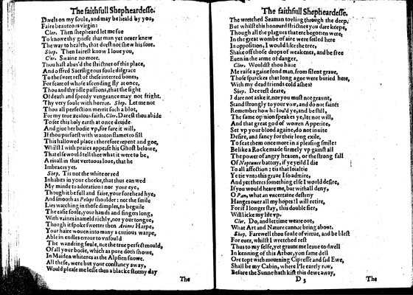

Image 15 (unnumbered page)

Dwels on my soule, and may be heald by you,  
Faire beauteous virgin:

***Clor.***

Then shepheard let me sue  
To knowe thy griefe that man yet neuer knew  
The way to health, that durst not shew his sore.

***Shep.***

Then fairest know I loue you,

***Clor.***

Swaine no more.  
Thou hast abus'd the strictnes of this place,  
And offred Sacriligeous foule disgrace  
To the sweet rest of these interred bones,  
For feare of whose ascending fly at once,  
Thou and thy idle passions, that the sight  
Of death and speedy vengeance may not fright.  
Thy very soule with horror.

***Shep.***

Let me not  
Thou all perfection merrit such a blot,  
For my true zealous faith.

***Clor.***

Darest thou abide  
To see this holy earth at once deuide  
And giue her bodie vp, for sure it will,  
If thou pursuest with wanton flames to fill  
This hallowed place: therefore repent and goe,  
Whilst I with praies appease his Ghost belowe,  
That else would tell thee what it were to be,  
A riuall in that vertuous loue, that he  
Imbraces yet.

***Shep.***

Tis not the white or red  
Inhabits in your cheeke, that thus •an wed  
My minde to adoration: nor your eye,  
Though it be full and faire, your forehead hye,  
And smooth as *Pelops* shoulder: not the smile  
Lies watching in those dimples, to beguile  
The easie soule, your hands and fingers long,  
With vaines inameld richly, nor your tongue,  
Though it spoke sweeter then *Arions* Harpe,  
Your haire wouen into many a curious warpe,  
Able in endles errour to vnfould  
The wandring soule, not the true perfect mould,  
Of all your bodie, which as pure doth showe,  
In Maiden whitenes as the Alpsien snowe,  
All these, were but your constancy away,  
Would please me lesse then a blacke stormy day

Unnumbered page  
  
The wretched Seaman toyling through the deep.  
But whilst this honourd strictnes you dare keepe,  
Though all the plagues that ere begotten were,  
In the great wombe of aire were setled here  
In opposition, I would like the tree,  
Shake off those drops of weakenes, and be free  
Euen in the arme of danger.

***Clor.***

Wouldst thou haue  
Me raise againe fond man, from silent graue,  
Those sparckes that long agoe were buried here,  
With my dead friends cold ashes?

***Shep.***

Deerest deare,  
I dare not aske it, nor you must not graunt,  
Stand strongly to your vow, and do not faint:  
Remember how he lou'd ye, and be still,  
The same opinion speakes ye, let not will,  
And that great god of wowen Appetite,  
Set vp your blood againe, do not inuite  
Desire, and fancy for their long exile,  
To seat them once more in a pleasing smile:  
Be like a Rocke made firmely vp gainst all  
The power of angry heauen, or the strong fall  
Of *Neptunes* battery, if ye yeild I die  
To all affection: tis that loialtie  
Ye tie vnto this graue I so admire,  
And yet theres something else I would desire,  
If you would heare me, but withall deny,  
O *Pan,* what an vncertaine desteny  
Hanges ouer all my hopes! I will retire,  
For if I longer stay, this double fier,  
Will licke my life vp.

***Clor.***

Do, and let time weare out,  
What Art and Nature cannot bring about.

***Shep.***

Farewell thou soule of virtue, and be blest  
For euer, whilst I wretched rest  
Thus to my selfe, yet graunt me leaue to dwell  
In kenning of this Arbor, yon •ame dell  
Ore topt with mourning Cipresse and sad Ewe,  
Shall be my Cabin, where I'le earely r•w,  
Before the Sunne hath kist this dewe away,

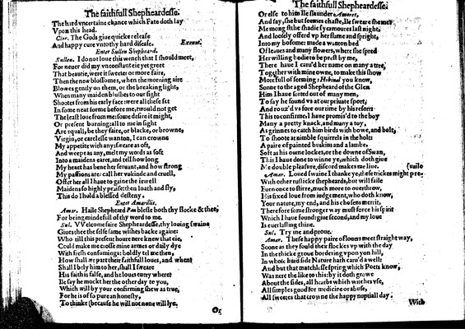

Image 16 (unnumbered page)

The hard vncertaine chance which Fate doth lay  
Vpon this head.

***Clor.***

The Gods giue quicke release  
And happy cure vnto thy hard disease.

*Exeunt.*

*Enter Sullen Shepheard.*

***Sullen.***

I do not loue this wench that I should meet,  
For neuer did my vnconstant eie yet greet  
That beautie, were it sweeter or more faire,  
Then the new blossomes, when the morning aire  
Blowes gently on them, or the breaking light,  
When many maiden blushes to our sight  
Shootes from his early face: were all these set  
In some neat forme before me, twould not get  
The least loue from me: some desire it might,  
Or present burning: all to me in sight  
Are equall, be they faire, or blacke, or browne,  
Virgin, or carelesse wanton, I can crowne  
My appetite with any: sweate as oft,  
And weepe as any, melt my words as soft  
Into a maidens eares, and tell how long  
My heart has bene her seruant, and how strong  
My passions are: call her vnkinde and cruell,  
Offer her all I haue to gaine the iewell  
Maidens so highly praise: then loath and fly,  
This do I hold a blessed desteny.

*Enter Amarillis.*

***Amar.***

Haile Shepheard *Pan* blesse both thy flocke & thee,  
For being mindefull of thy word to me.

***Sul.***

VVelcome faire Shepheardesse, thy louing swaine  
Giues thee the selfe same wishes backe againe:  
Who till this present houre nere knew that eie,  
Could make me crosse mine armes or daily dye  
With fresh consumings: boldly tel me then,  
How shall we part their faithfull loues, and when•  
Shall I bely him to her, shall I sweare  
His faith is false, and he loues euery where?  
Ile say he mockt her the other day to you,  
Which will by your confirming shew as true,  
For he is of so pure an honesty,  
To thinke (because he will not none will lye.

Unnumbered page  
  
Or else to him Ile slaunder *Amoret,*  
And say, she but seemes chaste, Ile sweare she •e•  
Me mongst the shadie sycamoures last night,  
And loosely offerd vp her flame and spright,  
Into my bosome: made a wanton bed  
Of leaues and many flowers, where she spred  
Her willing bodie to be prest by me,  
There haue I caru'd her name on many a tree,  
Together with mine owne, to make this show  
Morefull of seeming: *Hobinal* you know,  
Sonne to the aged Shepheard of the Glen  
Him I haue sorted out of many men,  
To say he found vs at our priuate sport,  
And rouz'd vs fore our time by his resorts  
This to confirme, I haue promis'd to the boy  
Many a pretty knack, and many a toy,  
As grinnes to catch him birds with bowe, and bolt,  
To shoote at nimble squirrels in the holt:  
A paire of painted buskins and a lambe,  
Soft as his owne lockes, or the downe of Swan,  
This I haue done to winne ye, which doth giue  
Me double pleasure, discord makes me liue.

***Amar.***

Loued swaine I thanke ye, these trickes might preuaile  
With other rus•icke shepheards, but will faile  
Euen once to stirre, much more to ouerthrow,  
His fixed loue from iudgement, who doth know,  
Your nature, my end, and his chosens merrit,  
Therefore some stronger way must force his spirit  
Which I haue found: giue second, and my loue  
Is euerlasting thine.

***Sul.***

Try me and proue.

***Amar.***

These happy paire of louers meet straight way,  
Soone as they fould their flockes vp with the day  
In the thicke groue bordering vpon yon hill,  
In whose hard side Nature hath caru'd a well:  
And but that matchlesse spring which Poets know,  
Was nere the like to this: by it doth growe  
About the sides, all hearbs which witches vse,  
All simples good for medicine or abuse,  
All sweetes that crowne the happy nuptiall day.

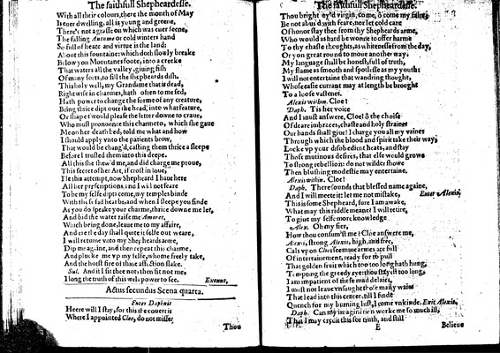

Image 17 (unnumbered page)

With all their colours, there the month of May  
Is euer dwelling, all is young and greene,  
There's not a grasse on which was euer seene,  
The falling *Autume* or cold winters hand  
So full of heate and virtue is the land:  
About this fountaine: which doth slowly breake  
Below yon Mountaines foote, into a creeke  
That waters all the valley, giuing fish  
Of many sorts, to fill the shepheards dish.  
This holy well, my Grandame that is dead,  
Right wise in charmes, hath often to me sed,  
Hath power to change the forme of any creature,  
Being thrice dipt ouer the head, into what feature,  
Or shape t'would please the letter downe to craue,  
Who must pronounce this charme to, which she gaue  
Me on her death bed, told me what and how  
I should apply vnto the patients brow,  
That would be chang'd, casting them thrice a sleepe  
Before I trusted them into this deepe.  
All this she shew'd me, and did charge me proue,  
This secret of her Art, if crost in loue,  
I'le this attempt, now Shepheard I haue here  
All her prescriptions• and I wi•l not feare  
To be my selfe dipt: come, my temples binde  
With these sad hearbs, and when I sleepe you finde  
As you do speake your charme, thrice downe me let,  
And bid the water raise me *Amoret,*  
Which being done, leaue me to my affaire,  
And ere the day shall quite it selfe out weare,  
I will returne vnto my Shepheards arme,  
Dip me againe, and then repeat this charme,  
And plucke me vp my selfe, whome freely take,  
And the hotst fire of thine affection slake.

***Sul.***

And if I fit thee not, then fit not me,  
I long the truth of this wels power to see.

*Exeunt,*

**Actus secundus Scena quarta.**

*Enter Daphnis*

Heere will I stay, for this the couert is  
Where I appointed *Cloe,* do not misse:

Unnumbered page  
  
Thou bright ey'd virgin, come, ô come my faire,  
Be not abus'd with feare, nor let cold care  
Of honor slay thee from thy Shepheards arme,  
Who would as hard be wonne to offer harme  
To thy chaste thoughts, as whitenesse from the day,  
Or yon great round to moue another way.  
My language shall be honest, full of truth,  
My flame as smooth and spotlesse as my youth:  
I will not entertaine that wandring thought,  
Whose easie currant may at length be brought  
To a loose vastenes.

*Alexis within.*

Cloe!

***Daph.***

Tis her voice  
And I must answere, Cloe! ô the choise  
Of deare imbraces, chaste and holy straines  
Our hands shall giue! I charge you all my vaines  
Through which the blood and spirit take their way,  
Lo•ke vp your disobedient heats, and stay  
Those mutinous desires, that else would growe  
To strong rebellion: do not wilder showe  
Then blushing modestie may entertaine.

*Alexis within.*

Cloe!

***Daph.***

There sounds that blessed name againe,  
And I will meete it: let me not mistake,

*Enter Alexis.*

This is some Shepheard, sure I am awake,  
What may this riddle meane? I will retire,  
To giue my selfe more knowledge

***Alex.***

Oh my fier,  
How thou consum'st me? Cloe answere me,  
*Alexis,* strong *Alexis,* high, and free,  
Cals vpon *Cloe*: see mine armes are full  
Of intertainement, ready for to pull  
That golden fruit which too too long hath hung,  
T•mpting the greedy eye: thou stayest too long,  
I am impatient of these mad delaies,  
I must not leaue vnsought those many waies  
That lead into this center, till I finde  
Quench for my burning lust, I come vnkinde.

*Exit Alexis.*

***Daph.***

Can my imagination worke me so much ill,  
That I may credit this for truth, and still

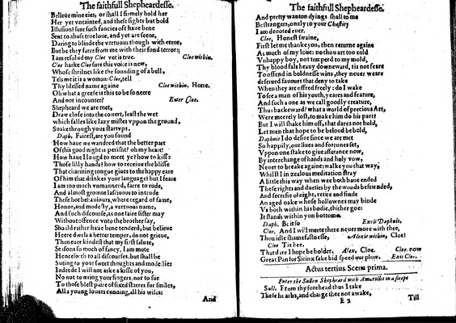

Image 18 (unnumbered page)

Belieue mine eies, or shall I firmely hold her  
Her yet vntainted, and these sights but bold  
Illusion? sure such fancies oft haue bene  
Sent to abuse true loue, and yet are seene,  
Daring to blinde the vertuous though with error,  
But be they farre from me with their fond terror:  
I am resolud my *Cloe* yet is true.

*Cloe within.*

*Cloe* harke *Cloe* sure this voice is new,  
Whose shrilnes like the sounding of a bell,  
Tels me it is a woman: *Cloe,* tell  
Thy blessed name againe

*Cloe within. Heere.*

Oh what a greefe is this to be so neere  
And not incounter?

*Enter Cloe.*

Shepheard we are met,  
Draw close into the co•ert, least the wet  
which falles like lazy mistes vppon the ground,  
Soake through yous startvps.

***Daph.***

Fairest, are you found  
How haue we wandred that the better part  
Of this good night is perisht? oh my heart!  
How haue I longd to meet ye? how to kisse  
Those lilly hands? how to receiue the blisse  
That charming tongue giues to the happy eare  
Of him that drinkes your language? but I feare  
I am too much vnmannerd, farre to rude,  
And almost growne lasciuous to intrude  
These hot behauiours, where regard of fame,  
Honor, and modesty, a vertuous name,  
And such discourse, as one faire sister may  
Without offence vnto the brother say,  
Should rather haue bene tenderd, but belieue  
Heere dwels a better temper, do not grieue,  
Then euer kindest that my first salute,  
Seasons so much of fancy, I am mute  
Hence•orth to all discourses, but shall be  
Suting to your sweet thoughts and modestie:  
Indeede I will not aske a kisse of you,  
No not to wring your fingers, nor to sue  
To those blest paire of fixed starres for smiles,  
All a young louers cunning, all his wiles:

Unnumbered page  
  
And pretty wanton dyings shall to m•  
Be strangers, onely to your *Chastity*  
I am deuoted euer.

***Cloe,***

Honest swaine,  
First let me thanke you, then returne againe  
As much of my loue: no thou art too cold  
Vnhappy boy, not temperd to my mold,  
Thy blood fals heauy downeward, tis not feare  
To offend in boldnesse wins, they neuer weare  
deserued fauours that deny to take  
When they are offred freely: do I wake  
To see a man of his youth, yeares and feature,  
And such a one as we call goodly creature,  
Thus backeward? what a world of precious Art,  
Were meerely lost, to make him do his part?  
But I will shake him off, that dares not hold,  
Let men that hope to be beloud be bold,  
*Daphnis* I do desire since we are met  
So happily, our liues and fortunes set,  
Vppon one stake to giue assurance now,  
By interchange of hands and holy vow,  
Neuer to breake againe: walke you that way,  
Whilst I in zealous meditation •tray  
A little this way when wee both haue ended  
These rights and dueties by the woods befriended,  
And secresie of night, retire and finde  
An aged oake whose hollownes may binde  
Vs both within his bodie, thither goe:  
It stands within yon bottom••

***Daph.***

Be it so

*Ex•it Daphnis.*

***Cloe.***

And I will meete there neuer more with thee,  
Thou idle shamefastnesse,

*Alexis within,*

Cloe!

***Cloe***

Tis hee.  
That dare I hope be bolder.

***Alex.***

Cloe.

***Cloe.***

now  
Great Pan for Sirinx sake bid speed our plow.

*Exit Cloe.*

**Actus tertius Scena prima.**

*Enter the Sullen Shepheard with Amarillis in a sleepe*

***Sull.***

From thy forehead thus I take  
These hearbs, and charge thee not awake,

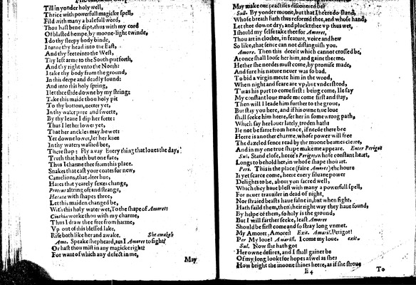

Image 19 (unnumbered page)

Till in yonder holy well,  
Thrice with powerfull magicke spell,  
Fild with many a balefull word,  
Thou hast bene dipt, thus with my cord  
Of blasted hempe, by moone-light twinde,  
I do thy sleepy body binde,  
I turne thy head into the East,  
And thy feete into the West,  
Thy left arme to the South put forth,  
And thy right vnto the North:  
I take thy body from the ground,  
In this deepe and deadly sound:  
And into this holy spring,  
I let thee slide downe by my string:  
Take this maide thou holy pit  
To thy bottom, neerer yet,  
In thy water pure and sweete,  
By thy leaue I dip her feete:  
Thus I let her lower yet,  
That her anckles may be wet:  
Yet downe lower, let her knee  
In thy waters washed bee,  
There stop: Fly away Euery thing that loues the day,  
Truth that hath but one face,  
Thus I charme thee from this place.  
Snakes that cast your coates for new,  
Camelions, that alter hue,  
Hares that yearely sexes change,  
*Proteus* altring oft and strange,  
*Haecatae* with shapes three,  
Let this maiden changed be,  
With this holy water wet, To the shape of *Amoret*:  
*Cinthia* worke thou with my charme,  
Thus I draw thee free from harme,  
Vp out of this blessed lake,  
Rise both like her and awake.

*She awakeh*

***Amo.***

Speake shepheard, am I *Amoret* to sight?  
Or hast thou mist in any magicke right?  
For want of which any defect in me,

Unnumbered page  
  
May make our practises discouered be?

***Sull.***

By yonder moone, but that I heere do stand,  
Whose breath hath thus reformd thee, and whose hand,  
Let thee downe dry, and pluckt thee vp thus wet,  
I should my selfe take thee for *Amoret,*  
Thou art in clothes, in feature, voice and hew  
So like, that sence can not distinguish you.

***Amore.***

Then this deceit which cannot crossed be,  
At once shall loose her him, and gaine thee me.  
Hether she needes must come, by promise made,  
And sure his nature neuer was so bad,  
To bid a virgin meete him in the wood,  
When night and feare are vp, but vnderstood,  
T'was his part to come first: being come, Ile say  
My constant loue made me come first and stay,  
Then will I leade him further to the groue,  
But stay you here, and if his owne true loue  
shall seeke him heere, set her in some wrong path,  
Which say her louer lately troden hath:  
Ile not be farre from hence, if neede there bee  
Heere is another charme, whose power will free  
The dazeled sence read by the moone beames cleare,  
And in my one true shape make me appeare.

*Enter Perigot*

***Sul.***

Stand close, heeee's *Perigot,* whose constant heart,  
Longs to behold her, in whose shape thou art.

***Peri.***

This is the place (faire *Amoret*) the houre  
Is yet scarce come, heere euery siluane power  
Delights to be, about yo• sacred well,  
Which they haue blest with many a powerfull spell,  
For neuer trauailer in dead of night,  
Nor straied beasts haue falne in, but when •ight,  
Hath faild them, then their right way they haue found,  
By helpe of them, so holy is the ground,  
But I will farther seeke, least *Amoret*  
Should be first come and so stray long vnmet.  
My Amoret, Amoret!

*Exit. Amaril.*

Perigot!  
Per My loue! *A•arill.* I come my loue.

*exit.*

***Sul.***

Now she hath got  
Her owne desires, and I shall gainer be  
Of my long lookt for hopes aswel as she;  
How bright the moone shines heere, as if she stroue

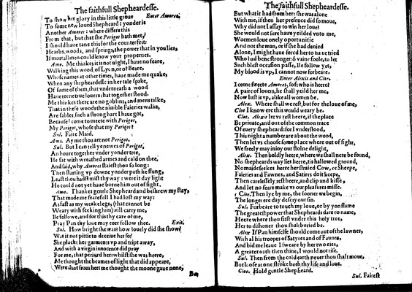

Image 20 (unnumbered page)

To show her glory in this little groue

*Enter Amoret.*

To some new loued Shepheard: yonder is  
Another *Amoret*: where differs this  
From that, but that she *Perigot* hath met,  
I should haue tane this for the counterfeit:  
Hearbs, woods, and springs, the power that in you lies,  
If mortall men could know your properties.

***Amo.***

Me thinkes it is not night, I haue no feare,  
Walking this wood of Lyon, or of Beare,  
Whose names at other times, haue made me quake,  
When any shepheardesse in her tale spake,  
Of some of them, that vnderneath a wood  
Haue torne true louers that together stood.  
Me thinkes there are no goblins, and mens talke,  
That in these woods the nimble Faieries walke,  
Are fables, such a strong hart I haue got,  
Because I come to meete with *Perigot,*  
My *Perigot,* whose that my *Perigot*?

***Sul.***

Faire Maid.

***Amo.***

Ay me thou art not *Perigot.*

***Sul.***

But I can tell ye newes of *Perigot,*  
An houre together vnder yonder tree,  
He sat with wreathed armes and cald on thee,  
And said, why *Amoret* staiest thou so long:  
Then starting vp downe yonder path he flung,  
Least thou hadst mist thy way: were it day light  
He could not yet haue borne him out of sight.

***Amo.***

Thankes gentle Shepheard and beshrew my stay,  
That made me fearefull I had lost my way:  
As fast as my weakelegs, (that cannot be  
Weary with seeking him) will carry me,  
Ile followe, and for this thy care of me,  
Pray Pan thy loue may euer follow thee.

*Exit.*

***Sul.***

How bright she was? how louely did she show?  
Was it not pittie to deceiue her so?  
She pluckt her garments vp and tript away,  
And with a virgin innocence did pray  
For me, that periurd her: whilst she was heere,  
Me thought the beames of light that did appeare,  
Were shot from her: me thought the moone gaue none,

Unnumbered page  
  
But what it had from her: she was alone  
With me, if then her presence did so moue,  
Why did not I assay to win her loue?  
She would not sure haue yeilded vnto me,  
Woemen loue onely oportunitie  
And not the man, or if she had denied  
Alone, I might haue forcd her to haue tried  
Who had bene stronger: ô vaine foole, to let  
Such blest occasion passe, Ile follow yet,  
My blood is vp, I cannot now forbeare.

*Enter Alexis and Cloe.*

I come sweete *Amoret,* soft who is heere?  
A paire of louers, he shall yeild her me,  
Now lust is vp, alike all women be.

***Alex.***

Where shall we rest, but for the loue of me,  
*Cloe* I know ere this would weary be.

***Cloe.***

*Alexis* let vs rest heere, if the place  
Be priuate, and out o• the common trace  
Of euery shepheard: for I vnderstood,  
This night a number are about the wood,  
Then let vs choose some place where out of sight,  
We freely may inioy our stolne delight,

***Alex.***

Then boldly heere, where we shall nere be found,  
No shepheards way lies heere, tis hallowed ground,  
No maide seekes heere her straied Cow, or Sheepe,  
Faieries and Fawnes, and Satires do it keepe,  
Then carelessely rest heere, and clip and kisse,  
And let no feare make vs our pleasures misse.

***Cloe.***

Then lye by me, the sooner we begin,  
The longer ere day descry our sin.

***Sul.***

Forbeare to touch my loue, or by yon flame  
The greatest power that Shepheards dare to name,  
Heere where thou first vnder this holy tree,  
Her to dishoner thou shalt buried be.

***Alex***

If Pan himselfe should come out of the lawnes,  
With al his troopes of Satyres and of Faunes,  
And bid me leaue I sweare by her two eies,  
A greater oath then thine, I would not rise.

***Sul.***

Then from the cold earth neuer thou shalt moue,  
But loose at one stroke both thy life and loue.

***Cloe.***

Hold gentle Shepheard.

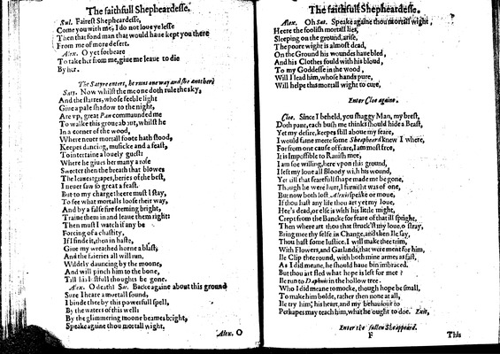

Image 21 (unnumbered page)

***Sul.***

Fairest Shepheardesse,  
Come you with me, I do not loue ye lesse  
Then that fond man that would haue kept you there  
From me of more desert.

***Alex.***

O yet forbeare  
To take her from me, giue me leaue to die  
By her.

*The Satyre enters, he runs one way and she another.*

***Saty.***

Now whilst theme one doth rule the sky,  
And the starres, whose feeble light  
Giue a pale shadow to the night,  
Are vp, great *Pan* commaunded me  
To walke this groue about, whilst he  
In a corner of the wood,  
Where neuer mortall foote hath stood,  
Keepes dancing, musicke and a feast,  
To intertaine a louely guest:  
Where he giues her many a rose  
Sweeter then the breath that blowes  
The leaues: grapes, beries of the best,  
I neuer saw so great a feast.  
But to my charge: heere must I stay,  
To see what mortalls loose their way,  
And by a false fire seeming bright,  
Traine them in and leaue them right:  
Then must I watch if any be  
Forcing of a chastity,  
If I finde it, then in haste,  
Giue my wreathed horne a blast,  
And the faieries all will run,  
Wildely dauncing by the moone,  
And will pinch him to the bone,  
Till his lustfull thoughts be gone.

***Alex.***

O death•

***Sat.***

Backe againe about this ground  
Sure I heare a mortall sound,  
I binde thee by this powerfull spell,  
By the waters of this well:  
By the glimmering moone beames bright,  
Speake againe thou mortall wight.

Unnumbered page

***Alex.***

Oh

***Sat.***

Speake againe thou mortall wight,  
Heere the foolish mortall lies,  
Sleeping on the ground, arise,  
The poore wight is almost dead,  
On the Ground his woundes haue bled,  
And his Clothes fould with his bloud,  
To my Goddesse in the wood,  
Will I lead him, whose hands pure,  
Will helpe this mortall wight to cure,

*Enter Cloe againe.*

***Cloe.***

Since I beheld, you shaggy Man, my brest,  
Doth pant, each bush me thinks should hide a Beast,  
Yet my desire, keepes still aboue my feare,  
I would faine meete some *Sheapheard* knew I where,  
For from one cause of feare, I am most free,  
It is Impossible to Rauish mee,  
I am soe willing, here vpon this ground,  
I left my loue all Bloody wi•h his wound,  
Yet till that fearefull shape made me be gone,  
Though he were hurt, I furnisht was of one,  
But now both lost• *Alexis* speake or moue,  
If thou hast any life thou art yet my loue,  
Hee's dead, or else is with his little might,  
Crept from the Bancke for feare of that ill spright,  
Then where art thou that struck'st my loue• o stray,  
Bring mee thy selfe in Change, and then Ile say,  
Thou hast some Iustice, I will make thee trim,  
With Flowers, and Garlands, that were ment for him,  
Ile Clip thee round, with both mine armes as fast,  
As I did meane, he should haue bin imbraced.  
But thou art fled what hope is left for mee?  
Ile run to *Daphnis* in the hollow tree.  
Who I did meane to mocke, though hope be small,  
To make him bolde, rather then none at all,  
Ile try him, his heart, and my behauiour to  
Perhapes may teach him, what he ought to doe.

*Exit,*

*Enter the sullen Sheappeard.*

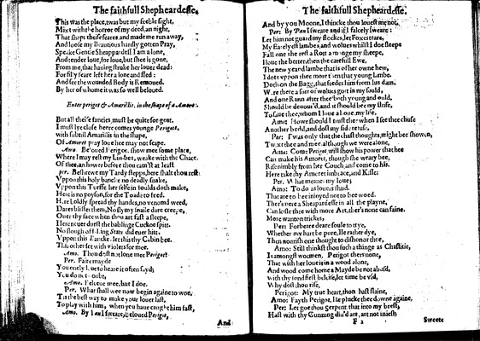

Image 22 (unnumbered page)

This was the place, twas but my feeble sight,  
Mixt with the horror of my deed, an night,  
That shapt theise feares• and made me run away,  
And loose my Beautious hardly gotten Pray,  
Speake Gentle Sheappardess I am alone,  
And tender loue, for loue, but shee is gone,  
From me, that hauing struke her louer dead:  
For filly feare left her a lone and fled:  
And see the wounded Body is Remoued.  
By her of whome it was so well beloued.

*Enter perigot & Amarillis. in the shape of a Amor•.*

But all theise fancies must be quite for go•t,  
I must lye close heere comes younge *Perigott,*  
with subtill Amarillis in the shape,  
Of *Amoret* pray loue hee may not scape.

***Amo.***

Beloued Perigot, show mee some place,  
Where I may rest my Li•bes, weake with the Chace•  
Of thee• an hower before thou cam'st at least

***per.***

Beshrewe my Tardy stepps, here shalt thou rest  
Vppon this holy bancke no deadly snake,  
Vppon this Turffe her selfe in foulds doth make,  
Here is no poyson, for the Toad• to feed.  
H•re •oldly spread thy handes, no venomd weed,  
Dares blister them, No sly my snaile dare creepe,  
Ouer thy face when thou art fast a sleepe,  
Here neuer durst the bablinge Cuckoe spitt.  
No slough off •ing Starr did euer hitt.  
Vppon this Bancke• let this thy Cabin bee.  
This other set with violets for mee.

***Amo.***

Thou dost not lone mee *Perigot*?

***Per.***

Faire mayde  
You onely l•ue to heare it often sayd;  
You do n•t •oubt,

***Amo.***

Beleeue mee, but I doe.

***Per.***

What shall wee now begin againe to woe,  
Tis the best way to make your louer last,  
To play with him, when you haue caught him fast,

***Amo.***

By I *an* I sweare, beloued *Perigot,*

Unnumbered page  
  
And by you Moone, I thincke thou louest me not.

***Per:***

By *Pan* I sweare and if I falcely sweare:  
Let him not guard my flockes, let Foxes teare,  
My Earelyest lambes, and wolues whilst I doe steepe  
Fall one the rest a Rott amonge my sheepe,  
I loue the better, then the carefull Ewe,  
The new yeand lambe that is of her owne hew,  
I dote vppon thee more t•en that young l•mbe.  
Doth on the Bagg, that feedes him from his dam.  
W•re there a sort of wolues go•t in my fould,  
And one Rann after thee both young and ould,  
Should be deuour'd, and it should bee my strife,  
To saue thee, whom I loue aboue, my life,

***Amo:***

Howe should I trust thee when I see thee chuse  
Another bedd, and dost my side refuse,

***Per:***

Twas only that the chast thoughts, might bee showen,  
Tw•xt thee and mee, although we were alone,

***Ama:***

Come *Perigot* will show his power that hee  
Can make his Amoret, though she weary bee,  
Rise nimbly from her Couch and come to his.  
Here take thy Amoret imbrace, and Kisse:

***Per.***

What meane• my loue;

***Amo:***

To do as louers shud.  
That are to bee inioyed not to bee woed.  
Ther's •ere a Sheapard esse in all the playne,  
Can kisse thee with more Art, ther's none can faine.  
More wanton trickes,

***Per:***

Forbeare deare soule to t•ye,  
Whether my hart be pure, Ile rather dye,  
Then nourish one thought to dishonor thee,

***Amo:***

Still thinkst thou such a thinge as Chastitie,  
Is amongst woemen. Perigot thers none,  
That with her loue is in a wood alone,  
And wood come home a Mayde be not abusd,  
With thy •ond first beleife, let time be vsd,  
Why dost thou rise,

***Perigot:***

My true heart, thon hast slaine,

***Amo.***

Fayth Perigot, Ile plucke thee downe againe,

***Per.***

Let goe thou Serpent that into my brest,  
Hast with thy Cunning diu'd art, art not iniest;

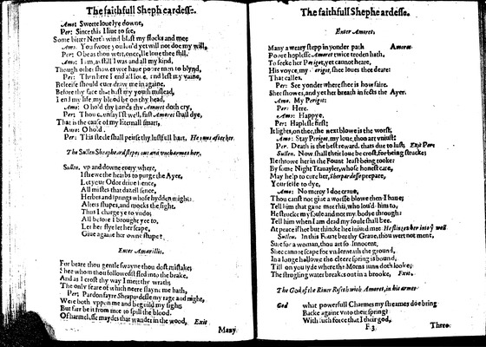

Image 23 (unnumbered page)

***Amo:***

Sweete loue lye downe,

***Per:***

Since this I liue to see,  
Some bitter North wind blast my flocks and mee

***Amo.***

You swore you lou'd yet will not doe my will,

***Per:***

O be as thou wert, once, Ile loue thee still,

***Amo:***

I am, as still I was and all my kind,  
Though other showes wee haue poore men to blynd,

***Per:***

Then here I end all loue, and lest my vaine,  
Beleei•e should euer draw me in againe,  
Before thy face that hast my youth mislead,  
I end my life my blood be on thy head,

***Amo:***

O hold thy hands thy *Amoret* doth cry,

***Per:***

Thou c•unsayl'st well, first *Amoret* shall dye,  
That is the cause of my Eternall smart,

***Auso:***

O hold.

***Per:***

This steele shall peirse thy lustfull hart,

*He •uns after he•*

*The Sullen Sheapheard stepes out and vncharmes her•*

***Sullen.***

vp and downe euery where,  
I strewe the hearbs to purge the Ayer•  
Let your Odor driue hence,  
All mistes that dazell sence,  
Herbes and springs whose hydden migh••  
Alters shapes, and mocks the sight.  
Thus I charge ye to vndo;  
All before I brought yee to•  
Let her flye let her scape,  
Giue againe her owne shape:

*Enter Amarillis.*

For beare thou gentle swayne thou dost mistake;  
Shee whom thou followedst fled into the brake•  
And as I crost thy way I mett thy wrath;  
The only feare of which neere slayne me hath,

***Per:***

Pardon fayre Sheapardes•e my rage and night,  
Were both vppon me and beguild my sight;  
But farr be it from mee to spill the blood.  
Of harmelesse maydes that wander in the wood,

*Exit*

*Unnumbered page  
  
Enter Amoret.*

Many a weary stepp in yonder path

*Amoret.*

Poore hoplesse *Amoret* twice troden hath,  
To seeke her *Perigot,* yet cannot heare,  
His voyce, my *•erigot,* shee loues thee deare:  
That calles.

***Per:***

See yonder where shee is how faire.  
Shee showes, and yet her breath infects the Ayer.

***Amo.***

My *Perigot*:

***Per:***

Here.

***Amo:***

Happye.

***Per:***

Haplesse first:  
It lights, on thee, the next blowe is the worst,

***Amo:***

Stay *Perigot,* my loue, tho• art vniust:

***Per.***

Death is the best reward, thats due to lust;

*Exit Per:*

***Sullen.***

Now shall their loue be crost, for being strucke;  
Ile throwe her in the Fount least being tooke:  
By some Night Trauayler, whose honest care,  
May help to cure her, *Sherpardesse* prepare,  
Your selfe to dye,

***Amo:***

No mercy I doe craue•  
Thou canst not giue a worsse blowe then I haue;  
Tell him that gaue mee this, who lou'd him to•  
He strucke my soule and not my bodye through:  
Tell him when I am dead my soule shall bee.  
At peace if hee but thincke hee iniurd mee•

*He flin•es her into ye well*

***Sullen.***

In this Fount bee thy Graue, thou wert not ment,  
Sure for a woman, thou art so Innocent•  
Shee cannot scape for vnderneath the ground,  
In a longe h•llowe the cleere spring is bound,  
Till on you syde where the Morns sunn doth looke•  
The strugling water breakes out in a brooke,

*Exit.*

*The God of the Riuer Riseth with Amoret, in his armes*

***God***

what powerfull Charmes my streames doe bring  
Backe againe vnto their spring?  
With such force that I their god,

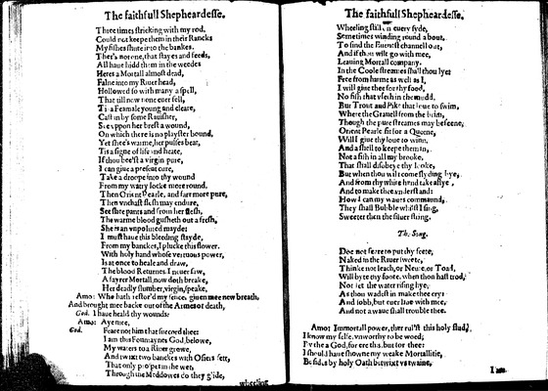

Image 24 (unnumbered page)

Three times stricking with my rod,  
Could not keepe them in their Rancks  
My fishes shute into the bankes.  
Ther's not one, that stayes and feeds,  
All haue hidd th•m in the weedes  
Heres a Mortall almost dead,  
Falne into my Riuer head,  
Hollowed so with many a spell,  
That till now none euer fell,  
Ti• a Feamale young and cleare,  
Cast in by some Rauisher,  
See vppon her brest a wound,  
On which there is no playster bound,  
Yet shee's wa•me, her pulses beat,  
Tis a signe of life and heate,  
If thou bee'st a virgin pure,  
I can giue a present cure,  
Take a droope into thy wound  
From my watry locke more round,  
Then Orient Pearle, and farr more pure,  
Then vnchast fl•sh may endure,  
See shee pants and •rom her flesh,  
The warme blood gusheth out a fresh,  
She is an vnpoluted mayde:  
I must haue this bleeding stayde,  
From my banckes, I plucke this flower.  
With holy hand whose vertuous power,  
Is at once to heale and draw•  
The blood Returnes• I neuer saw,  
A •ayrer Mortall, now doth breake,  
Her deadly slumber, virgin, speake,

***Amo:***

Who hath restor'd my sence, giuen mee new breath,  
And brought mee backe out of the Armes o• death,

***God.***

I haue heald thy wounds:

***Amo:***

Aye mee,

***God.***

Feare not him that succord thee:  
I am this Fountayne• God belowe,  
My waters to a Riuer growe,  
And twixt two banckes with Osiers sett,  
That only p•o•per in the wet,  
Through the Meddowes do they glide,

Unnumbered page  
  
Wheeling still •n euery syde,  
Sometimes winding round about.  
To •ind the Euenest channell o•t,  
And if thou wilt go with mee,  
Leauing Mortall company.  
In the Coole streames •hall thou lye:  
Free from harme as well as I,  
I will giue thee for thy food,  
No fish that vse•h in the mudd,  
But Trout and Pike that loue to swim,  
Where the Grauell from the bri•,  
Though the pure streames may beseene,  
Orient Pearle fit for a Queene,  
Will I giue thy loue to winn•  
And a shell to keepe them in,  
Not a fish in all my brooke,  
That shall disobeye thy l•oke,  
But when thou wilt come slyding bye,  
And from thy white h•nd take a•lye,  
And to make thee vnderstand:  
How I can my waues commaund,  
They shall Bubble whilst I sing,  
Sweeter then the siluer string.

**The Song.**

Doe not feare to put thy feete,  
Naked in the Riuer sweete,  
Thinke not leach, or Neu•e, or Toad,  
Will byte thy foote, when tho• hast trod,  
Not •et the water rising hye•  
As thou wadest in make thee cry:  
And sobb, but euer li•e with mee.  
And not a waue shall trouble thee.

***Amo:***

Immortall power, ther rul'•t this holy •lud,  
I know my selfe, vnworthy to be woed,  
By the a God, for ere this, but •or thee:  
I should haue showne my weake Mortallitie,  
Besides by holy Oath betwixt vs twaine,  
〈2 pages duplicate〉

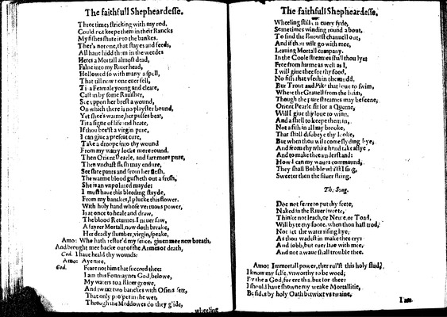

Image 25 (unnumbered page)

Unnumbered page

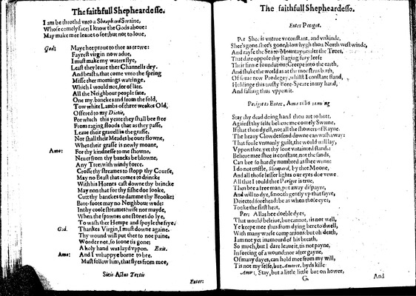

Image 26 (unnumbered page)

I am be throthd vnto a *Sheaphard* Swaine,  
Whose comely face; I know the Gods aboue:  
May make mee leaue to see; but not to loue,

***God:***

Maye hee proue to thee as •rewe:  
Fayrest virgin now adue,  
I must make my waters flye,  
Least they leaue ther Channells dry.  
And beasts, that come vnto the spring  
Misse ther mornings watringe.  
Which I would not, for of late.  
All the Neighbour people sate.  
One my banckes and from the fold,  
Tow white Lambs of three weeks Old,  
Offered to my *Dietie,*  
For which this yeare they shall bee free  
From raging floods that as they passe,  
Leaue their grauell in the grasse,  
Nor shall their Meades be ouer flowne,  
When their grasse is newly moane,

***Amo:***

For thy kindnesse to me showne,  
Neuer from thy bancks be blowne,  
Any Tree; with windy force.  
Crosse thy streames to stopp thy Course,  
May no Beast that comes to drincke  
With his Hornes cast downe thy brincke  
May non that for thy fishe doe looke,  
Cutt thy banckes to damme thy Brooke:  
Bare-foote may no Neighbour wade:  
In thy coole streames? wife nor mayde,  
When the spawn•s one stones do lye,  
To wash ther Hempe and spoyle the frye.

***God.***

Thankes Virgin, I must downe againe.  
Thy wound will put thee to noe paine.  
Wonder not, so soone tis gone;  
A holy hand was layd vppon.

*Exit.*

***Amo:***

And I vnhappye borne to bee.  
Must follow him, that flyes from mee,

*Finis Actus Tertis*

*Unnumbered page  
  
Enter Perigot.*

***P•r***

Shee is vntrue vnconstant, and vnkinde,  
Shee's gone• shee's gone, blow hygh thou North west winde,  
And rayse the Sea to Mountaynes: let the Trees,  
That dare oppose thy Raging fury leese  
Their firme foundation: Creepe into the ea•th,  
And shake the world as at the monstrus b•rth,  
Of some new Prodegey, whilst I constant stand,  
Holdinge this trusty Bore-Speare in my hand,  
And falling thus vppon it.

*Pe•igot to Enter, Ama ri•lis ••nu•ng*

Stay •hy dead doing hand thou art to hott,  
Against thy selfe belieue me comely Swaine,  
If that thou dyest, not all the showers of Rayne.  
The heauy Clowdes send downe can wash away:  
The •oule vnmanly guilt, the world will lay,  
Vppon thee, yet thy loue vntainted stands:  
Belieue mee shee is constant, not the sands,  
Can bee so hardly numbred as shee wunn:  
I do not triffle, *Sheapard,* by thee Moone,  
And all those lesser lights our eyes doe vewe  
All that I could thee *Perigot* is true,  
Then bee a freeman, put away dispayre,  
And will to dye, smooth gently vp that fayre,  
Deiected forehead: be as when those eyes,  
Tooke the first heat,

***Per:***

Allas hee doeble dyes,  
That would beleiue, but cannot, •is not well,  
Ye keepe mee thus from dying here to dwell,  
With many worse companions: but oh death,  
I am not yet inamourd of his breath,  
So much, but I dare leaue it, tis not payne,  
In forcing of a wound: nor after gayne,  
Of many dayes, can hold mee from my will,  
Tis not my selfe, but *Amoret.* byds kille•

***Am•:***

Stay, but a little• little but on hower,

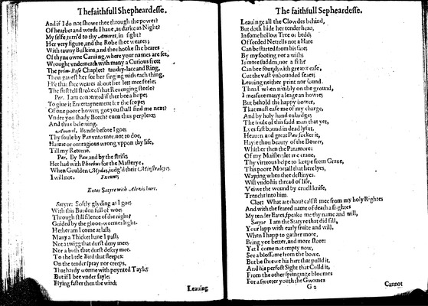

Image 27 (unnumbered page)

And if I do not showe thee through the power?  
Of hearbes and words I haue, as darke as Night?  
My selfe, turn'd to thy *Amoret,* in sight?  
Her very figure, and the Robe shee weares;  
With tawny Buskins, and thee hooke she beares  
Of thyne owne Caruing, where your names are set,  
Wrought vnderneath with many a Curious frett  
The *prim-Rose* Chaplet? taudry-lace and Ring,  
Thou gauest her for her singing with each thing,  
Else that shee weares about her lett mee feele;  
The first tell stroke of that Reuenging steele?

***Per.***

I am contented if ther bee a hope;  
To giue it Entertaynement for the scope;  
Of one poore hower; goe you shall find me next?  
Vnder you shady Beech? euen thus perplext;  
And thus beleiuing.

***Amaril.***

Bynde before I goe;  
Thy soule by *Pan* vnto mee, not to doe,  
Harme or outragious wrong vppon thy life,  
Till my Returne.

***Per.***

By *Pan* and by the strife;  
Hee had with *Phoebus* for the Masterye,  
When Goulden *Mydas,* iudg'd their *Minstralcye*;  
I will not.

*Exeunt;*

*Enter Satyre with Alezis hurt.*

***Satyre:***

Softly glyding as I goe;  
With this Burden full of woe;  
Through still silence of the night?  
Guided by the glooe-wormes light.  
Hether am I come at last;  
Many a Thicket hane I past;  
Not at twigg that durst deny mee;  
Nor a bush t•at durst descry mee.  
To the little Bird that sleepes:  
On the tender spray nor creeps,  
That hardly worme with poynted Tayle;  
But if I bee vnder sayle;  
Flying faster then the wind;

Unnumbered page  
  
Leauinge all the Clowdes behind,  
But doth hide her tender head,  
In some hollow Tree o• bedd;  
Of •eeded Nettells not a Hare  
Can be started from his fare;  
By my footing nor a wish;  
Is more sudden, nor a fish?  
Can bee found; with greater ease,  
Cut the vast vnbounded seaes;  
Leauing neither print nor •ound.  
Then I when nimbly on the ground,  
I measure many a leage an howre;  
But behold the happy bower,  
That must ease me of my charge,  
And by holy hand enlardge;  
The •oule of this sadd man that yet,  
Lyes fast bound in dead lysi•t,  
Heauen and great *Pan,* sucker it,  
Hay•e thou beauty of the Bower,  
Whither then the Paramore:  
Of my Maister; let me craue,  
Thy virteous helpe to keepe from Graue,  
This poore Mortall that here lyes,  
Wayting when thee destinyes.  
Will vndo his thread of life,  
Veiwe the wound by cruell knife,  
Trencht into him•

***Cl•r:***

What art thou? call'st mee from my holy Rightes  
And with the feared name of death a frightes  
My tender Eares, speake me thy name and will,

***Satyre***

I am the Statyre that did fill,  
Your lapp with early fruite and will,  
When I happ to gather more,  
Bring yee better, and more store:  
Yet I come not empty now,  
See a blossome from the bowe,  
But be shrewe his hart that pulld it,  
And his perfect Sight that Culld it,  
From the other springinge bloomes  
For a sweeter youth the Gwomes

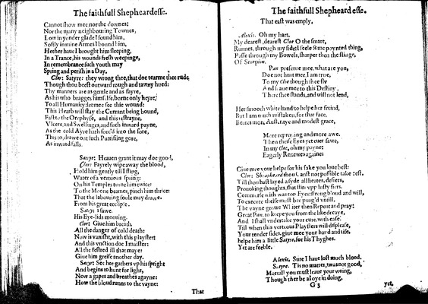

Image 28 (unnumbered page)

Cannot show mee nor the downes:  
Nor the many neighbouring Townes,  
Low in yonder glade I found him,  
Softly in mine Armes I bound him,  
Hether haue I brought him sleeping,  
In a Trance, his wounds fresh weepinge,  
In remembrance such youth may  
Spring and perish in a Day.

***Clor:***

Satyre: they wrong thee, that doe tearme thee rude  
Though thou beest outward rough and tawny hued:  
Thy manners are as gentle and as fayre,  
As his who bragges himselfe, borne only heyre,  
To all Humanity: let mee see thie wound:  
This Hearb will stay the Currant being bound,  
Fast to the Or•physe, and this restrayne,  
Vicers, and Swellinges, and such inward payne,  
As the cold Ayre hath forc'd into the sore,  
This to, drawe out such Putrifiing gore,  
As inward falls.

***Satrye:***

Heauen grant it may doe good,

***Clor:***

Fayrely wipe away the blood,  
Hold him gently till I fling,  
Water of a vertuous spring:  
On his Temples tu•ne him twice:  
To the Moone beames pinch him thrice:  
That the labouring soule may drawe.  
From his great ecclip•e.

***Satry:***

I sawe.  
His Eye-lids moouing.

***Clor:***

Giue him breath,  
All the danger of cold death:  
Now is vanisht, with this playster:  
And this vnction doe I maister:  
All the festred ill that maye:  
Giue him greife another day.

***Satyr:***

See hee gathers vp his spright  
And begins to hunt for light,  
Now a gapes and breathes agayne:  
How the bloud runns to the vayne:

Unnumbered page  
  
That east was emply.

***Alexis.***

Oh my hart,  
My dearest, dearest *Cloe* O the smart,  
Runnes, through my side: I feele some poynted thing,  
Passe through my Bowels, sharper then the stinge,  
Of *Scorpion.*  
*Pan,* preserue mee, what are you,  
Doe not hurt mee. I am true,  
To my *Cloe* though shee fly  
And leaue mee to this Destiny,  
There shee stands, and will not lend,  
  
  
Her smooth white hand to helpe her freind,  
But I am much mistaken, for that face,  
Beares more Austeritye and modest grace,  
  
  
More reprouing and more awe.  
Then theise Eyes yet euer sawe,  
In my *Cloe,* oh my payne:  
Eagerly Renewes againe:  
  
  
Giue mee your helpe for his sake you loue best:

***Clor:***

*Sheapheard* thou Canst not possible take rest.  
Till thou hast layed a syde all heates, desiers,  
Prouoking thoughts, that stirr vpp lusty fiers.  
Commerse with wanton Eyes: strong bloud and will,  
To execute theise must bee purg'd vntill,  
The vayne growe Whiter then Repent and pray:  
Great *Pan,* to keepe you from the like decaye,  
And I shall vndertake your cure with ease.  
Till when this verteous Playsters will displease,  
Your tender sides. giue mee your hand and rise.  
helpe him a little *Satyre.* for his Thyghes.  
Yet are feeble.

***Alexis.***

Sure I haue lost much blood.

***Satyre.***

Tis no matter, twas not good,  
Mortall you must leaue your woing,  
Though ther be aloye in doing,

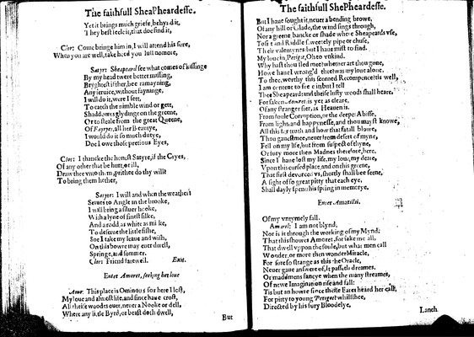

Image 29 (unnumbered page)

Yet it brings much griefe, behynd it,  
They best •eele it, that doe find it,

***Clor:***

Come bringe him in, I will attend his sore,  
When you are well, take heed you lust no mo•e,

***Satyr:***

*Sheapeard* see what comes of kissinge  
By my head twere better missing,  
Bryghtest if ther, bee ramayning,  
Any seruice, without fayninge,  
I will do it, were I sett,  
To catch the nimble wind or gett,  
Shaddowes glydinge on the greene,  
Or to steale from the great Queene,  
Of *Fayryes,* all her Beautye,  
I would do it so much dutye,  
Doe I owe those pretious Eyes,

***Clor:***

I thancke the honest Satyre, if the Cryes,  
Of any other that be hurt, or ill,  
Draw thee vnto th•m, prithee do thy will?  
To bring them hether,

***Satyre:***

I will and when the weathe•:  
Se•ues to Angle in the brooke,  
I will bring a siluer hooke,  
With a lyne of finest silke,  
And a rodd• as white as mi•ke,  
To deserue the little fishe,  
Soe I take my leaue and wish,  
On this bowre may euer dwell,  
Springe, and sommer.

***Clor:***

Friend farewell.

*Exit.*

*Enter Amoret, seeking her loue*

***Amo:***

This place is Ominous sor here I lost,  
My loue and almost life, and since haue crost,  
All theise woodes ouer, neuer a Nooke or dell,  
Where any li•tle Byrd, or beast doth dwell,

Unnumbered page  
  
But I haue sought it• neuer a bending browe,  
Of any hill or Glade, the wind sings through,  
Nor a greene bancke or shade whe•e Sheapeards vse,  
To si•t and Riddle sweetely pipe or chuse,  
Their valentynes• but I haue mist to find.  
My loue in, *Perigot,* Oh to vnkind.  
Why hast thou fled mee? whether art thou gone,  
Howe haue I wrong'd thee? was my loue alone,  
To thee, worthy this scorned Recompence? tis well,  
I am content to fee• eit; but I tell  
Thee Sheapeard: and theise lusty woods shall heare.  
Forsaken *Aomret*• is yet as cleare,  
Of any stranger fier, as Heauen is.  
From foule Corruption, or the deepe: Abisse,  
From light, and happynesse, and thou mayst knowe,  
All this for truth and how that fatall blowe,  
Thou gauest mee, neuer from desert of myne,  
Fell on my life, but from suspect of thyne,  
Or fury more then Madnes therefore, here.  
Since I haue lost my life, my loue, my dea•e,  
Vpon this cursed place, and on this greene,  
That first devorced vs, shortly shall bee seene,  
A sight of so great pitty that each eye,  
Shall dayly spen• his spring in memorye.

*Enter Amarillsi.*

Of my vntymely fall.

***Amaril:***

I am not blynd,  
Nor is it through the working of my Mynd.  
That this showes Amoret, for sake me all,  
That dwell vppon the soule, but what men call  
Wonder, or more then wonder Miracle,  
For sure so strange as this the Oracle,  
Neuer gaue answere of, It passeth dreames,  
Or maddmens fancye when the many streames,  
Of newe Imagination rise and fall:  
Tis but an howre since theise Eares heard her call,  
For pitty to young *Perigot*? whils•hee,  
Directed by his fury Bloodelye,

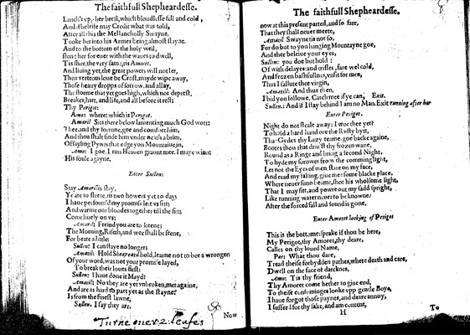

Image 30 (unnumbered page)

Lanch't vp• her brest, which bloudlesse fell and cold,  
And if beleife may Credit what was told,  
After all this the Mellancholly Swayne,  
Tooke her into his Armes being almost slayne.  
And to the bottom of the holy well,  
slung her for euer with the waues to dwell,  
Tis shee, the very same, tis *Amoret.*  
And liuing yet, the great powers will not let,  
Their verteous loue be Crost, mayde wipe away,  
Those heauy dropps of sorrow, and allay,  
The storme that yet goes high, which not deprest,  
Breakes, hart, and life, and all before it rest:  
Thy *Perigot*:

***Amo:***

where: which is *Perigot.*

***Amaril***

Sits there below lamenting much God wott:  
Thee, and thy fortune, goe and comfort him,  
And thou shalt finde him vnder neath a brim,  
Of sayling Pynes that edge yon Mountaiue in,

***Amo:***

I goe, I run Heauen graunt mee. I maye winn:  
His soule agayne.

*Enter Sullen:*

Stay *Amarillis* stay,  
Ye are to fleete, tis two howers yet to days  
I haue perform'd my promise le•t vs sitt;  
And warme our bloodes together till the sitt;  
Come liuely on vs;

***Amaril:***

Freind you are to keene;  
The Morning, Riseth, and wee shall be seene,  
For beare a little;

***Sullen:***

I can staye no longer;

***Amaril:***

Hold *Sheapeard* hold, learne not to bee a wronger;  
Of your word, was not your promise layed,  
To break their loues first:

***Sullen:***

I haue done it Mayd?

***Amaril:***

No they are yet vnbroken, met againe,  
And are as hard to part yet as the stayne?  
Is from the finest lawne,

***Sullen.***

I say they are.

Unnumbered page  
  
now at this present parted, and so farr,  
That they shall neuer meete,

***Amaril***

Swayne tis not so,  
For do but to yon hanging Mountayne goe,  
And ther beleiue your eyes,

***Sullen:***

you doe but hold:  
Of with delayes: and trifles, fare wel cold,  
And frozen bash•ullnes, vnfit for men,  
Thus I sallute thee virgin,

***Amaril:***

And thus then,  
I bid you followe, Catch mee if ye can,

*Exit.*

***Sullen.:***

And If I stay behind I am no Man.

*Exit running after her*

*Enter Perigot.*

Night do not steale away: I woe thee yet?  
To hold a hard hand ore the Rusty bytt,  
Tha• Gydes thy Lazy teame• goe backe againe,  
Bootes thou that driu'st thy frozen wane,  
Round as a Ringe and bring a second Night,  
To hyde my sorowes from the comming light,  
Let not the Eyes of men stare on my face,  
And read my falling• giue mee some blacke place,  
Where neuer sunn beame, shot his wholsome light,  
That I may sitt, and powre out my sadd spright,  
Like running water neuer to be knowne:  
After the forced fall and •ound is gone,

*Enter Amoret looking of Perigot*

This is the bottome: speake if thou be here,  
My Perigot, thy Amoret, thy deare,  
Calles on thy loued Name,

***Per:***

What thou dare,  
Tread theise forbydden pathes, where death and care,  
Dwell on the face of darcknes,

***Amo:***

Tis thy friend,  
Thy Amoret come hether to giue end,  
To theise consuminges looke vpp gentle Boye,  
I haue forgot those paynes, and deare annoy,  
I sufferd for thy sake, and am content,

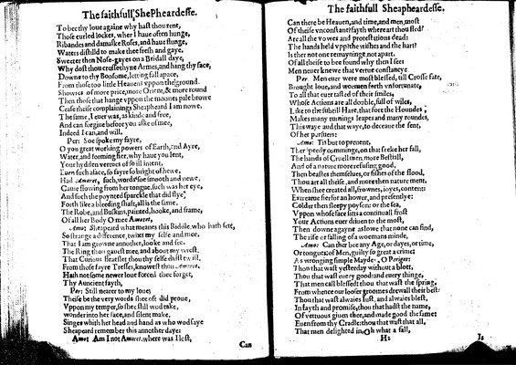

Image 31 (unnumbered page)

To bee thy loue againe why hast thou rent,  
Those curled lockes, wher I haue often hunge,  
Ribandes and damaske Roses, and haue flunge,  
Waters distilld to make thee fresh and gaye,  
Sweeter then Nose-gayes on a Bridall daye,  
Why dost thou crosse thyne Armes, and hang thy face,  
Downe to thy Boosome, letting fall apace,  
From those too little Heauens vppon the ground  
Showres of more price, more Orient, & more round  
Then those that hange vppon the moones pale browe  
Cease theise complainings Sheapheard I am nowe,  
The same, I euer was, as kinde and free,  
And can forgiue before you aske of mee,  
Indeed I can, and will.

***Per:***

Soe spoke my fayre,  
O you great working powers of Earth, and Ayre,  
Water, and forming fier, why haue you lent,  
Your hydden vertues of so ill intent,  
Euen such aface, so fayre so bright of hewe,  
Had *Amoret,* such, words •soe smooth and newe,  
Came flowing from her tongue, such was her eye,  
And such the poynted sparckle that did flye•  
Forth like a bleeding shaft, all is the same,  
The Robe, and Buskins, painted, hooke, and frame,  
Of all her Body O mee *Amoret,*

***Amo:***

Sheapeard what meanes this Riddle who hath sett,  
So strange a difference, twixt my selfe and mee,  
That I am growne annother, looke and see.  
The Ring thou gauest mee, and about my wrest.  
That Curious Braeslet thou thy selfe didst twist.  
From those fayre Tresses, knowest thou *Amoret.*  
Hath not some newer loue forced thee forget,  
Thy Auncient fayth,

***Per:***

Still nearer to my loue;  
Theise be the very words shee oft did proue,  
Vppon my temper, so shee still wod take,  
wonder into her face, and silent make,  
Singes whith her head and hand as who wod saye  
Sheapeard remember this annother daye:

***Amo:***

Am I not *Amoret.* where was I lost,

Unnumbered page  
  
Can there be Heauen, and time, and men• most  
Of theise vnconstant? fayth where art thou fled?  
Are all the vowes and protestations dead:  
The hands held vpp? the wishes and the hart?  
Is ther not one remayningne not apart,  
Of all theise to bee found why then I see:  
Men neuer knewe that vertue constancye

***Per***

Men euer were most blessed, till Crosse fate,  
Brought loue, and woemen forth vnfortunate,  
To all that euer tasted of their smiles,  
Whose Actions are all double, full of wiles,  
Like to the subtill Hare, that fore the Houndes,  
Makes many turnings leapes and many roundes,  
This waye aud that waye, to deceaue the sent,  
Of her p•rsuers:

***Amo:***

Tis but to preuent,  
Ther speedy comminge, on that seeke her fall,  
The hands of Cruell men• more Bestiall,  
And of a nature more refusing good,  
Then beastes themselues, or fishes of the flood,  
Thou art all theise, and more then nature ment,  
When shee created all, frownes, ioyes, content:  
Extreame fier for an hower, and presentlye:  
Colder then sleepy poyson: or the sea,  
Vppon whose face sitts a continuall frost  
Your Actions euer driuen to the most,  
Then downe agayne as lowe that none can find,  
The rise or falling of a woemans minde,

***Amo:***

Can ther bee any Age, or dayes, or time,  
Or tongues: of Men, guilty so great a crime:  
As wronging simple Mayde, O *Perigot:*  
Tho• that wast yesterday without a blott,  
Thou that wast euery good• and euery thinge,  
That men call blessed: thou that wast the spring.  
From whence our looser groomes drewall their best:  
Thou that wast alwaies Iust, and alwaies blest,  
In fayth and promise, thou that hadst the name,  
Of vertuous giuen thee, and made good the same:  
Euen from thy Cradle: thou that wast that all,  
That men delighted in, Oh what a fall,

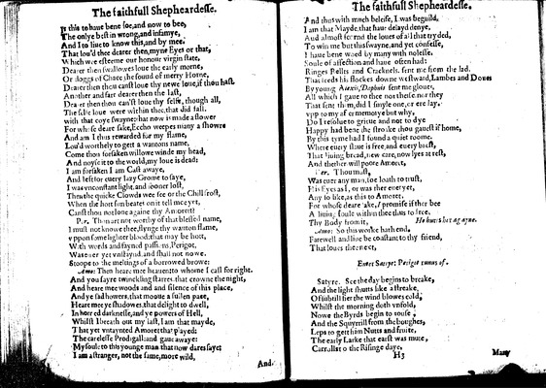

Image 32 (unnumbered page)

Is this to haue bene soe, and now to bee,  
The onlye best in wrong, and infamye,  
And I to liue to know this, and by mee.  
That lou'd thee dearer then, myne Eyes or that,  
Which wee esteeme our honour virgin state,  
Dearer then swallowes loue the early morne,  
Or doggs of Chace the souud of merry Horne,  
Dearer then thou canst loue thy newe loue, if thou hast•  
Another and farr dearer then the last,  
Dea•er then thou can'st loue thy selfe, though all,  
The selfe loue were wîthin thee, that did fall.  
with that coye swayne: hat now is made a flower  
For whose deare sake, Eccho weepes many a showre  
And am I thus rewarded for my flame,  
Lou'd worthely to gett a wantons name,  
Come thou forsaken willowe winde my head,  
And noyse it to the world, my loue is dead:  
I am forsaken I am Cast awaye,  
And left for euery lazy Grome to saye,  
I was vnconstant light, and sooner lost,  
Then the quicke Clowds wee see or the Chill •rost,  
When the hott sun beates on it tell mee yet,  
Canst thou not lone againe thy Amorett?

***Per.***

Thon art not worthy of that blessed name,  
I must not knowe thee, flynge thy wanton flame,  
vppon some lighter blood: that may be hott,  
With words and fayned passi•ns, Perigot,  
Was euer yet vnstaynd, and shall not nowe.  
Stoope to the meltings of a borrowed browe:

***Amo:***

Then heare mee heauen: to whome I call for right.  
And you sayre twinckling starres that crowne the night,  
And heare mee woods and and silence of this place,  
And ye sad howers, that mooue a sullen pace,  
Heare mee ye shadowes, that delight to dwell,  
In horred darknesse, and ye powers of Hell,  
Whilst I breath out my last, I am that mayde,  
That yet vntaynted Amoret tha• played:  
The carelesse Prodigall: and gaue awaye:  
My soule to this younge man that now dares say:  
I am a stranger, not the same, more wild,

Unnumbered page  
  
And thus with much beleife, I was be guild,  
I am that Mayde, that haue delayd denye,  
Aud almost scornd the loues of all that tryded,  
To win me but this swayne, and yet confesse,  
I haue bene woed by many with no lesse.  
Soule of affection and haue often had:  
Ringes Rellts and Cracknels. sent me from the lad.  
That •eeds his flockes downe westward, Lambes and Doues  
By young *Alexis, Daphnis* sent me gloues,  
All which I gaue to thee not theise nor they  
That sent them, did I smyle one, or ere lay.  
vpp to my af•er memo•ye but why,  
Do I resolue to grieue and not to dye  
Happy had bene the stroake thou gauest if home,  
By this tyme had I found a quiet roome.  
Where euery slaue is free, and euery brest,  
That liuing bread, new care, now lyes at rest,  
And thether will poore Amoret,

***Ver.***

Thou must,  
Was euer any man, soe loath to trust,  
His Eyes as I, or was ther euer yet,  
Any so like, as this to Amoret,  
For whose deare •ake, *I* promise if ther bee  
A liuing soule within thee thus to •ree,  
Thy Body from it,

*He hur•s her agayne.*

***Amo:***

So this worke hath end.  
Farewell and liue be constant to thy friend,  
That loues thee next,

*Enter Satrye: Perigot runus of.*

***Satyre.***

See the day begins to breake,  
And the light shutts like a streake,  
Of subtill fier the wind blowes cold,  
Whilst the morning doth vnfold,  
Nowe the Byrds begin to rouse,  
And the Squyrrill from the boughes,  
Leps to gett him Nutts and fruite,  
The early Larke earst was mute,  
Carr•lls to the Risinge daye,

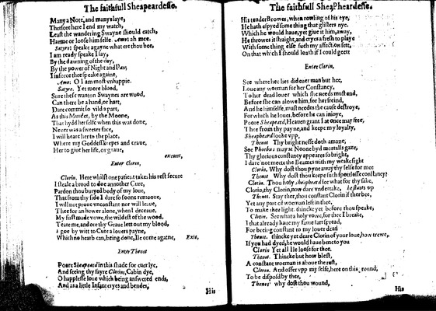

Image 33 (unnumbered page)

Many a Note, and manye laye,  
Therfore here I end my watch,  
Least the wandering Swayne should catch,  
Harme or loose him self••*Amo*: ah mee.

***Satyre:***

speake agayne what ere thou bee,  
I am ready speake I say,  
By the dawning of the day,  
By the power of Night and *Pan*;  
I inforce thee speake againe,

***Amo:***

O I am most vnhappie.

***Satyre.***

Yet more blood,  
Sure these wanton Swaynes are wood,  
Can there be a hand, or hart,  
Dare commit so vild a part,  
As this Murder, by the Moone,  
That hydd her selfe when this was done,  
Neuer was a sweeter face,  
I will beare her to the place,  
Where my Goddess keepes and craue,  
Her to giue her life, or graue,

*exeunt,*

*Enter Clorin,*

***Clorin,***

Here whilst one patient takes his rest secure  
I steale a broad to doe annother Cure,  
Pardon thou buryed body of my loue,  
That from thy side I dare so soone remooue,  
I will not proue vnconstant nor will leaue,  
Thee for an hower alone, when I deceaue,  
My first made vowe, the wildest of the wood,  
Teare me, and ore thy Graue lett out my blood,  
I goe by witt to Cure a louers payne,  
Which no hearb can, being done, Ile come againe,

*Exit,*

*Enter Thenot*

Poore *Sheapeard* in this shade for euer lye,  
And seeing thy fayre *Clorins,* Cabin dye,  
O happlesse loue which being answered ends,  
And as a little Infant cryes and bendes,

Unnumbered page  
  
Hist tender Browes, when rowling of his eye,  
He hath espyed some thing that glisters nye.  
Which he would haue, yet giue it him, away,  
He throwes it straight, and cryes a fresh to playe  
With some thing else such my affection sett,  
On that which I should loath if I could geett

*Enter Clorin.*

See where hee lies did euer man but hee,  
Loue any woeman for her Constancy,  
To her dead louer which she needs must end,  
Before she can alowe him, for her freind,  
And he himselfe, must needes the cause destroye,  
For which he loues, before he can inioye,  
Poore *Sheapeard,* Heauen grant I at once may free,  
Thee from thy payne, and keepe my loyalty,  
*Sheapheard* looke vpp,

***Thenot***

Thy brightnesse doth amaze,  
Soe *Phoebus* may at Noone byd mortalls gaze,  
Thy glorious constancy appeares so bright,  
I dare not meete the Beames with my weakesight

***Clorin.***

Why dost thou pyne away thy selfe for mee

***Thenot***

Why dost thou keepe such spottlesse constancy?

***Clorin.***

Thou holy *Sheapheard* see what for thy sake,  
Clorin, thy Clorin, now dare vndertake, *he starts vp*

***Thenot.***

Stay ther, thou constant Clorin if ther bee,  
Yet any part of woeman left in thee,  
To make thee light thincke yet before thou speake,

***Clorin.***

See what a holy vowe, for thee I breake,  
I that already haue my fame •arr spread,  
For beeing constant to my louer dead

***Thenot.***

thincke yet deare Clorin of your loue, how trewe,  
If you had dyed, he would haue bene to you

***Clorin***

Yet all Ile loose for thee.

***Thenot.***

Thincke but how blest,  
A constant woeman is aboue the rest,

***Clorin.***

And offer vpp my selfe, here on this •round,  
To be disposd by thee,

***Thenes***

why dost thou wound,

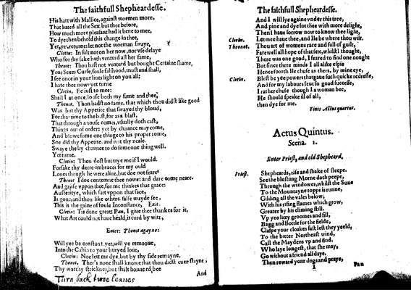

Image 34 (unnumbered page)

His hart with Mallice, against woemen more.  
That hated all the Sex, but thee before,  
How much more pleasant had it bene to mee,  
To dye then behold this change in thee,  
Yet, ye•• returne: let not the woeman swaye,

***Clorin:***

In sult not on her now, nor vse delaye  
Who for thy sake hath venturd all her fame,

***Thenot:***

Thou hast not venturd but bought Certaine shame,  
Your Sexes Curse, foule falshood, must and shall,  
I see once in your liues light on you all;  
I hate thee now: yet turne

***Clorin,***

Be iust to mee:  
Shall I at once• loose both my fame and thee,

***Thenot.***

Thon hadst no fame, that which thou didst like good  
Was but thy Appetite that swayed thy bloud,  
For tha• time to the best, for as a blast,  
That through a nouse comes, vsually doth cast,  
Things out of order: yet by chaunce may come,  
And blowe some one thinge to his proper rome,  
Soe did thy Appetite, and not thy zeale.  
Swaye the by chaunce to do some one thing well.  
Yet turne.

***Clorin:***

Thou dost but trye me if I would.  
Forsake thy deere imbraces for my ould  
Loues though he were aliue, but doe not feare•

***Thenot***

I doe contemne thee nowe: and dare come neare.  
And gayse vppon thee, for me thinkes that grace:  
Austeritye, which satt vppon that •ace,  
Is gone, and thou like others false mayde see,  
This is the gaine of foule Inconstance,

*Exit.*

***Clorin:***

Tis done great: *Pan,* I giue thee thankes for it,  
What Art could not haue heald, is curd by witt,

*Enter: Thenot agayne:*

Will ye be constant yet, will ye remooue,  
Into the Cabin to your buryed loue,

***Clorin:***

Noe lett me dye, but by thy side remayne,

***Thenot.***

Ther's none shall knowe that thou didst euer stayne,  
Thy worthy stricknes, but shalt honnerd bee

Unnumbered page  
  
And I will lye againe vnder this tree,  
And pine and dye for thee with more delight,  
Then I haue sorrow now to know thee light,

***Clorin.***

Let mee haue thee, and Ile be where thou wilt.

***Theonot.***

Thou art of womens race and full of guilt,  
Farewell all hope of that sex, whilst I thought,  
There was one good, I feared to find one nought  
But since there minds I all alike espie  
Hence foorth Ile chuse as thers, by mine eye,

***Clorin.***

Blest be yee powers that gaue such quicke redresse,  
And for my labours sent so good successe,  
I rather chuse though I a woman bee,  
He should speake ill of all,  
then dye for me.

*Finis Actus quartus.*

**Actus Quintus. Scena. 1.**

*Enter Priest, and old Shepheard.*

***Priest.***

Shepheards, rise and shake of sleepe.  
See the blushing Morne doth peepe,  
Through the windowes, whilst the Su•e  
To the Mountayne topps is runne,  
Gilding all the vales below,  
With his rising flames which grow,  
Greater by his climing still.  
Vp ye• lazy groomes and fill,  
Bagg and Bottle for the fielde,  
Claspe your cloakes fast lest they yeeld,  
To the bitter Northeast wind,  
Call the Maydens vp and find.  
Who laye longest, that she may,  
Go without a friend all daye.  
Then reward yonr dogs and praye,

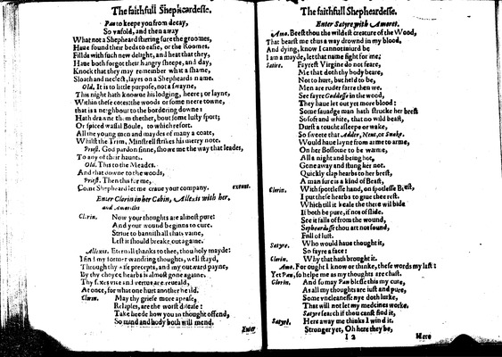

Image 35 (unnumbered page)

*Pan* to keepe you from decay,  
So vnfold, and then away  
What not a Shepheard stirring sure the groomes,  
Haue found their bed• to easie, or the Roomes.  
Fillde with such new delight, and heat that they,  
Haue both forgot their hungry sheepe, and day,  
Knock that they may remember what a shame,  
Sloath and neclect, layes on a Shepheards name.

***Old.***

It is to little purpose, not a swayne,  
This night hath knowne his lodging, heere; or layne,  
Within these cotes: the woods or some neere towne,  
that is a neighbour to the bordering downe:  
Hath drawne them thether, bout some lusty sport;  
Or spiced wassal Boule, to which resort.  
All the young men and maydes of many a coate,  
Whilst the Trim, Minstrell strikes his merry note.

***Priest.***

God pardon sinne, showe me the way that leades,  
To any of their haunts.

***Old.***

This to the Meades.  
And that downe to the woods,

***Priest.***

Then this for me,  
Come Shepheard let me craue your company.

*exeunt.*

*Enter Clorin in her Cabin, Allexis with her• and Amorillis*

***Clorin.***

Now your thoughts are almost pure:  
And your wound beginns to cure.  
Striue to bannish all thats vaine,  
Lest it should breake out againe.

***Allexis.***

Eternall thanks to thee, thou holy mayde:  
I find my former wandring thoughts, well stayd,  
Through thy •ise precepts, and my outward payne,  
By thy choyce hearbs is almost gone againe.  
Thy sexes vice and vertue are reueald,  
At once, for what one hurt another heald.

***Clorin.***

May thy griefe more apease,  
Relapses, are the worst disease:  
Take heede how you in thought offend,  
So mind and body both will mend.

*Unnumbered page  
  
Enter Satyre with Amoret.*

***Amo.***

Beest thou the wildest creature of the Wood,  
That bearst me thus a way drownd in my blood.  
And dying, know I cannot iniurd be  
I am a mayde, let that name fight for me:

***Satire.***

Fayrest Virgine do not feare,  
Me that doth thy body beare,  
Not to hurt, but held to be,  
Men are ruder farre then we.  
See fayre *Goddesse* in the wood,  
They haue let out yet more blood:  
Some sauadge man hath strucke her brest  
So soft and white, that no wild beast,  
Durst a toucht asleepe or wake,  
So sweete that *Adder, Neut,* or *Snake.*  
Would haue layn• from arme to arme,  
On her Bossome to be warme,  
All a night and being hot,  
Gone away and stung her not.  
Quickly clap hearbs to her brest,  
A man sure is a kind of Beast,

***Clorin.***

With spottlesse hand, on spotlesse Brest,  
I put these hearbs to giue thee rest.  
Which till it heale the there wil bide  
If both be pure, if no• of slide.  
See it falls of from the wound,  
*Sepheardesse* thou art not sound,  
Fall of lust.

***Satyre.***

Who would haue thought it,  
So fayre a face:

***Clorin.***

Why that hath brought it.

***Amo.***

For ought I know or thinke, these words my last:  
Yet *Pan,* so helpe me as my thoughts are chast.

***Clorin.***

And so may *Pan* blesse this my cure,  
As all my thoughts are iust and pure,  
Some vncleanesse nye doth lurke,  
That will not let my medcines worke.  
*Satyre* search if thou canst find it,

***Satyre.***

Here away me thinks I wind it.  
Stronger yet, Oh here they be,

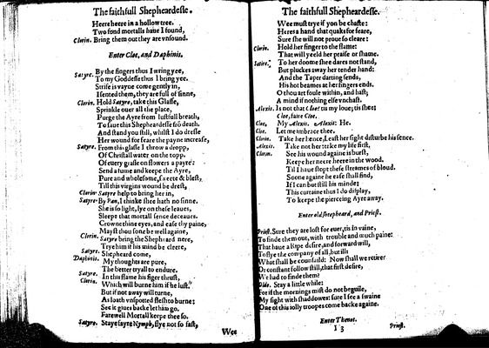

Image 36 (unnumbered page)

Heere heere in a hollow tree.  
Two fond mortalls haue I found,

***Clorin.***

Bring them out they are vnsound.

*Enter Cloe, and Daphinis.*

***Satyre.***

By the fingers thus I wring yee,  
To my Goddesse thus I bring yee.  
Strife is vayne come gently in,  
I sented them, they are full of sinne,

***Clorin.***

Hold *Satyre,* take this Glasse,  
Sprinkle ouer all the place,  
Purge the Ayre from lustfull breath,  
To saue this Shepheardesse frō death.  
And stand you still, whilst I do dresse  
Her wound for feare the payne increase,

***Satyre.***

From this glasse I throw a dropp,  
Of Christall water on the topp.  
Of euery grasse on flowers a payre:  
Send a fume and keepe the Ayre,  
Pure and wholesome, sweete & blest,  
Till this virgins wound be drest,

***Clorin.***

*Satyre* help to bring her in,

***Satyre.***

By *Pan,* I thinke shee hath no sinne.  
She is so light, lye on these leaues,  
Sleepe that mortall sence deceaues.  
Crowne thine eyes, and ease thy paine,  
Mayst thou sone be well againe,

***Clorin.***

*Satyre* bring the Sheph•ard nere,  
Trye him if his mind be cleere,

***Satyre.***

Shepheard come,

***Daphinis.***

My thoughts are pure,  
The better tryall to endure.

***Satyre.***

In this flame his figer thrust,

***Clorin.***

Which will burne him if he lust.  
But if not away will turne,  
As loath vnspotted flesh to burne:  
See it giues backe let him go.  
Farewell Mortall keepe thee so.

***Satyre.***

Stay fayre *Nymph,* flye not so fast,

Unnumbered page  
  
Wee must trye if yon be chaste:  
Heres a hand that quaks for feare,  
Sure she will not proue so cleare:

***Clorin.***

Hold her finger to the flame:  
That will yeeld her praise or shame.

***Satire.***

To her doome shee dares not stand,  
But pluckes away her tender hand:  
And the Taper darting sends,  
His hot beames at her fingers ends.  
O thou art foule within, and hast;  
A mind if nothing else vnchast.

***Alexis.***

Is not that *Cloe*? tis my loue; tis shee:  
*Cloe,* faire *Cloe.*

***Cloe.***

My *Alexis. Alexis*: He.

***Cloe.***

Let me imbrace thee.

***Clorin.***

Take her hence, Least her sight disturbe his sence.

***Alexis.***

Take not her: take my life first.

***Clorin.***

See his wound againe is burst,  
Keepe her neere heere in the wood.  
Til I haue stopt these streames of bloud.  
Soone againe he ease shall find,  
If I can but still his minde:  
This curtaine thus I do display,  
To keepe the pierceing Ayre away.

*Enter old sheepheard, and Priest.*

***Priest.***

Sure they are lost for euer, tis in vaine,  
To finde them out, with trouble and much paine:  
That haue a Ripe desire, and forward will,  
To flye the company of all, but ill:  
What shall be counsaild: Now shall we retire?  
Or constant follow still, that first desire,  
We had to finde them?

***Olde.***

Stay a little while:  
For if the mornings mist do not beguile,  
My sight with shaddowes: sure I see a swaine  
One of this iolly troopes come backe againe.

*Enter Thenot.*

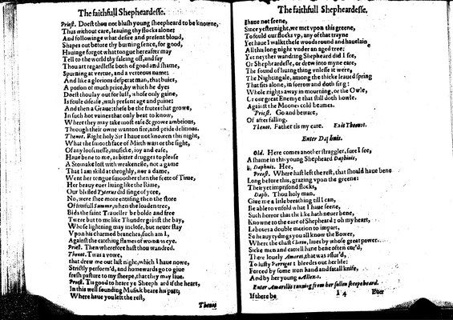

Image 37 (unnumbered page)

***Priest.***

Doest thou not blush young sheepheard to be knowne,  
Thus without care, leauing thy flocks alone:  
And followinge what desire and present bloud,  
Shapes out before thy burning sence, for good,  
Hauinge forgot what tongue hereafter may  
Tell to the world thy faleing off, and say  
Thou art regardlesse both of good and shame,  
Spurning at vertue, and a verteous name:  
And like a glorious desperat man, that buies,  
A poison of much price, by which he dyes  
Doest thou lay out for lust, whose only gaine,  
Is foule disease, with present age and paine:  
And then a Graue: these be the frutes that growe,  
In such hot vaines that only beat to know,  
Where they may take most ease & growe ambtious,  
Through their owne wanton fire, and pride de•itious.

***Thenot.***

Right holy Sir I haue not knowen this night,  
What the smooth face of Mirth was: or the sight,  
Of any loosenesse, musicke, ioy and ease,  
Haue bene to me, as bitter drugges to please  
A Stomake lost with weakenesse, not a game  
That I am skild at throghly, nor a dame,  
Went her tongue smoother then the feete of Time,  
Her beauy euer liuing like the Rime,  
Our blessed *Tyterus* did singe of yore,  
No, were shee more entising then the store  
Of fruitfull *Summr,* when the loaden tree,  
Bids the faint Traueller be bolde and free  
Twere but to me like Thunder gainst the bay,  
Whose lightning may inclose, but neuer stay  
Vpon his charmed branches, such am I,  
Against the catchiug flames of womans eye.

***Priest.***

Then wherefore hast thou wandred.

***Thenot.***

Twas a vowe,  
that drew me out last night, which I haue nowe,  
Strictly perform'd, and homewards go to giue  
fresh pasture to my sheepe, that they may liue.

***Priest.***

Tis good to heare ye Sheeph ard if the heart,  
In this well sounding Musick beare his part;  
Where haue you left the rest,

Unnumbered page  
  
I haue not seene,  
Since yesternight, we met vpon this greene,  
To fould our flocks vp, any of that trayne  
Yet haue I walkt these woods round and hauelaine  
All this long night vnder an aged tree•  
Yet neyther wandring Shepheard did I see,  
Or Shepheardesse, or drew into myne eare,  
The sound of liuing thing vnlesse it were,  
The Nightingale, among the thicke leaued spring  
That fits alone, in sorrow and doth sing:  
Whole nights away in mourning, or the Owle,  
Or our great Enemye that still doth howle.  
Against the Moones cold beames.

***Priest.***

Go and beware,  
Of after falling.

***Thenot.***

Father tis my care.

*Exit Theon•t.*

*Enter Da•hnis.*

***Old.***

Here comes another straggler, sure I see,  
A shame in this young Shepheard *Daphinis,*

***Daphnis.***

Hee,

***Preest.***

Where hast left the rest, that should haue bene  
Long before this, grazing vpon the greene:  
Their yet imprisond flocks,

***Daph.***

Thou holy man.  
Giue me a litle breathing till I can,  
Be able to vnfold what I haue seene,  
Such horror that the like hath neuer bene,  
Knowne to the eare of Shepheard: oh my heart,  
L•bours a double motion to impart,  
So heauy tydings you all know the Bower,  
Where the chast *Clorin,* liues by whose great power,  
Sicke men and cattell hane bene often cur'd,  
There louely *Amoret,* that was assur'd,  
To lusty *Perrigot*: bleedes out her life:  
Forced by some iron hand and fatall knife,  
And by her young *Allex•s.*

*Enter Amarillis running from her s•llen sheepeheard.*

If there be

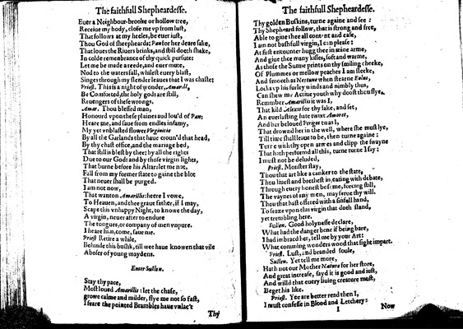

Image 38 (unnumbered page)

Euer a Neighbour-brooke or hollow tree,  
Receiue my body, close me vp from lust,  
That follows at my heeles, be euer iust,  
Thou God of sheepheards: *Pan* for her deare sake,  
That loues the Riuers brinks, and still doeth shake,  
In colde remenbrance of thy quick pursute:  
Let me be made a reede, and euer mute,  
Nod to the waters fall, whilest euery blast,  
Singes through my slender leaues that I was chaste:

***Priest.***

This is a night of wonder, *Amarill,*  
Be Comforted, the holy gods are still,  
Reuengers of these wrongs.

***Amar.***

Thou blessed man,  
Honourd vpon these plaines aud lou'd of *Pan*:  
Heare me, and saue from endles infamy,  
My yet vnblasted flower *Virginitie*  
By all the Garlands that haue croun'd that head,  
By thy chast office, and the mariage bed,  
That still is blest by thee: by all the rights  
Due to our God: and by those virgin lights,  
That burne before his Altar: let me not,  
Fall from my former state to gaine the blot  
That neuer shall be purged.  
I am not now,  
That wanton *Amarillis*: heere I vowe,  
To Heauen, and thee graue father, if I may,  
Scape this vnhappy Night, to knowe the day,  
A virgin, neuer after to endure  
The tongues, or company of men vnpure.  
I heare him, come, saue me.

***Priest***

Retire a while,  
Behinde this bushk, till wee haue knowen that vile  
Aboser of young maydens.

*Enter Sullen.*

Stay thy pace,  
Most loued *Amarillis*: let the chase,  
growe calme and milder, flye me not so fast,  
I feare the pointed Brambles haue vnlac't

Unnumbered page  
  
Thy golden Buskins, turne againe and see:  
Thy Shepheard follow, that is strong and free,  
Able to giue thee all cont•nt and case,  
I am not bashfull virgin, I can please:  
At first encounter hugg thee in mine arme,  
And giue thee many kisses, soft and warme,  
As those the Sunne prints on thy smiling cheeke,  
Of Plummes or mellow peaches I am sleeke,  
And smooth as *Neptune* when stearne *Eolus,*  
Lo•ks vp his surley winds and nimbly thus,  
Can shew my Actiue youth why doost thou flye.  
Remmber *Amarillis* it was I,  
That kild *Alexis* for thy sake, and set,  
An euerlasting hate twixt *Amoret,*  
And her beloued *Perigot* twas I,  
That drownd her in the well, where she must lye,  
Till time shall leaue to be, then turne againe:  
Tur•e with thy open armes and clipp the swayne  
That hath performd all this, turne turne I saye:  
I must not be deluded,

***Priest.***

Monster stay,  
Thou that art like a canker to the state,  
Thou liuest and brethest in, eating with debate,  
Through euery honest bosome, forcing still,  
The vaynes of any men, may serue thy will.  
Thou that hast offered with a sinfull hand,  
To seaze vpon this virgin that doth stand,  
yet trembling here.

***Sullen.***

Good holynesse declare,  
What had the danger bene if being bare,  
I had imbracd her, tell me by your Art:  
What comming wonders wood that fight impart.

***Priest.***

Lust, and branded soule,

***Sullen.***

Yet tell me more,  
Hath not our Mother *Nature* for her store,  
And great increase, sayd it is good and iust,  
And willd that euery liuing creature must,  
Beget his like.

***Priest.***

Yee are better read then I,  
I must confesse in Blood and Letchery:

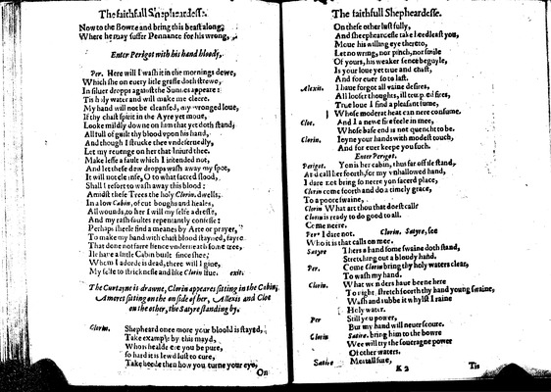

Image 39 (unnumbered page)

Now to the Bowre and bring this beast along,  
Where he may suffer Pennance for his wrong,

*Enter Perigot with his hand bloody,*

***Per.***

Here will I wash it in the mornings dewe,  
Which she on euery litle grasse doth strewe,  
In siluer dropps agai•st the Sunnes appeare:  
Tis holy water and will make me cleere.  
My hand will not be cleansed, my wronged loue,  
If thy chast spirit in the Ayre yet moue,  
Looke mildly downe on him that yet doth stand,  
All •ull of guilt thy blood vpon his hand,  
And though I strucke thee vndeseruedly,  
Let my reuenge on her that Iniurd thee.  
Make lesse a fault which I intended not,  
And let these dew dropps wash away my spot,  
It will not cle•nse, O to what sacred •lood,  
Shall I resort to wash away this blood:  
Amidst these Trees the holy *Clorin.* dwells,  
In a low *Cabin,* of cut boughs and heales,  
All wounds, to her I will my selfe a dresse,  
And my rash•faultes repentantly confesse:  
Perhaps sheele find a meanes by Arte or prayer,  
To make my hand with chast blood stayned, fayre  
That done not farre hence vnderneath some tree,  
Ile ha•e a little Cabin built since shee,  
Whom I adorde is dead, there will I giue,  
My selfe to stricknesse and like *Clorin* liue.

*exit.*

*The Curtayne is drawne, Clorin appeares sitting in the Cabin, Amoret sitting on the on side of her, Allexis and Cloe on the other, the Satyre standing by.*

***Glorin.***

Shepheard once more your bloold is stayed,  
Take example by this mayd,  
Who is healde e•e you be pure,  
so hard it is lewd lust to cure,  
Take heede then how you turne your eye•

Unnumbered page  
  
On these other lust fully,  
And sheephear•esse take •eedleast you,  
Moue his willing eye thereto,  
Let no wring, nor pinch, nor smile  
Of yours, his weaker sence beguyle,  
Is your loue yet true and chast,  
And for euer so to last.

***Alexis.***

I haue forgot all vaine desires,  
All looser thoughts, ill temp•ed fires,  
True loue I find a pleasant •ume,  
Whose moderat heat can nere consume.

***Cloe.***

And I a newe fire feele in mee,  
Whose base end is not quencht to be.

***Clorin.***

Ioyne your hands with modest touch,  
And for euer keepe you such.

*Enter Perigot.*

***Perigot.***

Yon is her cabin, thus far off ile stand,  
And call her foorth, for my vnhallowed hand,  
I dare not bring so neere yo• sacerd place,  
*Clorin* come foorth and do a timely grace,  
To a poore swaine,

***Clorin***

What art thou that doest call?  
*Clorin* is ready to do good to all.  
Come neere.

***Per•***

I dare not. *Clorin. Satyre,* see  
Who it is that calls on mee.

***Satyre***

Thers a hand some swaine doth stand,  
Stretching out a bloudy hand.

***Per.***

Come *Clorin* bring thy holy waters clear,  
To wash my hand.

***Clorin.***

What w•nders haue beene here  
To night stretch •oorth thy hand young swaine,  
Wash and •ubbe it whylst I raine  
Holy water.

***Per***

Still you power,  
But my hand will neuer scoure.

***Clorin***

*Satire•* bring him to the bowre  
Wee will try the soueragne power  
Of other waters.

***Satire***

Mo•tall su•e,

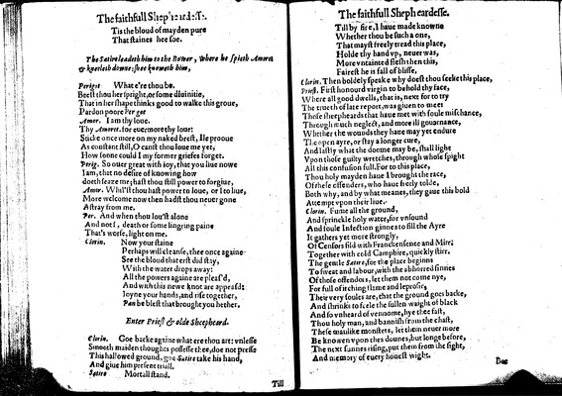

Image 40 (unnumbered page)

Tis the bloud of mayden pure  
That staines hee soe.

*The Satire leadeth him to the Bower, where he spieth Amoret & kneeleth downe: shee knoweth him,*

***Perigot***

What e're thou be.  
Beest thou her spright, or some diuinitie,  
That in her shape thinks good to walke this groue,  
Pardon poore *Per•got*

***Amor.***

I am thy loue.  
Thy *Amoret.* for euermore thy loue:  
Sticke once more on my naked brest, Ile prooue  
As constant still, O canst thou loue me yet,  
How soone could I my former griefes forget.

***Perig.***

So ouer great with ioy, that you liue nowe  
I am, that no desire of knowing how  
doeth seaze me; hast thou still power to forgiue,

***Amor.***

Whil'st thou hast power to loue, or I to liue,  
More welcome now then hadst thou neuer gone  
A stray from me.

***Per.***

And when thou lou'st alone  
And not •, death or some lingring pain•  
That's worse, light on me.

***Clorin.***

Now your staine  
Perhaps will cleanse, thee once againe  
See the bloud that erst did stay,  
With the water drops away:  
All the powers againe are pleas'd,  
And with this newe knot are appeasd:  
Ioyne your hands, and rise together,  
*Pan* be blest that brought you hether.

*Enter Priest & olde Sheepheard.*

***Clorin.***

Goe backe againe what ere thou art: vnlesse  
Smooth maiden thoughts possesse thee, doe not presse  
This hallowed ground, goe *Satire* take his hand,  
And giue him present triall.

***Satire***

Mortall stand.

Unnumbered page  
  
Till by fire, I haue made knowne  
Whether thou be such a one,  
That mayst freely tread this place,  
Holde thy hand vp, neuer was,  
More vntainted flesh then this,  
Fairest he is fall of blisse.

***Clorin.***

Then boldely speake why doest thou seeke this place,

***Priest.***

First honourd virgin to behold thy face,  
Where all good dwells, that is, next for to try  
The trueth of late report, was giuen to mee:  
Those sheepheards that haue met with •oule mischance,  
Through much neglect, and more ill gouernance,  
Whether the wounds they haue may yet endure  
The open ayre, or stay a longer cure,  
And lastly what the doome may be, shall light  
Vpon those guilty wretches, through whose spight  
All this confusion full. For to this place,  
Thou holy mayden haue I brought the race,  
Of these offenders, who haue freely tolde,  
Both why, and by what meanes, they gaue this bold  
Attempt vpon their liue.

***Clorin.***

Fume all the ground,  
And sprinckle holy water, for vnsound  
And foule Infection ginnes to fill the Ayre  
It gathers yet more strongly,  
Of Censors fild with Franckensence and Mirr.  
Together with cold Camphire, quickly stirr.  
The gentle *Satire,* for the place beginns  
To sweat and labour, with the abhorred sinnes  
Of those offendors, let them not come nye,  
For full of itching flame and leprosie,  
Their very soules are, that the ground goes backe,  
And shrinks to feele the •ullen waight of black  
And so vnheard of vennome, hye thee fast,  
Thou holy man, and bannish from the chast,  
These manlike monsters, let them neuer more  
Be knowen vpon thes dounes, but longe before,  
The next sunnes rising, put them from the sight,  
And memory of euery honest wight.

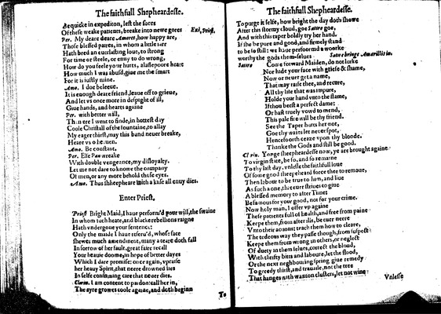

Image 41 (unnumbered page)

Be quicke in expedition, lest the sores  
Of these weake patients, breake into newe gores

*Exi• Priest.*

***Per.***

My deare deare *Amoret,* how happy are,  
Those blessed paires, in whom a little l•rr  
Hath bred an euerlasting loue, to strong  
For time or steele, or enuy to do wrong,  
How do you feele your hurts, a lasse poore heart  
How much I was abusd, giue me the smart  
For it is iustly mine.

***Amo.***

I doe beleeue.  
It is enough deare friend, leaue off to grieue,  
And let vs once more in despight of ill,  
Giue hands, and hearts againe

***Per.***

with better will,  
Th•n ere I went to finde, in hottest day  
Coole Christ all of the fountaine, to allay  
My eager thirst, may this band neuer breake,  
Heare vs o heauen.

***Amo.***

Be constant.

***Per.***

Else *Pan* wreake  
With double vengeance, my disloyalty.  
Let me not dare to knowe the company  
Of men, or any more behold those eyes.

***Amo.***

Thus shheepheare with a kisse all enuy dies.

*Enter Priest.*

***Priest***

Bright Maid, I haue perform'd your will, the swaine  
In whom such heate, and blacke rebellions raigne  
Hath vndergone your sentence:  
Only the maide I haue reseru'd, whose face  
shewes much amendment, many a teare doth fall  
In sorrow of her fault, great faire recall  
Your heauie doome, in hope of better dayes  
Which I dare promise: once again, vpraise  
her heauy Spirit, that neere drowned lies  
In selfe cons•ming care that neuer dies.

***Clorin.***

I am content to pardon: call her in,  
The ayre growes coole againe, and doth beginn

Unnumbered page  
  
To purge it selfe, how bright the day doth showe  
After this stormy cloud, goe *Satire* goe,  
And with this taper boldly try her hand.  
If she be pure and good, and firmely stand  
to be so still: we haue perfoormd a woorke  
worthy the gods them-selues

*Satire brings Amarillis in.*

***Satire***

Come forward Maiden, do not lurke  
Nor hide your face with griefe & shame,  
Now or neuer get a name,  
That may raise thee, and recure,  
All thy li•e that was impure,  
Holde your hand vnto the flame,  
If thou beest a perfect dame:  
Or hast truely vowd to mend,  
This pale fire will be thy friend.  
See the Taper hurts her not,  
Goe thy waies let neuer spot,  
Hencefoorth ceaze vpon thy bloode.  
Thanke the Gods and still be good.

***Cl•rin.***

Yonge sheepheardesse now, ye are brought againe  
To virgin state, be so, and so remaine  
To thy last day, vnlesse the faithfull loue  
Of some good sheepeheard force thee to remoue,  
Then labour to be true to him, and liue  
As such a one, that euer striues to giue  
A blessed memory to after Time:  
Be famous for your good, not for your crime.  
Now holy man, I offer vp againe  
These patients full of health, and free from paine  
Keepe them, from after ills, be euer neere  
Vnto their actions: teach them how to cleare,  
The tedeous way they passe though, from suspect  
Keepe them from wrong in others, or neglect  
Of duety in them selues, correct the bloud,  
With thrifty bitts and laboure, let the flood,  
Or the next neghbouring spring giue remedy  
To greedy thirst, and trauaile, not the tree  
That hanges with wanton clusters, let not wine

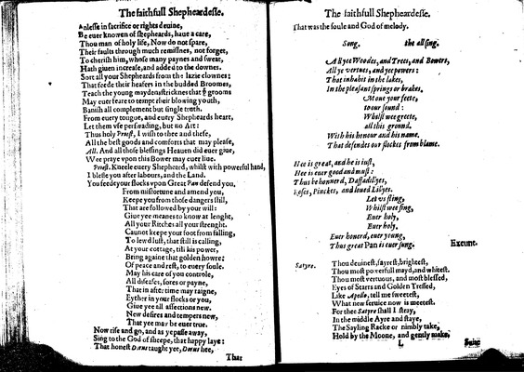

Image 42 (unnumbered page)

•nlesse in sacrifice or rights deuine,  
Be euer knowen of shepheards, haue a care,  
Thou man of holy life, Now do not spare,  
Their faults through much remissnes, not forget,  
To cherish him, whose many paynes and sweat,  
Hath giuen increase, and added to the downes.  
Sort all your Shepheards from the lazie clownes:  
That feede their heafers in the budded Broomes,  
Teach the young maydens tricknes that ye grooms  
May euer feare to tempt their blowing youth,  
Banish all complement but single truth.  
From euery tongue, and euery Shepheards heart,  
Let them vse perswading, but no Art:  
Thus holy *Priest,* I wish to thee and these,  
All the best goods and comforts that may please,

***All.***

And all those blessings Heauen did euer giue,  
Wee praye vpon this Bower may euer liue.

***Priest.***

Kneele euery Shepheard, whilst with powerful hand,  
I blesse you after labours, and the Land.  
You feede your flocks vpon Great *Pan* defend you.  
From misfortune and amend you,  
Keepe you from those dangers still,  
That are followed by your will:  
Giue yee meanes to know at lenght,  
All your Ritches all your strenght.  
Cannot keepe your foot from falling,  
To lewd lust, that still is calling,  
At your cottage, till his power,  
Bring againe that golden howre:  
Of peace and rest, to euery soule.  
May his care of you controle,  
All diseases, sores or payne,  
That in after time may raigne,  
Eyther in your flocks or you,  
Giue yee all affections new.  
New desires and tempers new,  
That yee may be euer true.  
Now rise and go, and as ye passe away,  
Sing to the God of sheepe, that happy laye:  
That honest *D•rus* taught yee, *Dorus* hee,

Unnumbered page  
  
That was the soule and God of melody.

**Song.**

*the all sing.*

All yee Woodes, and Trees, and Bowers,  
All ye vertues, and yee powers:  
That inhabit in the lakes,  
In the pleasant springs or brakes.  
Moue your feete,  
to our sound:  
Whilst wee greete,  
all this ground.  
With his honour and his name.  
That defendes our flockes from blame.  
  
  
Hee is great, and he is iust,  
Hee is euer good and must:  
Thus be honnerd, Daffadillyes,  
Roses, Pinckes, and loued Lillyes.  
Let vs fling,  
Whilst wee sing,  
Euer holy,  
Euer holy.  
Euer honerd, euer young,  
Thus great *Pan* is euer sung.

*Exeunt.*

***Satyre.***

Thou deuinest, fayrest, brightest,  
Thou most powerfull mayd, and whitest.  
Thou most vertuous, and most blessed,  
Eyes of Starrs and Golden Tressed,  
Like *Apollo,* tell me sweetest,  
What new seruice now is meetest.  
For thee *Satyre* shall I stray,  
In the middle Ayre and staye,  
Thy Sayling Racke or nimbly take,  
Hold by the Moone, and gently make.

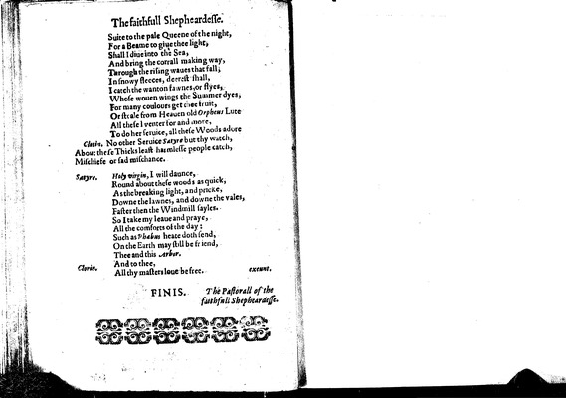

Image 43 (unnumbered page)

Suite to the pale Queene of the night,  
For a Beame to giue thee light,  
Shall I diue into the Sea,  
And bring the corrall making way,  
Through the rising waues that fall,  
In snowy fleeces, deerest shall,  
I catch the wanton fawnes, or flyes,  
Whose wouen wings the Summer dyes,  
For many coulours get thee fruit,  
Or steale from Heauen old *Orpheus* Lute  
All these I venter for and more,  
To do her seruice, all these Woods adore

***Clorin.***

No other Seruice *Satyre* but thy watch,  
About these Thicks least harmlesse people catch,  
Mischiefe or sad mischance.

***Satyre.***

*Holy virgin,* I will daunce,  
Round about these woods as quick,  
As the breaking light, and pricke,  
Downe the lawnes, and downe the vales,  
Faster then the Windmill sayles.  
So I take my leaue and praye,  
All the comforts of the day:  
Such as *Phaebus* heate doth send,  
On the Earth may still be friend,  
Thee and this *Arbor.*

***Clorin.***

And to thee,  
All thy masters loue be free.

*exeunt.*

*The Pastorall of the faithfull Shepheardesse.*

    FINIS.