QUICK START
TrainerMate essentials
Set up Zoom and your provider, then let TrainerMate prepare supported FOBS joining details.
The short version: Sign in to TrainerMate, connect every Zoom account you use, add each provider, then run your first course check.

Five-minute setup

1. Install and sign in
Use your TrainerMate ID and TrainerMate password.

2. Connect Zoom
Sign in on Zoom's own website, then approve TrainerMate. Repeat if you use more than one Zoom account.

3. Add your provider
Choose the provider, pair its Zoom account and enter the provider's FOBS username and password.

4. Let TrainerMate test the login
The test happens when you add the provider. Wait for Ready before continuing.

5. Run your first check
TrainerMate checks upcoming courses, existing Zoom details and supported FOBS records.
Keep in mind: TrainerMate helps with repeated admin. Always make your final professional check before delivering a course.

1. Install and sign in
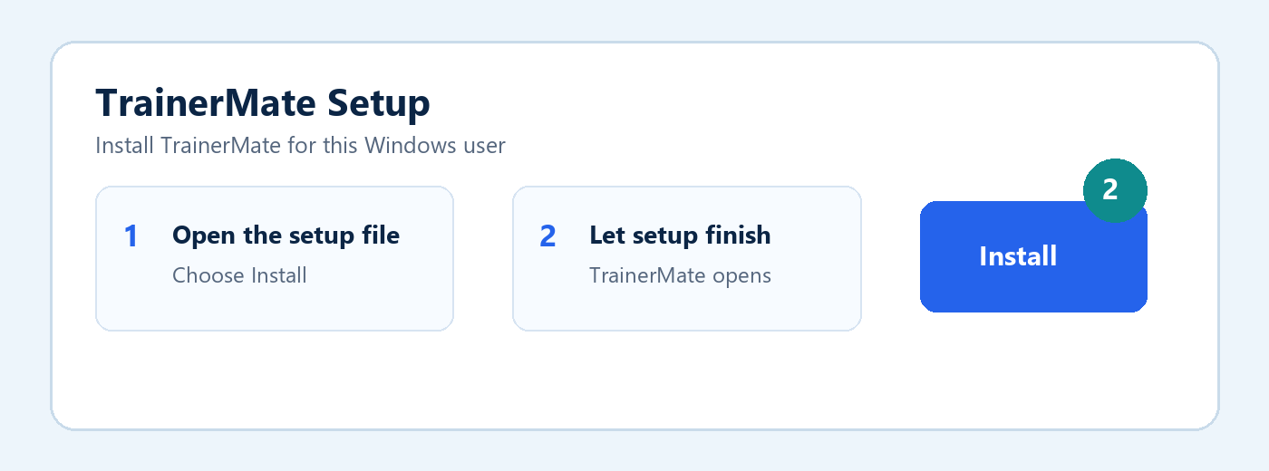

1. Open the downloaded setup file
The file name starts with TrainerMate Setup.

2. Choose Install
Existing TrainerMate profiles are kept when updating.

3. Log in to TrainerMate
Enter the TrainerMate ID and password created for the TrainerMate app.
Do not use here: Your Zoom password or FOBS password. Those belong to their own services.

2. Connect Zoom
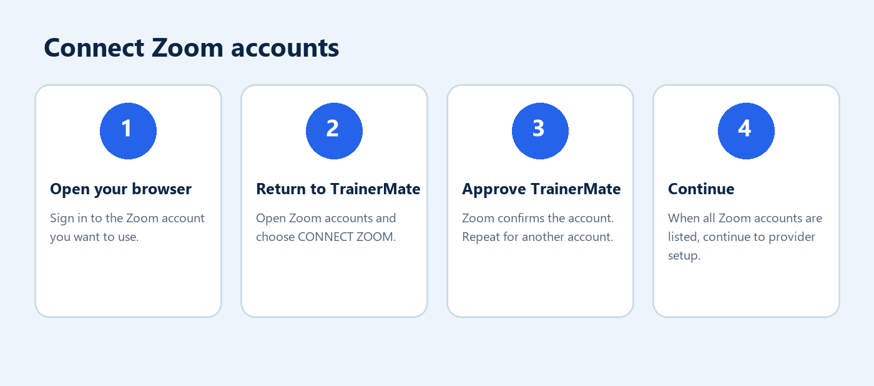
Your Zoom password stays with Zoom: TrainerMate sends you to Zoom's own approval page. TrainerMate never asks you to type your Zoom password into the app.

When you use more than one Zoom account
Connect each Zoom account before moving to provider setup. When all accounts appear in the list, choose Continue to provider setup.
Connected means confirmed: An account appears as connected only after Zoom has completed the approval.

3. Add a provider
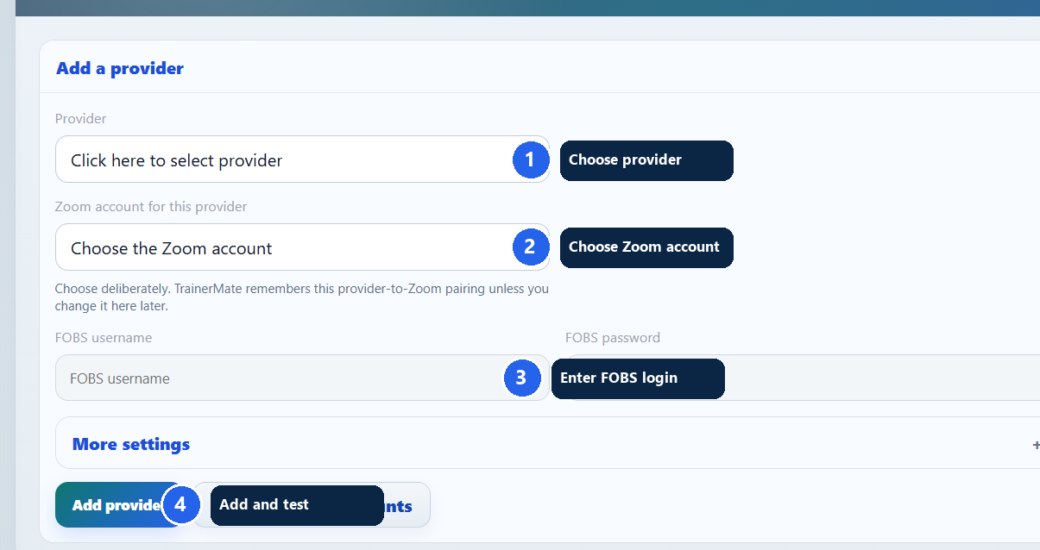

1. Choose the provider
Select the provider from the dropdown.

2. Choose its Zoom account
Select the Zoom account TrainerMate should use for this provider.

3. Enter the FOBS login
Use the username and password you normally use on that provider's FOBS website.

4. Choose Add and test provider
TrainerMate saves the details and tests the login in one action. This can take a little while.
Wait for the result: Ready means the provider login worked. If it does not, check the FOBS username and password and try again.

4. Everyday use

Run a course check
Open Dashboard and choose the full check or a shorter check. The progress panel shows which provider and course TrainerMate is checking.

What TrainerMate checks
- Upcoming courses on your connected provider portals.
- Whether a suitable Zoom meeting already exists.
- Whether supported FOBS joining details match the linked Zoom meeting.
- Whether something genuinely needs your attention.

If a check stops
Your saved courses and settings remain safe. Read the message shown, correct only what it asks for, then run the check again.
Avoid duplicate meetings: TrainerMate uses the Zoom meeting ID and saved link when matching courses, not only the course title.

Certificates (additional benefit)
Use Certificates to view expiry reminders and manage uploads for supported providers. This sits alongside the main Zoom and FOBS workflow.

FAQ: which login do I use?
Login | Where it is used | What to enter
TrainerMate | TrainerMate app sign-in | Your TrainerMate ID and TrainerMate password
Zoom | Zoom website approval page | Your normal Zoom email/sign-in and Zoom password
FOBS | Provider setup in TrainerMate | The username and password for that provider's FOBS website
Windows | Your computer | Your normal Windows sign-in; it is not a TrainerMate login

Why does my TrainerMate login not work on FOBS?
They are separate accounts. Use the login issued by that provider on its FOBS website.

Does TrainerMate know my Zoom password?
No. You sign in and approve TrainerMate on Zoom's own website.

I use two Zoom accounts. What should I do?
Connect both Zoom accounts first. When adding each provider, choose the correct Zoom account from the dropdown.

Why is TrainerMate testing my provider login?
It confirms the saved FOBS details work before a course check starts, reducing repeated failed login attempts.

The account service is taking time to start. Is that normal?
Yes. The online service can take a little while to wake. TrainerMate will keep the main app closed until sign-in is ready or clearly explain what to do.

A provider login failed. Is my data lost?
No. Correct the FOBS username or password, then use Add and test provider or Save and test login again.

Where do I get help?
Open Help in TrainerMate. Messages sent there reach TrainerMate support and replies appear in the app.

