Using Git-Gui For Pythoncad Repository

Open Git-Gui
{
(on Linux Mec os) Start Git-Gui From The shell
Linux :…. Girasole$: git-gui
(On Windows) With the right click on the folder -> GitGuiHere
}
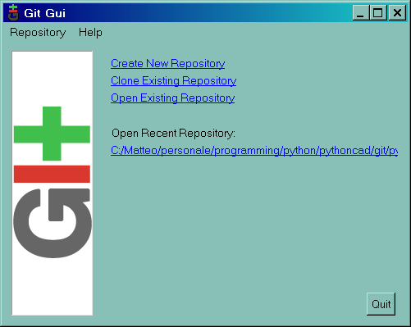

Clone Exsisting Repository

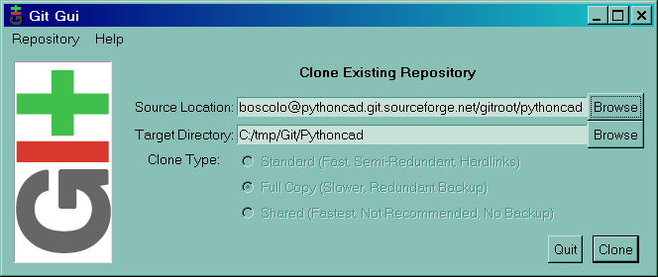

Source Location (Linux): ssh://matteoboscolo@pythoncad.git.sourceforge.net/gitroot/pythoncad/pythoncad
Source Location (Windows): ssh://matteoboscolo@pythoncad.git.sourceforge.net/gitroot/pythoncad/pythoncad/

Target Directory: Your Working directory..

Instead of matteoboscolo use your sourceforgeUser then ->Clone
After that you will receive a copy of All the source file in your local directory.

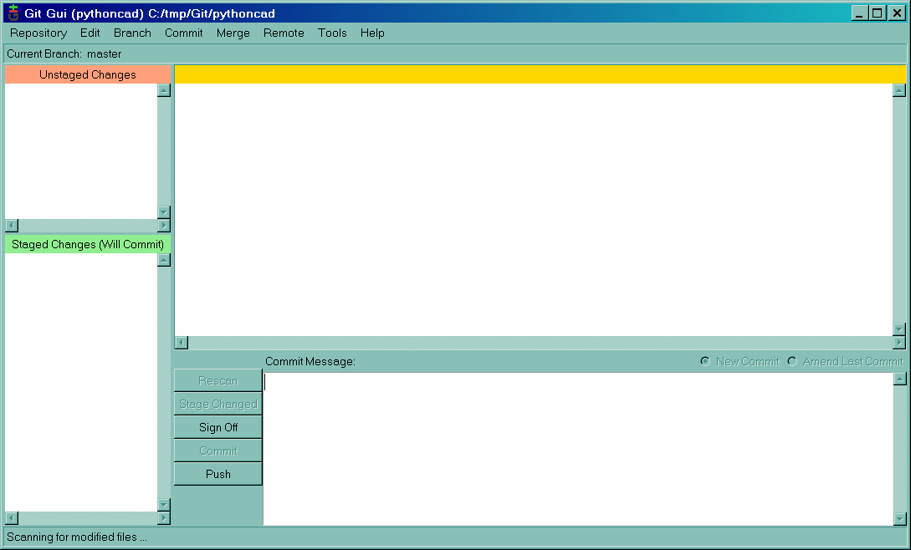

Now you folder is updated..

But the branch is master so we need to set R37 for uploading modification..

So Lets create a new branch…
Branch->Create
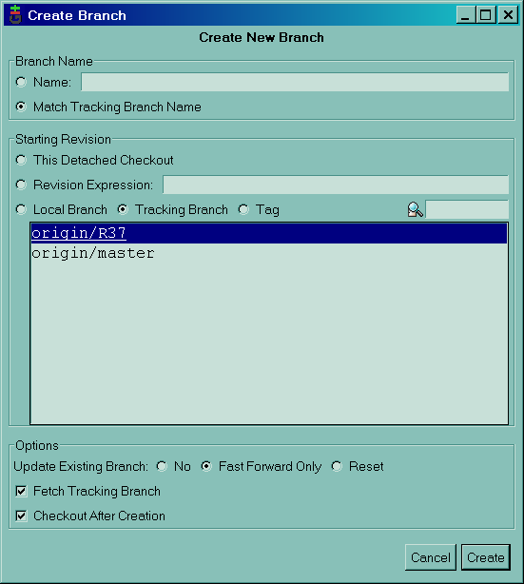

After Create command the R37 Branch will be created and you can see it in the main form

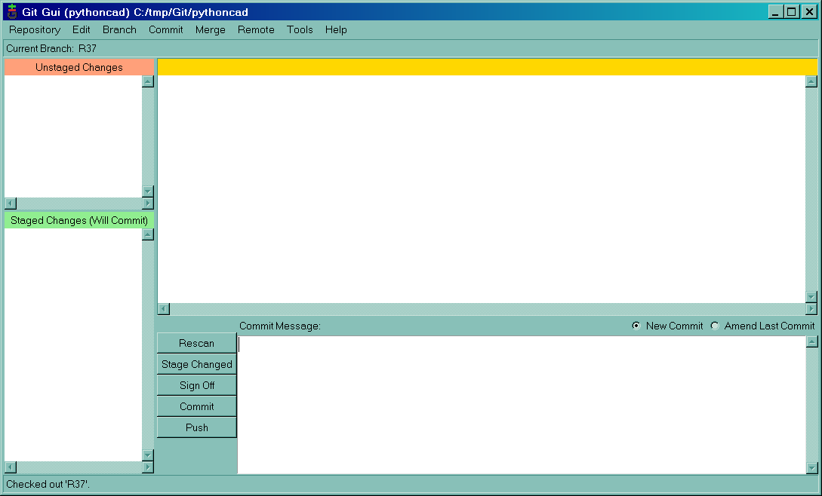

From Now Your Repository is ap to date with the server repository and you can Modifie the file under the Local folder.

In the git repository there is a file named pippo.txt … This file is placed there only for git testing … so you can modifie it.. and save

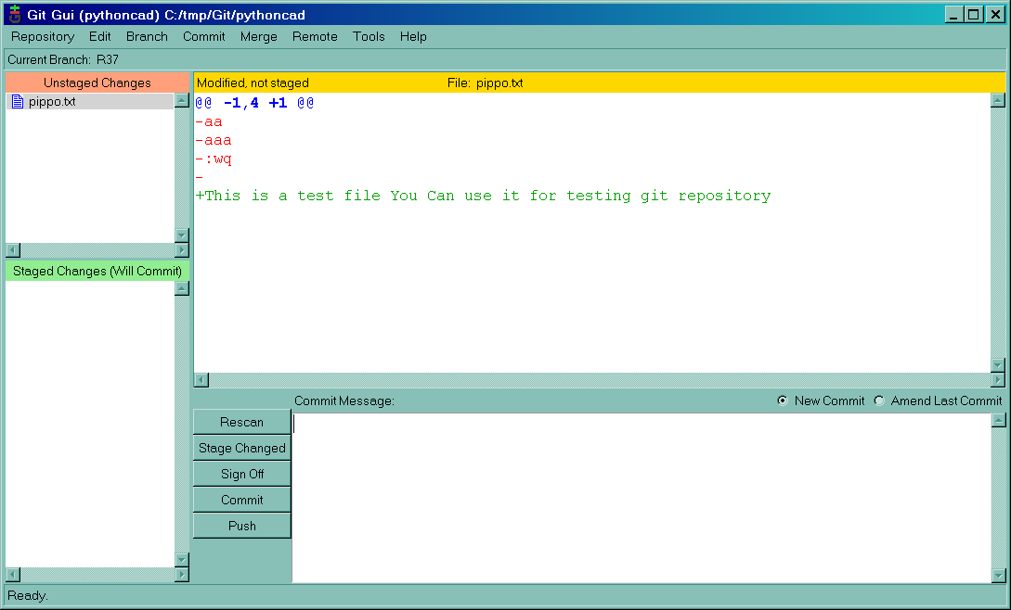
1

2

After the file is saved.. just Click on the rescan button
An in the Unstaged View the file will appare.

Double Click in the pippo.txt image and you get :

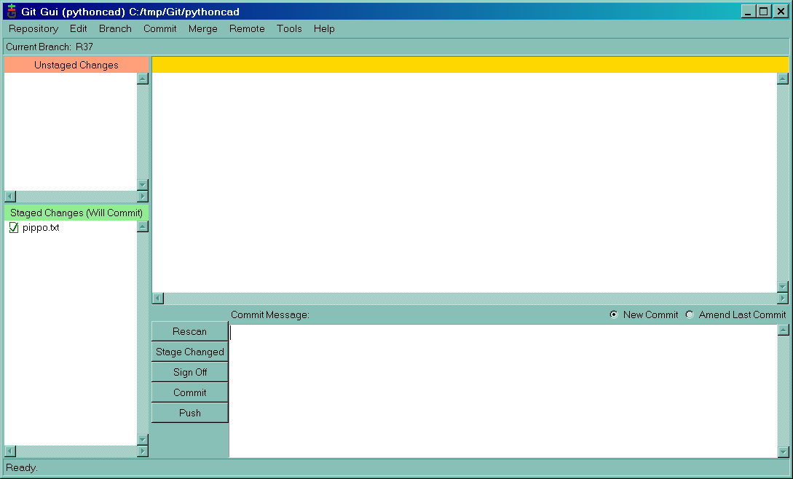
Write a message
Commit the changed

Write some Comment in the commit Message and the click on the commit Button.
Now you have committed the modification only on your local repository…
You need to use the push update command to Push your modification on the server..

Select R37 Branch

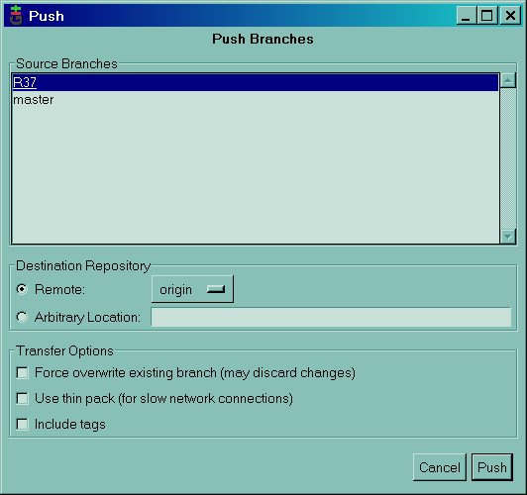

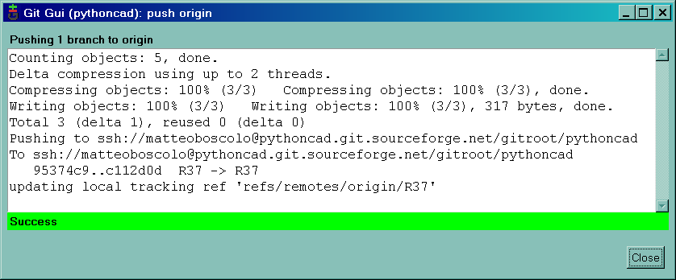

Attention to set properly the UserName and emailAddress for both Pythoncad rep and
Global Rep…
To se this dialog go to edit->option
Do Not Use My Account ☺

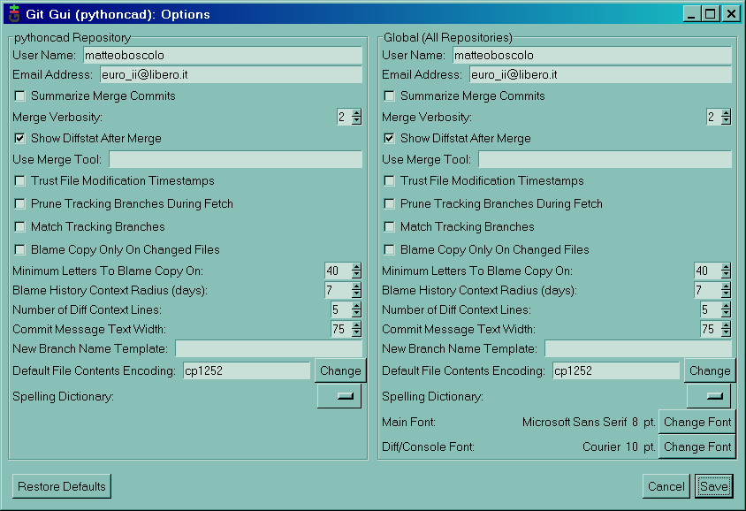

During all this operation the git-gui ask to you for a pws ..

In Linux you have to type it in shell

In Windows you have putty that prompt an inputbox ..

So if nothing appends maybe git-gui is waiting for a pws

