Honours Research & Project Methods: Project Proposal Marking and Feedback

Student: ...Sample A......................

Criteria & Feedback Commentary | Possible marks  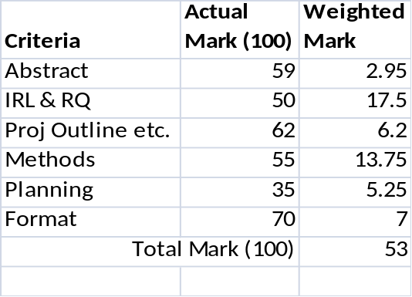
Abstract | 5
A reasonable abstract and reasonable quality of academic writing (I have ignored some minor English grammatical issues) A good ILR summary, but too much of the abstract is taken up with it. Thus whilst you give details of the development methodology, you have missed out the specific investigatory nature of the project. The envisaged results is not how the application may help individuals but should be your evaluation of the approaches you have used in manipulation open data to extract useful information. | 5
Introduction: Initial Review of Literature and Research Question | 35
16 cited references suggests a reasonable effort at obtaining an initial body of research. Also an Additional Bibliography shows extra overall engagement with the literature. You have not put the word count for your ILR at the end of the section. At 934 words it is too short and so will suffer a penalty of maximum of 50%. Setting that aside, you provide clear evidence that there is currently a real problem to be investigated and persuade the reader that what you're doing is important and relevant. However, it is mostly just the problem and not your possible application solutions which you might be incorporating in your development. Still the writing style is good and if you had made the word limit then it could have been a 65% ish mark for its general quality. The RQ is concentrating on the application itself rather than the open data processing approach which you are investigating. | 35
Introduction: Project Outline, Aim and Objectives | 10
A project's aim has to be to investigate something, you have stated more as to develop an application! Personally I don't think that a pre-interview with International students is required. Presumably you can develop the requirements, more informally, from your own experience and then just evaluate it post development with a target population (and you can do it with less students, i.e. around 10 should be sufficient). The project objectives are quite well explained although they could be described more SMARTly. You should also have numbered them SO1, PO1 etc. | 10
Methods | 25
The guidance explicitly asked for 3 key authors, 3 International Journal Titles and 3 Annual International Conferences which you think are relevant to your project topic and which you could "search within/for" as you start your main project literature review. You have 4 journals and 2 conferences, but I won't penalise). Students were asked to give information about each type of potential source in this sub-section, e.g. what type of research does your Journal/Conference accept publications in, why is that relevant to your project; who published the journal/organises the conference; how many years has the source been publishing/running? You haven't given me all of that detail only bits and pieces. In the Primary Method section, you haven't given the complete "picture" of the more detailed outline, only some general commentary about supplementary methods. | 25
Planning: Risks, Resources and Ethical Issues | 15
You have not presented the risks and resources in the correct tabular format (in terms of content) indicated in the last paragraph of section 6.1.6 on page 61 of the (Yellow) Honours Project Study Guide booklet. I am looking for only one single main risk for each primary objective/task. These risks are not directly associated with your POs (of which there were only 4). The risks themselves and the plans are too vague anyway. You have to specify the actual resources you will need, e.g. you must tell me what development software you will be using, not that you will need to obtain suitable software. Clear and analysis of ethical issues with good detail. Like a number of students do you have included "what you did in the proposal development" in your project plan. In your proposal you plan the project, not plan the proposal! The plan should start from immediately after the proposal is handed in! The tasks in your plan are not the same as the objectives you had identified in your section 1.3. It is basically just a general (but more detailed) Mr X version! | 15
Format | 10
Generally good academic style in the writing and well formatted report. However, should use single spacing and take a new page for each new chapter within the Report. | 10
General Comments (if any) | N/A
Total | 100

