Honours Research & Project Methods: Project Proposal Marking and Feedback

Student: .... Sample D.....................

Criteria & Feedback Commentary | Possible marks  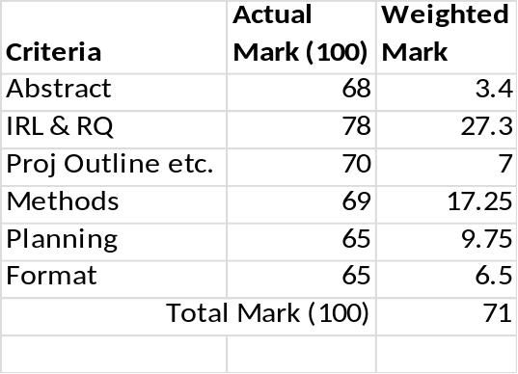
Abstract | 5
The Abstract is "well balanced" with approx. 30-40% of its word count for both your "introduction/Justification" and your actual Project/Methodology. I liked you into part as it showed me that you had clearly “learned” from the tutorial week 4 exercises. It was a pity that you didn’t then clearly state the aim of the project and its experimental approach, although it is fairly clear as an outline. For the final “envisaged results” you have told me the "answer" you expect from your project, not ways in which the results could be utilised to benefit stakeholders. | 5
Introduction: Initial Review of Literature and Research Question | 35
23 cited references suggest a very creditable effort at obtaining an initial body of research. Your use of in-text citations to support your argument was excellent, a real exemplar for other students! You provide clear evidence that there is currently a real problem to be investigated and persuade the reader that what you're doing is important and relevant. It had a real “research” feel. Possibly you spent a little too much early on about music in general, but really excellent overall. A very well refined research question which meets all of the criteria from HRPM Tutorial 5. | 35
Introduction: Project Outline, Aim and Objectives | 10
The project’s aim is very clear stated in detail and the objectives identify good “stepping stones”/tasks for your project. You should have labelled your objectives (secondary and primary) for later ease of reference in your planning section. You could also have expressed the bullet description of each (particularly the SOs more SMARTly). However, you extra explanation gives a bit clearer detail. | 10
Methods | 25
The guidance explicitly asked for 3 key authors, 3 International Journal Titles and 3 Annual International Conferences which you think are relevant to your project topic and which you could "search within/for" as you start your main project literature review. Whilst your basic commentary on each secondary source is good, you haven't given me all of the specific information such as journal publisher, when publication started, conference organisers, how many years it has been running for. You have also actually given me 6 authors (not 3)! There is good use of citations to support the methods used in the project. However, you should really have taken each PO and detailed each further rather than just concentrating on the key elements of the methodology and its evaluation (although this was excellent content). | 25
Planning: Risks, Resources and Ethical Issues | 15
You have fully followed the presentation of the risks and resources in the tabular format indicated in the last paragraph of section 6.1.6 on page 61 of the (Yellow) Honours Project Study Guide booklet. Whilst some of the commentary is a bit more like a “To-do list” (although some are plans, just a bit “high level”) you are demonstrates an good basic understanding on the logistics of undertaking the project. Clear and analysis of ethical issues with good detail. Good basic gantt chart plan. Your plan should have the task id as well as the textual description. | 15
Format | 10
Your citations are not all correct, i.e. you must use et. al. for more than two authors). The bibliography has very good attention to detail though. Very clear narrative style, very easy to read and understand. Generally very good academic style in the writing. You have fully followed the specified structure and headings. There are minor aspects of formatting which make it look a little untidy though: Use “full margin” justification throughout the document. Use more distinguishing fonts/type size for heading and sub-headings. | 10
General Comments (if any) | N/A
The quality of the proposal suggests that the student has the potential to conduct a high quality project. Just a little bit more consistency in the attention to detail and you would have got higher marks. | N/A
Total | 100

