Honours Research & Project Methods: Project Proposal Marking and Feedback

Student: .....Sample B....................

Criteria & Feedback Commentary | Possible marks  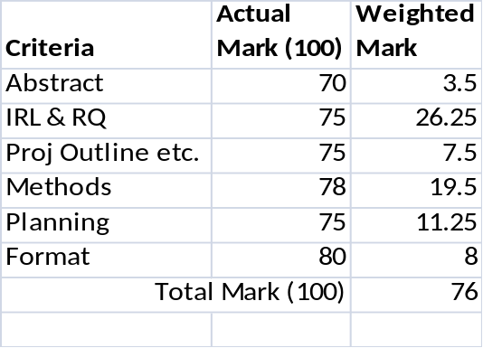
Abstract | 5
Overall a very good abstract. The methodology element doesn't quite say what game application will be developed and also the specific investigatory aspect of the project. Still excellent though. | 5
Introduction: Initial Review of Literature and Research Question | 35
34 cited references suggests an excellent effort at obtaining an initial body of research. Overall this is a really excellent effort. Your use of in-text citations to support your argument was excellent, a real exemplar for other students! You provide clear evidence that there is currently a real problem to be investigated and persuade the reader that what you're doing is important and relevant. Lots of "argument" being presented, lots of "conclusions" and "connections" being made. Your RQ though doesn't really do the detail in your ILR justice though. I now the detail of the application/technology being used and so why isn't that in the RQ? | 35
Introduction: Project Outline, Aim and Objectives | 10
The project’s aim is very clear stated in detail and the objectives identify good “stepping stones”/tasks for your project. Generally specify with clarity in what you are trying to achieve. Excellent detail again. | 10
Methods | 25
The guidance explicitly asked for 3 key authors, 3 International Journal Titles and 3 Annual International Conferences which you think are relevant to your project topic and which you could "search within/for" as you start your main project literature review. You have given me an excellent commentary on each of yours. There is a good discursive justification for the primary method used. There is good use of citations to support the methods used in the project. A good amount of extra detail. You seem to have taken on board all of the key points from the guidance material provided. It is this sort of result from a student which makes me feel that me producing such large amounts of material is worthwhile! | 25
Planning: Risks, Resources and Ethical Issues | 15
You have fully followed the presentation of the risks and resources in the tabular format indicated in the last paragraph of section 6.1.6 on page 61 of the (Yellow) Honours Project Study Guide booklet. You have clearly identified the main risk and associated resources for each of your Primary Research Phase Objectives. The identified risk for each separate objective is all highly relevant. The contingency plan for dealing with each risk demonstrates an excellent understanding by the student on the logistics of undertaking the project. Clear and analysis of ethical issues with good detail. It is also good to see that you have recognised that the interim report is not simply the main literature review and that you are intending to undertake/commence some of your Primary Research Phase tasks before that milestone's deadline. Very clear plan. | 15
Format | 10
An excellently formatted and presented document. Very clear narrative style, very easy to read and understand. Generally good academic style in the writing. Care and attention clearly given to the formatting of citations and references EXCEPT that your references are not listed in alpha order by author as is the Harvard requirement! This lowers your score here in an otherwise exemplary effort. | 10
General Comments (if any) | N/A
The quality of the proposal suggests that the student has the potential to conduct a high quality project. | N/A
Total | 100

