# **Project Organization**

## Systems Lifecycle

During the development of Raid Cinemas Online website, we have decided to take and Agile approach to development in the form of scrum. We have chosen to use this lifecycle because of its iterative development, customer involvement and scope for improvement.

Scrum is a form of agile development which we will be using during the project. Scrum begins with the Product Owner creating a priority list of user stories in the form of a project backlog. These use stories are the features that the system should have in order to satisfy the scenario and they are placed in priority order and the highest priority order stories are placed in the sprint backlog. Estimates are also made in terms of timescale of the finished product after all user stories have been decided.

There are three key roles in scrum. The Product Owner, the Scrum Master and the Team. The Product Owner is usually the key stakeholder in the project. He is responsible for providing the desired features and vision for the project, also deciding which of them is most important. The Scrum Master is the person who make sure the team is on track and where it needs to be. He motivates the team and tries to keep a high morale throughout the project. The Team is just all the people who are involve in developing the system. It can be anything from the programmers to graphic designers.

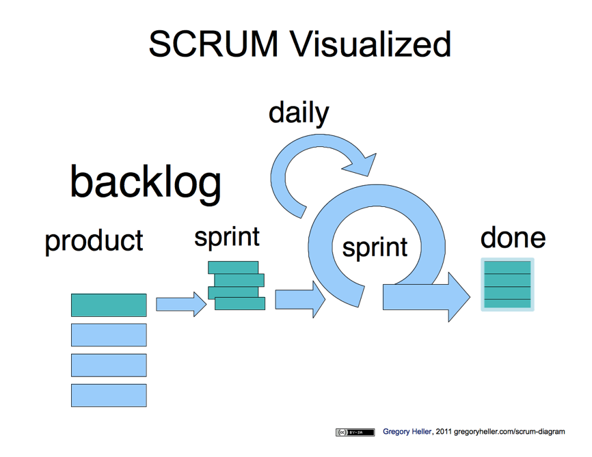Scrum allows the project to be broken down into small development chunks, or sprints as they are commonly called. A sprint begins with the planning stage. The highest priority user story will be implemented first so enough planning is made so they can start on the developing the feature set from that user story. They then build the product followed by testing and reviewing. These cycles typically last between one to three weeks and by the end you have a product which could be ready to use. This cycle is iterated until all features have be developed. Daily standup meetings take place to discuss how the project Is going and make sure its on tack for completion. Plan meetings also occur at the beginning pf each sprint with the product owner to ensure he is happy with what is going to be implemented in that sprint.

At the end of the sprint the product owner will usually perform acceptance testing to see if he is happy with the system so far; it can sometimes be an automated test on the system. This form of testing is usually based from a scenario and if it can pass the scenario it will pass the acceptance test and can then happily move onto the next sprint. Regular meetings occur between the Product Owner and the Scrum Master to ensure the Product Owner is happy with the way the project is going and to discuss any further features that may be needed.

Scrum can also support Pair Programming, which we will be using, although it is a practice of XP. By using Pair Programming, it firstly allows the team to be held collectively responsible for the development of the system. Meaning that not one person will be held responsible for any errors or bugs that may be found in the system and cause it not to work. Following on from that, Pair Programming allows for an informal, continuous code review process. Programmers are usually paired up with one other programmer and the code written is then reviewed by the other programmer, this allows the code to be read at least twice which will maximize productivity and evidently lead to better quality code, finding bugs early on in the development process.

Image website: <http://home.gregoryheller.com/sites/gregoryheller.com/files/scrum_visualized.png>

The Raid Cinemas project has a number of key characteristics which has lead us to use scrum to aid the development of the project.

Many other cinema companies already have an online booking system which has allowed us to look at them with the customer, review what he doesn’t like about them and what he would want from his system. This allowed us to gain a solid set of requirements before development. However, we have taken into consideration that the project may be bigger than initially anticipated and more requirements/features may rise so we have added an extra week onto the time which the project is intended to be finished to compensate for any set back which we may have.

We want to make sure that the customer is satisfied at all times throughout the development and gets to see the project during the development. By using scrum this will allow the Product Owner to prioritize which he thinks is most important and what’s to be developed first. At the beginning and end of each sprint he will have meetings to make sure he is satisfied with what has been developed and will get to perform testing on the system to ensure it is what was expected. The system will be split into different development increments also known as sprints. At the end of each sprint we feel it is important for the customer to interact with the features that have been implemented to allow for continuous feedback so the system can be improved.

By developing in sprints it allows the project to be broken down into small manageable chunks. This allows the us to clearly see how much progress we are making, making sure we are going to meet the deadlines/milestones

For the development of this project we have set a timescale from ___ to ___ which gives us ___ to complete the project. This also gives the development team an extra week after the development is due to finish to allow for any changes and or errors to be fix that may come into play during the development of the system. By using scrum as our lifecycle model we can implement pair programming, which allows us to narrow down the amount of errors that may occur when programming

## Project Team Structure

There are three key roles within the scrum development process which are key in the success of the project:

Product Owner – Usually the primary stakeholder, the product owner is responsible for the overall success of the project. He prioritizes the features in the project backlog and has a real vision for the product which he wants to be developed. The product owner must make confident decisions to help aid business value and the development of the project so the outcome is exactly what his vision of the project was.

Key Responsibilities: Decides what has to be done and the priority order which it should be done.

Scrum Master – The Scrum Master is the manager of the agile development cycle. He is responsible for the success of each sprint, making sure the development team are able to complete each sprint. The Scrum Master usually coordinates the daily stand up meetings with the becomes a link between the team and the product owner.

Key Responsibilities: To protect the process, ensure there are no issues throughout the development.

Team – The scrum team is usually made up from different members from programmers to designers. All members collaborate together to develop the project throughput the series of sprints. There is not one sole member responsible if the product fails, everyone has collective ownership of the product.

Key Responsibilities: Develops and tackles the tasks during the project.

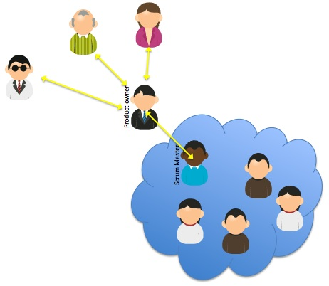

The scrum key roles structure is demonstrated here:

http://www.scrum-institute.org/Scrum_Roles_The_Scrum_Team.php

Our team will be structured with:

* One project manager
* Six developers (2 Programmers, 2 Graphics Designers, 1 contents specialist…)
* Product Owner