EXPERIMENTER PROTOCOL AND SCRIPT

Before running the study:
- Before printing, be sure to read the document labeled “INSTRUCTIONS - PLEASE READ!” in the shared folder
  - It is crucial that you replace the highlighted fields in the "productivity reports" with your site's 90th percentile and local currency prior to printing.
- Aim to recruit ~20 participants per session. Ensure you have a minimum of 5 participants per session.
- Print, assemble and gather the materials:
  - Workbooks
  - Productivity reports
  - Consent forms
  - Debrief forms
  - Folders (with internal pockets)
  - Large manila (sealable) envelopes
  - Pens
  - Cash (if your site is using cash)
  - Small (sealable) envelopes for cash
  - 2 carboard deposit boxes
    - Label each with coloured paper matching the materials (e.g., yellow paper labelled “Place sealed envelope here” and blue paper labelled “Place folder here.”) Example:


- ***IMPORTANT*** Match the designated workbook and productivity report (i.e., check that the unique anagrams match) so that each participant receives a matching set of materials!
- Assemble the folders:
  - In the left internal pocket place:
    - The workbook
  - In the right internal pocket, place:
    - The productivity report
Example:
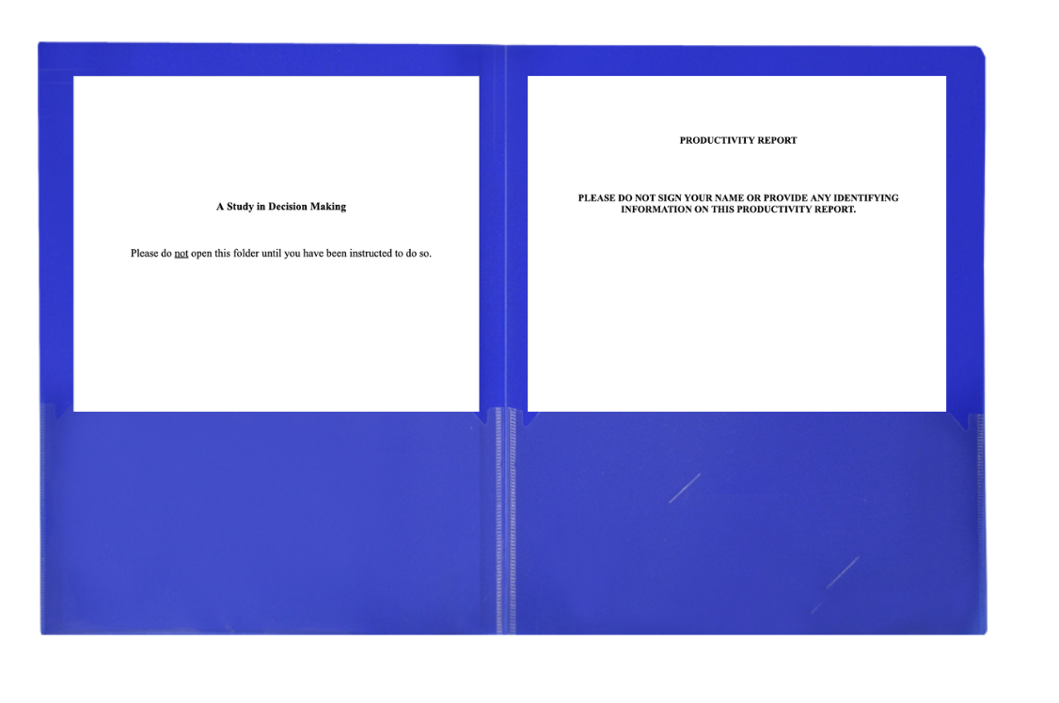
The day of the study:

- Prepare the room to give a sense of privacy
    - Cover any windows in the room
    - Make sure that there is plenty of space between each workstation. Use dividers if possible
- At each workstation, place:
  - 1 (closed) folder containing the workbook and productivity report
  - Beneath the folder, place 1 large manila envelope
  - On top of the folder, place 1 consent form
  - Beside the folder, place 1 pen and the cash envelope

Example:

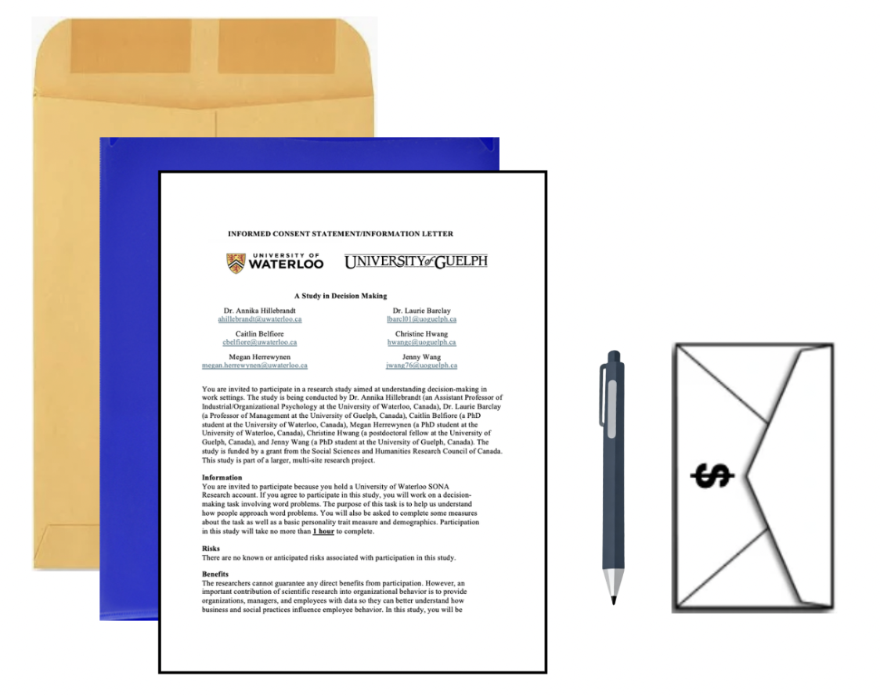
  - Set up the experimenter slides
  - Ensure the timer alarm sound is audible across the room
  - Set up very clear deposit boxes (cardboard boxes) at the front of the room
    - Depending on your space, it would work well to place each box directly beneath Slide 15’s graphic
  - Have 2-3 experimenters to run the study:
    - 1 experimenter will read the script
    - 1 experimenter will remain outside the lab room
    - Either an additional experimenter or the person reading the script will also change the slides

When the study begins:

Please follow the instructions below as closely as possible. In black are the steps of what to do, and in blue is what the experimenter will say aloud.

- Display Slide 1 on the screen.
- Welcome participants to the lab space.

Come on in! Please take a seat at one of the workstations we have set up for you. You can put your belongings underneath your desk. Please be sure to put your phones on silent and tuck them away.

While you are getting settled, please do not open the folder in front of you. Once everyone is ready, I will give you further instructions.

- Allow participants to enter the lab and get settled. Ensure that they do not open the folders.

Welcome everyone and thank you for participating in our decision-making study!
Please take a moment to read the consent form in front of you. Let me know if you have any questions or concerns before you sign it. Again, please do not touch the folder until you are instructed to do so.
- Once all participants have been seated, close the door and have a second researcher stand outside of the lab room to turn away any late participants. Give participants a few minutes to read and sign the consent form before moving on with the study. Note that participants who arrive after this point will not be allowed to join.
Once you have completed and signed the consent form, please raise your hand to let us know, and one of the researchers will come to collect your form. Once we have everyone’s form, we will begin the study all together.
- Have a second researcher help to collect the consent forms as participants complete them. Once they have all been collected, begin the study.

Study begins:
Thanks everyone for completing our consent form. I just want to reiterate from the form that all data we collect from you will be held anonymously. Later in the study, we will ask you to report some demographic information, but this will not be used to identify you. We only gather this information to study demographic trends.
To further protect your anonymity, please do not put your name or any other identifying information on any workbooks or other materials throughout the study.
As we go through the study, please take your time to read all instructions very carefully.
Does anyone have any questions or concerns before we get started?

- Answer any questions.

Great! Now, we are going to begin. Can everyone please open the folder in front of you. On the left-hand side you will find a workbook titled “A study in decision making.” Please remove this workbook from your folder. You can set your folder aside for now, keep everything else inside.

Please turn to the first page in your workbook. You will find some instructions. Take a moment to read these instructions.

The task that you will be completing today is an anagram task. That is, you will receive a set of jumbled letters, and your task is to create as many words as you can from the letters available. There are rules for creating words (read these slowly and clearly):

- Each word must be at least two letters long.
- No proper nouns.
- Use each of the 7 letters only once per word.
- Words can only be used in one form.
I am going to give you one minute to create as many words as you can. We are going to have two practice rounds so you can get familiar with the task.
When I instruct you to turn the page, you will see the letters for practice round 1. You will create as many words as you can within one minute. After the one-minute time limit has expired, you are going to hear an alarm sound. When you hear the sound, please turn immediately to the next page and work on the next practice round.

Does anyone have any questions?

- Answer any questions.
- Change to Slide 2.

Is everyone ready to begin the practice rounds? Ready…. Begin!
- Advance to Slide 3.
- Let the following two timer slides run automatically while students perform the practice trials. At the end of Practice Trial #1, when the alarm sound happens, also say at the same time:

That is the end of the first practice round, now turn to the next page. You won’t say this in the actual rounds, just during the practice to acquaint them with the activity.

- After they complete both trials, the slideshow will stop on Slide 5.
Now that you are familiar with the task, please turn the page. Please read about your goal and respond to the questions on this page. Please wait once you are finished. When everyone is ready, we will move on to the main trials together.
- Wait for participants to read their goal and answer the four questions. You may say things like “does anyone need more time?” to gauge when everyone has completed. Once everyone has finished, move on to the main trial.
We are going to begin the main trial now. There will be 7 mains rounds and you will again have 1 minute per round. There is also an 8th round. This 8th round does not really count, it’s just there so we can pilot-test some anagrams for future studies.
As a reminder, when you hear the sound, please stop writing and turn to the next page. I will not be speaking this time, so listen for the sound. Ready?....Begin!

- Move to Slide 6. The main trials will begin, running from Round #1 – Round #8. The slides will run automatically while the participants perform the main trial anagrams and will end on Slide 14.

Great! That brings us to the end of the task. There are a few questions at the end of your workbook that you may fill out now. As a reminder, do not put your name or any other identifying information on any workbooks or answer sheets to protect your anonymity. Please take your time.

When you are all done, please wait until everyone else has finished, too. We will move on to the last part of the study all together.

Wait for participants to complete the demographics and follow-up survey. You may say things like “does anyone need more time?” to gauge when everyone has completed. Once everyone has finished, move on to the productivity reports.

Next, please take out the Productivity Report from your folder.

For this portion of the study, I will ask you to check your work on the main trials. You may pull out your phone to scan the QR code, which will direct you to a Scrabble Dictionary website that allows you to check whether the words you created are valid. Please take your time to do this and cross out any invalid words.

Please only use your phone to access the Scrabble Dictionary - not for any other purposes. Once you have checked your work, please tuck your phone away for the rest of the study.

Once you have checked your work, you will need to complete this productivity report indicating whether you produced a specific number of valid words. Again, please skip the 8th anagram - it does not count.

Once this report is completed, seal it in the large envelope.

When you are all done checking your work, please take the cash that you earned out of the cash envelope. Please re-seal this envelope when you are finished.

Once you have checked your work and retrieved your cash, please put your workbook, back into your folder, and ensure that your productivity report and cash envelope are sealed in the large envelope.

Switch to Slide 15.

So, when you are done, you should have 1) a sealed large envelope containing your productivity report and cash envelope, and 2) your folder containing your workbook. Say this slowly and hold up materials to make it very clear.
Please place the sealed large envelope with the productivity report in this box (point) and place the folder with the workbook in this box (point). Make this very clear – motion to emphasize. Say more than once if needed.
When you are finished, please collect your belongings, deposit your materials, and meet us outside so we don’t disturb any of the other participants.
- Leave the room and don’t look into the room – give participants privacy. Stand outside of the room with a stack of debriefing letters. As participants leave the room, thank them for participating and hand them a debriefing letter.

After the study:

- Match the workbooks to the productivity reports (i.e., by matching the 8th anagram).
  - Staple these materials together.
- Count the amount of money taken from each envelope.
  - Write the dollar amount on the workbook to ensure this information remains associated with the corresponding workbook and productivity report.
- Complete the quality report.

