SUNDAY, AUGUST 26, 2012

Kolaches - A Taste of Texas

[[](http://photo.blogpressapp.com/show_photo.php?p=12/08/26/3970.jpg)](http://photo.blogpressapp.com/show_photo.php?p=12/08/26/3970.jpg)  
I decided to write this post a little differently. You may notice I am writing in first person for a change. I wanted to share a little back story on my family's favorite recipe.  
First you may be asking what is a Kolache? They are sweet little buns filled with all sorts of delicious fillings.  
  
We first had these tasty treats after we moved to Texas for my husband, Keith's job. There is a chain of restaurants there called [The Kolache Factory](http://www.kolachefactory.com/). Once we tried them we were hooked. We were there almost every weekend. Whenever any of our family or friends came to visit from Chicago we would order some of every kind for them to taste. I've never met anyone who didn't love a Kolache!  
  
After 2 1/2 years we moved to Indianapolis, again for my husbands job. We were thrilled to live a little closer to our family and friends in Chicago. I thought we would have to say good buy to our beloved Kolaches (yes they are that good!). Can you imagine my surprise when Keith told me there was a Kolache Factory just a few miles from our new home! Phew!!!! We were able to continue to feed our little habit.  
  
A few years later we had the opportunity to move back home to Chicago. We were so happy to be back home with our family and friends. But, it wasn't long before we started missing our old friend Kolache. We even looked into having our friends in Texas and Indy shipping them to us, but it cost more to ship them than to buy tham. The homemade mama in me wouldn't let us do that. So, Keith and I started looking for kolache recipes. We couldn't find any. We started looking for bread and roll dough that we could use, but nothing was quite right.  
  
I kept an eye out online and one day I stumbled upon a recipe on [Homesick Texan](http://homesicktexan.blogspot.com/2007/03/sweet-escape-kolaches.html). I had finally found someone who understood my obsession for Kolaches!! She has a beautiful blog full of wonderful recipes from Texas. I also just saw that she has a cookbook out! Yea! Can't wait to get it!  
Homesick Texan gives a history of Kolaches and has a great recipe for making traditional ones.   
  
We couldn't wait to try her recipe. The dough was great! It tasted almost exactly like the way we remembered it. We made a few changes. We like the dough a little sweeter so I added a little more sugar, and for some reason I always find I need more flour. We also like nontraditional fillings like the ones at the Kolache Factory. We fill ours with everything from sausages to buffalo chicken. Keith and I hope you'll give them a try!   
  
[[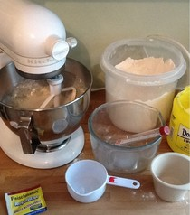](http://photo.blogpressapp.com/show_photo.php?p=12/08/26/3971.jpg)](http://photo.blogpressapp.com/show_photo.php?p=12/08/26/3971.jpg)  
Kolaches - Adapted from Homesick Texan  
  
Ingredients:  
  
1 package of active dry yeast  
1 cup of warm milk  
1/2 cup sugar  
4 cups of all-purpose flour (I always need 4 cups)  
2 eggs for dough  
1/2 cup melted butter  
1 teaspoon of salt  
1 egg for egg wash  
  
This will make about 24 kolaches. I recommend doubling the recipe. They are always gone within a day or two.  
  
1. In a large bowl, combine yeast, warm milk (105-110 degrees) sugar and one cup of flour. Cover and let it rise until doubled in size.  
  
2. In a small bowl beat the 2 eggs, slowly add the 1/2 cup of melted butter and salt.  
3. Add egg mixture to yeast mixture and mix.  
4. Mix in the flour, 1/2 cup at a time. I usually have to knead the last cup in by hand. It is a really soft, slightly sticky dough.  
5. Knead dough for about 10 minutes on a well floured surface. Place dough in a well greased bowl. Cover with plastic wrap and let rise until doubled in size - about an hour.  
[[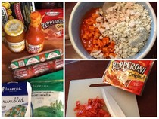](http://photo.blogpressapp.com/show_photo.php?p=12/08/26/3972.jpg)](http://photo.blogpressapp.com/show_photo.php?p=12/08/26/3972.jpg)  
While the dough is rising, get your fillings ready. Some of our favorites are:  
-Buffalo chicken and blue cheese  
-ham and cheese  
-cheese and hotdogs (cut in half)  
-sausage and cheese  
-milk chocolate  
-pepperoni, pizza sauce and mozerella  
-chopped chicken and alfredo or pesto  
-taco  
-chicken curry  
-spinach and feta  
The possibilities are endless! We haven't found anything we don't like in a kolache!   
  
[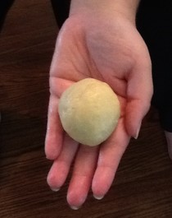](http://photo.blogpressapp.com/show_photo.php?p=12/08/26/3973.jpg)  
  
After dough has risen, punch it down and pull off egg-sized pieces. In your hands, roll pieces into balls and then flatten to about 4 inches in diameter.   
  
[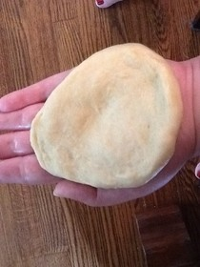](http://photo.blogpressapp.com/show_photo.php?p=12/08/26/3974.jpg)  
  
Spoon about 1 to 1 1/2 Tbls of filling.   
  
[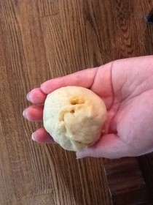](http://photo.blogpressapp.com/show_photo.php?p=12/08/26/3975.jpg)  
  
Close dough around filling. Pinch it shut and place seam side down on greased cookie sheet. Cover with plastic wrap and let rise 20 min. Preheat oven 375 degrees.  
  
[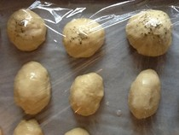](http://photo.blogpressapp.com/show_photo.php?p=12/08/26/3976.jpg)  
  
Beat the third egg. Before you bake the kolaches, brush with egg. If you are making a couple different flavors, you may want to mark them. We sprinkled Italian seasoning on top of the pizza flavored one, and paprika on the cheese and chorizo kolaches.   
  
[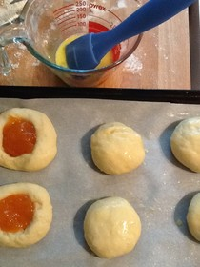](http://photo.blogpressapp.com/show_photo.php?p=12/08/26/3977.jpg)  
  
To make the more traditional Kolaches, make flattened balls of dough. Let them rise. Right before you bake them gently make a little well in the center and fill with low sugar preserves.  
  
[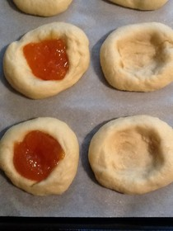](http://photo.blogpressapp.com/show_photo.php?p=12/08/26/3978.jpg)  
  
Bake in oven at 375 degrees for 12 to 15 minutes. They will be lightly golden brown when they are done.  
  
[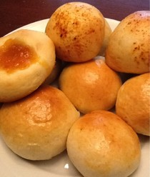](http://photo.blogpressapp.com/show_photo.php?p=12/08/26/3979.jpg)  
  
Let them cool on cooling rack. They will be very hot!  
  
[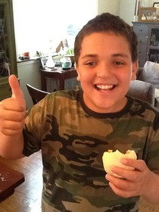](http://photo.blogpressapp.com/show_photo.php?p=12/08/26/3980.jpg)  
  
Ben gives them a big thumbs up!  
I hope you'll give this recipe a try! I know you'll love them as much as my family! (But you have been warned, they are soooo addictive!!!)  
Thanks for reading!!