과제물 하는 방법

* 예시-
* 숙제 업로드 시기: 약 5일~6일전
* 확인방법: 리더스 싸이트 접속 (<http://www.leadersacademy.com>) -> INTRO(대치 & 분당) 선택 -> 로그인-> 마이 페이지-> 과제물에서 확인 (가입 없이 재학생에게 ID,P.W 부여해줌)

|  |  |  |  |  |  |  |  |  |
| --- | --- | --- | --- | --- | --- | --- | --- | --- |
| **번호** | | **과목** | | **제출기한** | **제목** | | **첨부파일** | **평가의견** |
|  | | | | | | | | |
|  | |  | | | | | | |
|  | | | | | | | | |
|  | |  | | | | | | |
|  | | | | | | | | |
| 1 |  | | 2014-07-06 (일)  - 제출일자는 수업 오는 날짜를 말함 | | | [OP21C-PD BCFE](javascript:winscroll('/mypage/homework_view?seq=19404','mypage_homework_detail','468','400'))  –클릭~ | [1](http://daechi.leadersacademy.com/mypage/target=) | 제출전 |
|  | | | | | | | | |
| 1. http://daechi.leadersacademy.com/skin/img/p_prev.gif1http://daechi.leadersacademy.com/skin/img/p_next.gifhttp://daechi.leadersacademy.com/skin/img/p_end.gif | | | | | | | | |

- [OP21C-**P**D (반명, 반명뒤에 **P**:Pathos, **E**: Ethos, **J:** Junior 교재를 뜻함) SCPA](javascript:winscroll('/mypage/homework_view?seq=4035','mypage_homework_detail','468','400'))(패캣명) –클릭 ~ 과제물 창이 하나 생성됨

* 예시

**과제물**

|  |  |
| --- | --- |
| 제출기한 | 2014-07-06 (일) |
| 평가 | 제출전 |
| 첨부파일 | [0630151707_SCPA 2014.pdf](http://aca2000.net/xmlservice/down.asp?acaNum=73176&filename=0630151707_SCPA%202014.pdf) – 클릭~ 첨부파일 다운로드 후 패캣 읽어 옴 |
| 세부내용  – 세부 내용 참고해서 읽어 옴. 리서치 필요할 경우 해야 함. | 10/26/2015 - 11/01/2015 Student Letter   TOURNAMENT TIME Ready for a chance to compete? It"s coming November 28. You can pick to SPEAKING, ACTING or PUBLIC FORUM DEBATE. Learn more at http://nsdakorea.org/event_walker/international011.php   CULTURE: ENTERTAINMENT (Junior & Ethos Debates)  JUNIOR: (HERO) THR the dominance of superhero movies. (pages 58-65)  Intro: https://en.wikipedia.org/wiki/Superhero_film  Prop: http://deadline.com/2014/11/superhero-oversaturation-norman-lloyd-1201271072/  Opp: http://time.com/79410/justice-league-superhero-universe/  More: http://www.denofgeek.com/movies/comic-book-adaptations/32829/63-upcoming-comic-book-movies-and-when-to-expect-them  ETHOS: (SNLS) THBT singers should not be allowed to lip-sync. (pages 58-65)  Intro (Video): https://www.youtube.com/watch?v=ovMNl0gGFNY  Prop: http://seoulbeats.com/2014/07/reasons-mbcs-banned-lip-syncing/  Opp: http://abcnews.go.com/Entertainment/pop-stars-lip-sync/story?id=24086986  Korea: http://www.koreaboo.com/trending/girls-generation-midst-lip-syncing-controversy/   ECONOMICS: FACTORS OF PRODUCTION (Pathos & Logos Debates)  PATHOS: (BCFE) THBT government bailouts of companies should be conditional on firing of top executives. (pages 52-59)  Intro: http://foreignpolicy.com/2008/09/15/the-list-the-worlds-biggest-bailouts/  Prop: http://www.globalbusinessnews.net/story.asp?sid=661  Opp: http://www.bloombergview.com/articles/2013-06-10/when-bailouts-make-moral-and-economic-sense  Korea: http://www.economist.com/node/176129   LOGOS: (PSCR) THW prohibit the sale of goods produced under conditions which harm workers. (pages 52-59)  Intro: https://en.wikipedia.org/wiki/History_of_labour_law  Prop: http://www.salon.com/2014/06/17/6_of_the_worst_countries_in_the_world_for_workers_partner/  Opp: http://www.ibtimes.com/despite-low-pay-poor-work-conditions-garment-factories-empowering-millions-bangladeshi-women-1563419  Korea: http://thediplomat.com/2015/04/the-sad-plight-of-south-koreas-migrant-workers/ |

* 예시

**첨부파일 클릭 후 열기~**

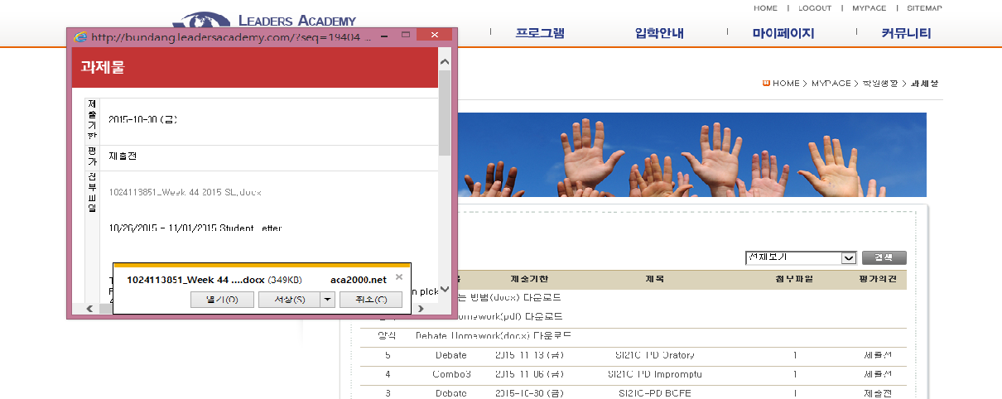

* **아래 첨부파일을 다운로드 후 각각에 해당하는 교재(Pathos, Ethos, Junior) 예: 학생이 해당하는 교재가 Pathos일 경우 Pathos부분만 해오면 됨. 1개월에 한번** [**Impromptu**](javascript:winscroll('/mypage/homework_view?seq=19626','mypage_homework_detail','468','400'))**인 경우 즉흥토론이기 때문에 Student Letter만 읽어 오시면 됩니다.**

**10/26/2015 – 11/01/2015 Student Letter**

**TOURNAMENT TIME**

Ready for a chance to compete? It’s coming November 28. You can pick to SPEAKING, ACTING or PUBLIC FORUM DEBATE. Learn more at <http://nsdakorea.org/event_walker/international011.php>

**CULTURE: ENTERTAINMENT (Junior & Ethos Debates)**

**JUNIOR: (HERO)** THR **읽어올 Topic 제목 ->** **the dominance of superhero movies.** 매주-써오는 숙제->(pages 58-65)

->아래 링크 주소 리서치 후 책에 있는 Topic 을 읽고 써오는 숙제를 해오면 됨

Intro: <https://en.wikipedia.org/wiki/Superhero_film>

Prop: <http://deadline.com/2014/11/superhero-oversaturation-norman-lloyd-1201271072/>

Opp: <http://time.com/79410/justice-league-superhero-universe/>

More: <http://www.denofgeek.com/movies/comic-book-adaptations/32829/63-upcoming-comic-book-movies-and-when-to-expect-them>

**ETHOS: (SNLS)** THBT **읽어올 Topic 제목->** **singers should not be allowed to lip-sync**  매주-써오는 숙제-> (pages 58-65)

->아래 링크 주소 리서치 후 책에 있는 Topic 을 읽고 써오는 숙제를 해오면 됨

Intro (Video): <https://www.youtube.com/watch?v=ovMNl0gGFNY>

Prop: <http://seoulbeats.com/2014/07/reasons-mbcs-banned-lip-syncing/>

Opp: <http://abcnews.go.com/Entertainment/pop-stars-lip-sync/story?id=24086986>

Korea: <http://www.koreaboo.com/trending/girls-generation-midst-lip-syncing-controversy/>

**ECONOMICS: FACTORS OF PRODUCTION (Pathos & Logos Debates)**

**PATHOS: (BCFE)** THBT 읽어올 Topic 제목-> **government bailouts of companies should be conditional on firing of top executives**. 매주-써오는 숙제-> pages 52-59)

->아래 링크 주소 리서치 후 책에 있는 Topic 을 읽고 써오는 숙제를 해오면 됨

Intro: <http://foreignpolicy.com/2008/09/15/the-list-the-worlds-biggest-bailouts/>

Prop: <http://www.globalbusinessnews.net/story.asp?sid=661>

Opp: <http://www.bloombergview.com/articles/2013-06-10/when-bailouts-make-moral-and-economic-sense>

Korea: <http://www.economist.com/node/176129>

**LOGOS: (PSCR)** THW 읽어올 Topic 제목-> **prohibit the sale of goods produced under conditions which harm workers**. 매주-써오는 숙제-> (pages 52-59)

->아래 링크 주소 리서치 후 책에 있는 Topic 을 읽고 써오는 숙제를 해오면 됨

Intro: <https://en.wikipedia.org/wiki/History_of_labour_law>

Prop: <http://www.salon.com/2014/06/17/6_of_the_worst_countries_in_the_world_for_workers_partner/>

Opp: <http://www.ibtimes.com/despite-low-pay-poor-work-conditions-garment-factories-empowering-millions-bangladeshi-women-1563419>

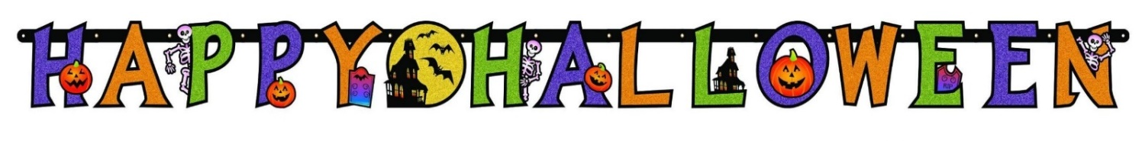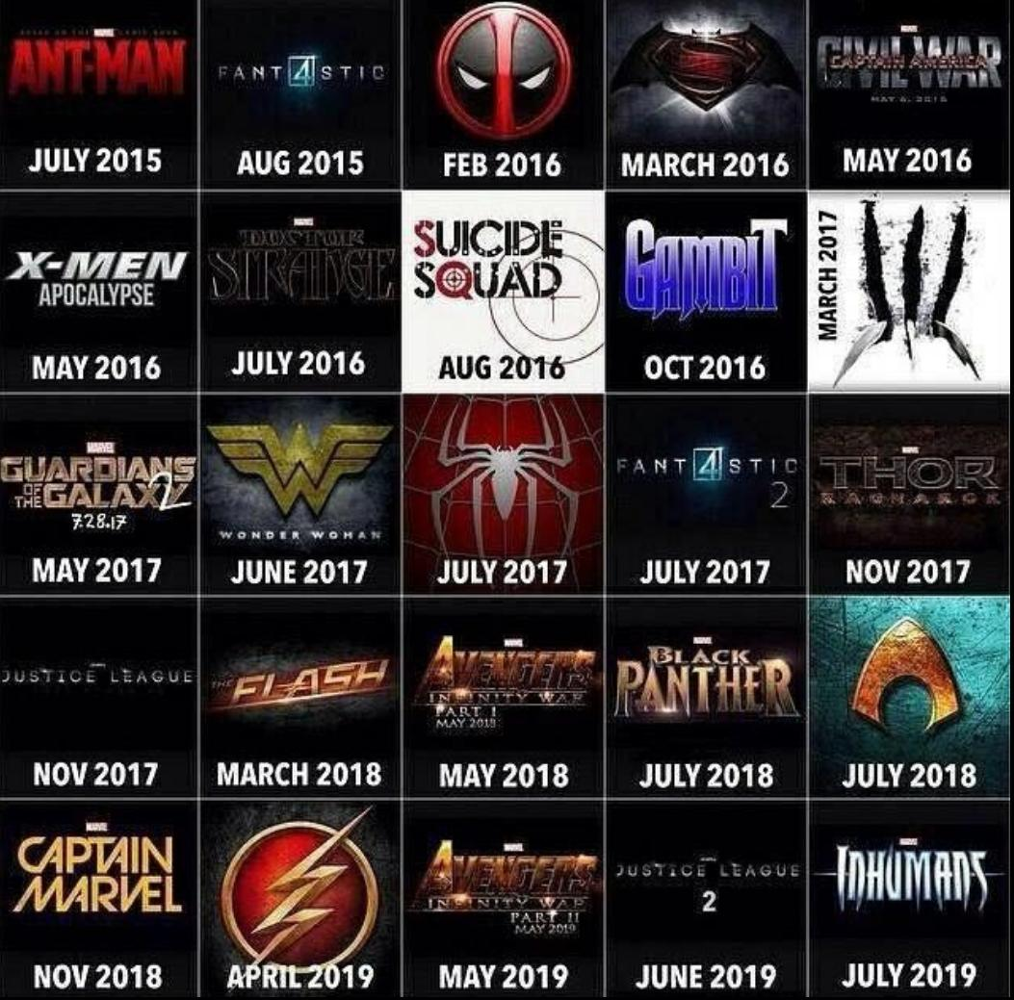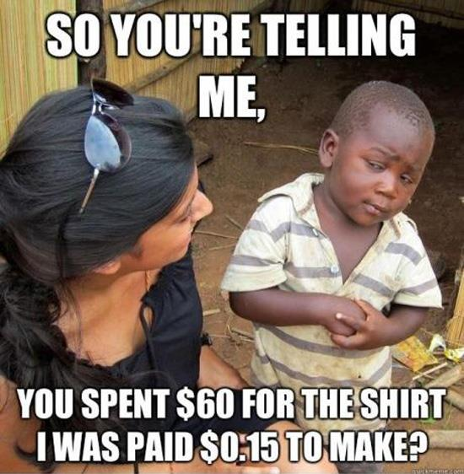Korea: <http://thediplomat.com/2015/04/the-sad-plight-of-south-koreas-migrant-workers/>