This deliverable will primarily focus on fine tuning the model presented in deliverable 2, and address missing information that was omitted from the past deliverable.

Class imbalance: In the entire dataset, there are 138 positive cases of heart disease, and 165 sample points where there is no heart disease present. Therefore, there is no apparent class imbalance that would heavily impact the results of the model.

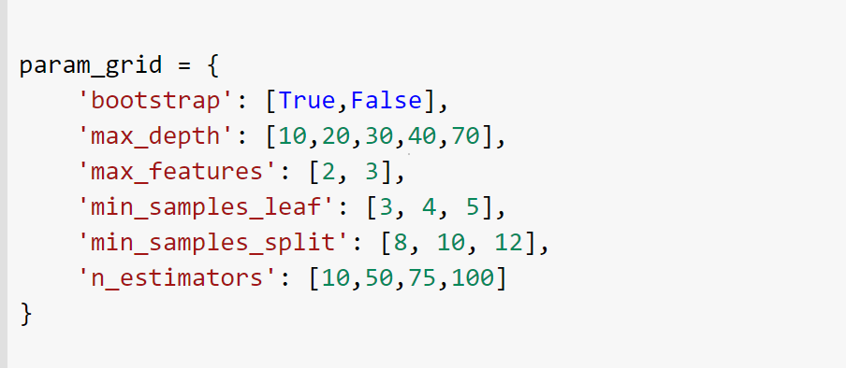



Further, I have decided to use a Random Forest Classifier. Using this new model, i have achieved a 86.89% accuracy as opposed to the previous 85.5% from the BaggingClassifier in deliverable 2.

The parameters chosen are listed above.

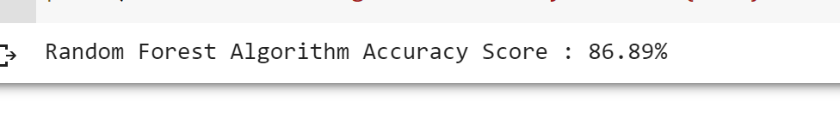

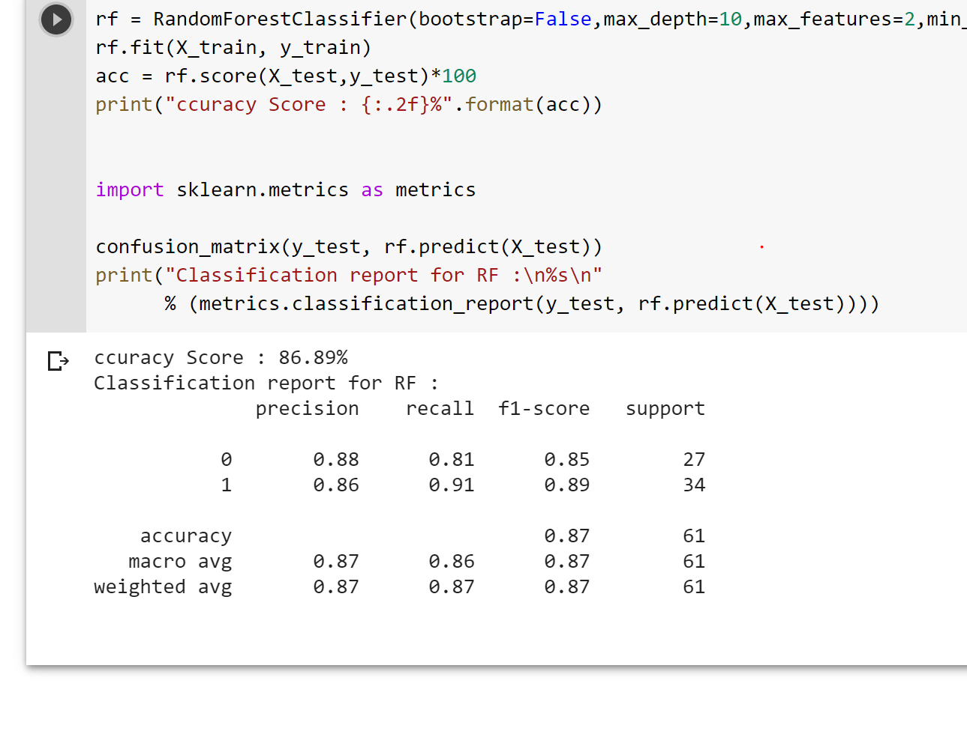

The f1 score for a positive case of heart disease is 0.85, and 0.89 for a negative case.

**Web application:**

The web application will have a simple form like interface. Since there are 13 parameters needed to predict a value, there will be 13 entries for the user to fill in on the form. I have begun coding the website, and have attached a screenshot to show the general skeleton of the website. It is still in early stages. Of course, there will be improvements to the design and interface before the presentation.

