5-Minute Morning Routine

Documentation for software development of a react website



Nucamp Full Stack Bootcamp

From Bootsrap to React Project Report

**Christine Anthony**

**Cody Trent**

11 November 2021

**1. Introduction**

* This is a self-improvement website/application that can be used to inspire people to take the first steps to affect long-term changes to routine or lifestyle. Phase 1 of the project was to build the site using the Bootstrap framework. Phase II (this phase) revamps the project using the React Library and JavaScript.
* The website will present a 5-minute morning routine to prime the mind to be receptive to fulfilling personal goals and/or habit change throughout the rest of the day.
* The routine will be composed of 3 items: inspirational quote, mantra, goal for the day. In the absence of a user account, the site will present a sample routine based on common goals (i.e. learn a new language or stop smoking). With a user account, the site will incorporate the user’s personal goals, quotes, and mantras into the morning routine.
* Below is the current UI design for each site page:

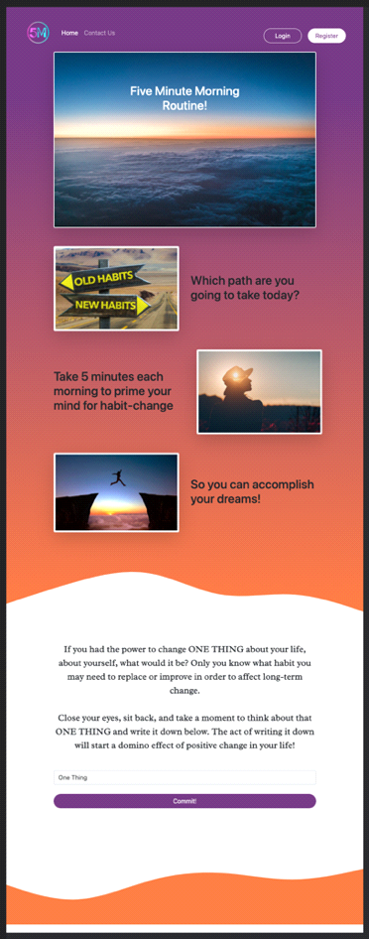 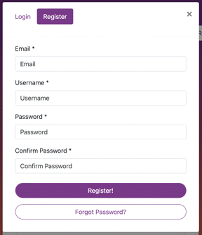 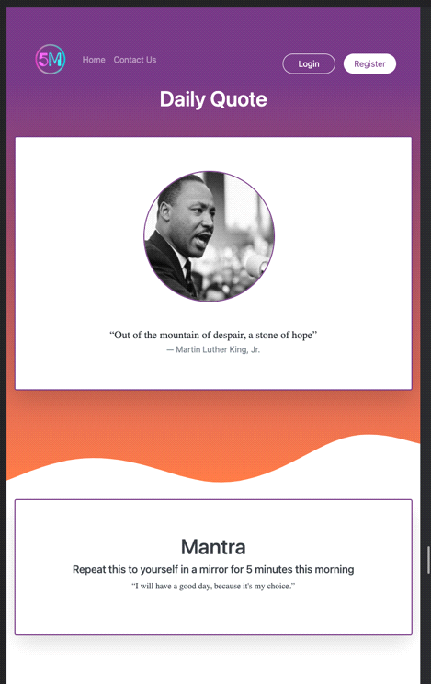

(accounts page under revision)

|  |  |
| --- | --- |
| Dev Stack | Features |
| html | collapsible navbar toggle |
| css | tabbed modal |
| Sass | form-group |
| Reactstrap | wave svg |
| JavaScript | embedded cards |
| React |  |
|  |  |

**2. How the project will benefit from React**

* Advantages to using React over Bootstrap
* The website/app has several elements that will need to be updated regularly upon user input, such as goal entries and updating completed routines.
* The ability to update those elements using state will be an advantage over recreating the updated elements with input variables every time.
* Since the user will be making daily entries into their account page (entering goals, checking off completed daily routines, updating routines), we’ll need a strong server-side rendering capability. React and node.js are perfect for this.
  1. Elements that will use setState():
* Selection of Inspirational quote of the day with picture
* Select or input Mantra of the day to read aloud with picture
* Input Goal of the day
* Reactstrap will also be used to efficiently implement responsiveness

**3. Expected list of React components**

* The website/app uses the following reusable components:
* Navbar
* Images with text
* Commit section - text and form
* Daily quote
* Mantra
* Goals list
* Goals section detail
* In the goals sections of the accounts page, the user “Likes” a routine checklist that resets every day. The user manually checks off the routine completed each day, earning badges to display on the user profile. Each goal would have 1-3 routines to choose from and a max of 2 active goals will be an option at a time, so people don’t overwhelm themselves with too many at once. Once people set their goals, they can then set their own routine checklist to try and achieve those goals. If the routines are checked off every day for 30 days, the ability to achieve

**4. Features Wish List**

* Your goal giving more badge rewards will unlock the ability to set another goal.
* Track number of days in a row the routine is performed with reward system for reaching # of days in a row. Reward may be in form of satisfying visual effect with sound.
* Pull in inspirational quotes and mantras via API (Rapidapi.com).
* Build our own APL in back end for quotes.
* Sticky breadcrumb like the one on figma.com that activates the buttons .associated with the viewport you’re on while scrolling. INSPIRE > MANTRA > GOAL.
* Align login/register modal to center of screen.
* Notification to use app at a time of day chosen by the user (React native).
* Carousel on top with drag & drop feature into a Pinterest-like ‘My Inspirational Photos’ album.
* A hovering down arrow to indicate scroll down.
* A “Get the App” button in nav.
* Change colors from greys to colors post mantra, goals activities.
* Avoid reloading page whenever possible (React).
* jQuery .scroll()
* Filterable quotes and mantras by genre.
* Link to user profile - submitted quote – shows users goals .
* Badge system to display in profile.