5-Minute Morning Routine

Documentation for software development of a Single Page React Web App



Nucamp Full Stack Bootcamp

Project Report - From Bootsrap to React

**Christine Anthony**

**Cody Trent**

26 December 2021

**https://github.com/chriscyber/fiveminuteroutine-react**

**1. Introduction**

* This is a self-improvement website/application that can be used to inspire people to take the first steps to affect long-term changes to routine or lifestyle. The web app presents a 5-minute morning routine to prime the mind to be receptive to fulfilling personal goals and/or habit change throughout the rest of the day.
* Phase 1 of the software development project was to build the static site using the Bootstrap framework. Phase II revamped the project using the React library and JavaScript to implement functionality. Phase III (this phase) continues development of the react-based web app with increased functionality including backend features to store user account information.
* The routine is composed of 3 items: inspirational quote, mantra, goal of the day. In the absence of a user account, the site will present a sample routine based on common goals (i.e., learn a new language or stop smoking). With a user account, the site will incorporate the user’s personal goals, quotes, and mantras into the morning routine.

Below is the current UI design for each site page:

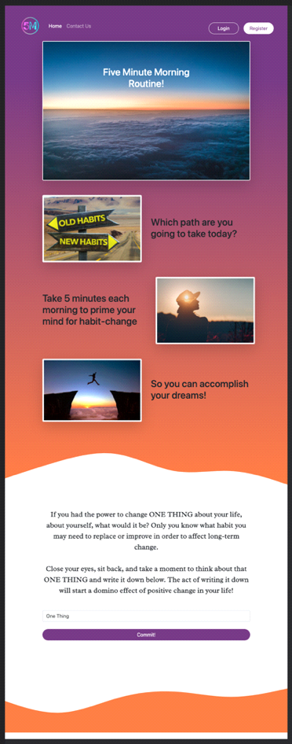 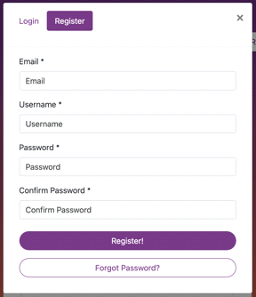

|  |  |
| --- | --- |
| Dev Stack | Features |
| React | Controlled registration and login |
| JavaScript | Add and remove goals items |
| React-Bootstrap | collapsible navbar toggle |
| Firebase | data persistence in database |
| Sass | embedded cards |
| css | wave svg |
|  | form-group |
|  | tabbed modals |

**2. How the project will benefit from React**

* Advantages to using React over Bootstrap
* The app has several elements that will need to be updated regularly with user input, such as goal entries and updating completed routines.
* The ability to update those elements using state will be an advantage over recreating the updated elements with input variables every time.
* Since the user will be making daily entries into their account page (entering goals, checking off completed daily routines, updating routines), we’ll need a strong server-side rendering capability. React and node.js are perfect for this.
  1. Elements that will use setState():
* Selection of Inspirational quote of the day with picture
* Select or input Mantra of the day to read aloud
* Input Goal of the day
* React-Bootstrap will also be used to efficiently implement responsiveness across various sized viewports.

**3. React Components Implemented**

* The website/app uses the following reusable components:
* Site Nav
* Account Daily Quote
* Account Goals
* Account Mantras
* Goal
* Goal Creation modal
* Login/Registration modal
* Login Form
* Register Form
* Home Images with text
* Home form with text
* Mantra
* Goals (with subcomponents)
* Next steps

1. We are currently hard coding the quotes and mantra samples to be maintained in the firebase database.
2. We are generating a sample account page (should the user not register after submitting the first commit goal).
3. We are refining logic for how quotes and mantras are selected and mapped to goals.

**4. Features Wish List**

* Planned functionality for Goals section

In the goals section of the accounts page, the user “likes” a routine checklist that resets every day. The user manually checks off the routine completed each day, earning badge rewards along the way which display on the user profile. Each goal would have 1-3 routines to choose from. A max of 2 active goals will be active at a time, so people don’t overwhelm themselves with too many at once. Once people set their goals, they can then set their own routine checklist to try and achieve those goals. If the routines are checked off every day for the goal achievement phase (30 days by default), or by a selected date, the ability to achieve your goal will unlock the ability to set another goal.

* Functionality Wish List

In the goals section of the accounts page, the user “likes” a routine checklist that resets every day. The user manually checks off the routine completed each day, earning badge rewards along the way which display on the user profile. Each goal would have 1-3 routines to choose from. A max of 2 active goals will be active at a time, so people don’t overwhelm themselves with too many at once. Once people set their goals, they can then set their own routine checklist to try and achieve those goals. If the routines are checked off every day for the goal achievement phase (30 days by default), or by a selected date, the ability to achieve your goal will unlock the ability to set another goal.

* Track number of days in a row the routine is performed with reward system for reaching # of days in a row. Reward may be in form of satisfying visual effect with sound.
* Pull in inspirational quotes and mantras via API (Rapidapi.com).
* Build our own API in back end for quotes.
* Sticky breadcrumb like the one on figma.com that activates the buttons .associated with the viewport you’re on while scrolling. INSPIRE > MANTRA > GOAL (maybe save this for React Native phase).
* Align login/register modal to center of screen.
* Notification to use app at a time of day chosen by the user (save for React Native).
* Carousel on top with drag & drop feature into a Pinterest-like ‘My Inspirational Photos’ album.
* A hovering down arrow to indicate scroll down.
* A “Get the App” button in nav (post mobile app phase).
* Filterable quotes and mantras by genre.
* Animations:

images on home page on load

upon submission of first goal from home page

on completion of daily routine and progress awards

* User profile – access to users’ submitted goals and quotes.
* Badge system to display in profile.