**Test that balance limit can be reached:**

Initial test -

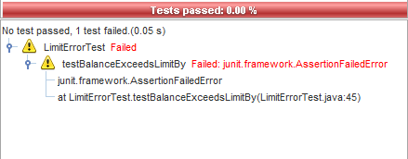

Test after changing < to <= in method-

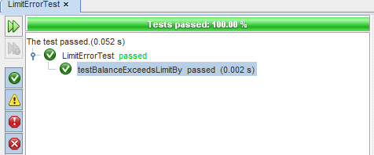

**Test Player Balance is updated correctly:**

Initial test -

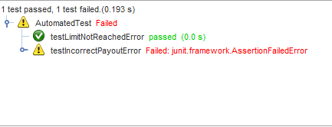

Test after adding bet to winnings on setting player balance –

