**Bug**: When a Player wins the game does not add the correct amount to the player balance.

**Hypothesis 1**: The Bug exists within the playRound method of the Game class.

Test: Check and see if the winnings variable set by the playRound method is accurate after method call. Also check player balance before and after.

Prediction: Balance is accurate in terms of player profit. Player balance increases incorrectly.

Result: Player received two matches but their balance only increased by 5. Hypothesis confirmed.

**Hypothesis 2**: The parameters of the playRound method are sane.

Test: Check parameters before method call.

Prediction: Parameters are sane.

Result: Parameters are sane. Hypothesis confirmed.

**Hypothesis 3**: The call of player.takeBet() incorrectly takes from the player balance.

Test: Check player balance before and after takeBet is called.

Prediction: Balance is reduced 5 more than it is supposed to be.

Result: Player balance is reduced correctly. Hypothesis falsified.

**Hypothesis 4**: Line 43 is incorrectly calculating amount to be added to player balance.

Test: Check result of calculation.

Prediction: Calculation will produce incorrect result.

Result: Result is incorrect as an amount to update player balance but correct in terms of player winnings. The line is not infected.

**Hypothesis 5**: Line 43’s origins are sane.

Test: Check origins of variables and ensure correct values.

Prediction: origins are sane.

Result: Lines 43’s origins are sane. Hypothesis confirmed.

**Hypothesis 6**: Line 46 is setting the player balance incorrectly.

Test: Check player balance before and after line 46.

Prediction: Balance will be 100 before and incorrectly set to 110 after.

Result: Line 46 is infected. Balance is sane before line 46 and insane after. Hypothesis confirmed.

**Hypothesis 7**: Adding the bet amount to winnings when player balance is set on line 46 will remedy bug.

Test: Add bet to winnings when player balance is set.

Prediction: Balance will be 100 before and correctly set to 115 after.

Result: Balance is sane before and after line 46. Bug is fixed. Hypothesis confirmed.

Before bug fix:

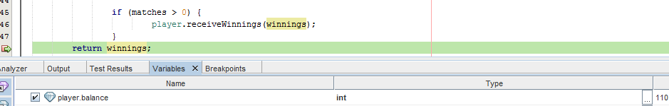

After Bug fix:

