**Bug**: All dice rolls after the first 3 are the same and not random.

**Hypothesis 1**: The Bug arises from the playRound method of the Game class failing to randomize the dice.

Test: Check dice values before and after the playRound method is called on line 49 within the main method.

Prediction: Dice values will not be changed by the playRound method from their initialized value.

Result: Dice values did not change. Hypothesis confirmed.

**Hypothesis 2**: The parameters of the playRound method are sane.

Test: Check parameters before method call.

Prediction: Parameters are sane.

Result: Parameters are sane. Hypothesis confirmed. Bug must occur within the playRound method.

**Hypothesis 3**: The roll method that is called on line 37 within the playRound method fails to randomize the dice’s value.

Test: Check Dice Values before and after method call.

Prediction: Dice values will not be randomized but remain the same.

Result: Dice values were not changed but remained their initialized value. Hypothesis confirmed.

**Hypothesis 4**: Origins of the roll method are sane

Test: Check that the getRandom method returns a randomly picked dice value.

Prediction: getRandom will consistently return a random dice value.

Result: getRandom methods consistently returns random values. Method used by roll is sane. Roll method is infected. Hypothesis confirmed.

**Hypothesis 5**: The roll method of the Dice class should set dice value to random rather than returning a random dice value. This would resolve the bug.

Test: Restructure method so that it sets dice value rather then returning a value.

Prediction: Dice values will be randomized with each turn. Bug will be resolved.

Result: Dice values are randomized each turn. The bug is remedied. Hypothesis Confirmed.

Before Fix:

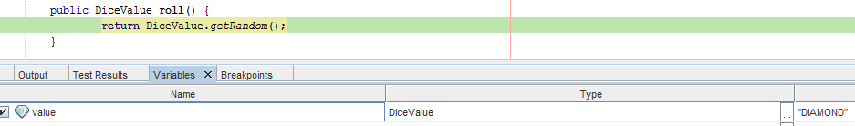

After Fix:

