OpenSim GUI Quick-Reference
There are several key components of the OpenSim GUI that will be referred to later in this document. The table below introduces you to these GUI components.

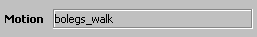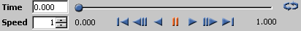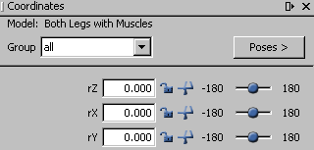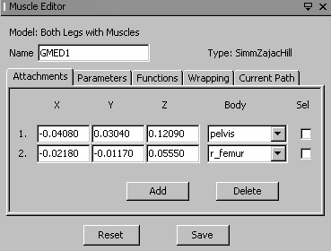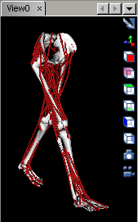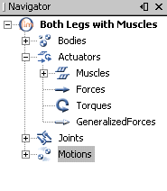
Title
Screenshot
Toolbar
Model Drop Down Menu
Motion Text Box
Motion Slider / Video Controls
View Window
Navigator Window
Coordinates Window
Muscle Editor
GUI Components
The View Window
Mouse Operations
Rotate Rotate by clicking the left mouse and dragging.
Pan Pan by clicking the center mouse and dragging left or right, or
by clicking left mouse with shift and dragging left or right.
Zoom Zoom by clicking the right mouse and dragging up or down.
Refit Refit the models in the view window by typing “r”.
Recenter Center around an object by selecting the object (ctrl+left mouse) and typing “r”.

Icons
Change background color.
Look at model from world’s –X direction.
Similarly, = +X, = -Y, = +Y, = -Z, = +Z.
Toggle the display of world coordinate axes on and off.
Take a snapshot of the view. A tiff image is saved.
Record a movie. Clicking this icon toggles movie recording on and off.
Create or edit a Camera Dolly.

Hot-Keys
i Zoom in.
o Zoom out.
x Align with X axis.
y Align with Y axis.
z Align with Z axis.
r Refit selected objects to the view. All models are fit in view if nothing is selected.

Selection
Select Select an object using ctrl+left mouse. After selection, the name of the selected object shows in the status bar and the object is colored yellow. Selection is possible only on the current model.
Add Add to the current selection using shift+ctrl+left mouse. Re-selecting an object toggles its selection.
Clear Clear all selections using ctrl+left mouse in an empty area of the view.
Drag Drag objects by selecting them and then by clicking and dragging with the left mouse.
Currently only dragging of muscle points is supported.

The Navigator Window
The Navigator Window shows a hierarchical representation of loaded models, provided quick access to the different components that make up a model (e.g., bodies, actuators, joints, and motions). The current model and motions are shown in bold. Double-clicking on a node toggles the display of the object in View Windows. When available, interval-selection is done with shift+ left mouse. By right mouse clicking on a component, a context sensitive menu will be shown that allows you to perform operations on the component. The items in these context sensitive menus are described below.

Display Menu
Display > Show Show selected object(s) if currently hidden in view window.
Display > Show Only Hide all other siblings.
Display > Hide Hide selected object(s) if currently shown in view window.
Display > Flat-Shaded Display an object with flat shading.
Display > Smooth-Shaded Display an object with smooth shading.
Display > Wireframe Display an object as a wireframe mesh.
Display > Color… Change the color of an object.
Display > Opacity… Change the opacity (transparency) of an object.

Model
Make Current Make the selected model current.
Rename Rename the selected model. For the change to be permanent, you must save.
Info Display information about a model, such as developers and relevant publications.
Close Close the selected model.
Display->Model Offset Add a translational offset to the selected model’s world position.

Motion
Make Current Make the selected motion current. The motion toolbar plays the current motion.
Rename Rename the selected motion. For the change to be permanent, you must save.
Save As… Save the selected motion to a storage (.sto) file.
Close Close the selected motion.
Sync. Motions Synchronize playback of selected motions. To synchronize, select multiple motions using ctrl+left mouse and then right mouse click on one of the selected motions.

Plotter Windows
Plotting is available under Tools > Plot…. Many plotter windows can be open concurrently.

Mouse Operations
Zoom In Draw a rectangle by left mouse clicking and dragging toward the lower right corner.
Zoom Out Draw a rectangle by right mouse clicking and dragging toward the upper left corner.
Annotate Mark the plot with x,y coordinates using ctrl+left mouse button.
Query Query the x,y coordinates of a curve by hovering the mouse pointer over the curve.

Plot Area
Right mouse clicking anywhere in the plot area will bring up a menu with the following items:
Properties… Modify the title, axis labels, ranges, background colors, and fonts.
Print… Print the plot.
Export Image… Export the plot as a tiff image.
Export Postscript… Export the plot as a postscript file suitable for reading into other applications.
Zoom In > Zoom in.
Zoom Out > Zoom out.
Auto Range > Select ranges for the x and y axes that will show all the curves in the plot.
Export Data… Export the plot data to a text file.

Plot Folder
Right mouse clicking on the yellow folder at the top of the “Curves List” window will bring up a menu with the following items:
Properties… Modify the title, axis labels, ranges, background colors, and fonts.
Export Data… Export the plot data to a text file.

Curve-List
Right mouse clicking on curves listed in the “Curves List” window (lower right) will bring up a menu with the following items:
Info… Show a short description of the sources used to generate the curve.
Rename… Rename a curve.

Camera Editor Window
A Camera dolly allows users to specify camera positions while playing a motion. This comes in handy when making movies to zoom in on areas and/or events of interest. Users must have a motion loaded before they can use camera dollies. The "Camera Editor" window is accessible through the button ". Camera dollies can be selected from the context menu off the same button.
- The left panel of the "Camera Editor" shows a list of currently defined camera dollies with buttons to Add, Del, Load, Save to allows users to create a new camera dolly, delete selected one, load dolly descriptions from a file or save them to a file.
- Buttons on the right panel operate on the currently selected camera dolly.
- To populate the key-frame sequence associated with a camera dolly:
- Make the camera dolly current (selected on left panel).
- Add a key-frame, by moving the motion slider and repositioning the camera in the View window then press Add from the right panel. This adds a key-frame to the selected dolly with associated time from the motion slider.
- Keep adding key frames as needed while advancing the motion slider.
- To try the current camera dolly, grab the motion slider and OpenSim will interpolate the model and camera positions between the specified key-frames.
- Key frames can be reordered by specifying time associated with them.
- Individual key-frames can be inspected by picking them in the right panel and picking the button to "Set current View" and can be replaced by picking them in the right panel, modifying the camera position then picking “From Current View”

