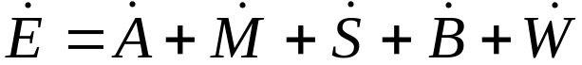,

where 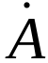 is the activation heat rate, 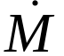 is the maintenance heat rate, 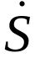 is the shortening heat rate, 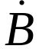 is the basal metabolic rate, and 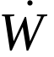 is the work rate (Mommaerts, 1969; Hatze and Buys, 1977; Davy and Audu, 1987; Anderson and Pandy, 2001).

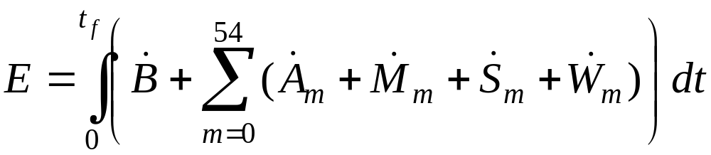

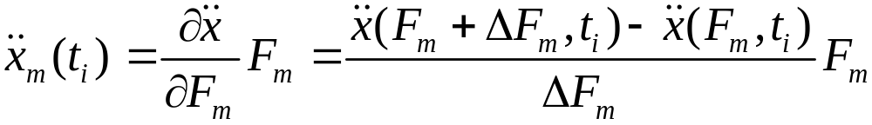

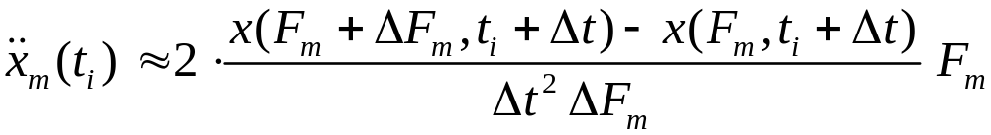
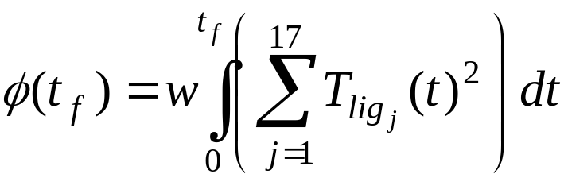

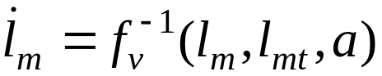
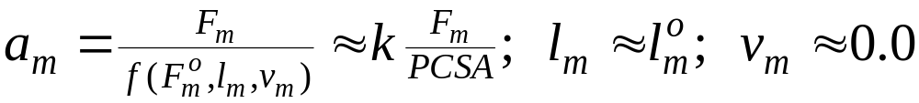

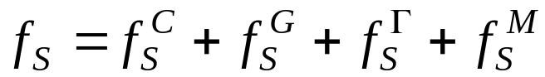,
where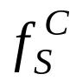, 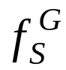, 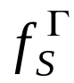, and 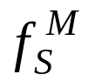 are the contributions made to the spring forces by the centrifugal, gravity, ligament, and muscle forces, respectively.

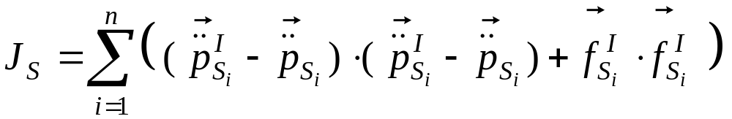,
where 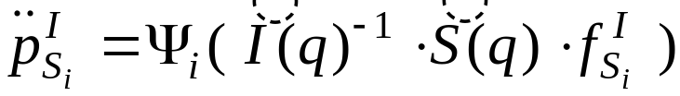 and 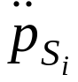 is the actual acceleration of the 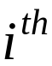 spring point that occurred during the simulation.

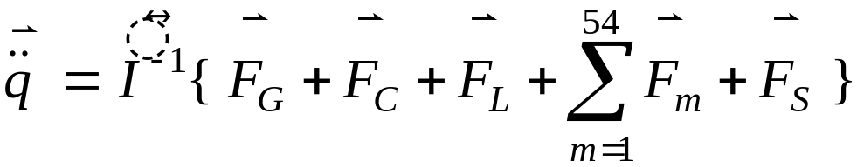,
where 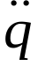 is the vector of joint accelerations, 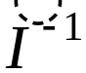 is the inverse of the system mass matrix, and 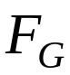, 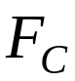, 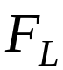, 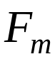, and 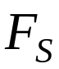 are vectors of generalized forces due to gravity (G), Coriolis and centripetal forces (C), ligaments (L), a muscle force (), and ground reaction forces (S) that were modeled by the foot springs (Kane and Levinson, 1985; Zajac and Gordon, 1989).

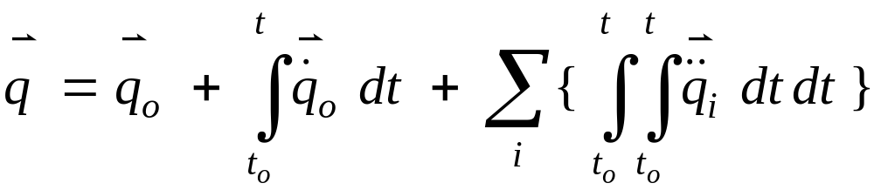; 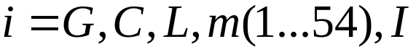
where 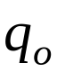 is a vector of the initial joint positions at time 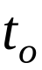.

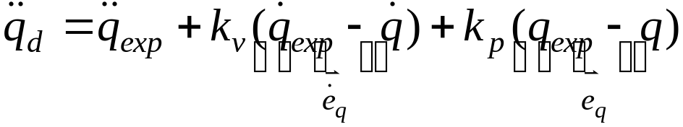,
where 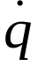 and 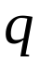 are the generalized speeds and coordinates of the model, 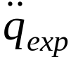, 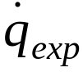, and 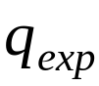 are the experimental accelerations, velocities, and positions corresponding to the generalized coordinates of the model, and 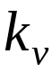 and 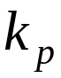 are feedback gains for the velocity errors (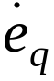) and position errors (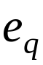), respectively.

