SimTrack: Software for Generating Muscle-Actuated Simulations of Movement

Frank C. Anderson, Chand T. John, Eran Guendelman, Allison S. Arnold, Scott L. Delp
Stanford University, Stanford, California, United States of America

Introduction

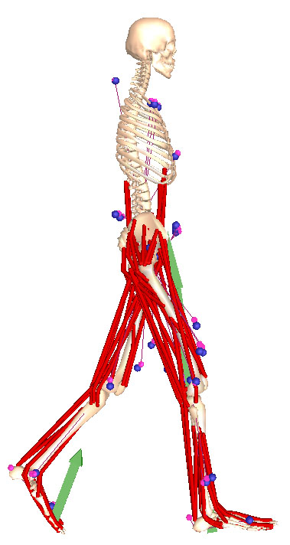
Understanding and treating movement disorders in individuals with cerebral palsy, stroke, Parkinson’s, and other diseases represents a challenging and major health care concern. The challenge arises in part because many elements of the neuromusculoskeletal system interact to produce movement. Abnormal movement may arise from a combination of many sources including …, …, …., and …. Using experiments alone to identify the sources of movement disorders and design treatments has two fundamental limitations. First, important variables, such as the force generated by muscles, are generally not measurable. Second, it is difficult to establish cause-effect relationships.
Fig. 1: Musculoskeletal model.
Forward dynamic simulation, used in combination with experiments, has long been recognized as a potentially powerful technique for elucidating how the elements of the neuromusculoskeletal system interact to produce movement. A dynamic simulation of movement that integrates mathematical models describing the anatomy, physiology, and mechanics of the neuromusculoskeletal system is capable of providing estimates of important variables, such as muscle forces and joint moments. More importantly, such simulations enable cause-effect relationships to be examined rigorously. For example, using a muscle-actuated simulation, one can separately quantify the likely movement consequences of common treatments such as altering bone geometry (e.g., de-rotational osteotomies), performing tendon transfers, and altering muscle excitation patterns by injection of botulinum toxin.
Historically, the computational cost of generating coordinated muscle-actuated simulations of movement has been high, requiring days, weeks, or even months of computer time (Anderson and Pandy, 2001; Neptune et al., 2001; Hase et al., 20??; Higginson et al., 20??). Recent breakthroughs in the application of robotic-style control techniques to biomechanical systems have dramatically reduced the time needed to generate such simulations. In particular, computed muscle control (CMC) has been used to compute the muscle excitation patterns that drove a 21-degree-of-freedom, 92-muscle model to track the experimental gait data of 10 healthy adults (Thelen and Anderson, 2006). A simulation of a half-cycle of gait that reproduced joint angles with tolerances about 1° were generated with only about 30 minutes of computer time.
While the speed and accuracy of CMC makes it feasible for dynamic simulation to be used more broadly, the software implementation of Thelen and Anderson (2006) was limited to movements of short duration (i.e., about half a second or less). This limitation was due primarily to an algorithm in their workflow called the residual elimination algorithm (REA) designed to eliminate inconsistencies between the experimental kinematic and force plate data.
In this paper, we describe our SimTrack software built around CMC for generating muscle-actuated simulations of movement. In particular, we focus on a new algorithm called the residual reduction algorithm (RRA), designed to replace REA and enable the generation of accurate simulations of longer duration.

Methods

SimTrack guides users through four steps to create a simulation (Fig. 2). As input, SimTrack takes a dynamic model of the musculoskeletal system, experimentally-measured kinematics, and reaction forces and moments. While this approach is general, we will describe it in the context of generating simulations of gait, since this is one of the most challenging applications.
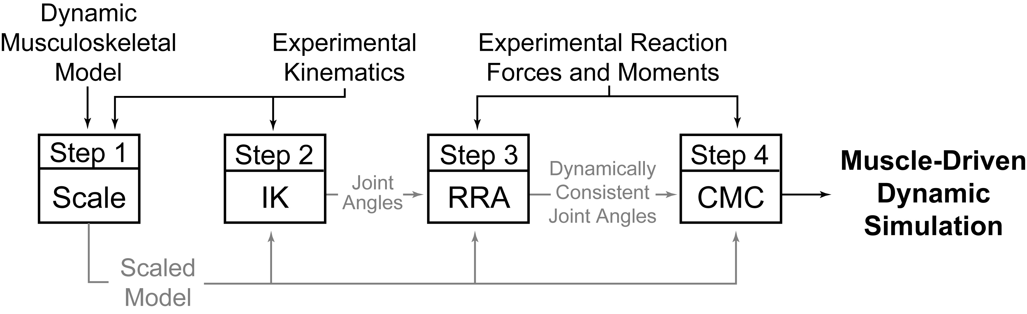
In Step 1, a dynamic musculoskeletal model (e.g., a SIMM model [ref]) is scaled to match the anthropometry of an individual subject. The dimensions of each body segment in the model are scaled based on relative distances between pairs of markers obtained from a motion capture system and the corresponding marker locations in the model. The mass properties of the body segments are scaled proportionally so that the total measured mass of the subject is reproduced. Muscle fiber lengths and tendon slack lengths of the muscle-tendon actuators are scaled so that they each remain the same percentage of total actuator length, preserving the force-generating properties of the muscles.
In Step 2, an inverse kinematics (IK) problem is solved to determine the model generalized coordinates 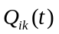 that best reproduce the raw marker data obtained from motion capture. Step 2 is formulated as a least-squares problem that minimizes the differences between the measured marker locations and the model’s virtual marker locations, subject to joint constraints [ref]. If the experimental kinematics include a set of joint centers or joint angles produced by motion capture software, these may also be included in the formulation.
From motion capture, we are given ground reaction data as a function of time,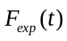, which has 18 components: three forces, three moments, and three center-of-pressure coordinates for each of the subject’s two feet. In Step 3, we first apply a low-pass FIR filter to the function at 6 Hz, the maximum frequency at which significant changes in movement occur in gait [cite some papers]. We then fit and with generalized cross-validated splines [Woltring] of order 5 and 3 respectively to produce smooth functions 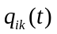 and 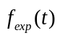. In practice, these two functions are inconsistent [cite Vaughan, Kuo, Cahouet], so a residual force 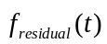 is needed to allow the model to follow the given kinematics while the ground reaction forces are applied to it. By Newton’s 2nd Law, the total force on the model is equal to its mass times acceleration,

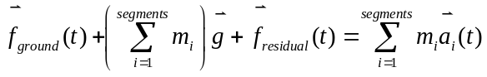,

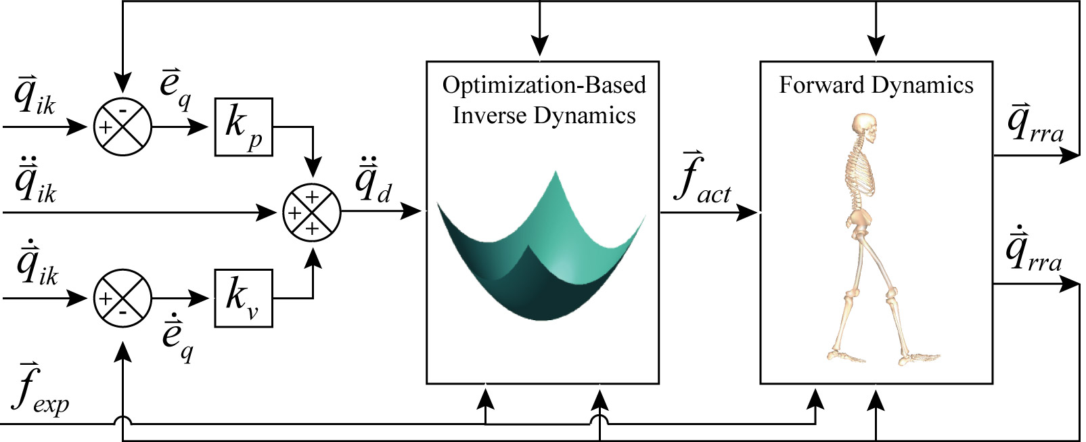

where 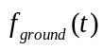 is the net force applied to the model by the ground, 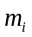 and are the mass and acceleration, respectively, of body segment of the model, and is acceleration due to gravity. An analogous equation relates the ground reaction moment 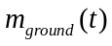 to the residual moment 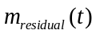. The three components of and the three components of are collectively referred to as the residuals. The residuals are computed and averaged over the duration of the movement. Specific changes are recommended in the center of mass location of the model’s torso that reduce the average values of the residuals over the duration of the movement. Then a residual reduction algorithm (RRA) solves a control problem in which each generalized coordinate of the model is controlled by an idealized actuator. In particular, the six degrees of freedom between the model and the ground are actuated by the six residuals. RRA steps forward in time, computing actuator forces 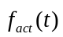 at each time t that will cause the model to move from its current configuration 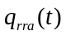 to its desired configuration 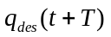 in the next time step. The actuator forces are computed by minimizing a performance criterion,

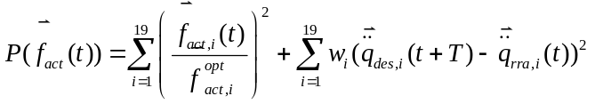,

where 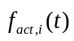 is the i^{th} actuator force, 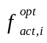 is the optimal force of the i^{th} actuator, and 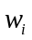 is the weight of the acceleration error in the i^{th} generalized coordinate. The desired acceleration 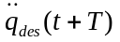 is computed using a proportional-derivative control law [cite a CMC paper]. The first six components of are the residuals and the remaining components are the joint moments. By attempting to keep the residuals low, the desired accelerations may not be met. Thus the new kinematics may differ from the original kinematics . The model with its altered torso center of mass location, the resulting kinematics , the original kinematics , and the original ground reaction data are the inputs into Step 4.
In Step 4, computed muscle control (CMC) is used to generate a set of muscle excitations that produce a coordinated muscle-driven simulation of the subject’s movement [cite CMC 2006]. CMC uses a static optimization criterion to distribute forces across synergistic muscles and proportional-derivative control to generate a forward dynamic simulation that closely tracks the kinematics derived in Step 3. Although a static performance criterion is used, the full state equations representing the activation and contraction dynamics of the muscles are incorporated into the forward dynamic simulation. In our current implementation, the force between the foot and the ground is not modeled; rather, the measured ground reaction forces and moments are applied directly to the foot. When analyzing a simulation, spring-damper elements are introduced between the feet and the ground to allow the reaction forces and moments to respond to perturbations (e.g., altered muscle forces).
To investigate the performance of RRA, we used SimTrack to generate a simulation of normal walking for a male subject (age ??, height ??, mass 60.61 kg) walking at a self-selected speed of 1.12 m/sec. A generic musculoskeletal model was scaled to fit the size and weight of the subject. Third, inverse kinematics was used to compute generalized coordinates describing the subject’s motion from the marker data. Fourth, RRA was used to compute an altered set of kinematics that reduced the residual forces needed to simulate the model’s motion. Fifth, CMC was used to generate a simulation of the subject’s motion.

Results

Application of RRA substantially reduced the residuals needed to make the inverse kinematics solution consistent with the experimental ground reactions (Fig. 4). The residual forces computed prior to the application of RRA were large and noisy, ranging from ±50N for the Fx and Fz components and ±100N for Fy. After application of RRA, the residual forces were dramatically reduced so that the peak forces were less than 5N (Fig. 4: Fx, Fy, Fz). The residual moments were more resistant to reduction (Fig. 4, Mx, My, Mz). The amplitudes of Mx and Mz were reduced by about 50% from peakls of about 30Nm down to peaks of about 15Nm. In contrast to Mx and Mz, My (the axial residual) was not noisy and RRA did not reduce its magnitude appreciably, suggesting that the My residuals were not because of noise in the experimental data but due to unmodeled dynamics (i.e., a lack of arms in the musculoskeletal model).
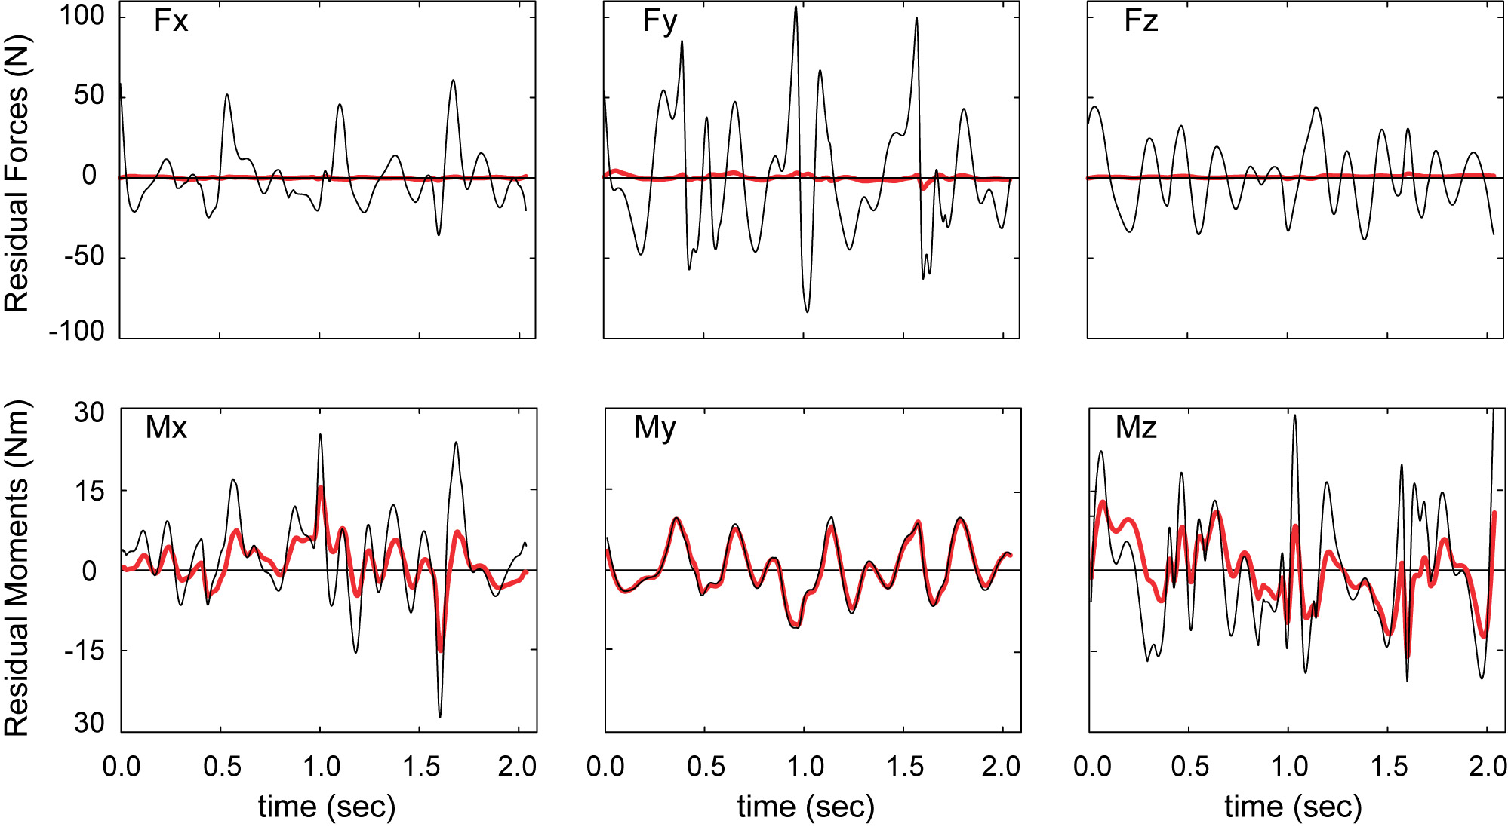

The application of RRA resulted in only minor changes to the kinematics from the inverse kinematics solution. Despite the dramatic reduction in residual forces, only minor changes were made to the translations of the pelvis (the base segment of the model): 3 mm in X, 1 mm in Y, and 34 mm in Z. The largest changes in joint angles occurred in right and left hip flexion/extension, but these changes were less than 0.5° and only for brief periods of time. Most joint angles, like back axial rotation (Fig. 5: compare thick red line to the thin black line), were within 0.1° of the original IK solution. In contrast, REA applied to the same data using the same model produced much larger deviations, especially in back axial rotation (Fig. 5: compare dashed green line to thin black line).

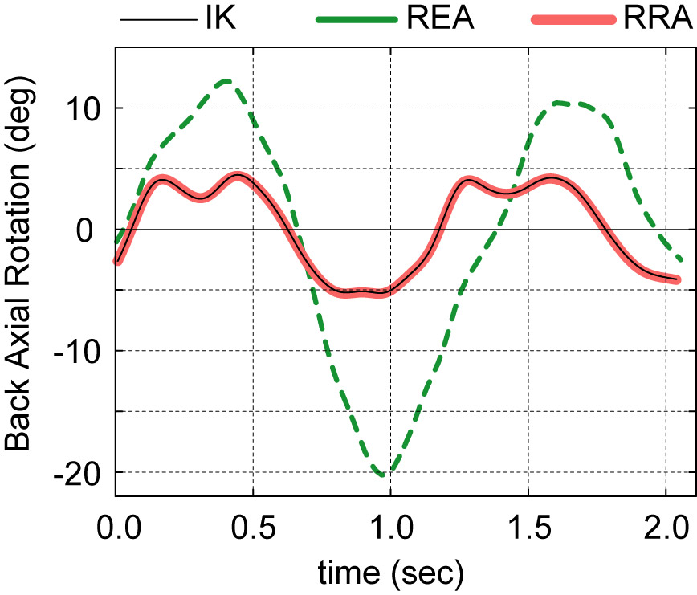
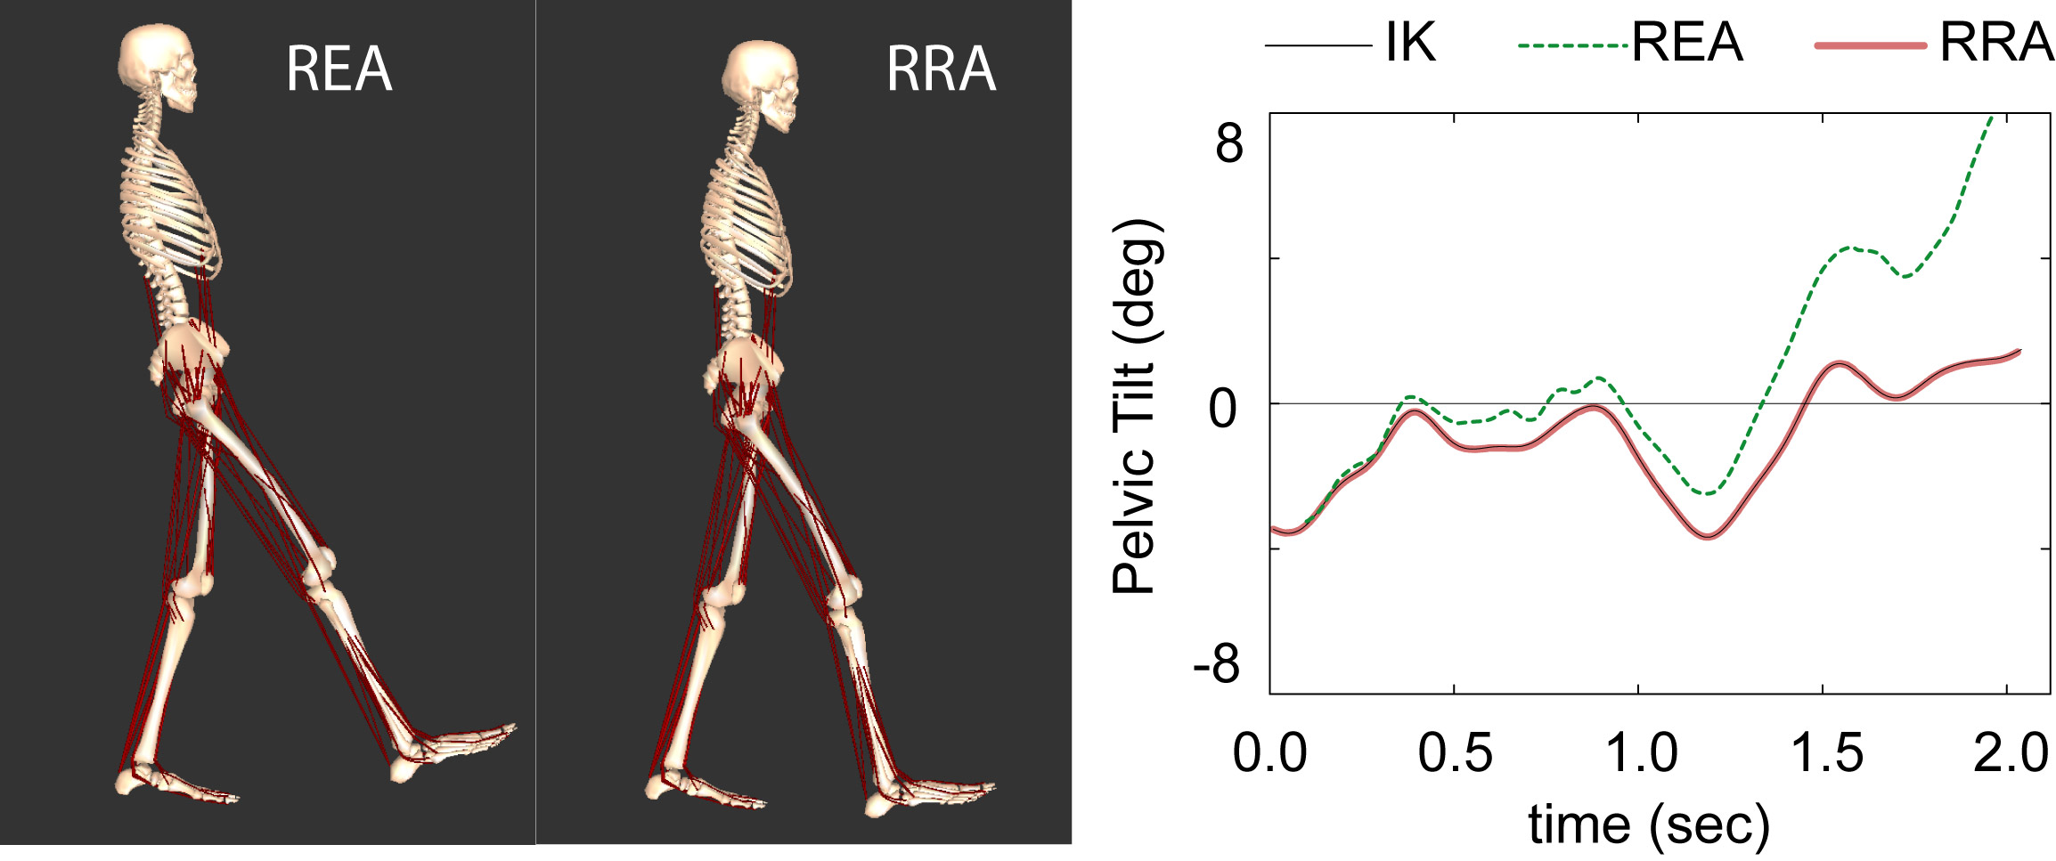

Fig. 6: Comparison of CMC simulations generated from REA- and RRA- processed kinematics. (a) Snapshot of the model at the end of the simulations. (b) Pelvic tilt starts to drift from the
Fig. 5: Axial rotation in the back joint following application of REA and RRA.
CMC was able to generate a muscle-actuated simulation that closely tracked the RRA-processed kinematics. The excitation patterns predicted for the muscles were consistent with electromygraphical recordings from the subject (not shown). Peak tracking error in the translation of the pelvis was less than 1mm. Tracking errors in the joint angles were generally less than 0.1°. At the end of the simulation (t = 2.0 sec), the model remained close to the experimental kinematics (Fig. 6: compare thick red line to thin black line in (b)). In contrast, without the application of residuals, the CMC simulation based on the REA-processed kinematics was beginning to fall over (Fig. 6a) and the pelvic tilt of the model began to drift from the desired kinematics at around 0.5 sec (Fig. 6b).

Discussion

Acknowledgements

Subject data from Gillette/Mike Schwartz; funding…
Paul’s plotting program; acknowledge any other OpenSim developers?

References

