
Documents

Programming with OpenSim
Release 2.0
June 1, 2009
Jeff Reinbolt, Ajay Seth, Ayman Habib, Scott Delp
Website: SimTK.org/home/opensim

Acknowledgments

OpenSim was developed as a part of SimTK and funded by the Simbios National Center for Biomedical Computing through the National Institutes of Health and the NIH Roadmap for Medical Research, Grant U54 GM072970. Information on the National Centers can be found at http://nihroadmap.nih.gov/bioinformatics.

Trademarks and Copyright and Permission Notice

SimTK and Simbios are trademarks of Stanford University. The documentation for OpenSim is freely available and distributable under the MIT License.

Copyright (c) 2009 Stanford University

Permission is hereby granted, free of charge, to any person obtaining a copy of this document (the "Document"), to deal in the Document without restriction, including without limitation the rights to use, copy, modify, merge, publish, distribute, sublicense, and/or sell copies of the Document, and to permit persons to whom the Document is furnished to do so, subject to the following conditions:

This copyright and permission notice shall be included in all copies or substantial portions of the Document.

THE DOCUMENT IS PROVIDED "AS IS", WITHOUT WARRANTY OF ANY KIND, EXPRESS OR IMPLIED, INCLUDING BUT NOT LIMITED TO THE WARRANTIES OF MERCHANTABILITY, FITNESS FOR A PARTICULAR PURPOSE AND NONINFRINGEMENT. IN NO EVENT SHALL THE AUTHORS, CONTRIBUTORS OR COPYRIGHT HOLDERS BE LIABLE FOR ANY CLAIM, DAMAGES OR OTHER LIABILITY, WHETHER IN AN ACTION OF CONTRACT, TORT OR OTHERWISE, ARISING FROM, OUT OF OR IN CONNECTION WITH THE DOCUMENT OR THE USE OR OTHER DEALINGS IN THE DOCUMENT.

Brief Description
Individuals who read this guide will learn advanced programming features of OpenSim through real-life illustrations and exercises. These examples will enable you to create simulations on your computers, analyze those simulations, and add new functionalities on your own.

Audience
This guide is recommended for those who desire in-depth knowledge of musculoskeletal simulation with OpenSim and how to begin using the public Application Programming Interface (API). Before reading this guide, you should already by an OpenSim user and have programming experience in C++.

Table of Contents

1 Guide Overview 1
2 Performing a Simulation 3
2.1 An Example main() Routine 3
2.2 Create a New OpenSim Model 3
2.3 Create a Ground Body 3
2.4 Save the OpenSim Model 4
2.5 Create a Block Body 4
2.6 Create a Free Joint Between Ground and Block 5
2.7 Initialize the OpenSim Model System 6
2.8 Define the Acceleration of Gravity 6
2.9 Define the Initial and Final Simulation Times 6
2.10 Define the Initial Position and Velocity States of Block 6
2.11 Create the Integrator and Manager 7
2.12 Integrate the System Equations of Motion 7
2.13 Save the Simulation Results 7
2.14 Create Two Opposing Muscles 8
2.15 Define the Initial and Final Controls 9
2.16 Define the Initial Activation and Fiber Length States 9
2.17 Create Contact Geometry and Elastic Foundation Force 10
2.18 Create Prescribed Force 11
2.19 Create a Constraint 12
3 Analyzing a Simulation 13
3.1 Section Title 13
4 Adding New Functionality 15
4.1 Section Title 15

Guide Overview

This guide provides an introduction to the public Application Programming Interface (API) available within OpenSim, a freely available package for musculoskeletal modeling and dynamic simulation of movement. For more information on OpenSim, visit the OpenSim project site at http://simtk.org/home/opensim. The project site provides a forum for users to ask questions and share expertise.

This guide serves as a summary of the tools and capabilities of OpenSim available to the C++ programmer. In the second chapter, we will focus on writing a main() routine to perform a forward dynamic simulation using OpenSim. In the third chapter, we will focus on writing an analysis plug-in to analyze a simulation. In the fourth chapter, we will focus on adding functionality to OpenSim.

To present the OpenSim API, we will use a simplified model throughout this guide. The model consists of 2 segments connected by 1 joint along with the 2 muscles. This simple model is not intended for research.

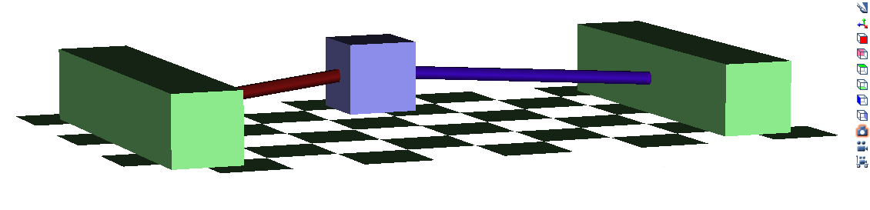

Performing a Simulation

An Example main() Routine

In this chapter, we will write a main() routine to perform a forward dynamic simulation using OpenSim. We will build it up in pieces, starting from the simplest possible OpenSim model, a single block. In the end, we will have an OpenSim model with two muscles performing a tug-of-war on the block. The resulting source code and associated files for this example are located in the OpenSim source code repository:
https://simtk.org/svn/opensim/Branches/OpenSim_BuiltOn_SimTK_1_1/OpenSim/Examples/AdvancedProgrammingMain.
Performing a forward dynamic simulation in OpenSim involves a series of steps. Each of these steps usually requires only a few lines of code. The following sections explain the steps labeled in the example main() routine.

Create a New OpenSim Model

To perform a simulation, we first create a new OpenSim model and set its name in our main() routine.
#include <OpenSim/Simulation/Model/Model.h>

using namespace OpenSim;

int main()
{
// Create a new OpenSim model
Model osimModel;
osimModel.setName("osimModel");

return 0;
}
While the main() routine above compiles and runs, the new OpenSim model is “empty” and no useful information is saved to file.

Create a Ground Body

After we have created a new OpenSim model, we create a ground body and add display geometry to it in order to visualize the body in the OpenSim GUI.
// Create a ground body
Body& ground = osimModel.getGroundBody();
ground.addDisplayGeometry("ground.vtp");
ground.addDisplayGeometry("anchor1.vtp");

ground.addDisplayGeometry("anchor2.vtp");
Again, the current main() routine compiles and runs, but no useful information is saved to file.

Save the OpenSim Model

After we have created a ground body and added its display geometry, we save the model to a file with the “.osim” extension in order to visualize the model we have created.
// Save the OpenSim model to a file
osimModel.print("osimModel.osim");
After we compile and run the current main() routine, we can open the model in the OpenSim GUI and visualize the ground body (highlighted with green for this guide).

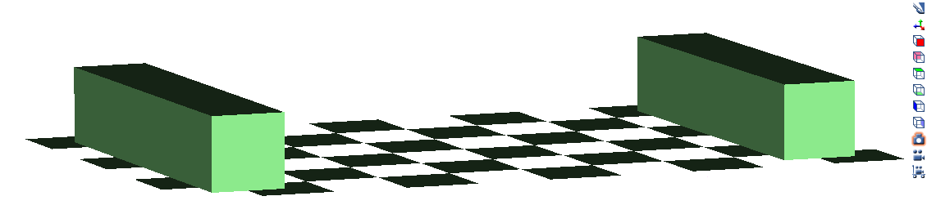

Create a Block Body

To add an additional body to the OpenSim model, we create a block body with inertial properties and add display geometry to it.
// Create a 20 kg, 0.1 m^3 block body
double blockMass = 40.0, blockSideLength = 0.1, blockInertia =
blockMass/12.0*2.0*blockSideLength*blockSideLength;
SimTK::Vec3 blockMassCenter(0,0,0);
Body block("block",blockMass,blockMassCenter,
SimTK::Inertia(SimTK::Vec3(blockInertia)).toMat33());
block.addDisplayGeometry("block.vtp");
At this point, the block body cannot be visualized in the GUI until we connect it to the ground body with a joint.

Create a Free Joint Between Ground and Block

To finish adding the block body to the OpenSim model, we create a free joint (i.e., 6 degrees-of-freedom) between the ground and block.
// Create a free joint between the ground and block
Coordinate *jointXRotation = new Coordinate("xRotation",TransformAxis::Rotational,-2*SimTK_PI,2*SimTK_PI);
Coordinate *jointYRotation = new Coordinate("yRotation",TransformAxis::Rotational,-2*SimTK_PI,2*SimTK_PI);
Coordinate *jointZRotation = new Coordinate("zRotation",TransformAxis::Rotational,-2*SimTK_PI,2*SimTK_PI);
Coordinate *jointXTranslation = new Coordinate("xTranslation",TransformAxis::Translational,-10.0,10.0);
Coordinate *jointYTranslation = new Coordinate("yTranslation",TransformAxis::Translational,-10.0,10.0);
Coordinate *jointZTranslation = new Coordinate("zTranslation",TransformAxis::Translational,-0.3,0.3);
CoordinateSet *jointCoordinateSet = new CoordinateSet;
jointCoordinateSet->append(jointXRotation);
jointCoordinateSet->append(jointYRotation);
jointCoordinateSet->append(jointZRotation);
jointCoordinateSet->append(jointXTranslation);
jointCoordinateSet->append(jointYTranslation);
jointCoordinateSet->append(jointZTranslation);
TransformAxis *jointXRotationAxis = new TransformAxis("xRotationAxis",*jointXRotation,SimTK::Vec3(1,0,0));
TransformAxis *jointYRotationAxis = new TransformAxis("yRotationAxis",*jointYRotation,SimTK::Vec3(0,1,0));
TransformAxis *jointZRotationAxis = new TransformAxis("zRotationAxis",*jointZRotation,SimTK::Vec3(0,0,1));
TransformAxis *jointXTranslationAxis = new TransformAxis("xTranslationAxis",*jointXTranslation,SimTK::Vec3(1,0,0));
TransformAxis *jointYTranslationAxis = new TransformAxis("yTranslationAxis",*jointYTranslation,SimTK::Vec3(0,1,0));
TransformAxis *jointZTranslationAxis = new TransformAxis("zTranslationAxis",*jointZTranslation,SimTK::Vec3(0,0,1));
TransformAxisSet *jointTransformAxisSet = new TransformAxisSet;
jointTransformAxisSet->append(jointXRotationAxis);
jointTransformAxisSet->append(jointYRotationAxis);
jointTransformAxisSet->append(jointZRotationAxis);
jointTransformAxisSet->append(jointXTranslationAxis);
jointTransformAxisSet->append(jointYTranslationAxis);
jointTransformAxisSet->append(jointZTranslationAxis);
CustomJoint free("free",ground,SimTK::Vec3(0,0.05,0),block,SimTK::Vec3(0),*jointCoordinateSet,*jointTransformAxisSet);
osimModel.addJoint(&free);
After we compile and run the current main() routine, we can open the model in the OpenSim GUI and visualize the ground body (highlighted with green for this guide) and block body (highlighted with blue for this guide).

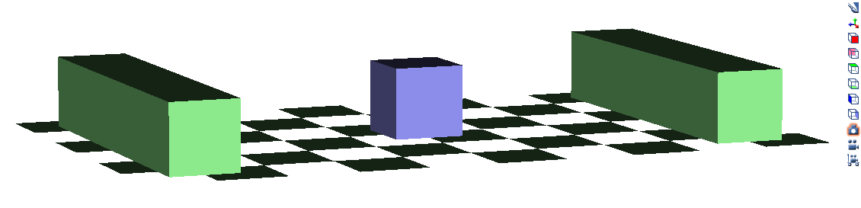

Initialize the OpenSim Model System

To begin simulating the block falling, we initialize the system and create the system state.
// Initialize the system
SimTK::State& si = osimModel.initSystem();

Define the Acceleration of Gravity

In order for the block to actually fall during the simulation, we define the acceleration of gravity to pull the block towards the ground.
// Define the acceleration of gravity
osimModel.setGravity(SimTK::Vec3(0,-9.80665,0));

Define the Initial and Final Simulation Times

We define the initial time to start the simulation and the final time to finish the simulation.
// Define the initial and final simulation times
double initialTime = 0.0;
double finalTime = 5.0;

Define the Initial Position and Velocity States of Block

In addition, we define the initial position and velocity of the block. Moreover, for the free joint, the position and velocity states are numbered 0 (x-rotation), 1 (y-rotation), 2 (z-rotation), 3 (x-translation), 4 (y-translation), and 5 (z-translation).
// Define the initial position and velocity states
SimTK::Vector& qi = si.updQ(); // block positions
SimTK::Vector& ui = si.updU(); // block velocities
qi = 0.0; // set all positions to zero
qi[3] = 0.1; // set x-translation coordinate position
qi[4] = 0.05; // set y-translation coordinate position
ui = 0.0; // set all velocities to zero

Create the Integrator and Manager

We create the integrator and manager for the simulation in order to perform the numerical integration of the system equations of motion during the forward dynamics simulation.

#include <OpenSim/Simulation/Manager/Manager.h>

// Create the integrator and manager for the simulation.
osimModel.getSystem()->realize(si, SimTK::Stage::Velocity);
SimTK::RungeKuttaFeldbergIntegrator integrator(*osimModel.getSystem());
integrator.setMaximumStepSize(1.0e-3);
integrator.setMinimumStepSize(1.0e-8);
integrator.setAccuracy(1.0e-4);
integrator.setAbsoluteTolerance(1.0e-4);
Manager manager(&osimModel, osimModel.getSystem(), &integrator);

Integrate the System Equations of Motion

We integrate the system equations of motion from the initial time to the final time of the simulation. Depending on your computer speed, this numerical integration could take from a few to several seconds.
// Integrate from initial time to final time
manager.setInitialTime(initialTime);
manager.setFinalTime(finalTime);
std::cout<<"\n\nIntegrating from "<<initialTime<<" to "<<finalTime<<std::endl;
manager.integrate(si);

Save the Simulation Results

After we have performed the integration for the forward dynamics simulation, we save the resulting motion in order to visualize the simulation we have created.
// Save the simulation results
Storage statesDegrees(*manager.getStateStorage());
osimModel.updSimbodyEngine()->convertRadiansToDegrees(statesDegrees);
statesDegrees.setWriteSIMMHeader(true);
statesDegrees.print("tugOfWar_states_degrees.mot");
After we compile and run the current main() routine, we can load the motion in the OpenSim GUI and visualize the simulation.

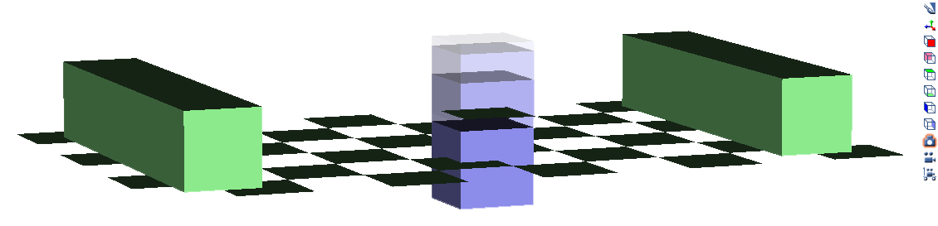

Create Two Opposing Muscles

To prevent the block from falling through the ground, we create two opposing muscles between the ground and block.
#include <OpenSim/Actuators/Schutte1993Muscle.h>
#include <OpenSim/Actuators/Thelen2003Muscle.h>
#include <OpenSim/Simulation/Model/ForceSet.h>
// Create two muscles

double maxIsometricForce = 1000.0, optimalFiberLength = 0.1, tendonSlackLength = 0.2, pennationAngle = 0.0, activation = 0.0001, deactivation = 1.0;
Schutte1993Muscle *muscle1 = new Schutte1993Muscle("muscle1",maxIsometricForce,optimalFiberLength,tendonSlackLength,pennationAngle);
muscle1->setActivation1(activation);
muscle1->setActivation2(deactivation);
Thelen2003Muscle *muscle2 = new Thelen2003Muscle("muscle2",maxIsometricForce,optimalFiberLength,tendonSlackLength,pennationAngle);
muscle2->setActivationTimeConstant(activation);

muscle2->setDeactivationTimeConstant(deactivation);

// Update the model's force set
osimModel.updForceSet()->append(muscle1);
osimModel.updForceSet()->append(muscle2);

// Reinitialize the system (with new muscles)

SimTK::State& s = osimModel.initSystem();

// Define the muscle points between the ground and block

MusclePoint *muscle1Point1 = new MusclePoint;
muscle1Point1->setName("muscle1-point1");
muscle1Point1->setBody(ground);
muscle1Point1->setup(&osimModel,&(muscle1->getGeometryPath()));
muscle1Point1->setAttachment(s,SimTK::Vec3(0.0,0.05,-0.35));

MusclePoint *muscle1Point2 = new MusclePoint;
muscle1Point2->setName("muscle1-point2");
muscle1Point2->setBody(block);
muscle1Point2->setup(&osimModel,&(muscle1->getGeometryPath()));
muscle1Point2->setAttachment(s,SimTK::Vec3(0.0,0.0,-0.05));

muscle1->getGeometryPath().updAttachmentSet().append(muscle1Point1);
muscle1->getGeometryPath().updAttachmentSet().append(muscle1Point2);

MusclePoint *muscle2Point1 = new MusclePoint;
muscle2Point1->setName("muscle2-point1");
muscle2Point1->setBody(ground);
muscle2Point1->setup(&osimModel,&(muscle2->getGeometryPath()));
muscle2Point1->setAttachment(s,SimTK::Vec3(0.0,0.05,0.35));

MusclePoint *muscle2Point2 = new MusclePoint;
muscle2Point2->setName("muscle2-point2");
muscle2Point2->setBody(block);
muscle2Point2->setup(&osimModel,&(muscle2->getGeometryPath()));
muscle2Point2->setAttachment(s,SimTK::Vec3(0.0,0.0,0.05));

muscle2->getGeometryPath().updAttachmentSet().append(muscle2Point1);

muscle2->getGeometryPath().updAttachmentSet().append(muscle2Point2);

Define the Initial and Final Controls

We define the initial control for each muscle at the start the simulation and the final controls at the finish the simulation, where there is a linear interpolation between initial and final controls here.
#include <OpenSim/Simulation/Control/ControlSet.h>
// Define the initial and final controls
double initialControl[2];
double finalControl[2];
initialControl[0] = 1.0;
initialControl[1] = 0.05;
finalControl[0] = 0.05;
finalControl[1] = 1.0;
osimModel.getControlSet()->
setControlValues(initialTime,initialControl);

osimModel.getControlSet()->setControlValues(finalTime,finalControl);

Define the Initial Activation and Fiber Length States

In addition, we define the initial activation and fiber length of each muscle. Moreover, we initialize the states for each muscle after setting the states.
// Define the initial muscle states
muscle1->setDefaultActivation(initialControl[0]); // muscle1 activation
muscle1->setDefaultFiberLength(0.1); // muscle1 fiber length

muscle1->initState(si); // initialize muscle1 state
muscle2->setDefaultActivation(initialControl[1]); // muscle2 activation
muscle2->setDefaultFiberLength(0.1); // muscle2 fiber length
muscle2->initState(si); // initialize muscle2 state
After we compile and run the current main() routine, we can load the motion in the OpenSim GUI and visualize the simulation.

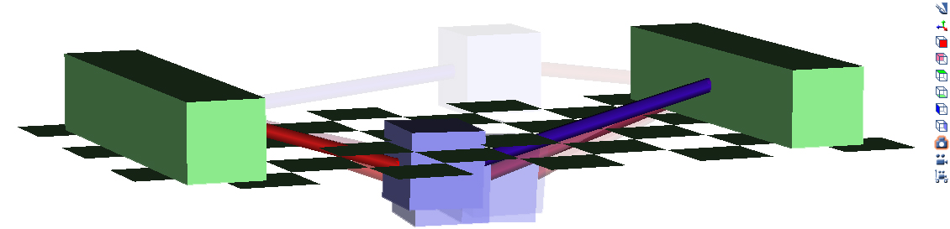

Create Contact Geometry and Elastic Foundation Force

To prevent the block from penetrating the ground, we create some contact geometry and elastic foundation force between the ground and block.
#include <OpenSim/Simulation/Model/ContactHalfSpace.h>
#include <OpenSim/Simulation/Model/ContactGeometrySet.h>
#include <OpenSim/Simulation/Model/ElasticFoundationForce.h>
#include <OpenSim/Simulation/Model/ContactMesh.h>
// Create ContactGeometry.
ContactHalfSpace halfSpace(SimTK::Vec3(0), SimTK::Vec3(0, 0, -0.5*SimTK_PI), ground);
halfSpace.setName("ground");
osimModel.updContactGeometrySet()->append(&halfSpace);
OpenSim::ContactGeometry* geometry;
geometry = new ContactMesh("blockRemesh192.obj", SimTK::Vec3(0), SimTK::Vec3(0), block);
geometry->setName("block");
osimModel.updContactGeometrySet()->append(geometry);

// Create an ElasticFoundationForce.
OpenSim::Force* force;
force = new OpenSim::ElasticFoundationForce();
osimModel.updForceSet()->append(force);
OpenSim::ElasticFoundationForce::ContactParameters* contactParams = new OpenSim::ElasticFoundationForce::ContactParameters();
contactParams->updGeometry().append("block");
contactParams->updGeometry().append("ground");
contactParams->setStiffness(1.0e8);
contactParams->setDissipation(0.01);
contactParams->setDynamicFriction(0.25);
dynamic_cast<OpenSim::ElasticFoundationForce*>(force)->updContactParametersSet()->append(contactParams);
After we compile and run the current main() routine, we can load the motion in the OpenSim GUI and visualize the simulation.

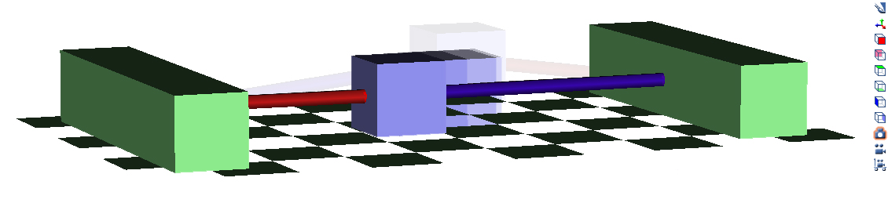

Create Prescribed Force

To push the block during the tug-of-war, we create a prescribed force applied to the block.
#include <OpenSim/Simulation/Model/PrescribedForce.h>
#include <OpenSim/Common/LinearFunction.h>
// Create a prescribed force applied to the block
PrescribedForce prescribedForce(block);
prescribedForce.setForceIsInGlobalFrame(false);
LinearFunction *prescribedForceX = new LinearFunction(), *prescribedForceY = new LinearFunction(), *prescribedForceZ = new LinearFunction();
prescribedForceX->addPoint(0, 0);
prescribedForceX->addPoint(5, -blockMass*9.80665*3.0);
prescribedForceY->addPoint(0, 0);
prescribedForceZ->addPoint(0, 0);
prescribedForce.setForceFunctions(prescribedForceX, prescribedForceY, prescribedForceZ);
LinearFunction *prescribedForcePointX = new LinearFunction(), *prescribedForcePointY = new LinearFunction(), *prescribedForcePointZ = new LinearFunction();
prescribedForcePointX->addPoint(0, 0.1);
prescribedForcePointY->addPoint(0, 0);
prescribedForcePointZ->addPoint(0, 0);
prescribedForce.setPointFunctions(prescribedForcePointX, prescribedForcePointY, prescribedForcePointZ);
osimModel.updForceSet()->append(&prescribedForce);
After we compile and run the current main() routine, we can load the motion in the OpenSim GUI and visualize the simulation. Save prescribed force to show in GUI.

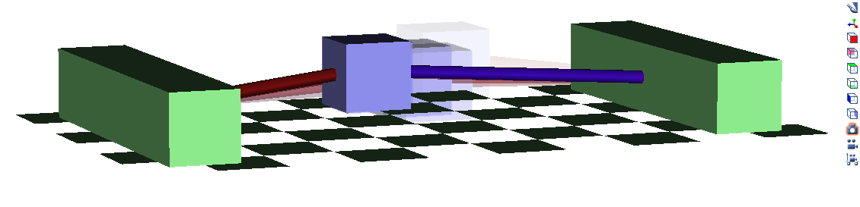

Create a Constraint

Text.
code
Text.

Image

Analyzing a Simulation

Section Title

Section text. Copy and paste from 2008 Jamboree.

Adding New Functionality

Section Title

Section text.

