
OpenSim
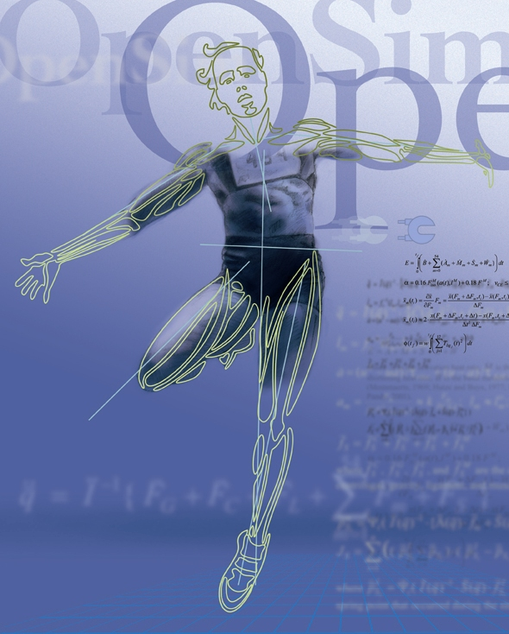

User’s Guide
Release 1.5
March 21, 2008
Website: SimTK.org/home/opensim

OpenSim User’s Guide

Authors

Frank C. Anderson, Ph.D.
Eran Guendelman, Ph.D.
Chand T. John, M.S.
May Q. Liu, M.S.
Katherine R. S. Holzbaur, Ph.D.
Ayman Habib, Ph.D.
Peter Loan, M.S.
Scott L. Delp, Ph.D.

Trademarks and Copyright and Permission Notice

SimTK and Simbios are trademarks of Stanford University. The documentation for OpenSim is freely available and distributable under the MIT License.

Copyright (c) 2008 Stanford University

Permission is hereby granted, free of charge, to any person obtaining a copy of this document (the "Document"), to deal in the Document without restriction, including without limitation the rights to use, copy, modify, merge, publish, distribute, sublicense, and/or sell copies of the Document, and to permit persons to whom the Document is furnished to do so, subject to the following conditions:

This copyright and permission notice shall be included in all copies or substantial portions of the Document.

THE DOCUMENT IS PROVIDED "AS IS", WITHOUT WARRANTY OF ANY KIND, EXPRESS OR IMPLIED, INCLUDING BUT NOT LIMITED TO THE WARRANTIES OF MERCHANTABILITY, FITNESS FOR A PARTICULAR PURPOSE AND NONINFRINGEMENT. IN NO EVENT SHALL THE AUTHORS, CONTRIBUTORS OR COPYRIGHT HOLDERS BE LIABLE FOR ANY CLAIM, DAMAGES OR OTHER LIABILITY, WHETHER IN AN ACTION OF CONTRACT, TORT OR OTHERWISE, ARISING FROM, OUT OF OR IN CONNECTION WITH THE DOCUMENT OR THE USE OR OTHER DEALINGS IN THE DOCUMENT.

Acknowledgments

OpenSim was developed as a part of SimTK and funded by the Simbios National Center for Biomedical Computing through the National Institutes of Health and the NIH Roadmap for Medical Research, Grant U54 GM072970. Information on the National Centers can be found at http://nihroadmap.nih.gov/bioinformatics.

Table of Contents

Introducing OpenSim 1
1.1 What is OpenSim? 1
1.1.1 Capabilities and Limitations 2
1.1.2 Relation to SimTK 2
1.1.3 Compatibility with SIMM 2
1.1.4 Graphical User Interface 2
1.1.5 Command-line Execution 2
1.1.6 Developing in OpenSim 2
1.2 What’s Covered in this Manual 3
1.2.1 Intended Audience 3
1.2.2 Organization of This Document 3
1.2.3 Conventions Used in This Document 3
1.3 How to Get Started 3
1.3.1 Installation 3
1.3.2 Tutorials 4
1.4 Additional Resources and Help 4
Installation 5
2.1 Overview 5
Graphical User Interface 7
3.1 Overview 7
Opening, Saving, Importing and Exporting 9
4.1 Overview 9
3D Views 11
5.1 Overview 11
Navigator Window 13
6.1 Overview 13
Coordinates Window 15
7.1 Overview 15
Motion Playback with the Toolbar 17
8.1 Overview 17
Creating Animations 19
9.1 Overview 19
Muscle Editor 21
10.1 Overview 21
Joint Editor 23
11.1 Overview 23
Excitation Editor 25
12.1 Overview 25
Plotting 27
13.1 Overview 27
Scaling 29
14.1 Overview 29
14.2 How It Works 29
14.2.1 Scaling 30
14.2.2 Marker Placement 31
14.3 Inputs and Outputs 32
14.3.1 Settings File(s) 32
14.3.2 Input(s) 33
14.3.3 Output(s) 33
14.4 How to Use the GUI for Scaling 34
14.5 Scaling Via Command-line Execution 34
14.6 Settings Files and XML Tag Definitions 34
14.6.1 Scale Setup File 34
14.6.2 Scale Marker Set File 41
14.6.3 Scale Scale Set File 43
14.6.4 Scale Measurement Set File 46
14.6.5 Scale Tasks File 49
Inverse Kinematics (IK) 53
15.1 Overview 53
15.2 How to Use the GUI for Scaling 53
15.3 Scaling Via Command-line Execution 53
15.4 Settings Files and XML Tag Definitions 53
Appendix A 54
Appendix B 55
References 57

List of Tables

Table 2-1. Document sections Error! Bookmark not defined.
Table 3-1. Suggested formatting details for a document Error! Bookmark not defined.

List of Figures

Figure 2-1. Dialog window for inserting breaks Error! Bookmark not defined.
Figure 2-2. The outlining toolbar is circled in red within the Microsoft Word document Error! Bookmark not defined.
Figure 2-3. Dialog window for modifying preset styles Error! Bookmark not defined.
Figure 2-4. Dialog window for modifying the format of the table of contents Error! Bookmark not defined.
Figure 2-5. The caption dialog window Error! Bookmark not defined.
Figure 2-6. Dialog window for creating a list of figures or list of tables.. Error! Bookmark not defined.
Figure 3-1. The Field dialog window Error! Bookmark not defined.
Figure 3-2. Tab settings for page headers Error! Bookmark not defined.
Figure 3-3. Modifications needed to create a more sophisticated first page for a chapter Error! Bookmark not defined.

List of Examples

chapter
1

Introducing OpenSim

What is OpenSim?
The SimTrack Workflow is a set of tools that enables you to generate muscle-actuated forward dynamic simulations of movement.

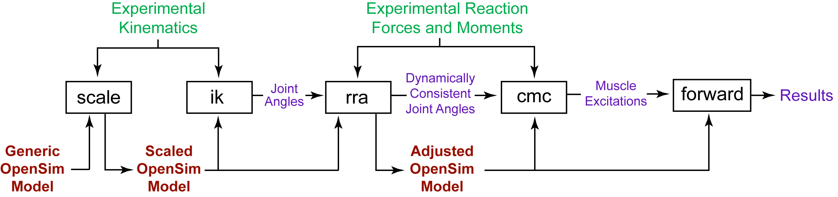

Figure 1-1: Workflow for generating a simulation from experimental data.
OpenSim has tools for scaling a generic musculoskeletal model to the dimensions of a subject (scale), solving an inverse kinematics problem to find model joint angles that best reproduce the subject’s motion (ik), reducing dynamic inconsistencies between the model and experimental data (rra), solving for muscle excitations that drive the model to track the experimental motion using computed muscle control (cmc), and running forward dynamic simulations to generate analysis results (forward).

Capabilities and Limitations

Relation to SimTK

Compatibility with SIMM

Graphical User Interface

Command-line Execution

Developing in OpenSim

What’s Covered in this Manual

Intended Audience
This user’s guide is intended for those users of OpenSim who wish to generate muscle actuated simulations from motion capture data. OpenSim is an object-oriented modeling framework written in C++ for the simulation, control, and analysis of neuromusculoskeletal systems. Users of OpenSim are likely to range from programmers and engineers who model the neuromusculoskeletal system to scientists and clinicians who use simulation to investigate the biomechanics of movement. This manual, because it largely details the software engineering aspects of OpenSim, is likely to be of greater interest to programmers and engineers. Although not required, a working knowledge of SIMM from Musculographics, Inc. and familiarity with the C++ programming language is recommended.

Organization of This Document
Chapter 2 covers installation.
Chapters 3-8 describe how to use the basic components of the GUI.
Chapter 9 describes how to create animations.
Chapters 10-12 covers the editors.
Chapter 13 covers plotting.
Chapters 14-19 covers the tools.
Chapter 20 describes how to prepare your data.
Tutorials and a Quick Reference are found at the end.

Conventions Used in This Document

How to Get Started

Installation

Tutorials

Additional Resources and Help

chapter
2

Installation

Overview

chapter
3

Graphical User Interface

Overview

chapter
4

Opening, Saving, Importing and Exporting

Overview

chapter
5

3D Views

Overview

chapter
6

Navigator Window

Overview

chapter
7

Coordinates Window

Overview
chapter
8

Motion Playback with the Toolbar

Overview

chapter
9

Creating Animations

Overview

chapter
10

Muscle Editor

Overview

chapter
11

Joint Editor

Overview

chapter
12

Excitation Editor

Overview

chapter
13

Plotting

Overview

chapter
14

Scaling

Overview
The scale tool alters the anthropometry of a generic model so that it matches a particular subject as closely as possible. The scaling is performed based on a combination of measured distances between x-y-z marker locations and manually-specified scale factors. The marker locations are usually obtained using motion capture equipment. The unscaled model has a set of virtual markers placed in the same anatomical locations as the experimental markers. The dimensions of each segment in the model are scaled so that the distances between the virtual markers match the distances between the experimental markers. Manual scale factors, which may come from other anthropometric analyses, can be used as an alternative to the measurement-based scaling for any body segment. Once the dimensions of the segments have been scaled to match the subject, the scale tool can also be used to move some or all of the virtual markers on the model so that they are coincident with the measured locations on the subject.

How It Works
The two main steps of the scale tool are scaling and marker placement.

Scaling
The scaling step scales both the mass properties (mass and inertia tensor) as well as the dimensions of the body segments. The main task involved in this step is computing the scale factors for each body segment. This is accomplished using a combination of measurement-based and manual scaling.

Measurement-based scaling
This type of scaling determines scale factors by comparing distances between markers on the model and experimental marker positions provided in a TRC file. A single scale factor is computed using one or more marker pairs.

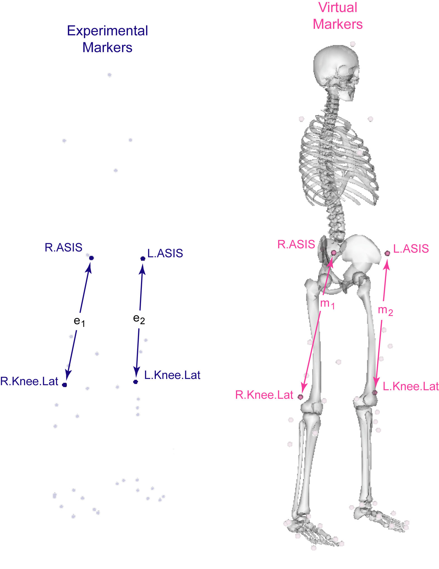
Figure 14-2: Marker pairs for measurement-based scaling. Experimental markers are shown in dark blue; virtual model markers are shown in pink. Ratios of the distances between experimental markers (e_{i}) and the corresponding model markers (m_{i}) are used as the basis for scaling each of the segments in the model.

For example, suppose two marker pairs are used: p₁={R.ASIS, R.Knee.Lat} and p₂={L.ASIS, L.Knee.Lat}. The distance for pair 1 on the model (m₁) is computed by placing the model in its default configuration (all generalized coordinates get assigned their default values, as specified in the <default_value> property of <SimmCoordinate> in the OpenSim model file). The experimental distance between pair 1 (e₁) is computed by looking at each frame of experimental marker data in the given TRC file, computing the distance between the pair for that frame, and taking the average across all frames in a user-specified time range. The scale factor due to pair 1 is then s₁=e₁/m₁. If the markers were further apart in the TRC file than on the model, this indicates that the segment(s) in the model supporting these markers are too small. The overall scale factor is then the average of the scale factors computed due to all of the pairs (e.g., s=(s₁+s₂)/2, in this case, where s₂ is the scale factor due to pair 2). This overall scale factor s can then be used to scale any segments, and along any combination of the x-y-z axes.

Manual scaling
As an alternative to computing scale factors using measured marker positions, it is possible for the user to specify the x-y-z scale factors for a segment manually. This is useful if the actual scale factors for segments are known, or were computed using some alternative algorithm.

Combining measurement-based and manual scaling
The two approaches to computing segment scale factors can be combined in a user-specified order. Each segment starts off with its x-y-z scale factors being {1,1,1}. When measurement-based scaling is run, it modifies only the scale factors along its specified axes. When manual scaling is run, it modifies the scale factors for all three axes (since there is currently no way to specify a subset of the axes in manual scaling).

Mass scaling
The scale factors computed using measurement-based or manual scaling are used to scale the sizes of the segments. In addition, the masses of the segments are adjusted so that the total mass of the body equals the specified subject mass.
There are two different ways the individual segment masses may be adjusted. One approach is to preserve the mass distribution which ensures that the masses of the subject-specific model segments are in the same proportion as they were in the generic model. This scales the masses using a constant factor independent of the scale factors that were used to scale the individual segment sizes. The alternative approach incorporates the size scale factors, still ensuring the total mass equals the subject mass, but having the mass of the scaled segments reflect their scale in size.
In any case, the inertia tensor of each segment is updated to reflect its new size and mass. [SAY SOMETHING ABOUT NONUNIFORM SCALING OF INERTIA TENSORS].

Marker Placement
After scaling the model, the next step is to move the model’s markers to match experimental marker locations in a static pose. The static pose is computed by trying to match some combination of experimental marker positions and generalized coordinate values, as in the inverse kinematics (IK) step (Add reference to the section with this info). The marker locations corresponding to the “static pose” are computed by averaging the marker positions in a given TRC file across a user-specified time range. The reader is referred to the next chapter (recommend using the specific chapter number here….you can use insert->reference->cross-reference so that the number gets updated automatically) for more background on how IK works. Just like IK, marker and coordinate weights are used to determine how strongly the algorithm should try to match them. Once a static pose is computed using the IK-based algorithm, all model markers (except for those designated as fixed) are moved to the averaged “static pose” positions of the experimental markers.

Inputs and Outputs
Figure 14- shows the required inputs and outputs for the scale tool. Each is described in more detail in the following sections. File names can be arbitrarily chosen, right? It’d be good to let the user know that the naming convention used below is purely for the sake of the example.

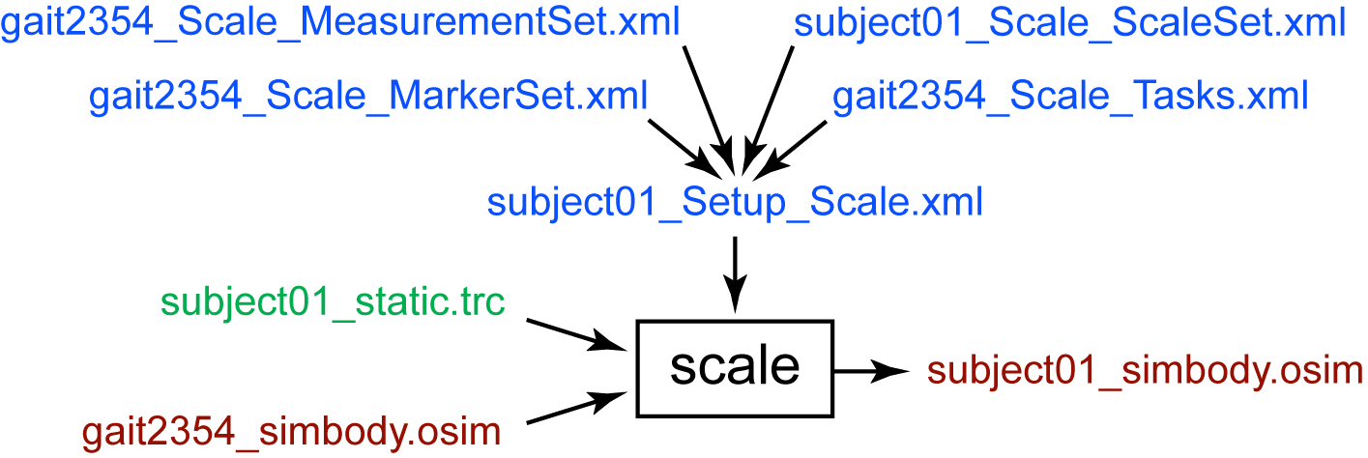
Figure 14-2: Inputs and outputs of the scale tool. Experimental data are shown in green; OpenSim files (.osim) are shown in red; settings files are shown in blue.

Settings File(s)
The subject01_Setup_Scale.xml file is the setup file for the scale tool. It contains settings, described in detail in Section 14.6.1 , and refers to other files that contain additional settings. These other files are listed below:

gait2354_Scale_MarkerSet.xml: Marker set for the scale tool. It contains the set of virtual markers that are placed on the body segments of the model.

gait2354_Scale_MeasurementSet.xml: Measurement set for the scale tool. It contains pairs of experimental markers, the distance between which are used to scale the generic musculoskeletal model.

subject01_Scale_ScaleSet.xml: Scale set for the scale tool. It contains a set of manual scale factors to be applied to the generic musculoskeletal model.

gait2354_Scale_Tasks.xml: Inverse kinematics tasks for the scale tool. In addition to scaling the model, the scale tool moves the virtual markers on the model so that their positions match the experimental marker locations. To do this, the scale tool must position the model so that it best matches the position of the subject. This requires an inverse kinematics problem to be solved. This file contains the inverse kinematics tasks (i.e., a specification of which virtual and experimental markers should be matched up during the inverse kinematics solution) and their relative weightings.

Input(s)

Two data files are required by the scale tool:

subject01_static.trc: Experimental marker trajectories for a static trial. A static trial is usually several seconds of data with the subject posed in a known static position. A segment of a regular motion file can be used as a static trial if desired, but this is not typically done.

your_model.osim: OpenSim musculoskeletal model. This model is scaled to match the anthropometry of your subject.

Output(s)

The scale tool generates a single file:

subject01_simbody.osim: OpenSim musculoskeletal model scaled to the dimensions of the subject.

How to Use the GUI for Scaling
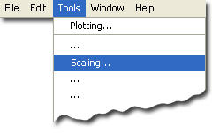
The Scale Tool is accessed by selecting Scaling… from the Tools menu. Like all tools, the operations performed by the Scale Tool apply to the current model. The name of the current model is shown in bold in the Navigator. Any model can be made the current model by right-clicking on its name and selecting Make Current. See Chapters ?? and ?? for information on opening models and making a particular model current.
The Scale Tool is controlled by a dialog with three tabbed panes (Fig. 4.2). The Settings pane is used to specify parameters relating to the subject data, the generic model, and how the model is to be scaled. The Scale Factors pane is used to specify the scale factors for each segment. The Static Pose Weights pane is used to specify weights on marker positions and joint angles for solving an inverse kinematics problem for the static pose. The inverse kinematics solution for the static pose is used to place the virtual markers on the model so that they coincide with the measured marker locations on the subject.

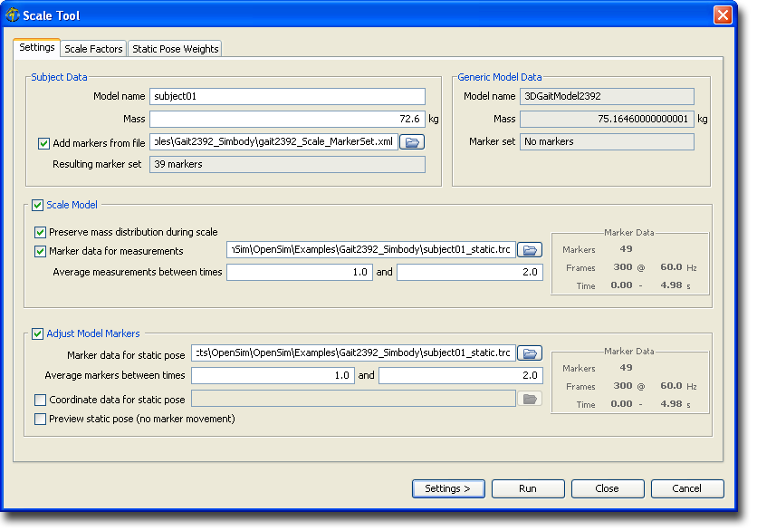
Figure 14-3: Scale Tool dialog.

At the bottom of the dialog are four buttons. The Settings > button is used to load or save settings for the tool. The Run button starts execution. The Close button closes the dialog. Note that the Close button can be clicked immediately after execution has begun; the execution will complete even though the dialog has been closed. The Cancel button closes the dialog and cancels all operations that have not yet been completed.

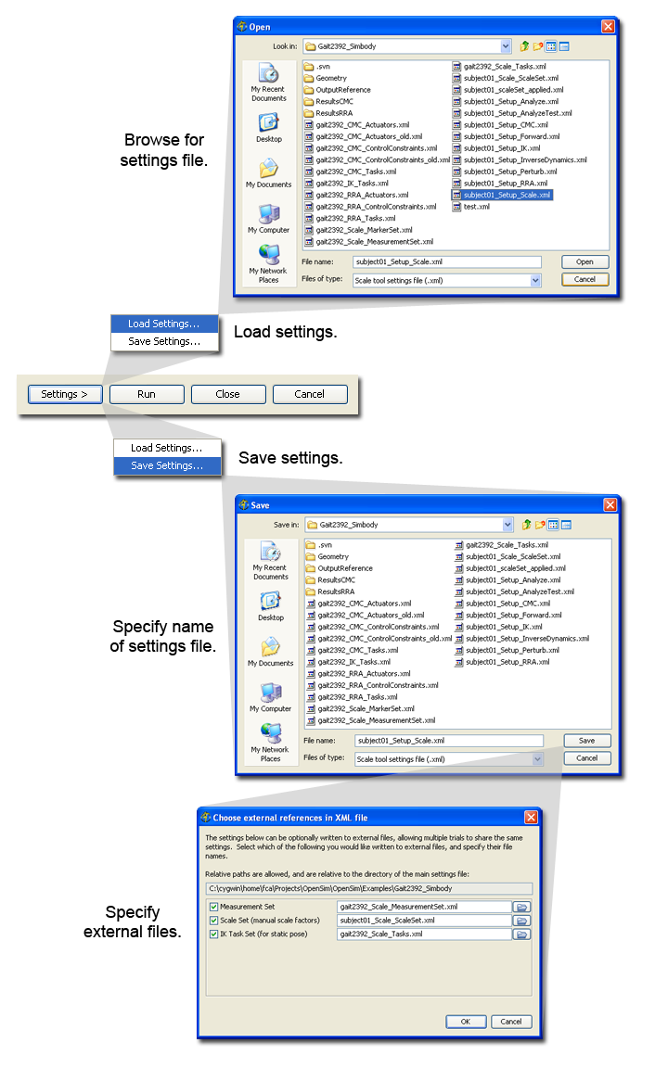
Figure 14-4: Saving and loading settings.
When the Settings > button is clicked, you are presented with the choice of loading or saving settings for the tool (Fig. 4.3). This feature can be very useful as most tools require many parameters to be set before they can be run.
If you click Load Settings…, you will be presented with a file browser that displays all files ending with the .xml suffix. You may browse for an appropriate settings file (e.g., subject01_Settings_Scale.xml) and click Open. The Scale Tool will then be populated with the settings in that setup file.
If you have manually entered or modified settings, you may save those settings to a file for future use. If you click Save Settings…, a save dialog will come up in which you can specify the name of the settings file. The name you specify for the file should have a suffix of .xml. Click Save to save the settings to file. After you click Save, you may be presented with another dialog that asks you whether or not you would like to save some of the settings to separate external files. This can be useful if you would like to reuse those settings for other trials or subjects. Check the boxes of the settings that you’d like to save to external files and specify the names of these files. All of these files should have a suffix of .xml.

Settings Pane
The settings pane (Fig. 14.3) is used to specify parameters relating to the subject data, the generic model, and how the model is to be scaled. The pane is organized into four main sections entitled Generic Model Data, Subject Data, Scale Model, and Adjust Model Markers.

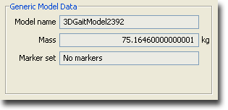
Figure 14-5: Generic Model Data.

The section for Generic Model Data displays uneditable information about the generic model that is to be scaled. It gives the model name, the model mass, and whether or not a marker set is included as part of the model (Fig. 4.4).

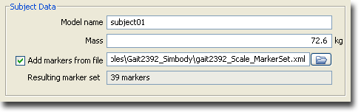
Figure 14-6: Subject Data.

The section for Subject Data displays editable information that allows you to specify the name of the new model that will be generated, the subject’s total mass, and whether or not to add markers to the model from an external marker set. If you select the check box next to Add markers from file, you will be required to specify a settings file that contains markers. You may use the button to browse for a marker set. Once a marker set is read in, the number of markers in the marker set will be displayed just below the file name.

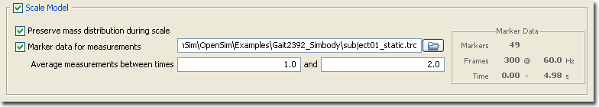
Figure 14-7: Controlling how a model is scaled.

The Scale Model section provides access to basic settings for specifying how a model is scaled. If the Scale Model box in the upper left-hand corner is not checked, the model will not be scaled. If the box is checked, the model will be scaled and a number of options become available. When the box for Preserve mass distribution during scale is checked, the total mass of the generic model is scaled so that it equals the mass of the subject while preserving the relative masses of its body segments. So, for example, if in the generic model the mass of the thigh is twice that of the shank, the mass of the thigh in the scaled model will also be twice that of the scaled shank. If this check box is not checked, the segment masses are scaled based solely on the scale factors applied to each body segment.
To use measurement-based scaling, a TRC file that contains suitable marker data must be specified. A static trial (i.e., a trial in which the subject is stationary in some known position) is typically used for this purpose. To specify a file containing marker data, check the box labeled Marker data for measurements. When this is done, you will be able to specify a file in the text box to the right. Click the button to browse for a file. Once the marker data is loaded, information about the trial will be displayed in a box on the far right entitled Marker Data. The information includes the total number of markers in the TRC file (the marker data is arranged in columns of x, y, and z coordinates), number of frames, frame rate, and the time interval over which the data is available. The distances between marker pairs used to compute the scale factors for the segments is based on averaging the marker positions over a time interval. To specify the time interval, enter the starting and final times in the text boxes to the right of the label Average measurements between times. The starting time should always be less than or equal to the final time. If you are computing scale factors based on a dynamic trial (i.e., a trial in which the subject was moving), use a small time interval or specify the same starting and final time to pick out a single frame of data.

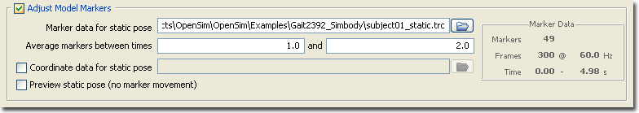
Figure 14-8: Adjusting Model Markers.

The Adjust Model Markers section provides access to basic settings for specifying how markers on the model are moved so that they are coincident with the experimental marker locations. If the Adjust Model Markers box is not check, markers will not be moved. If the box is checked, a number of options become available.

Scaling Via Command-line Execution

scale -S <setup file name>

Settings Files and XML Tag Definitions
The settings files are XML files whose tags specify properties to be used by OpenSim for scaling models. The tags used for each type of settings file are defined in the following sections.

Scale Setup File
There are 5 major sections to a scale setup file: execution parameters; subject-specific parameters (e.g., mass, height, age); parameters related to the generic model to scale; scaling properties; and marker placement properties. A sample scale setup file is provided in Example 14-1.

Specifying execution parameters
The properties for the scale operation are enclosed inside the opening and closing tags <ScaleTool> and </ScaleTool>. The name attribute name="subject01" specifies the execution name, though it is not used anywhere.

Example 14-1: XML file for a scale setup file
(e.g., subject01_Setup_Scale.xml)
<?xml version="1.0" encoding="UTF-8"?>

<ScaleTool name="subject01">

<mass> 72.6 </mass>
<height> 1803.4 </height>
<age> 99 </age>
<notes> This is an example setup file for scale.exe. </notes>

<GenericModelMaker name="">
<model_file> gait2354.osim </model_file>
<MarkerSet file="gait2354_Scale_MarkerSet.xml"/>
</GenericModelMaker>

<ModelScaler name="">
<scaling_order> measurements manualScale </scaling_order>

<ScaleSet file="subject01_Scale_ScaleSet.xml"/>

<MeasurementSet file="gait2354_Scale_MeasurementSet.xml"/>
<marker_file> subject01_static.trc </marker_file>
<time_range> 1 2 </time_range>

<preserve_mass_distribution> true </preserve_mass_distribution>

<output_joint_file> subject01_scaledOnly.jnt </output_joint_file>
<output_muscle_file> subject01_scaledOnly.msl </output_muscle_file>
<output_model_file> subject01_scaledOnly.osim </output_model_file>
<output_scale_file> subject01_scaleSet_applied.xml</output_scale_file>
</ModelScaler>

<MarkerPlacer name="">
<IKTaskSet file="gait2354_Scale_Tasks.xml"/>
<marker_file> subject01_static.trc </marker_file>
<time_range> 1 2 </time_range>
<coordinate_file> gait2354_zeros.mot </coordinate_file>
<output_joint_file> subject01.jnt </output_joint_file>
<output_muscle_file> subject01.msl </output_muscle_file>
<output_model_file> subject01.osim </output_model_file>
<output_motion_file> subject01_static_output.mot </output_motion_file>
</MarkerPlacer>

</ScaleTool>

Example 14-1: Annotated XML file for a scale setup file
(e.g., subject01_Setup_Scale.xml)
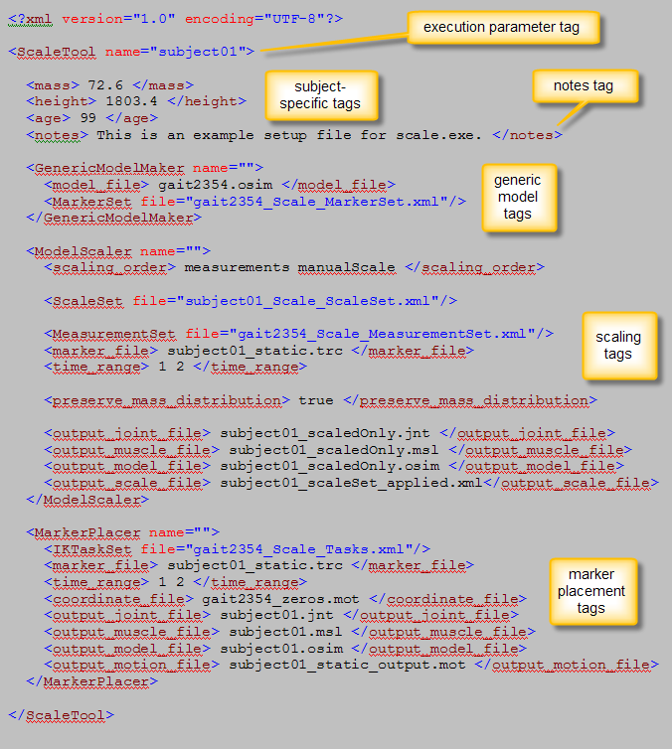

Specifying subject-specific parameters
Subject specific measurements are specified in the <mass>, <height>, and <age> properties. These are in kg, mm, and years, respectively. Currently, <height> and <age> are specified for informational purposes only, and do not affect the scaling result. (In fact they do not appear in the subject-specific model output by scale). The <mass> property, however, is used: the final model will have total mass equal to this specified mass value.

<notes> tag
The <notes> property is another purely informational (for the user) property that does not get propagated to any output files.

Specifying a generic model to scale
The generic model that will be scaled is specified within the <GenericModelMaker> tag. In particular, <model_file> points to the OpenSim model file that will be scaled. In Example 14-1 above, it is gait2354.osim (a gait model with 23 degrees of freedom and 54 muscles).
The <MarkerSet> property can be used to add or update markers in the generic model. In the example, gait2354.osim does not include any markers, so the <MarkerSet> given in the external file gait2354_Scale_MarkerSet.xml (referred to using the file attribute—[[[NEED TO EXPLAIN HOW TO USE THIS EARLIER IN THIS SECTION]]]) adds the full marker set necessary for this example. This file is described in more detail in Section 14.6.2 below. [[[ARE THERE OTHER WAYS TO SPECIFY A MARKER SET???]]]

Specifying scaling properties
Scaling properties are enclosed in the <ModelScaler> tag. As described in Section 14.2 (How It Works) above, a combination of measurement-based and manual scaling can be used. <scaling_order> specifies which of the two is used (using the keywords measurements and manualScale, respectively), or, if both are listed, the order in which they are applied.

Properties for manual scaling
The <ScaleSet> tag is used to specify the scale set supplying the manual scale factors. In the example above, this tag refers to the external file subject01_Scale_ScaleSet.xml (using the file attribute—[[[ NEED TO EXPLAIN HOW TO USE THIS EARLIER IN THIS SECTION]]]). See Section 14.6.3 below for more details about the contents of this XML file.

Properties for measurement-based scaling
The relevant parameters for measurement-based scaling are <MeasurementSet>, <marker_file>, and <time_range>.
<MeasurementSet> (in this case specified in the external file gait2354_Scale_MeasurementSet.xml) specifies which marker pairs are used to compute the scales and which bodies those scale factors are applied to. In addition, the experimental marker positions need to be supplied. The <marker_file> property points to a TRC [[[IS THIS EXPLAINED SOMEWHERE, MAY WANT TO PUT INTO A GLOSSARY AT THE END??]] file containing these marker positions, and <time_range> indicates which subset of the frames in the TRC file the marker-pair distances should be averaged across.

Mass scaling properties
The <preserve_mass_distribution> property specifies whether the scaled model’s segment masses should be in the same proportion as they were in the generic model (see Section 14.2 above on How It Works).

Specifying output of scaling-only step (before marker placement)
The scaling step can (optionally) produce a number of output files. Assuming the marker placement step is executed, none of the intermediary output files from the scaling step are strictly necessary, but can be useful for debugging (e.g., to see what the model looks like after scaling but before markers are moved). The properties controlling the output file names are:

- <output_joint_file> generates the scaled-only SIMM jnt file
- <output_muscle_file> generates the scaled-only SIMM msl file
- <output_model_file> generates the scaled-only OpenSim model file
- <output_scale_file> generates a <ScaleSet> file consisting of the x-y-z scale factors used to scale each segment

If the tags specifying these files are omitted or the file names are blank, then no files will be written.

Specifying marker placement properties
The marker placement properties are enclosed within the <MarkerPlacer> tag. Note that it is valid to omit this section from the XML file if only scaling (and no marker placement) is desired.
As mentioned in Section 14.2 (How It Works), a “static pose” needs to be defined and the model needs to be placed in a configuration matching that pose as best as possible. This reduces to an inverse kinematics (IK) problem, and so many of the properties used in the marker placement step are similar to the properties in IK. The reader should therefore refer to the IK chapter (Chapter 15) for additional details on some of these properties.
The <IKTaskSet> property is used to specify the marker and coordinate weights which IK will use in order to compute the static pose. In the example above, a file attribute is used to refer to an external XML file. More details of the file contents are given in Section 14.6.5 (Inverse Kinematics Tasks File) below.
The <marker_file> and <coordinate_file> properties are used to specify experimental marker and coordinate values, respectively. These values are used by the IK tool to compute the static pose.

<marker_file> tag
Since file specified by the <marker_file> tag will in general have multiple frames of marker data (i.e., marker trajectories recorded during a static trial), these are averaged within the time range specified by the <time_range> tags to give a single, fixed set of experimental marker positions. If the experimental marker locations in <marker_file> do not represent a static trial (subject not moving or only slightly moving) then averaging marker positions across a large time window does not really make sense. In this case, the values for <time_range> should be reduced and/or the file specified by <marker_file> should be edited to only contain a few rows of nearly-stationary marker positions. [[[WHAT ARE THE UNITS USED FOR TIME RANGE???]]]

<coordinate_file> tag
The coordinate values specified by <coordinate_file> are not averaged the same way the marker data is. Rather, the values from the row corresponding to the initial time of <time_range> are used. In Example 14-1, the coordinate values from time t=1 will be used as the “experimental coordinate values”.

Moving markers to match experimental locations
The IK solver will be invoked to try to find generalized coordinate values for the model which put it in a pose that closely matches the “static pose” experimental marker positions and coordinate values. After the model’s static pose is computed, a selected subset of the model’s markers are moved to match the averaged experimental marker locations (those that were used to define the static pose).
Only markers which are tagged as “not fixed” are moved to match the experimental markers. This is done within the file specified by <MarkerSet>. Each marker that is moveable should have its <fixed> property set to false. <fixed> is a property of <Marker> (See Section 14.6.2 ). The remaining markers are untouched.

Specifying final scaling and marker placement output
After marker placement, the final subject-specific model is ready for output. The only essential file to be output in this step is the subject-specific OpenSim model, specified in <output_model_file>. Additional files can be output for debugging and SIMM visualization purposes. These are:

- <output_joint_file> - the subject-specific SIMM jnt file
- <output_muscle_file> - the subject-specific SIMM msl file
- <output_motion_file> - a motion file consisting of a single row of values representing the “static pose” in which model markers were moved to match experimental markers. This file can be visualized in SIMM. Note: since this motion file only contains a single frame, to view it in SIMM’s Model Viewer, you need to use the “start >” button to start playing the motion; the motion slider does not appear to work).

Scale Marker File
The scale marker file contains a list of the virtual markers that are placed on the body segments of the model. In Figure 14-, this is the file gait2354_Scale_MarkerSet.xml. An example of a marker file is shown in Example 14-2.

Example 14-2: XML file for a scale marker file
(e.g., gait2354_Scale_MarkerSet.xml)
<?xml version="1.0" encoding="UTF-8"?>

<MarkerSet name="gait2354_Scale">

<objects>

<Marker name="Sternum">
<location> 0.07 0.3 0 </location>
<body> torso </body>
<fixed> false </fixed>
</Marker>

<Marker name="R.Acromium">
<location> -0.03 0.44 0.15 </location>
<body> torso </body>
<fixed> false </fixed>
</Marker>

<Marker name="L.Acromium">
<location> -0.03 0.44 -0.15 </location>
<body> torso </body>
<fixed> false </fixed>
</Marker>

<Marker name="Top.Head">
<location>0.00084 0.657 0.0</location>
<body> torso </body>
<fixed> false </fixed>
</Marker>

<!-- . . additional <Marker> tags cut for brevity . . -->

</objects>

</MarkerSet>

Example 14-2: Annotated XML file for a scale marker file
(e.g., gait2354_Scale_MarkerSet.xml)
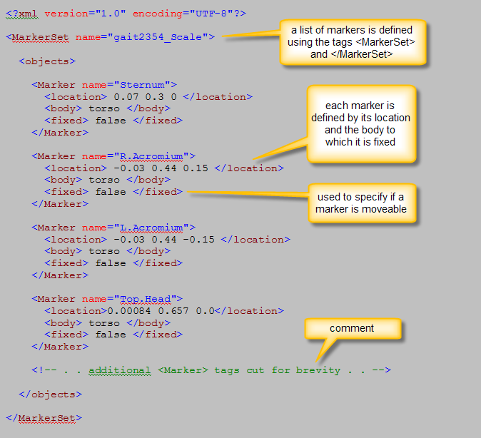

Specifying a list of markers
The list of markers are enclosed inside the opening and closing tags <MarkerSet> and </MarkerSet>. The name attribute name="gait2354_Scale" specifies [[[??? WHAT DOES IT SPECIFY AND IS IT USED ANYWHERE???? ALSO, WHY ARE THE TAGS <OBJECTS> AND </OBJECTS> NEEDED?????]]]

Specifying a marker for the generic model
Specifying a marker consists of specifying its <location>, as well as the <body> to which the marker is attached (i.e., which body its location is measured with respect to). The marker name is given by the name attribute of the <Marker> tag (e.g., Sternum for the first marker in Example 14-2 above). [[[??? WHAT ARE THE COORDINATES FOR LOCATION: X, Y, Z? IN WHAT UNITS? WHERE DOES THE NAME SPECIFIED BY <BODY> COME FROM—IS IT DEFINED BY THE NAME ATTRIBUTE OF THE MARKER TAG???? ]]]
The <fixed> property is used in the marker placement step and can be set to either true or false. [[[??? IS THIS CORRECT??? I AM GUESSING THAT THESE ARE THE VALID VALUES FOR THIS TAG. IS THIS TAG OPTIONAL??? WHAT HAPPENS IF YOU DON’T DEFINE THIS TAG FOR A MARKER????]]]] If it is set to false, the marker will move during marker placement to match the position of its corresponding experimental marker. Otherwise it will stay fixed.

Manual Scaling File

The manual scale factors can be set using the <ScaleSet> and </ScaleSet> tags. <ScaleSet> is a set consisting of <Scale> tags, each of which gives manual scale factors as described below. In Figure 14-, the scale factors are specified in the file gait2354_Scale_ScaleSet.xml. An example of a manual scaling file is shown in Example 14-3. [[[??? WHY IS THE TAG FOR <OBJECTS> NEEDED???]]]

Example 14-3: XML file for a manual scaling file
(e.g., gait2354_Scale_ScaleSet.xml)
<?xml version="1.0" encoding="UTF-8"?>

<ScaleSet name="gait2354_Scale">

<objects>

<Scale name="">
<scales> 1.14724 1.14724 1.14724 </scales>
<segment> femur_r </segment>
<apply> true </apply>
</Scale>

<Scale name="">
<scales> 1.14724 1.14724 1.14724 </scales>
<segment> femur_l </segment>
<apply> true </apply>
</Scale>

<Scale name="">
<scales> 0.988523 0.988523 0.988523 </scales>
<segment> tibia_r </segment>
<apply> true </apply>
</Scale>

<Scale name="">
<scales> 0.988523 0.988523 0.988523 </scales>
<segment> tibia_l </segment>
<apply> true </apply>
</Scale>

</objects>

</ScaleSet>

Example 14-3: Annotated XML file for a manual scaling file
(e.g., gait2354_Scale_ScaleSet.xml)
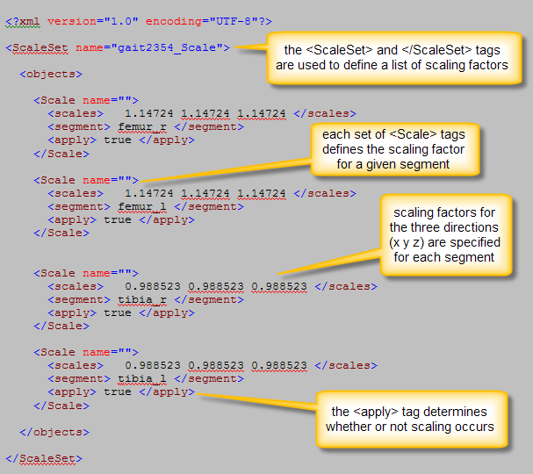

<scales> tag
Each <Scale> tag specifies the x-y-z scale factors in its <scales> property. A scale factor of 1.0 means that no scaling occurs. In the example above, all of the scales represented uniform scaling (equal x, y, and z scale factors). Note: the scale factors in Example 14-3 were computed using a utility that computed experimental segment lengths using a functional joint center approach. This utility is not yet part of the standard OpenSim distribution. [[[??? WHAT ARE THE LIMITS FOR <SCALES>???? IS THIS TAG REQUIRED????]]]

<segment> tag
The <segment> tag is used to specify which segment will be scaled using those factors. [[[??? WHAT IS THE NAMING CONVENTION FOR THE SEGMENT TAG—IN OTHER WORDS, WHERE DOES THE NAME FEMUR_L COME FROM—IS THIS CASE SENSITIVE??? IS THIS TAG REQUIRED???? ALSO, WHAT HAPPENS IF YOU DON’T SPECIFY A SEGMENT IN THE MANUAL SCALING FILE—DOES IT DEFAULT TO NO SCALING??? ]]]

<apply> tag
The <apply> property can be used to disable certain scales. <apply> can be set to either true or false. [[[??? IS THIS CORRECT??? I AM GUESSING THAT THESE ARE THE VALID VALUES FOR THIS TAG. IS THIS TAG OPTIONAL???]]] By default <apply> is set to true, so it can generally be omitted. [[[???THIS PARAMETER SEEMS REDUNDANT TO ME? HOW CAN YOU DISABLE A SCALE—DOES THAT MEAN THAT YOU DISABLE SCALING IN ONE DIRECTION OR THE SCALING FOR THAT ENTIRE SEGMENT??? WHY WOULD YOU WANT TO DO THAT? IF YOU DON’T WANT SCALING, COULDN’T YOU JUST OMIT THAT SEGMENT OR PUT THAT SEGMENT IN WITH SCALING FACTORS OF 1.0 1.0 1.0??? ]]]

Measurement-Based Scaling File
The measurement-based scaling file contains pairs of experimental markers, the distance between which are used to scale the generic musculoskeletal model. In Figure 14-, the experimental measurements used for scaling are specified in the file gait2354_Scale_MeasurementSet.xml.
An example of this type of file is shown in Example 14-4. The <MeasurementSet> tag specifies a set of <Measurement> objects. Each set of <Measurement> tags lists the marker pairs that go into computing the scale factor, and all the bodies to which this scale factor will be applied. When defining the bodies, the axes to scale along are also defined. Details about specifying the marker pairs and the bodies are given below. [[[??? WHY IS THE TAG FOR <OBJECTS> NEEDED???]]]

Example 14-4: XML file for a measurement-based scaling file
(e.g., gait2354_Scale_MeasurementSet.xml)
<?xml version="1.0" encoding="UTF-8"?>

<MeasurementSet name="gait2354">

<objects>

<!-- . . additional <Measurement> tags cut for brevity . . -->

<Measurement name="thigh">

<apply> true </apply>

<MarkerPairSet>
<objects>
<MarkerPair>
<markers> R.ASIS R.Knee.Lat </markers>
</MarkerPair>
<MarkerPair>
<markers> L.ASIS L.Knee.Lat </markers>
</MarkerPair>
</objects>
</MarkerPairSet>

<BodyScaleSet>
<objects>
<BodyScale name="femur_r">
<axes> X Y Z </axes>
</BodyScale>
<BodyScale name="femur_l">
<axes> X Y Z </axes>
</BodyScale>
<BodyScale name="patella_r">
<axes> X Y Z </axes>
</BodyScale>
<BodyScale name="patella_l">
<axes> X Y Z </axes>
</BodyScale>
</objects>
</BodyScaleSet>

</Measurement>

<!-- . . additional <Measurement> tags cut for brevity . . -->

</objects>

</MeasurementSet>

Example 14-4: Annotated XML file for a measurement-based scaling file
(e.g., gait2354_Scale_MeasurementSet.xml)
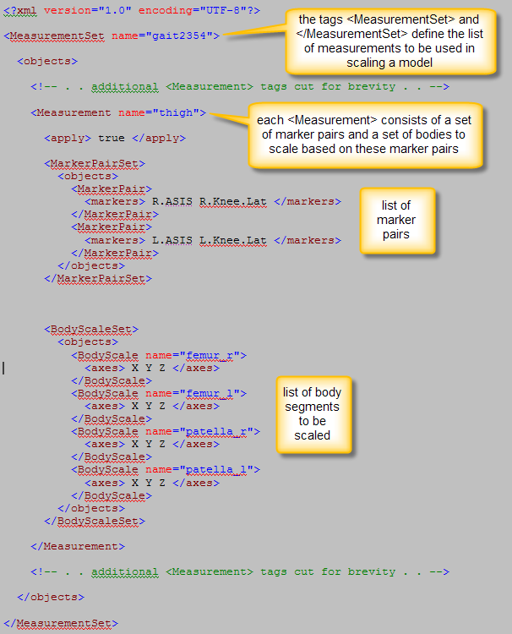

<apply> tag
The <apply> property of <Measurement> is used to specify whether a measurement is enabled or not, and takes on the values of either true or false. [[[??? IS THIS CORRECT???]]] It is true by default and so can typically be omitted.

Specifying marker pairs used to compute a scale factor
The list of marker pairs is enclosed in a <MarkerPairSet> tag, each pair being given in a <MarkerPair> object that is defined by the <markers> tag. Each set of <markers> tags provides the names of two [[[???WHAT NAME MUST BE USED HERE—WHERE DOES THE NAME COME FROM???]]]. In Example 14-4, two marker pairs are given. Recall from Section 14.2 (How It Works) that this means that the final scale factor will be computed by averaging the scale factors determined by each individual pair.

Specifying bodies to be scaled
The list of bodies to be scaled using the scale factors determined by the marker-pair-measurements is given in a <BodyScaleSet> tag, with each <BodyScale> specifying the body through its name attribute. [[[???WHAT NAME MUST BE USED HERE—WHERE DOES THE NAME COME FROM, ANOTHER FILE? ANOTHER TAG????]]].
The <axes> tag indicates the axis/axes along which to scale and can take on the values X, Y, and/or Z. In the above example, the femur and patella on both sides of the body (r = right, l = left) will be uniformly scaled in the x, y, and z directions using these measurement-based scale factors. [[[???PROVIDE EXAMPLE OF JUST SCALING IN TWO DIRECTIONS. IS CAPITALIZATION NEEDED TO SPECIFY THE AXIS????]]].

Inverse Kinematics Tasks File
The inverse kinematics (IK) tasks file is an external XML file containing the <IKTaskSet> referred to from the main scaling Setup file above (Section 14.6.1). In Example 14-1, the IK tasks file is gait2354_Scale_Tasks.xml. Example 14-5 provides an example of this type of file.
The IK tasks file specifies properties associated with error terms. A brief description of the tags used to describe these properties is given below. Chapter 15 on Inverse Kinematics provides more details.

Marker tasks
The <IKMarkerTask> tags are used to specify the weights associated with the marker error terms in the IK formulation. See the IK chapter (Chapter 15) for more details.

Example 14-5: XML file for an inverse kinematics tasks file
(e.g., gait2354_Scale_Tasks.xml)
<?xml version="1.0" encoding="UTF-8"?>
<IKTaskSet name="gait2354_Scale">

<objects>
<IKMarkerTask name="Sternum"> <weight>1</weight> </IKMarkerTask>
<IKMarkerTask name="R.Acromium"> <weight>1</weight>
</IKMarkerTask>
<IKMarkerTask name="L.Acromium"> <weight>1</weight>
</IKMarkerTask>
<IKMarkerTask name="Top.Head"> <weight>1</weight>
</IKMarkerTask>
<!-- . . additional <IKMarkerTask> tags cut for brevity . . -->

<!-- Coordinates -->
<IKCoordinateTask name="subtalar_angle_r"> <value>0</value>
</IKCoordinateTask>
<IKCoordinateTask name="mtp_angle_r"> <value>0</value>
</IKCoordinateTask>
<IKCoordinateTask name="subtalar_angle_l"> <value>0</value>
</IKCoordinateTask>
<IKCoordinateTask name="mtp_angle_l"> <value>0</value>
</IKCoordinateTask>
<IKCoordinateTask name="lumbar_extension">
<value>0</value>
<weight>1000.0</weight>
</IKCoordinateTask>

</objects>
</IKTaskSet>

Example 14-5: Annotated XML file for an inverse kinematics tasks file
(e.g., gait2354_Scale_Tasks.xml)
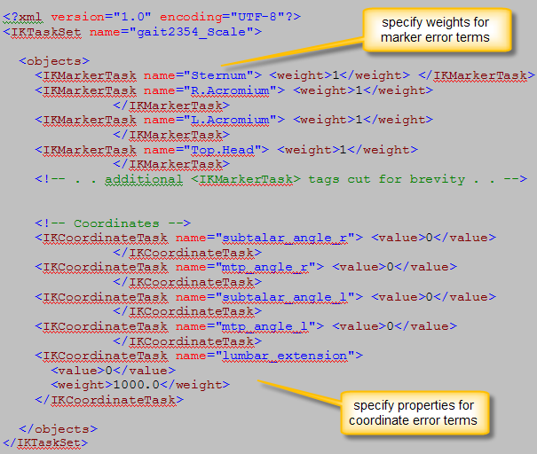

Coordinate tasks
The <IKCoordinateTask> tags are optional and are used to specify properties associated with the coordinate error terms in the IK formulation. See the IK chapter (Chapter 15) for more details. In Example 14-5, the subtalar and mtp angles are locked, and are assigned to the constant value of 0 radians. [[[WHAT SPECIFICATION INDICATES THAT THE SUBTALAR AND MTP ANGLES ARE LOCKED]]]. Additionally, we have an additional task which attempts to keep the (unprescribed) lumbar_extension coordinate close to 0 by setting its desired value to 0 and giving it a large weight.
chapter
15

Inverse Kinematics (IK)

Overview
The purpose of the IK step is to find the joint angles in the model that best reproduce the experimental kinematics recorded for a particular subject. The experimental kinematics targeted by IK includes experimental marker positions as well as experimental generalized coordinate values.

How It Works

The inverse kinematics tool goes through each time step (frame) of motion and computes generalized coordinate values which put the model in a configuration that “best matches” experimental marker and coordinate values for that time step. Mathematically, the “best match” is expressed as a weighted least squares problem, whose solution aims to minimize both marker and coordinate errors.

Marker Errors
A marker error is the distance between an experimental marker and the corresponding marker on the model when it is oriented using the generalized coordinates computed by the IK solver. Each marker has a weight associated with it, specifying how strongly that marker’s error term should be minimized.

Coordinate Errors
A coordinate error is the difference between an experimental coordinate value and the coordinate value computed by IK. What do we mean by “experimental coordinate values?” These are not obtained using a motion capture system, but may be computed from experimental marker data by various specialized algorithms (e.g., defining anatomical coordinate frames and using them to define joint frames that define joint angles). A fixed desired value for a coordinate can also be specified (e.g., if we know a specific joint’s angle should stay at 0 degrees). The inclusion of experimental coordinate values is optional; the IK tool can solve for the motion trajectories using marker matching alone..
A distinction should be made between prescribed and unprescribed coordinates. A prescribed coordinate (also referred to as a locked coordinate) is a generalized coordinate whose trajectory is known and which will not be computed using IK. It will get set to its exact trajectory value instead. This can be useful when you have enough confidence in some generalized coordinate value that you don’t want the IK solver to change it.
An unprescribed coordinate is a coordinate which is not prescribed, and whose value is computed using IK.
Using these definitions, only unprescribed coordinates which have associated experimental coordinate trajectories appear in the least squares equation solved by IK. Each coordinate has a weight associated with it, specifying how strongly that coordinate’s error term should be minimized.

Weighted Least Squares Equation
The weighted least squares problem solved by IK is
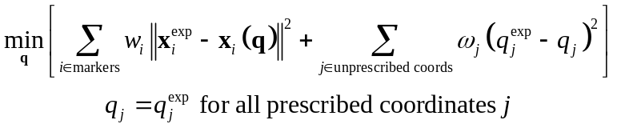
where q is the vector of generalized coordinates being solved for, x_{i}^{exp} is the experimental position of marker i, x_{i}(q) is the position of the corresponding marker on the model (which depends on the coordinate values), q_{j}^{exp} is the experimental value for coordinate j. Prescribed coordinates are set to their experimental values (e.g., in the gait2354 and gait2392 examples, the subtalar and metatarsophalangeal (mtp) joints are locked, and during IK are assigned the prescribed value of 0 degrees). [[[WHERE IS THE gait2392 EXAMPLE???]]]
The marker weights (w_{i}’s) and coordinate weights (ω_{j}’s) are specified in what are known as “IK marker tasks” and “IK coordinate tasks” tags, respectively. These are all specified within a single IK “task set” tag, as will be outlined in the XML setup file section below (Section 15.6).
This least squares problem is solved using a general quadratic programming solver, with a convergence criterion of 0.0001 and a limit of 1000 iterations. These are currently fixed values that cannot be changed in the XML files.

Important Note About Units
The least squares solution depends on the choice of length and angle units. The units used by IK are the model’s units, which are meters for length and radians for angles. This is important, for example, if you wish to compare these results to a different IK solver that uses degrees for measuring coordinate errors. In order to get similar results using OpenSim’s choice of radians as units, you should alter the weight accordingly: scale each coordinate’s weight by 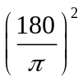 (so a weight of 1 used with a degrees-based IK solver becomes 3282.806…).
[[[CLARIFY: IS THAT A WEIGHT OF 1 WITHIN OPENSIM BECOMING A WEIGHT OF 3282.806 USED IN A DEGREES-BASED IK SOLVER? AS WRITTEN, IT SOUNDS LIKE THE OPPOSITE]]]
[Technically, the length units can be changed by setting the <length_units> property in the OpenSim model, but this is not recommended… more flexible support for units is forthcoming...]

Inputs and Outputs
The primary inputs to IK are the following files:
- Subject-specific OpenSim model [.osim file] generated by scaling a generic model using the scale tool, or by other means
- Experimental marker trajectories for each trial [.trc file]
- Experimental generalized coordinate values for each trial (optional) [.mot file]

[[[WHAT ARE THE FORMATS FOR THESE FILES? INCLUDE INFO HERE OR IN ANOTHER SECTION. WHAT ABOUT THE SETUP XML FILES? WOULD BE HELPFUL TO HAVE A DIAGRAM LIKE FIGURE 14-1.]]]
For each trial processed by IK, the output is a motion file [[[IS THIS A .MOT FILE—WHAT’S THE FORMAT FOR THIS FILE? INCLUDE INFO HERE OR IN ANOTHER SECTION]]]. containing the generalized coordinate trajectories computed by IK.

How to Use the GUI for Inverse Kinematics

Inverse Kinematics Via Command-line Execution
ik -S <setup file name>

Settings Files and XML Tag Definitions
The settings files are XML files whose tags specify properties to be used by OpenSim for performing the inverse kinematics. The tags used for each type of settings file are defined in the following sections.

Inverse Kinematics Setup File
There are 3 properties that need to be specified in an inverse kinematics setup file: the model to which the IK solver is to be applied; the marker and coordinate error weightings to be used; and the specific trials to be used by the solver. A sample inverse kinematics setup file is provided in Example 15-1.

Example 15-1: XML file for an inverse kinematics setup file
(e.g., subject01_Setup_IK.xml)
<?xml version="1.0" encoding="UTF-8"?>
<IKTool name="subject01">

<model_file> subject01.osim </model_file>

<IKTaskSet file="gait2354_IK_Tasks.xml"/>

<IKTrialSet name="">
<objects>

<IKTrial name="first trial">
<marker_file> subject01_walk1.trc </marker_file>
<coordinate_file> subject01_walk1.mot </coordinate_file>

<time_range> 0.4 2.0 </time_range>

<output_motion_file> subject01_walk1_ik.mot
</output_motion_file>
</IKTrial>

</objects>
</IKTrialSet>

</IKTool>

Example 15-1: Annotated XML file for an inverse kinematics setup file
(e.g., subject01_Setup_IK.xml)
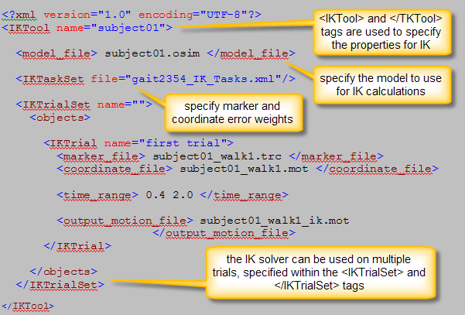

Specifying IK execution parameters
The properties for IK are enclosed inside the opening and closing tags <IKTool> and </IKTool>. If desired, the name attribute name="subject01" can be used to specify the execution name, though it is not used anywhere.

Specifying the model
The <model_file> property specifies the file name of the subject-specific OpenSim model that will be matched against the experimental data and/or coordinate values. Typically this will be the scaled model generated by the scale tool.
The file for the model must contain a <SimmKinematicsEngine> tag, which can be found under the <DynamicsEngine> tag. So the SD/Fast model generated using makeSDFastModel is not appropriate, since it contains an <SdfastEngine> tag instead of the <SimmKinematicsEngine> tag. [[[WHEN/IN WHAT PROGRAM IS THE makeSDFastModel USED? IT’D HELP TO PUT IT IN CONTEXT]]]

Specifying the IK tasks
The IK tasks are used to specify the weights on the marker and coordinate error terms used by the IK solver. The set of IK tasks is specified in the <IKTaskSet> property. In Example 15-1, it points to an external file (gait2354_IK_Tasks.xml) using the file attribute. [[[COULD YOU ALSO JUST EMBED THE INFO DIRECTLY INTO THE SET-UP FILE??]]]

Per-trial properties
Multiple experimental trials can be processed during a single execution of IK. [[[EXPLAIN WHAT HAPPENS WITH MULTIPLE TRIALS. WHAT ARE THE OUTPUTS? WHAT IS THE BENEFIT TO RUNNING MULTIPLE TRIALS AT ONCE?]]]
The settings for each trial are enclosed by the <IKTrial> and </IKTrial> tags, and the <IKTrialSet> and </IKTrialSet> tags enclose a set of such trials. The <objects> tag is needed for sets (see appendix). Note that in the XML file shown in Example 15-1, only a single trial is computed.
For each trial, the following parameters are needed: the file name for the experimental marker trajectories, the file name for the experimental coordinate values, the time range for computing the inverse kinematics, and the output motion file name. Each of these parameters is explained in more detail in the following sections. [[[WHICH PROPERTIES ARE REQUIRED AND WHICH ARE OPTIONAL???]]]

Experimental marker and coordinate values
The <marker_file> property specifies a .trc file containing marker trajectories for this trial. These trajectories give the experimental marker positions which IK will attempt to match as described in Section 15.2 (How It Works). [[[ARE THE FORMATS FOR A .TRC AND A .MOT FILE GOING TO BE GIVEN IN AN APPENDIX? IF SO, ADD A SENTENCE DIRECTING THE READER TO THE APPENDIX.]]]

The <coordinate_file> property specifies a .mot file containing experimental coordinate values (e.g., joint angles computed using anatomical reference frames) for this trial. Only values for coordinates whose IKCoordinateTask object has <from_file> set to true are taken from the file. [[[THIS IS UNCLEAR TO SOMEONE UNFAMILIAR WITH OPENSIM FILE FORMATS. WHERE IS THE IKCOORDINATE TASK OBJECT DEFINED, AND WHAT EXACTLY IS MEANT BY “OBJECT”??? POINT THE READER TO THE SECTION WHERE HE/SHE CAN GET MORE INFORMATION ABOUT THIS OBJECT.]]]
If none of the coordinates have <from_file> set to true, the <coordinate_file> property becomes optional. However, a coordinates file is typically specified even in this situation, because it may also contain other data, such as ground reaction forces and torques, which are copied into the output file generated by IK. This is the case for the example XML files displayed here. [[[THE XML FILES ALONE DON’T DEMONSTRATE THIS—WE’D NEED TO ACTUALLY SEE THE .MOT FILE, WHICH IS WHERE I AM ASSUMING THE <FROM_FILE> TAG IS SET, IN ORDER TO MAKE THIS INTO THE EXAMPLE YOU’RE DESCRIBING.]]]

Time range
<time_range> specifies the start and end times for the IK computation (e.g., t=0.4s to t=2.0s in Example 15-1 above). [[[ARE THE UNITS ALWAYS SECONDS? SPECIFY FOR READER.]]] A start time earlier than the first available marker/coordinate data is snapped to the initial time of the data. Similarly, the end time is snapped to the final time of the data, if necessary. [[[IF THE MARKER FILE IS USED TO DETERMINE THE ACTUAL TIME POINTS FOR THE COMPUTATION, DO THE START AND END TIMES JUST SNAP TO THE BEGINNING AND END TIMES FOR MARKER DATA? PERHAPS ADDING A CONCRETE EXAMPLE HERE WOULD HELP.]]]]

Note that the marker file is used to determine the actual time steps (frames) at which IK is computed. Furthermore, if a coordinate file is used, the time values of the rows of data in the coordinate file must match the time values of the data in the marker file. [[[DOES OPENSIM GIVE AN ERROR IF THE TIME VALUES DON’T MATCH, OR DO YOU JUST WIND UP GETTING GARBAGE FOR OUTPUT???]]]

Output file
<output_motion_file> specifies the name of the motion file generated by IK. The columns of this file are:
- Unprescribed generalized coordinates (those solved for by IK), followed by
- Prescribed generalized coordinates (those with fixed values not solved for by IK), followed by
- Any user data (data found in the <coordinate_file> which is not directly used by IK, e.g., ground reaction forces)

[[[ARE THE COORDINATES GIVEN X, THEN Y, THEN Z? WHAT ARE THE UNITS?? WHAT DOES EACH ROW REPRESENT?? IS THERE ANY HEADER INFO PROVIDED???]]]

Inverse Kinematics Tasks File
The inverse kinematics tasks file is an external XML file containing the <IKTaskSet> tags used to specify properties associated with error terms during the IK computation. This file is referred to from the main IK setup file (See Example 15-1). An example IK tasks file is given in Example 15-2 below. Recall that this file is common to all IK trials.
If desired, the name attribute (e.g., name=”gait2354_IK" as shown in Example 15-2) can be used to specify the execution name for IKTaskSet, though it is not used anywhere. [[[IS THIS STATEMENT TRUE??? IF NOT, PLEASE CORRECT.]]]

Example 15-2: XML file for an inverse kinematics tasks file
(e.g., gait2354_IK_Tasks.xml)
<?xml version="1.0" encoding="UTF-8"?>

<IKTaskSet name="gait2354_IK">

<objects>
<!-- Markers -->
<IKMarkerTask name="Sternum"> <weight>1</weight> </IKMarkerTask>
<IKMarkerTask name="R.Acromium"> <weight>0.5</weight>
</IKMarkerTask>
<IKMarkerTask name="L.Acromium"> <weight> 0.5 </weight>
</IKMarkerTask>
<IKMarkerTask name="Top.Head"> <weight> 0.1 </weight>
</IKMarkerTask>
<!-- . . additional <IKMarkerTask> tags cut for brevity . . -->

<!-- Coordinates -->
<IKCoordinateTask name="subtalar_angle_r"> <value> 0 </value>
</IKCoordinateTask>
<IKCoordinateTask name="mtp_angle_r"> <value> 0 </value>
</IKCoordinateTask>
<IKCoordinateTask name="subtalar_angle_l"> <value> 0 </value>
</IKCoordinateTask>
<IKCoordinateTask name="mtp_angle_l"> <value> 0 </value>
</IKCoordinateTask>

</objects>
</IKTaskSet>

Example 15-2: Annoated XML file for an inverse kinematics tasks file
(e.g., gait2354_IK_Tasks.xml)
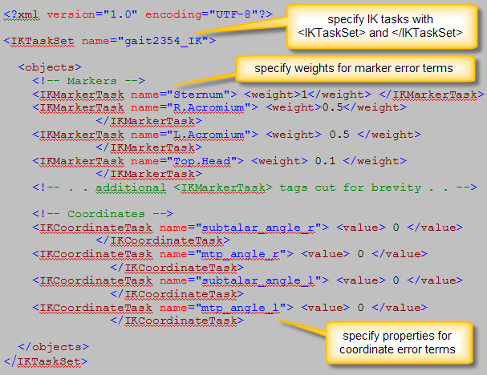

Marker tasks
The <IKMarkerTask> tags are used to specify the weights associated with the marker error terms in the IK formulation. A specific marker is identified using the name attribute of <IKMarkerTask>.
The <weight> property specifies the weight multiplying the squared-error term for that marker. These weights are the w_{i}‘s appearing in the formula given in Section 15.2 (How It Works). A larger weight means that the error term for that marker will be more significant in the least-squares equation, so the IK computation will try to find a closer match between that marker’s position and its experimental position, as compared to a marker with a smaller weight. By default, the weight for a marker is assumed to be zero, indicating that the IK solver will not attempt to match that marker to its experimental position. The default weight is used if <weight> is not specified or if the <IKMarkerTask> is omitted for a marker.
Experimental marker positions come from the .trc file specified by the <marker_file> property in the <SimmIKTrial>. [[[WHERE IS <SIMMIKTRIAL> SPECIFIED???]]]

Coordinate tasks
The <IKCoordinateTask> tags are used to specify properties associated with the coordinate error terms in the IK formulation. A specific coordinate is identified using the name attribute of <IKCoordinateTask>.
Three properties can be specified in a <IKCoordinateTask>. These are <weight>, <from_file>, and <value>. These properties are not required.

<weight> tag
The <weight> property specifies the weight multiplying the squared-error term for that coordinate. These weights are the ω_{i}‘s appearing in the formula given in Section 15.2 (How It Works), and they tell the IK solver how closely it should try to match a given coordinate to its experimental value: the larger the weight, the closer the match should be.
Recall from Section 15.2 (How It Works) that there are two types of coordinates: prescribed and unprescribed. If the OpenSim model specifies a coordinate to be locked (the <IKCoordinateTask> has <locked> set to true [[[EXAMPLE OF THIS WOULD BE HELPFUL. THE <locked> TAG HASN’T BEEN DESCRIBED TO-DATE. NEED TO ADD EXPLANATION FOR THIS]]]), then it is a prescribed coordinate. Prescribed coordinates will be assigned an exact value and will not be solved for by IK. Thus, the <weight> property has no effect on prescribed coordinates; it is only relevant for unprescribed coordinates.
For an unprescribed coordinate, if <weight> is not specified or if its <IKCoordinateTask> is omitted altogether, the weight for that coordinate is assumed to be zero, meaning that IK will not attempt to match that coordinate to any particular value.

Specify experimental values to be matched
For both prescribed and unprescribed coordinates with nonzero weights, the experimental value to be matched needs to be specified. [[[I THOUGHT WEIGHTS DIDN’T MATTER FOR PRESCRIBED COORDINATES….]]]
One way to do this is to specify a .mot file using the <from_file> and </from_file> tags. If <from_file> is set to true, then the experimental coordinate values for that coordinate come from the .mot file specified by the <coordinate_file> property in the IK setup file (See Example 15-1).
If <from_file> is set to false or is not specified, then a constant experimental value is used instead of the time-varying trajectory from file. This constant value comes from:
- The <value> property of the <IKCoordinateTask>, or if that’s not specified then
- The <value> property of the <SimmCoordinate> in the OpenSim model, or if that’s not specified then
- The <default_value> property of the <SimmCoordinate> in the OpenSim model.

In Example 15-2 above, the subtalar and mtp angles are locked (prescribed) [[[WHY ARE THESE PRESCRIBED? THEY DON’T HAVE THE <LOCKED> TAG SET TO TRUE HERE…]]], and <value> is used to specify that they should be locked at 0 radians. <weight> is not needed since these are prescribed coordinates and will be set to 0 exactly. Note, too, that since the <SimmCoordinate> properties corresponding to the subtalar and mtp angles have <default_value> set to 0, we could have relied on the default behavior and omitted all of the <IKCoordinateTask> above. [[[WE DON’T SEE THE FILE FOR THE OPENSIM MODEL, SO THE EXPLANATION ABOUT THE <SIMMCOORDINATE> TAG DOESN’T MAKE SENSE. ALSO, IT WOULD BE VERY HELPFUL TO HAVE AN EXAMPLE FILE SHOWING THE USE OF THE OTHER TAGS, E.G., <FROM_FILE> AND <LOCKED>]]]

chapter
16

Inverse Dynamics

Overview
Start typing here….

chapter
17

Forward Dynamics

Overview
Start typing here…

chapter
18

Computed Muscle Control

Overview
Start typing here…

chapter
19

Analyzing Simulations

Overview
Start typing here…

chapter
20

Preparing Your Data

Overview
Start typing here…

Experimental Data

Marker Data

Scripts for reading C3D files

Forceplate

Electromyography

Lab Coordinates

File Formats

Marker (.trc files)

Motion (.mot files)

Storage (. sto files)

Model Data

Converting SIMM Models

simmToOpenSim

Supported muscle models

Existing Models

Scalable Gait Model

Appendix A

Appendix B

References

