SimTrack: Software for Rapidly Generating Muscle-Actuated Simulations of Long-Duration Movement

Frank C. Anderson, Chand T. John, Eran Guendelman, Allison S. Arnold, Scott L. Delp
Stanford University, Stanford, California, United States of America

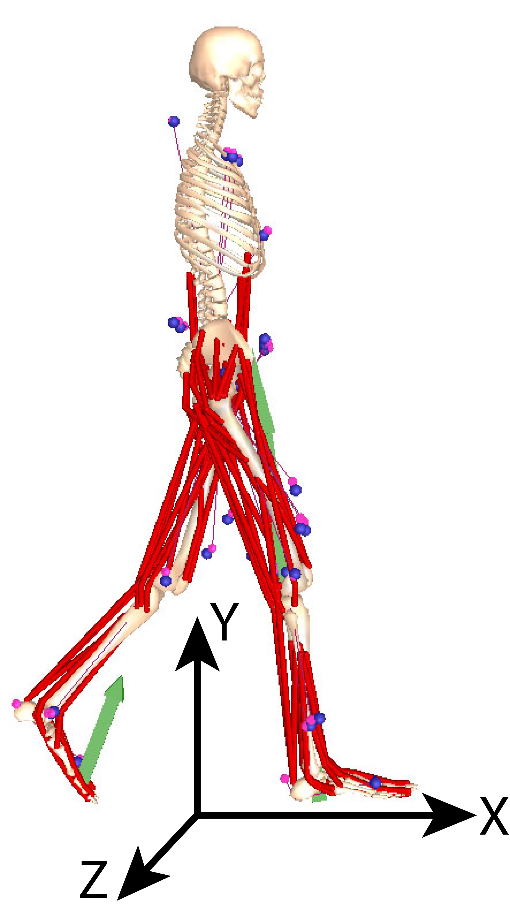
Introduction
Fig. 1: Musculoskeletal Model.
Understanding and treating movement disorders in individuals with cerebral palsy, stroke, Parkinson’s, and other diseases represents a challenging and major health care concern. Using experiments alone to identify the sources of abnormal movement and design treatments is limited because important variables, such as muscle forces, are generally not measurable, and because it is difficult to establish cause-effect relationships. Muscle-actuated dynamic simulations are becoming an increasingly viable approach for elucidating how the elements of the musculoskeletal system interact to produce movement. To apply this emerging technology to help identify the elements that impact an individual’s movement disorder (e.g., bone deformities, abnormal muscle excitations, and weakness) and evaluate potential treatments, we need three-dimensional, muscle-actuated simulations that accurately reproduce the gait dynamics of individual patients [3].
Historically, the generation of three-dimensional muscle-actuated simulations has incurred great computational expense, requiring days, weeks, or even months of computer time [1,5,6,9]. Recent breakthroughs in the application of robotic-style control techniques to biomechanical systems have dramatically reduced the time needed to generate such simulations. With only about 30 minutes of computer time, computed muscle control (CMC) has been used to generate accurate simulations of gait using detailed musculoskeletal models (Fig. 1) [10]. To date, however, the application of CMC has been limited to movements that are only about half a second long, which is not long enough to capture even one gait cycle. The reason is that the quality of the experimental data is relied upon to maintain the balance of the model. Unfortunately, experimental data is often noisy and incomplete. Experimental kinematics (e.g., marker data and joint angles) are often dynamically inconsistent with measured force-plate data [7], and arm motion is not routinely collected in clinical gait labs.
Several strategies can be used to ameliorate the impact of noisy and incomplete data. One strategy is to compute and apply residual forces and moments to maintain the balance of the model. This approach is undesirable because, depending on the quality of the experimental data, such residuals can be large (e.g., as much as 20% of body weight). Another strategy is to eliminate the residuals by altering the experimental kinematics so that they are dynamically consistent with the measured ground reaction forces. This approach, termed the Residual Elimination Algorithm (REA) [10], has several drawbacks as well. First, due to modeling assumptions (e.g., modeling the heads, arms, and trunk as a single rigid body), it may not be correct to reduce the residuals to zero. Second, without applying some small amount of residual forces and moments during a simulation it is not possible to maintain the balance of the model for long-duration movements.
We have developed a new method, called the Residual Reduction Algorithm (RRA), that reduces the size of the residuals but does not eliminate them entirely. This enables muscle-actuated simulations to be generated for movements of longer duration, and potentially compensates for unmodeled dynamics, such as arm swing. We have implemented this method in SimTrack, a software framework for generating muscle-actuated simulations of movement. This paper provides an overview of SimTrack and describes RRA in detail.

Methods
SimTrack consists of four steps [3]. As input, SimTrack takes a dynamic model of the musculoskeletal system, experimentally-measured kinematics, and ground reaction forces and moments. In Step 1, the musculoskeletal model (e.g., [2]) is scaled to match the anthropometry of a subject. In Step 2, an inverse kinematics (IK) problem is solved to determine the model coordinates (e.g., joint angles) that best reproduce the marker data obtained from motion capture.

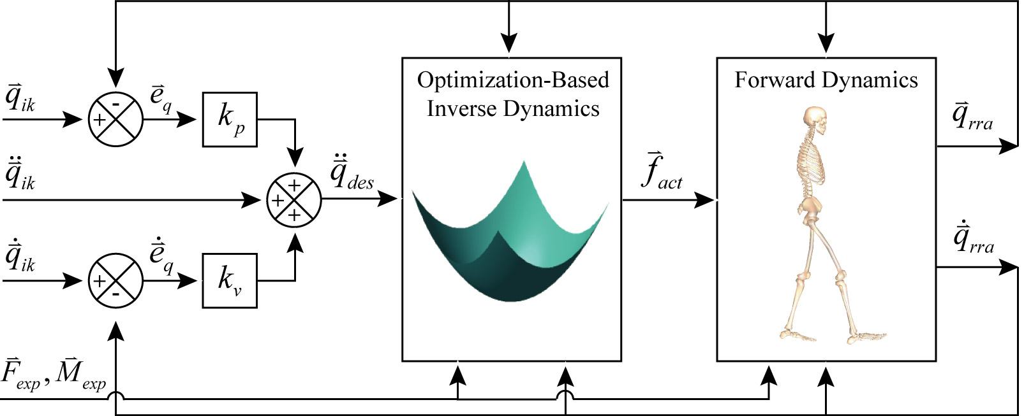
Fig. 2: Schematic of the Residual Reduction Algorithm (RRA).

In Step 3, the coordinates are low-pass filtered at 6 Hz. Then, the coordinates and the experimental ground reaction forces and moments are fit with generalized cross-validated splines [11] to produce smooth functions 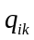, 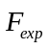, and 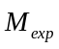. Due to experimental errors and modeling assumptions, the kinematics are not dynamically consistent with the ground reaction forces [7], and a residual force 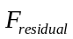 is needed to drive the model to track the given kinematics. By Newton’s 2nd Law,
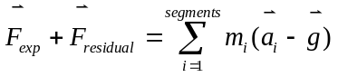, (1)
where 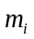 and are the mass and acceleration of body segment , and is acceleration due to gravity. An analogous equation relates the ground reaction moment to the residual moment 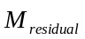. The residuals are computed and averaged over the duration of the movement. The center of mass of the model’s torso is then altered by a small amount to reduce the residual averages. The residual reduction algorithm (RRA) is then applied to alter the kinematics () to further reduce the residuals (Fig. 2). To accomplish this, a control problem is solved in which each coordinate of the model is controlled by an idealized actuator. Specifically, the six degrees of freedom between the model and the ground are actuated by the six residuals, and each joint angle is actuated by an idealized joint moment. RRA steps forward in time, computing the actuator forces 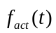 that will cause the model to move from its current configuration 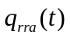 toward its desired configuration 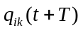 in the next time step, where T is a small increment in time (e.g., 1 msec). The actuator forces are computed by minimizing a performance criterion,
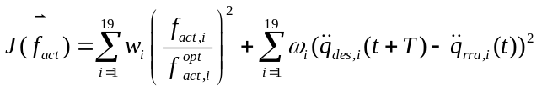, (2)
where 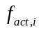 and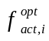 are the force and the optimal force of the i^{th} actuator, 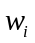 and 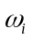 are weights on the actuator stresses and acceleration errors, and 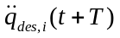 is the desired acceleration of the i^{th} model coordinate, which is computed using a proportional-derivative control law:

, (3)

where 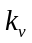 and 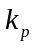 are gains on the velocity and positions errors. The first six components of are the residuals and the remaining components are the joint moments. By attempting to keep the residuals low, the desired accelerations may not be met. Thus the new kinematics may differ from the original kinematics 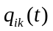.
In Step 4, computed muscle control (CMC) is used to generate a set of muscle excitations that produce a coordinated muscle-driven simulation of the subject’s movement [10]. CMC uses a static optimization criterion to distribute forces across synergistic muscles and proportional-derivative control to generate a forward dynamic simulation that closely tracks the kinematics derived in Step 3. The residuals computed in Step 3 are applied to the pelvis (the base segment of the model), and the measured ground reaction forces and moments are applied directly to the feet.
To investigate the performance of RRA, we used SimTrack to generate a simulation of normal walking for a male subject (age 14.6 yrs, height 1.68 m, mass 60.61 kg) walking at a self-selected speed of 1.12 m/sec. Gait data were provided by Gillette Children’s Specialty Healthcare and consisted of 2.2 seconds of raw marker data, ground reaction forces and moments, and electromyographical recordings for a number of accessible muscles. A generic musculoskeletal model with 21 degrees of freedom actuated by 92 muscles [2] was scaled to fit the subject (Fig. 1). The pelvis was modeled as a rigid segment that was allowed to rotate and translate in three dimensions with respect to the ground. The head, arms, and torso were represented as a single rigid segment that articulated with the pelvis via a ball-and-socket joint located at about the third lumbar vertebra. No arms were included in the model as marker data for the arms were not available for this subject. Each hip was modeled as a ball-and-socket joint, each knee as a planar joint, and each ankle-subtalar complex as two revolute joints. Muscle activation dynamics were characterized by a first-order differential equation with rise and decay time constants of 10 and 40 milliseconds. Muscle-tendon contraction dynamics were described by a lumped-parameter model that accounts for the force-length-velocity properties of muscle and the elastic properties of tendon.

Results
SimTrack required about 1 minute to compute the IK solution, 10 minutes to run RRA, and 1 hour to generate a muscle-actuated simulation using CMC. The muscle excitation patterns computed by CMC were consistent with electromygraphical recordings obtained from the subject (not shown). The final simulation tracked the joint angles to within 1° of the original experimental kinematics. Fig. 5 shows snapshots of the simulation.

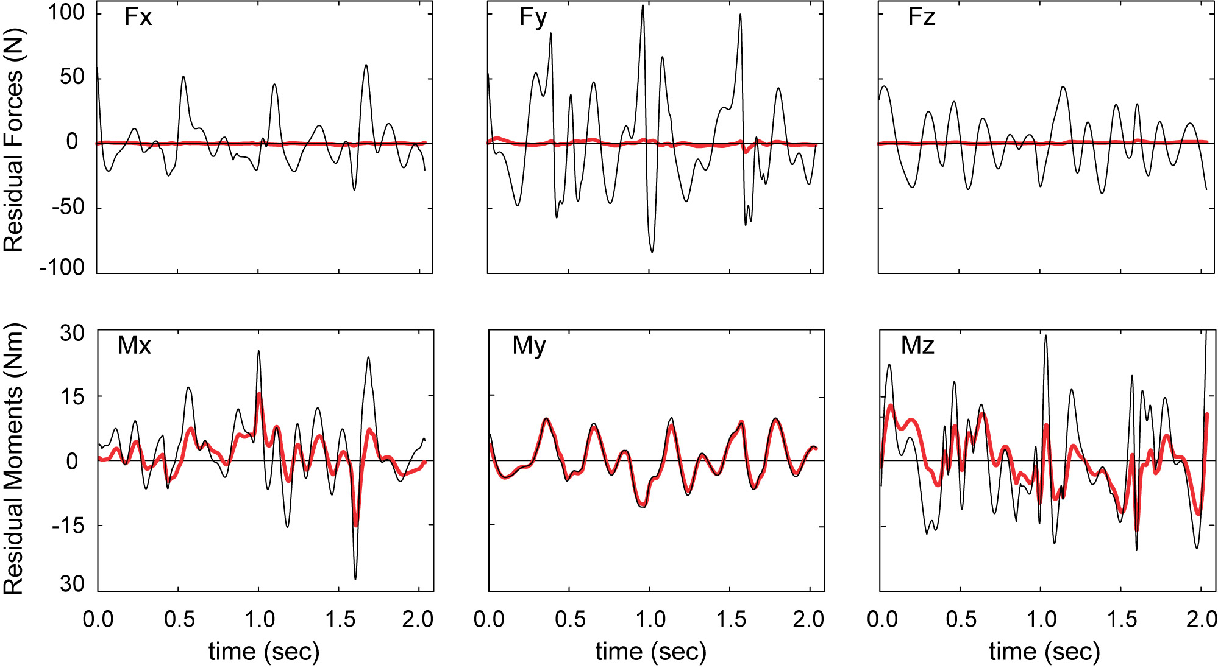
Fig. 3: Residuals before (thin black lines) and after (thick red lines) application of RRA.

Application of RRA substantially reduced the residuals (Fig. 3). The residual forces prior to the application of RRA were noisy and high in amplitude (±50 N for Fx and Fz, ±100 N for Fy). Subsequent to RRA, the amplitudes were less than 5 N. The residual moments were more resistant to reduction. Mx and Mz were reduced by about 50% from peaks of about 30 Nm down to about 15 Nm. In contrast to Mx and Mz, My (the axial residual) was not noisy and RRA did not reduce its magnitude appreciably, suggesting that My was due not to experimental noise but mainly to unmodeled dynamics (e.g., the model had no arms).
RRA made only minor changes to the experimental kinematics. Despite the dramatic reduction in residual forces, the translation of the pelvis (the base segment of the model) was altered by only 3 mm in X, 1 mm in Y, and 34 mm in Z. The largest change in the joint angles was less than 0.5° and this was only for a brief period of

time. Most joint angles, like back axial rotation, were within 0.1° of the original IK solution (Fig. 4). In contrast, REA applied to the same data produced much larger deviations, especially in back axial rotation (Fig. 4). This occurred because of an attempt of REA to compensate for a lack of arms in the model by over-rotating the torso.
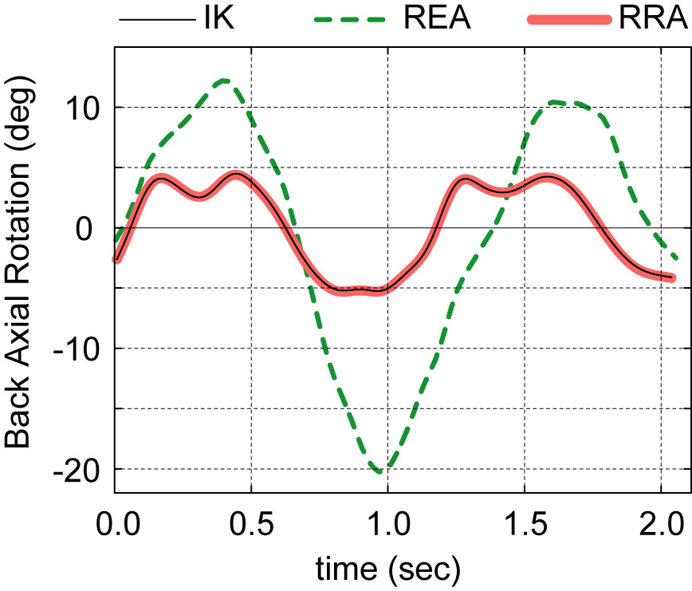
At the end of the movement, the CMC simulation based on the RRA-processed kinematics remained close to the experimental kinematics (Fig. 5, RRA). In contrast, without the application of residuals, the model was beginning to fall over (Fig. 5, REA).

Discussion
Fig. 4: Axial rotation in the back joint following application of REA and RRA. RRA is much closer to the IK solution.
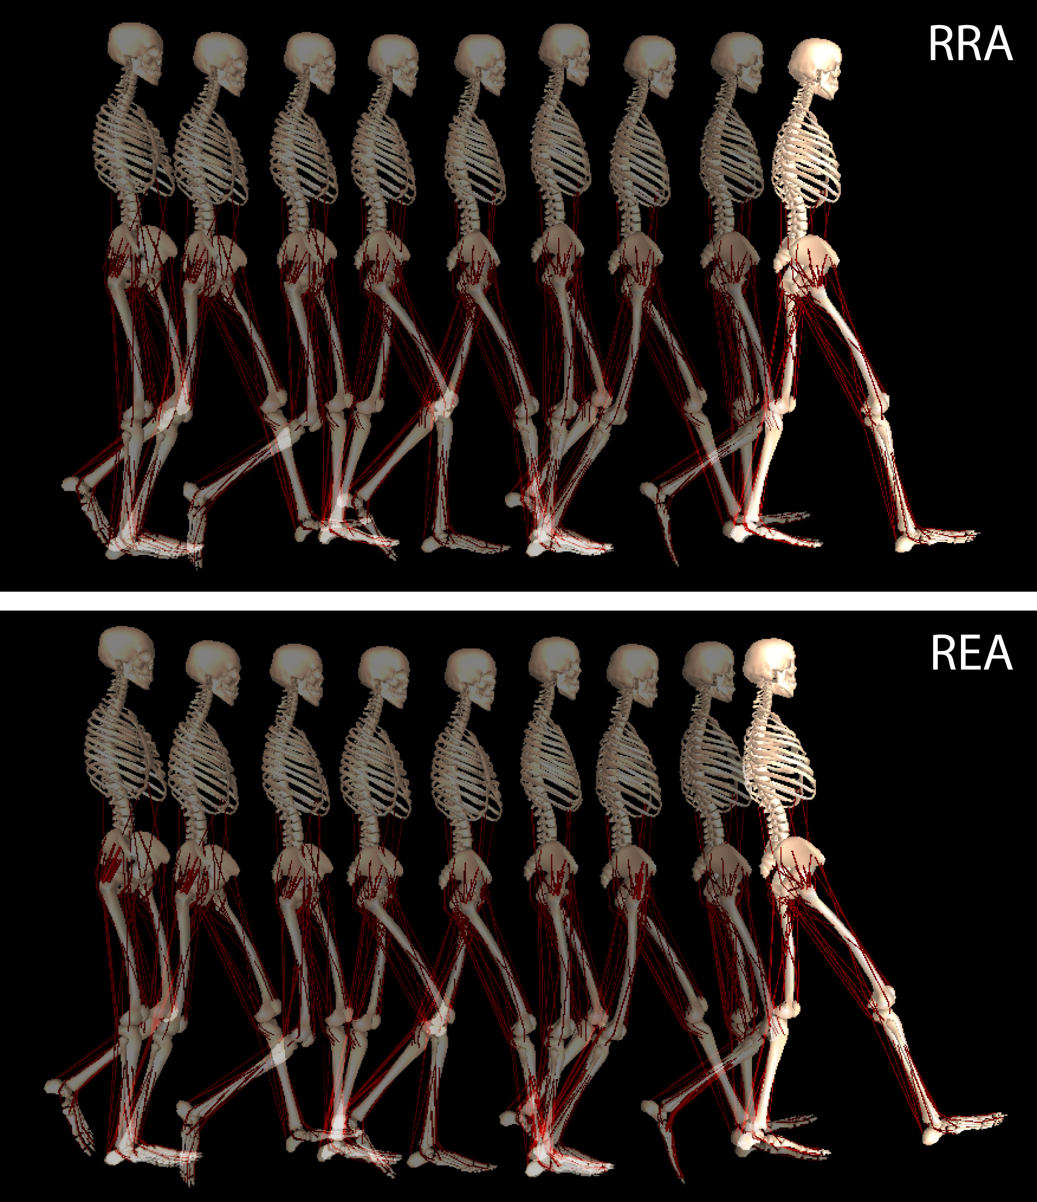
In the last decade, advances in optimization along with parallel computing have made it possible to generate simulations of greater and greater complexity [1,4,5,6,8]. With the development of CMC, it has become possible to generate such simulations in minutes on single-processor desktop computers. RRA has enabled the generation of simulations of movements of considerably longer duration than was previously possible with CMC while remaining faithful to the measured kinematics. The duration of the movement simulated in the current study was just over 2.0 seconds, and we believe that this same approach will allow simulations of movements of much longer durations still.
Fig. 5: Comparison of CMC simulations based on RRA- and REA-processed kinematics.
The ability to create coordinated muscle-driven simulations rapidly provides new research opportunities. For example, with SimTrack it is now feasible to generate and analyze 3D simulations of many subjects and thereby establish norms for muscle function. It is also possible to investigate how impairments in the musculoskeletal system may contribute to abnormal movements in individual subjects, and to explore the functional consequences of treatments in these subjects [3].

Acknowledgements
We gratefully acknowledge Ayman Habib, Peter Loan, and Paul Mitiguy for their contributions to the SimTrack software, Darryl Thelen for allowing us the use of his lab’s implementation of REA, and Mike Schwartz and Gillette Children’s Specialty Healthcare for providing the clinical gait data. This work was funded by the National Institutes of Health through the NIH Roadmap for Medical Research Grant U54 GM072970 and through NIH Grants HD33929 and HD046814.

References
[1] Anderson and Pandy (2001), J Biomech Eng 123, 381-90. [2] Delp et al. (1990), IEEE Trans Biomed Eng 37, 757-67. [3] Delp et al. (in press). IEEE Trans Biomed Eng. [4] Fregly et al. (2005), J Biomech Eng 127, 465-74. [5] Hase et al. (2003), J Visual Comput Animat 14, 73-92. [6] Higginson et al. (2006), J Biomech 39, 1769-77. [7] Kuo (1998), J Biomech Eng 120, 148-59. [8] McLean et al. (2003), J Biomech Eng 125, 864-74. [9] Neptune et al. (2001) J Biomech 34, 1387-98. [10] Thelen and Anderson (2006), J Biomech 39, 1107-15. [11] Woltring (1986), Adv Eng Software 8, 104-13.

